**Write a program to implement wordcount using Pig.**

Input file :

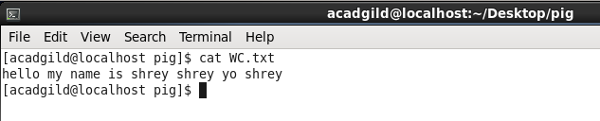

Commands on grunt shell :

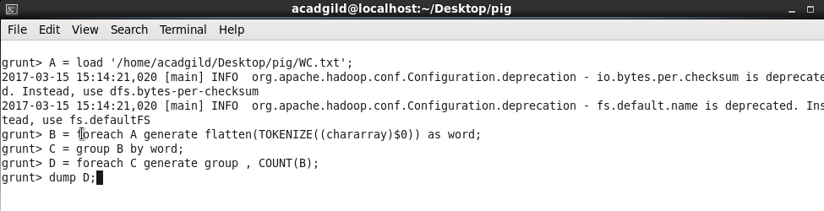

Dump result :

