**First load the file :**



**1.Write a pig script find the average age of male and female persons died in the titanic tragedy .**

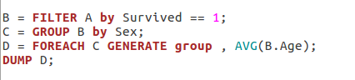

**Output :**

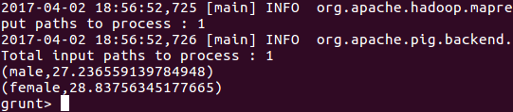

**2.Write a pig script to find the number of people died and survived in each class**

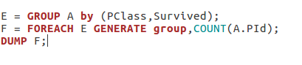

**Output :**

