**First load the file :**

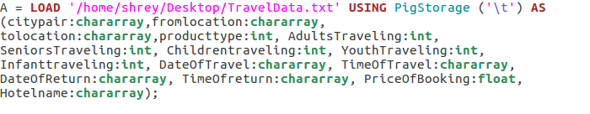

**1.Write a pig script to find the top 20 destination people travel the most: Based on the given data**

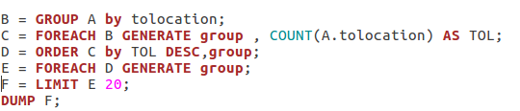

**Output :**

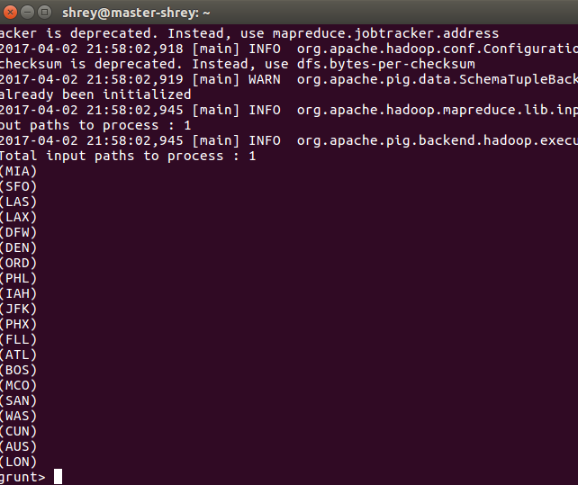

**2. Write a pig script to find the top 20 locations from where people travel the most.**

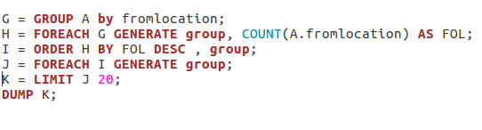

**Output :**

