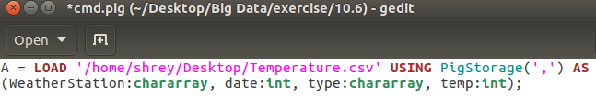First load the file :

1.Write a pig script to find the minimum temperature observed in a given weather station in a particular year

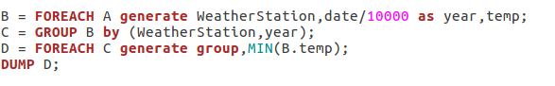

**Output :**

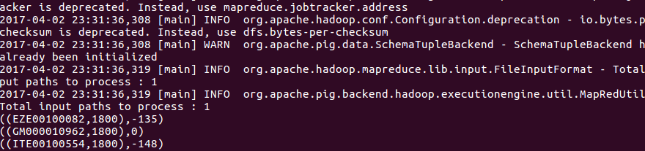

2. Write a pig script to find the maximum temperature observed in a given weather station in a particular year

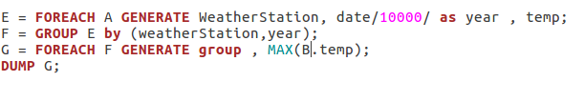

**Output :**

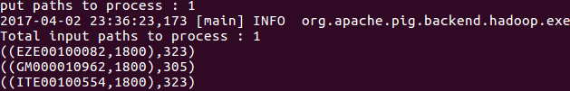

3. Write a pig script to find the number of readings given by each weather station according to the dataset

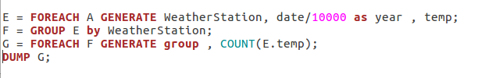

**Output :**

