Building.csv

–BuildingID, BuildingMgr, BuildingAge, HVACproduct,Country

HVAC.csv

–Date, Time, TargetTemp, ActualTemp, System, SystemAge, BuildingID

●Using Distributed cache join the two datasets and find out the number of temperature variations in each country using mapreduce.

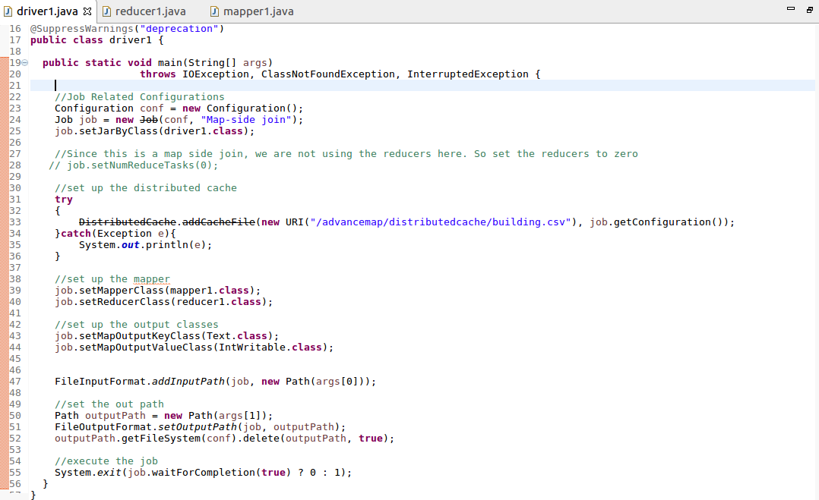

**Driver :**

**Mapper :**

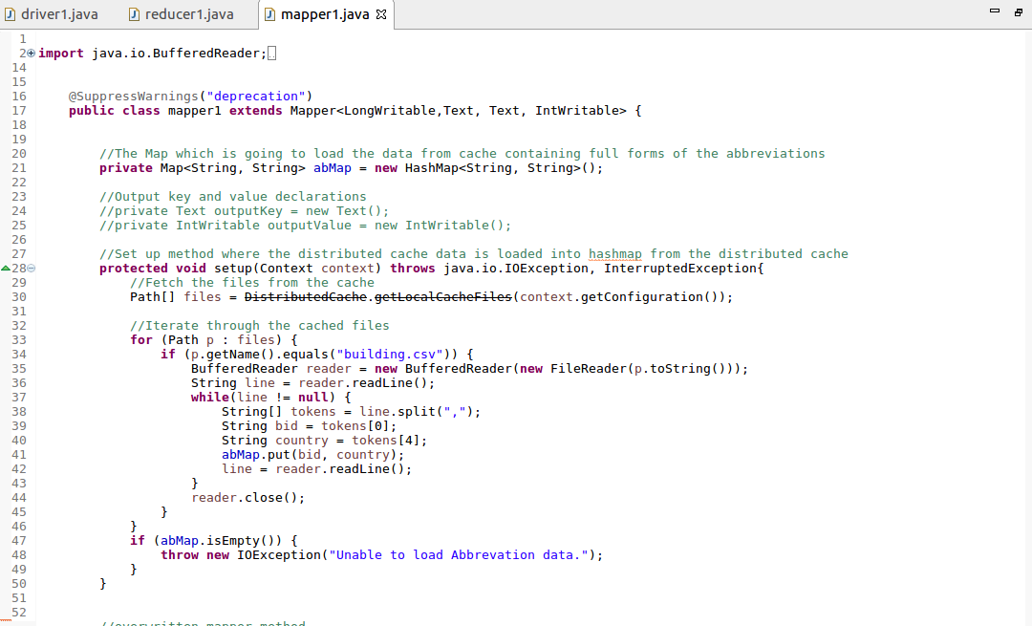

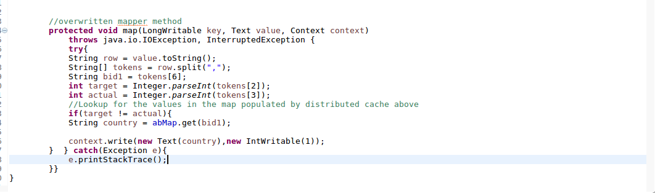

**Reducer :**

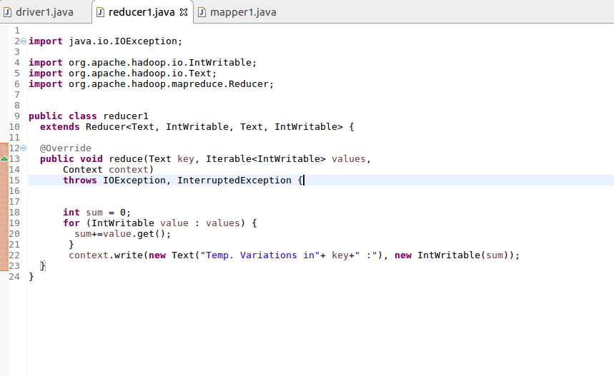**Exectuting JAR :**

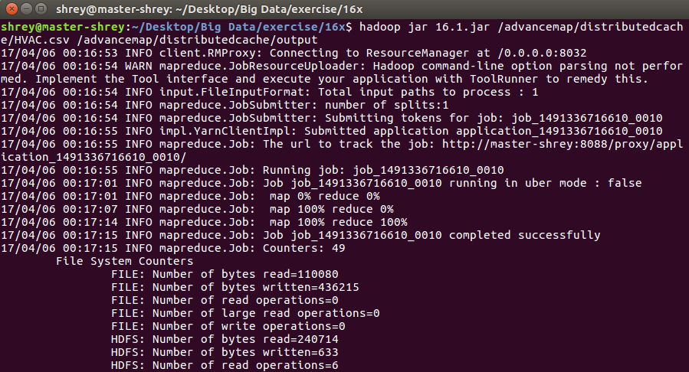

**Output :**

