Building.csv

–BuildingID, BuildingMgr, BuildingAge, HVACproduct,Country

HVAC.csv

–Date, Time, TargetTemp, ActualTemp, System, SystemAge, BuildingID

●Execute

Session 16 -

Assignment 1 (Machine and Sensor data analysis)

using Reduce side join

and compare which join is faster in normal conditions.

**Driver :**

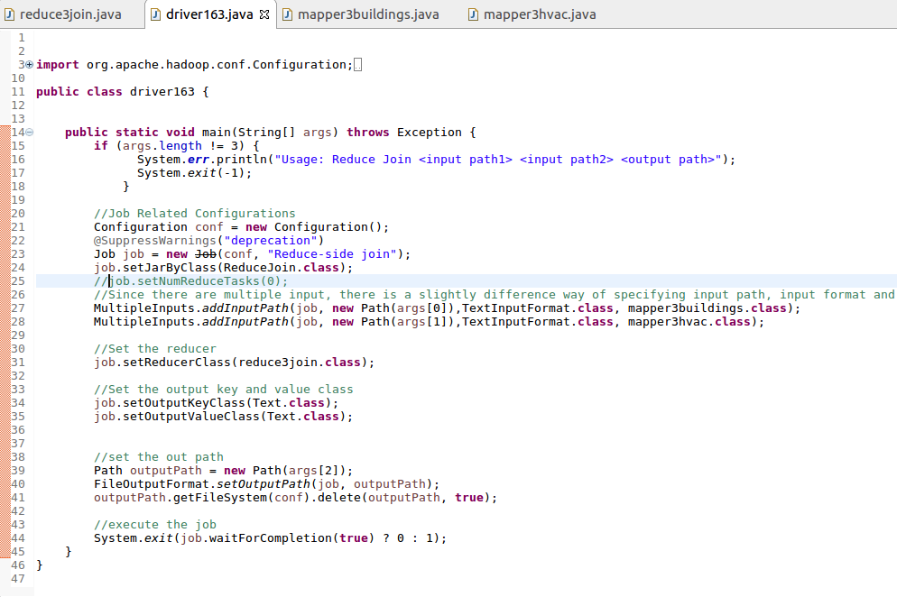

**Mappers :**

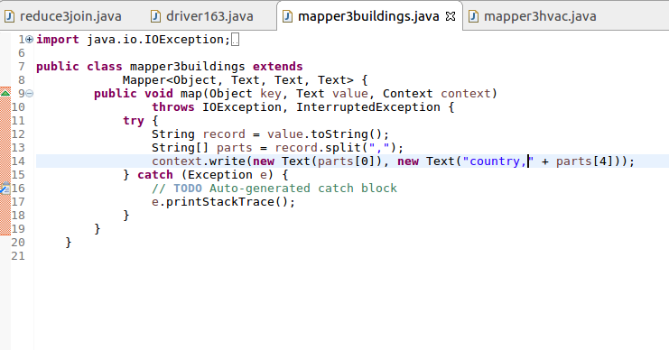

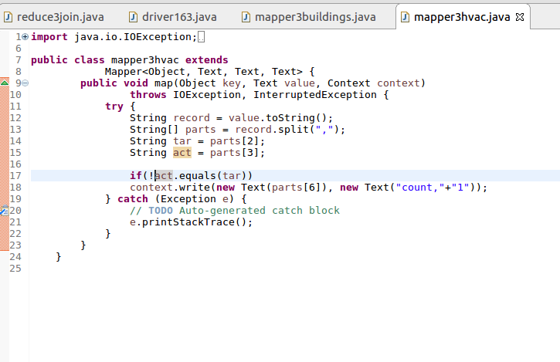

**Reducer :**

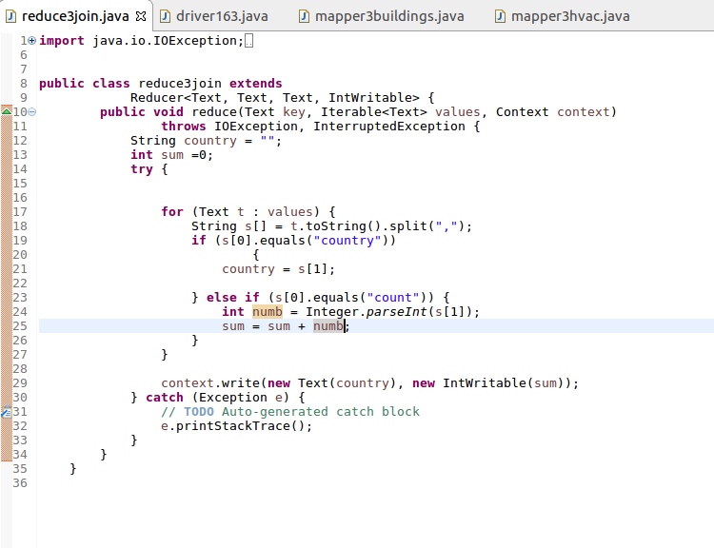

**Output :**

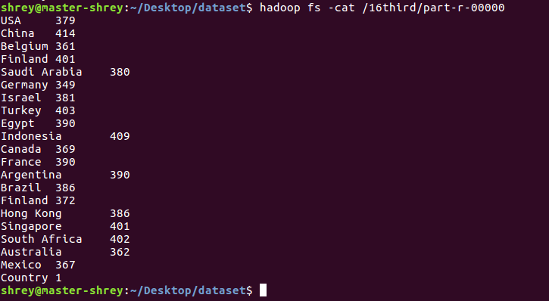

One comparing the time taken by map-side and reduce-side joins , i reached to a conclusion that

Map-side Join is best bet when one of the tables is small enough to fit in memory to complete the job in a short span of time.