Write a secondary sort program to generate the top 2 maximum temperatures corresponding

to every year from the temperature dataset

**Driver :**

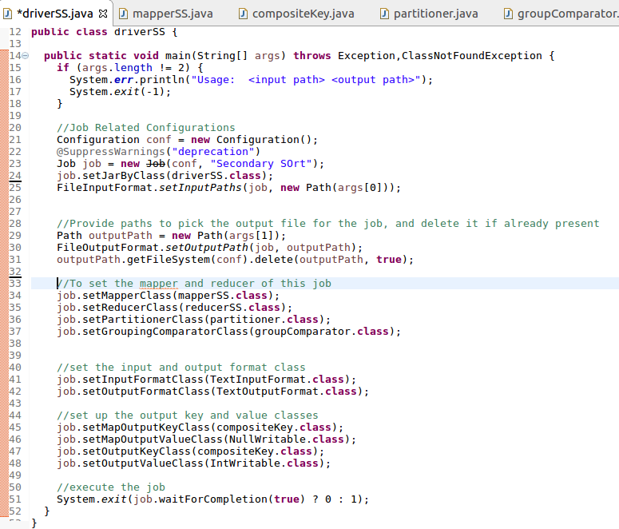

**Mapper :**

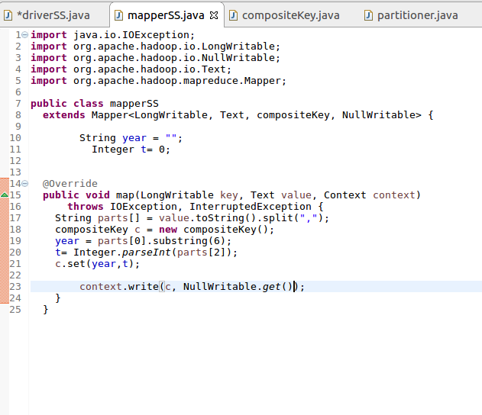

**Composite Key class :**

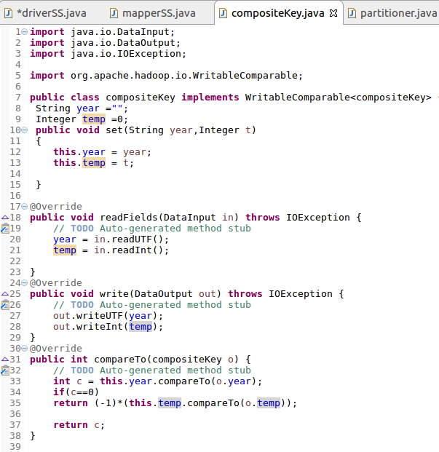

**Cont.**

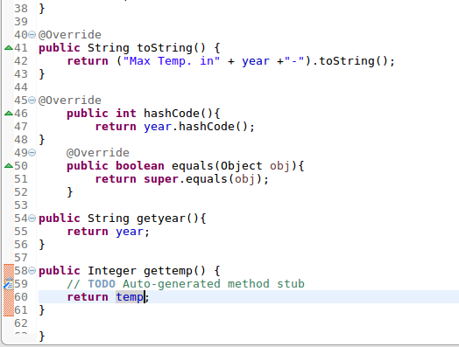

**Custom Partitioner class :**

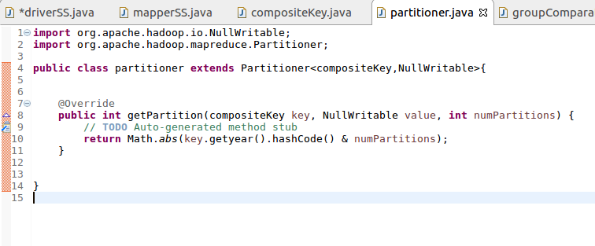

**Group Comparator class :**

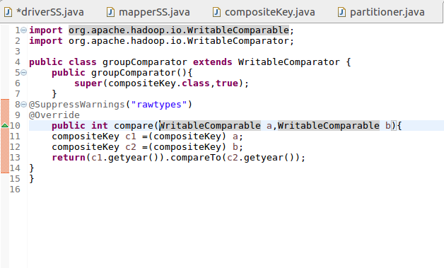

**Reducer :**

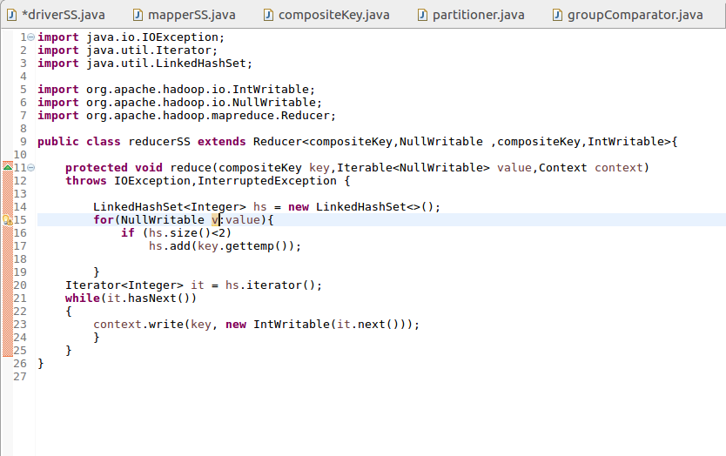

**Output :**

