Write a mapreduce job that takes configuration from command line (min.word.count). Based

on the configuration, it should perform count of words from a document and produce only

those words in the output whose count is greater than or equal to the configura

tion.

**Driver :**

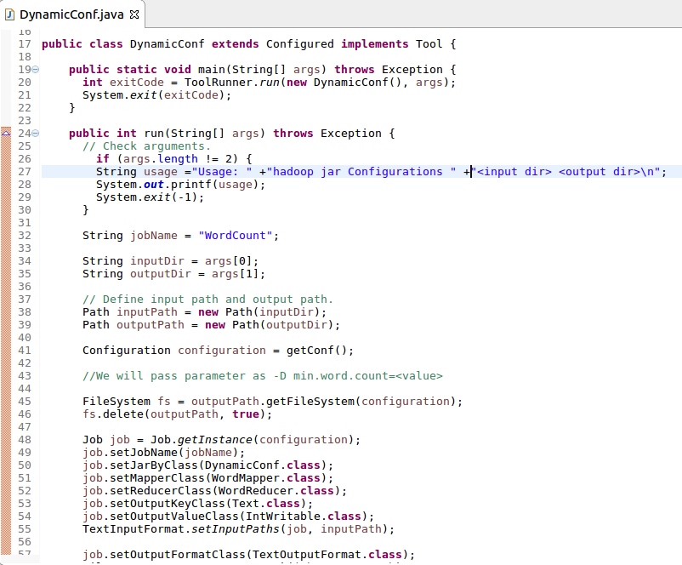

**Mapper :**

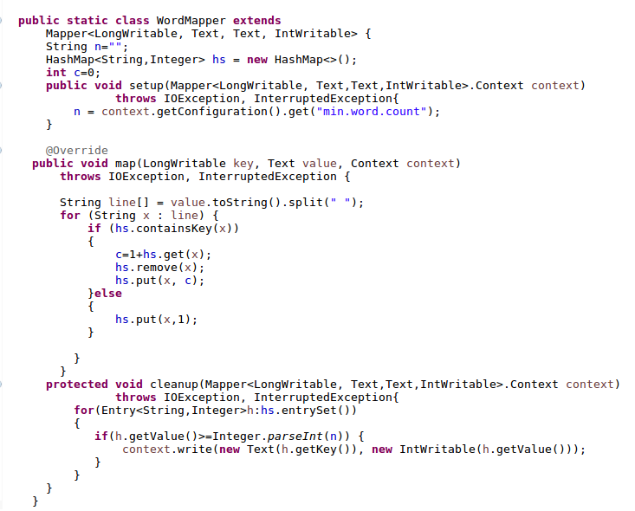

**Reducer :**

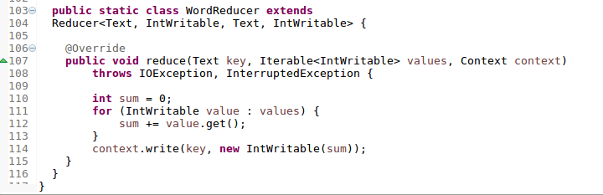

**Input file :**

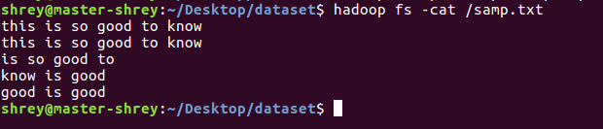

**Output :**



