Write a map reduce program to desing a custom counter to count number of people are affected

with 'PULMONARY' disease and 'BRONCHITIS & ASTHMA' in the state 'CA'.

**Driver :**

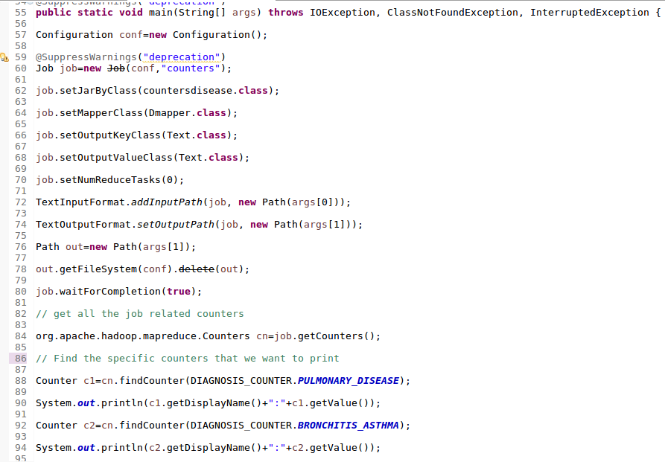

**Mapper with the enum defined just above the class :**

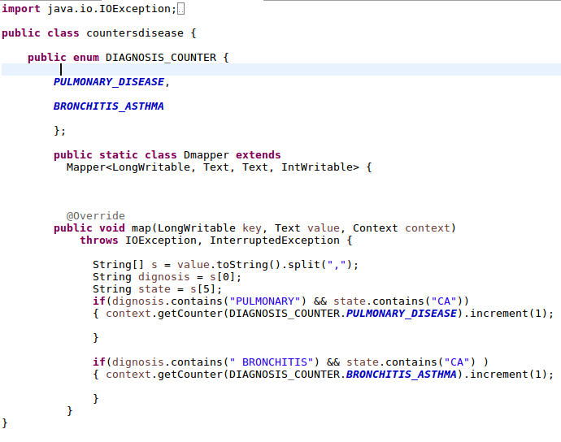

**Output :**

