Run a map only job on the word count program using static configurations.

Input file :

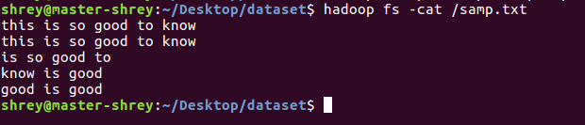

**For simplicity I have combined all the class into one file :**

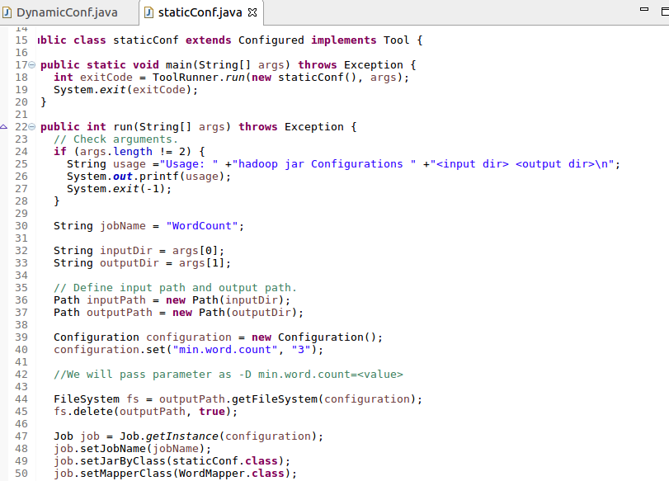

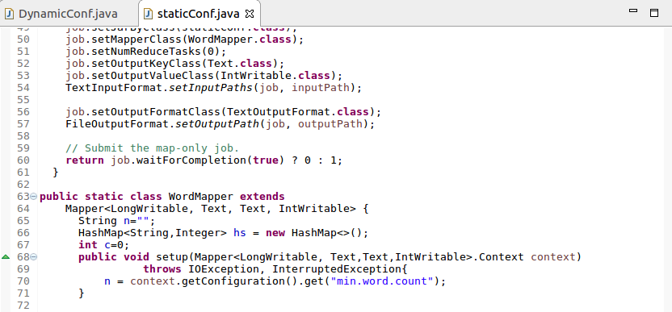

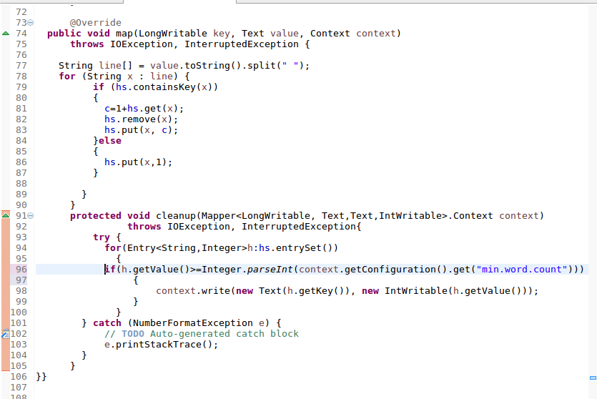

**Output :**

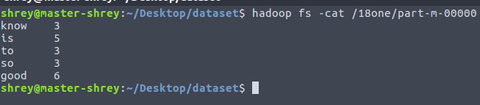

**2.Run the mapreduce word count program and set the number of reducers to 2 using**

**static configurations**

Changed the number of reducers in thr driver part to acheieve output :

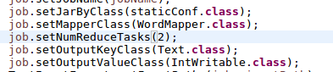

**Output :**

