**Merge the small files in hadoop using command.**

**Input files :**

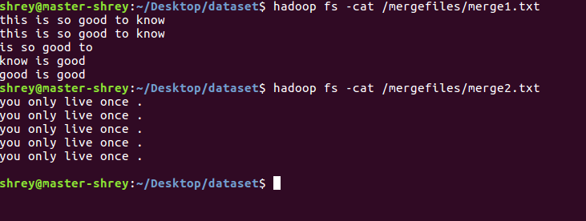

**Storing the files on HDFS:**

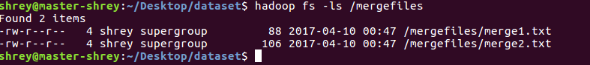

**Command and Output file(**Stored on Local**)** :

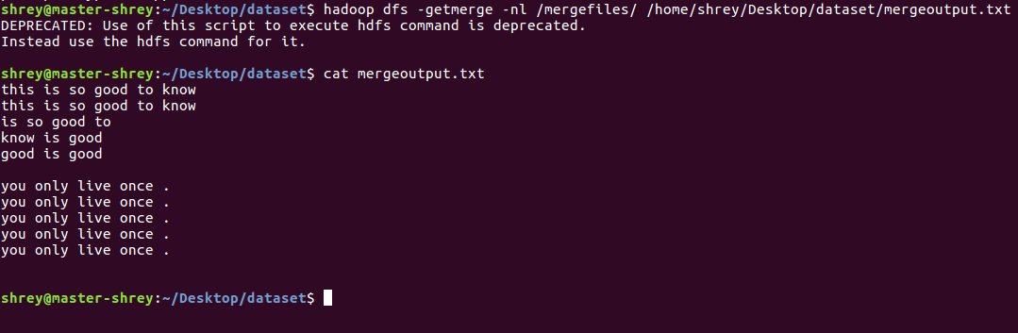

* -nl is a third optional parameter used to give a new line between the files.