Create a database named 'custom'. Create a table named temperature_data inside custom having below fields: 1. date (mm-ddyyyy) format 2. zip code 3. temperature The table will be loaded from comma-delimited file. Load the dataset.txt (which is ',' delimited) in the table.

// database created

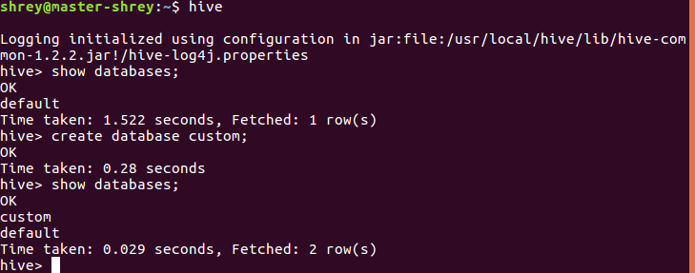

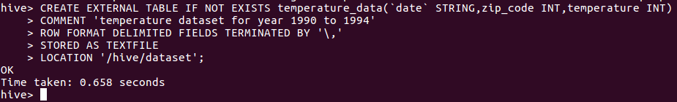// creating the table and as well as loading the values into the table using the comma separated values.

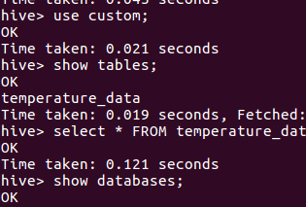

Using HiveQL query to produce output.

