**Assignment 24.2**

● Fetch date and temperature from temperature_data where zip code is greater than 300000 and less than 399999.

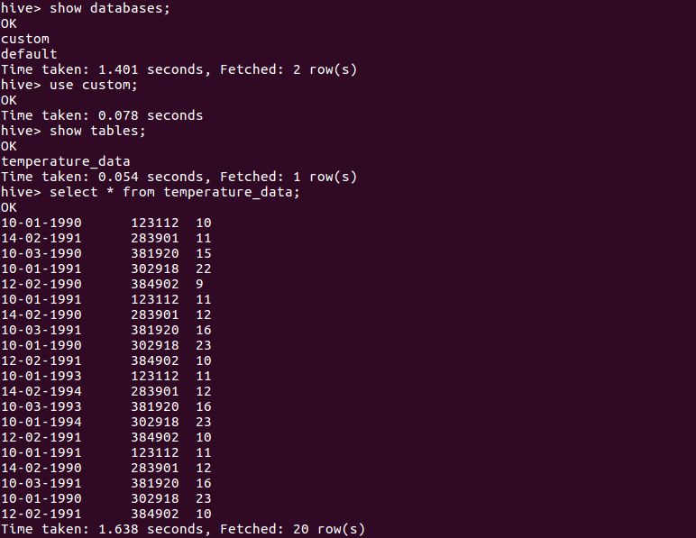

The database custom was created and the table temperature_data was also created. The following data is stored in the table.

***Note - This same database and table is used by for all the questions***

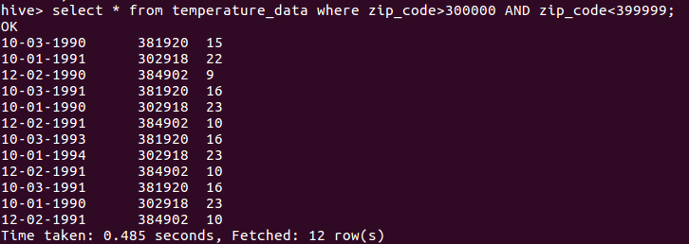

Here we are selecting the entries which has the zipcode in the range of 300000 and 399999.

● Calculate maximum temperature corresponding to every year from temperature_data table.

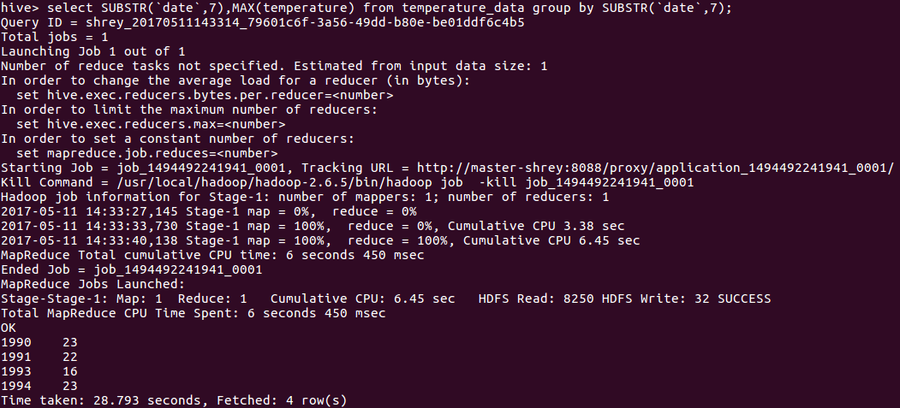

The database custom was created and the table temperature_data was also created. The following data is stored in the table.We are using the substrting to display the year only from the date and the max temperature. Also the group is done according to the substring of the date only so that the values are sorted according to the date.

● Calculate maximum temperature from temperature_data table corresponding to those years which have at least 2 entries in the table.

● Create a view on the top of last query, name it temperature_data_vw.

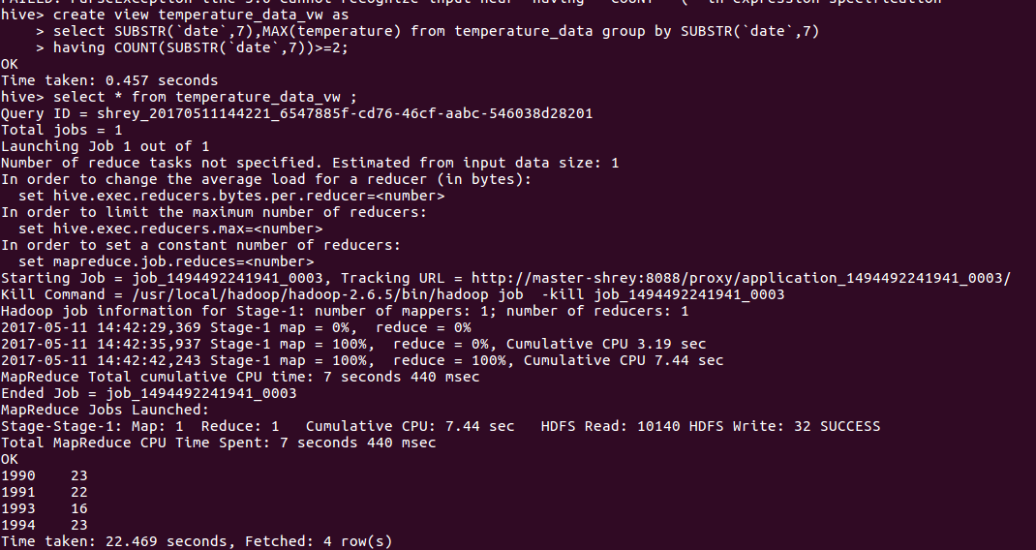

We are using the substrting to display the year only from the date and the max temperature. Also the group is done according to the substring of the date only so that the values are sorted according to the date.

And also adding the condition that the count should be greater than or equal to 2 so that the years for which the readings are taken twice are only taken into account.

Here the view is created using the command “ CREATE VIEW ” and then displayed the view.

● Export contents from temperature_data_vw to a file in local file system, such that each file is '|' delimited.

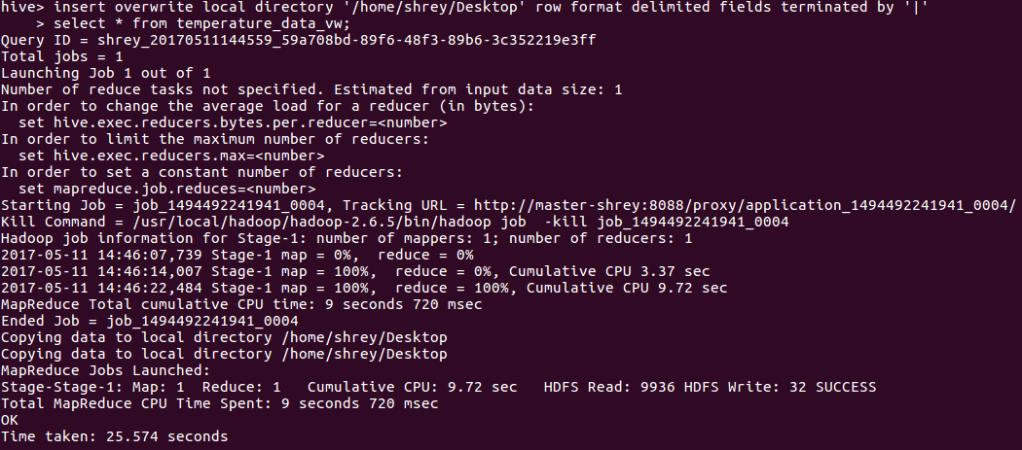

In this we have got the value of the view in the local system using the command ‘insert overwrite’. The delimiting value is ‘|’.

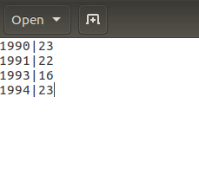

Hence we can see in the output the values are delimited by ‘|’.