Assignment 24.6

Write a hive query to find the minimum temperature observed in a given weather station in a particular year.

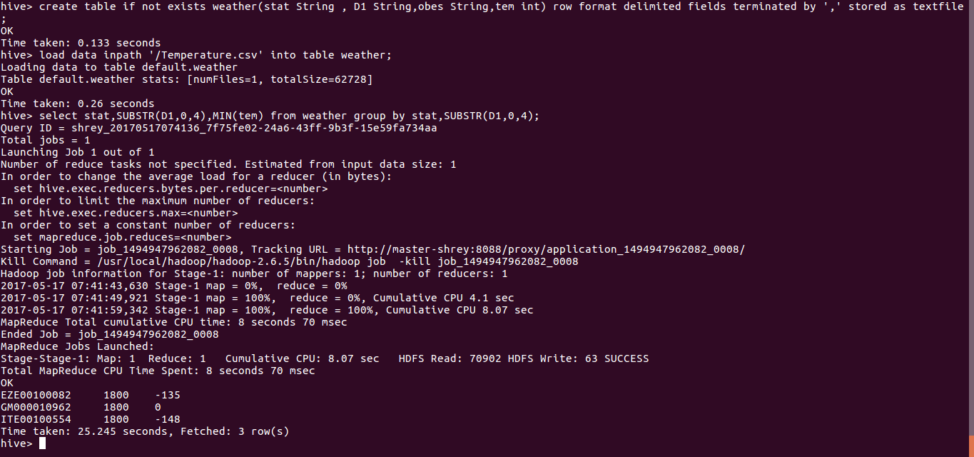

Here I have created the table with given respective datafields.

Here used the subString to get the only the year as well as min function to get the minimum temperature. The grouping is done according to the station and the year hence we get value for each station and year.

Write a hive query to find the maximum temperature observed in a given weather station in a particular year.

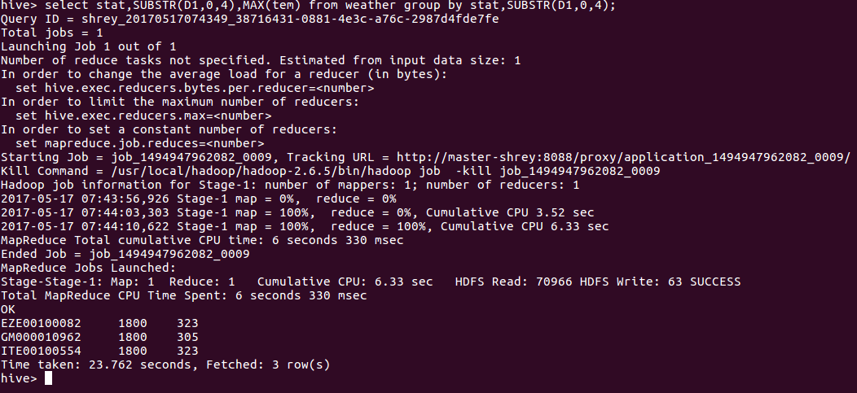Similarly here we are using the same code but to find the maximum value we are using the MAX() function.

Write a hive query to find the number of readings given by each weather station according to the dataset.

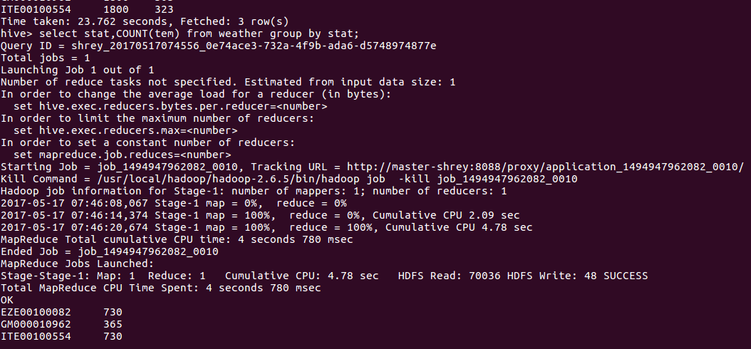

In this as we have to find the count of the recordings hence we are using the COUNT() function and grouping is done according to the station only.