**Assignment 27.2**

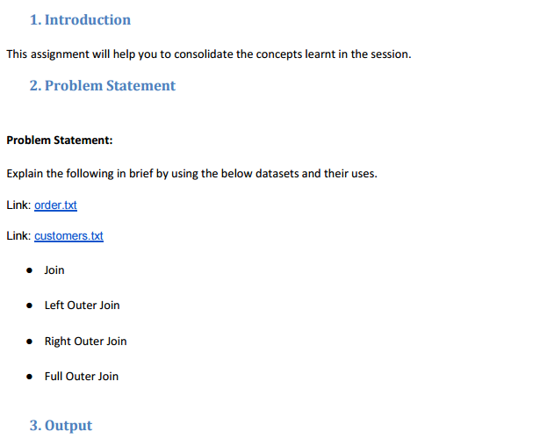

* First, we will create table order_data and then will load the given dataset into the table.
* Using describe we can describe the columns and their datatypes.

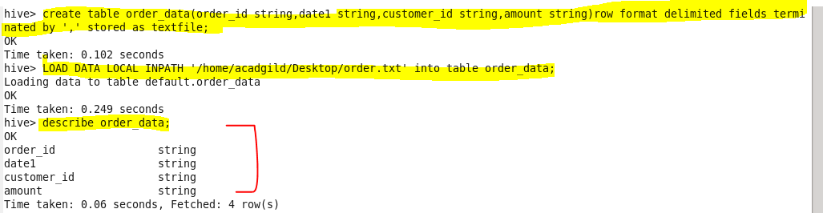

* So our order_data table is :

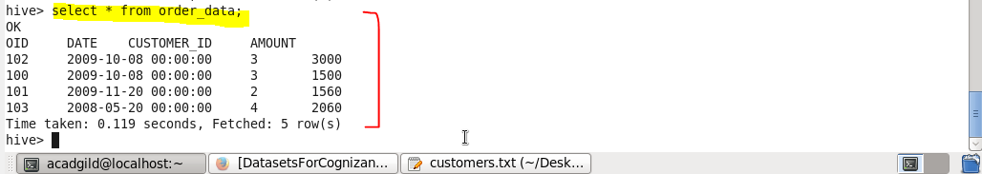

* Now we will create table customer_data and then will load the given dataset into the table.
* Using describe we can describe the columns and their datatypes.

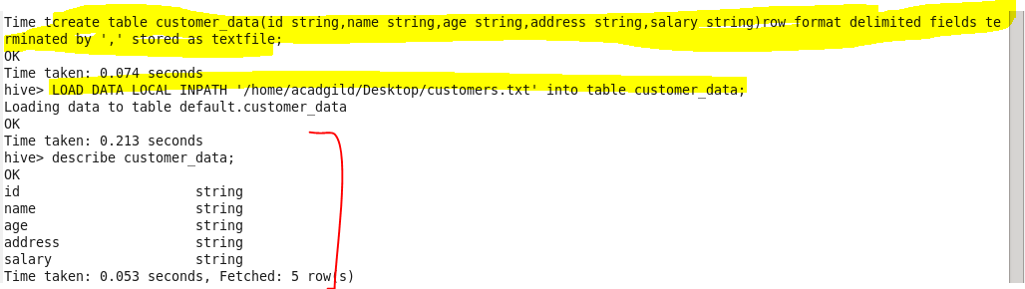

* So our customer_data table is :

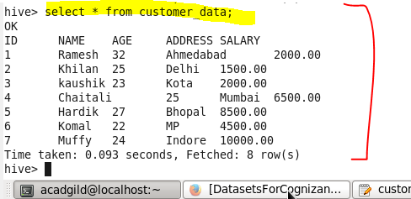

● **JOIN**

JOIN clause is used to combine and retrieve the records from multiple tables. A JOIN condition is to be raised using the primary keys and foreign keys of the tables.

Here, joining ‘order_data’ and ‘customer_data’ tables using JOIN and ‘select’ is used to display the output.

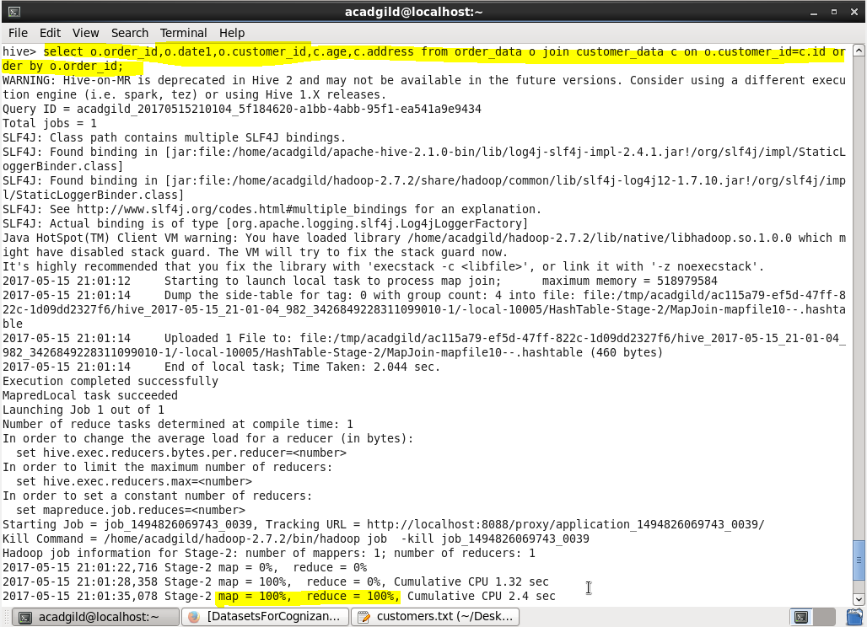

**Output :**

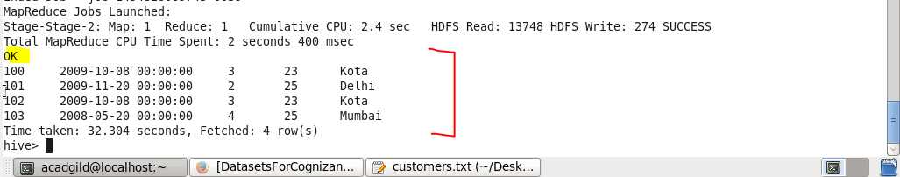

● **Left Outer Join**

A LEFT JOIN or LEFT OUTER JOIN returns all the values from the left table even if no matching value in the second table, plus the matched values from the right table, or NULL in case of no matching JOIN predicate.

Below is the query using left outer join.

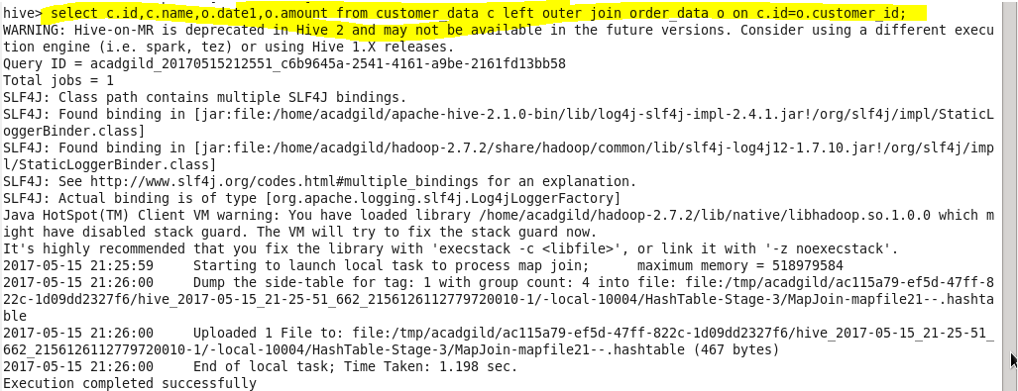

**Output :**

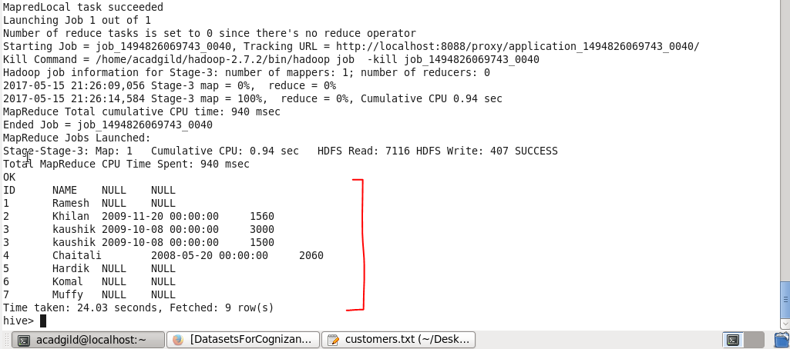

**● Right Outer Join**

A RIGHT JOIN returns all the values from the right table, plus the matched values from the left table, or NULL in case of no matching join predicate.

Below is the query using right outer join.

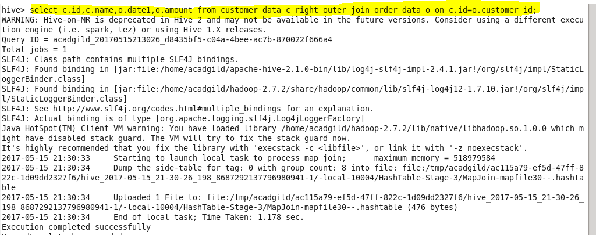

**Output :**

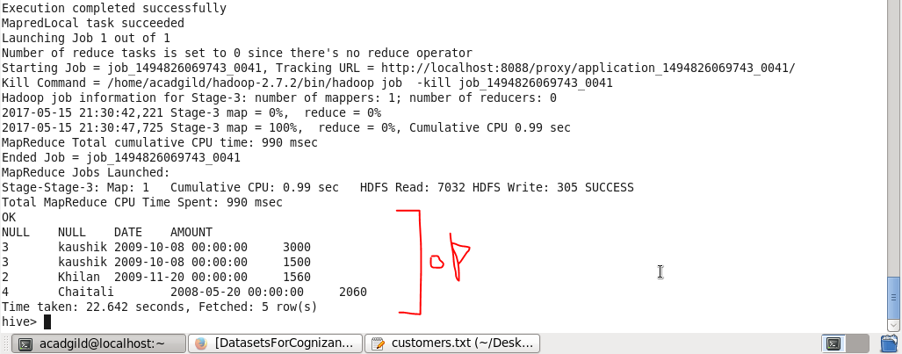

**● Full Outer Join**

The FULL OUTER JOIN in HIVEQL combines the records of both the left and the right outer tables that fulfil the JOIN condition. The joined table contains either all the records from both the tables, or fills in NULL values for missing matches on either side.

Below is the query using full outer join with output.

