**Ans 1:**

Yes we can overload the method with same return type .

import java.util.*;

class Acad

{

public int sum(int a,int b)

{

int sum = a+b;

return sum;

}

public int sum(int a,int b,int c)

{

int sum = a+b+c;

return sum ;

}

public static void main(String []args)

{

Scanner sc = new Scanner(System.in);

int x = sc.nextInt();

int y = sc.nextInt();

int z = sc.nextInt();

Acad ac = new Acad();

System.out.println(ac.sum(x, y));

System.out.println(ac.sum(x,y,z));

}

}

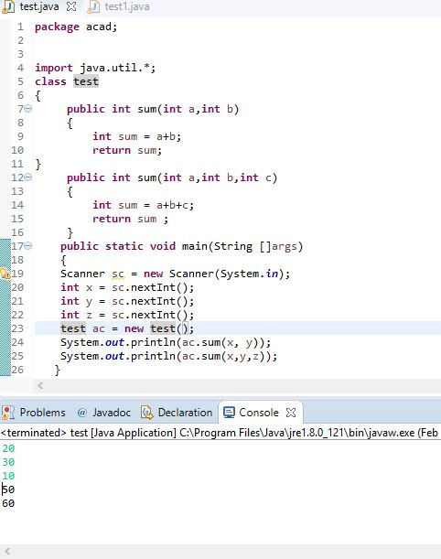

**Ans 2:**

import java.util.*;

class Acad

{

public static void main(String []args)

{

int temp=0;

Scanner sc = new Scanner(System.in);

System.out.println("Enter the number of element u wants to enter in your array");

int n = sc.nextInt();

int a[] = new int[n];

for(int i=0;i<n;i++)

{

a[i] = sc.nextInt();

}

for (int i = 0; i < n; i++)

{

for (int j = i + 1; j < n; j++)

{

if (a[i] < a[j])

{

temp = a[i];

a[i] = a[j];

a[j] = temp;

}

}

}

System.out.print("Descending Order:");

for (int i = 0; i < n - 1; i++)

{

System.out.print(a[i] + ","); }

System.out.print(a[n - 1]);

}

} 