**Assignment 32.2**

Problem Statement:

● Use Hbase shell for performing the following operations

● Create the table customer with two column families

● Personal details and order details as column families. Create a unique number as row key (ssn/Aadhar no.,etc) Insert at least 10 records to each column Insert following values for personal details column family Name, age, city, state

● Insert following values for order details column family

● Order no., order quantity, and order amount

● Use put command to insert the values for each record. Use get command, to retrieve all the records of single customer.

Creating table customer with two column families personal details and order details



Using put command:

Inserting values for personal details column : name

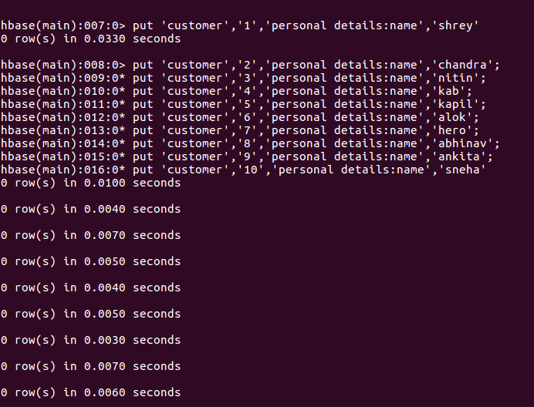

Inserting values for personal details column : age

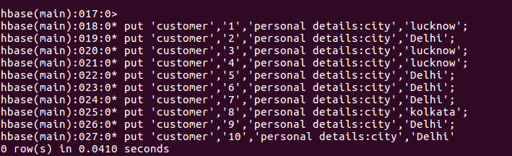

Inserting values for personal details column :city

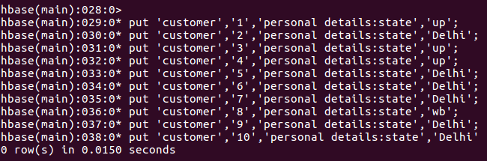

Inserting values for personal details column : state

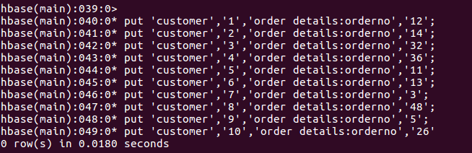

Inserting values for order details column :order number

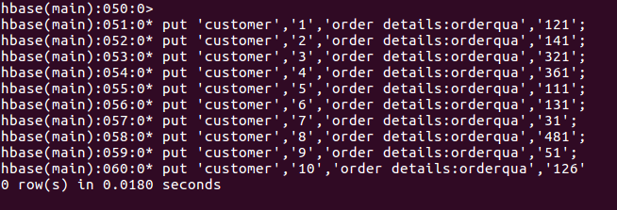

Inserting values for order details column : order quantity

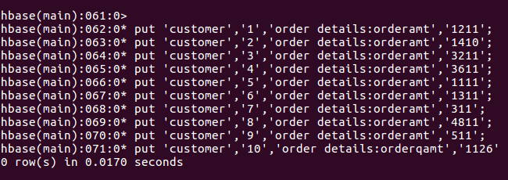

Inserting values for order details column :order amount

Retrieving values using get function of table ‘customer’

