**Input File:**

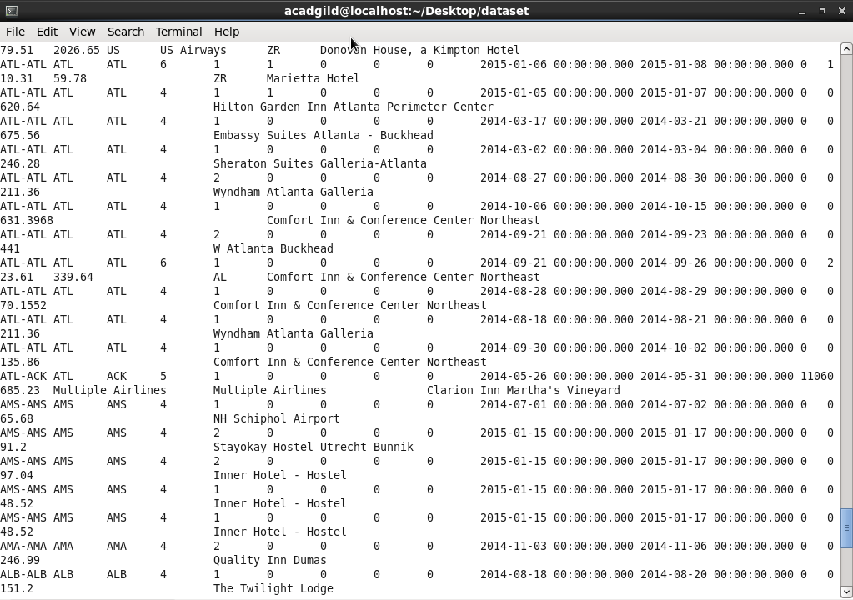

**I have used same driver and reducer code for 3 question only mapper changes respectively.**

**CODE:Driver:** 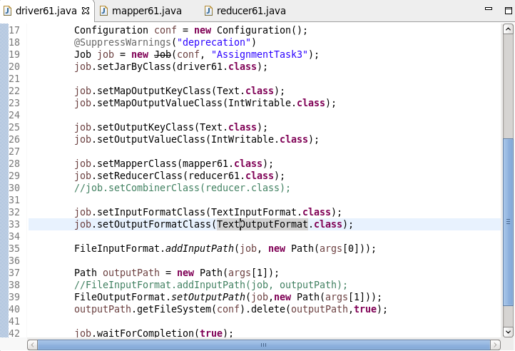

**Reduce :**

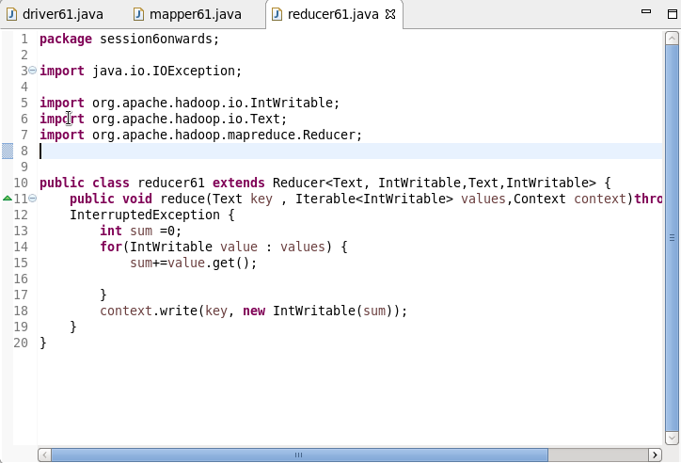

**1 .Find out how many people has chosen their destination as MIA and MCO**

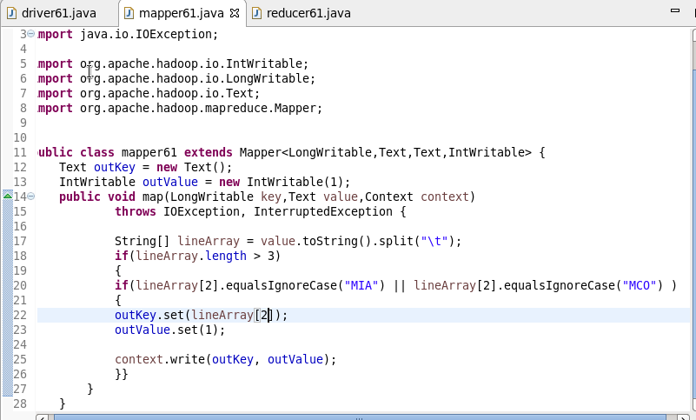

**Output :**

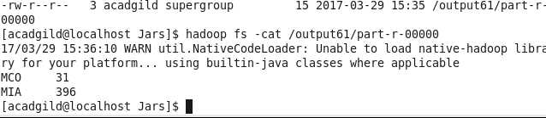

**2. Find out the number of people undertaken the trips from the places MIA and HOU**

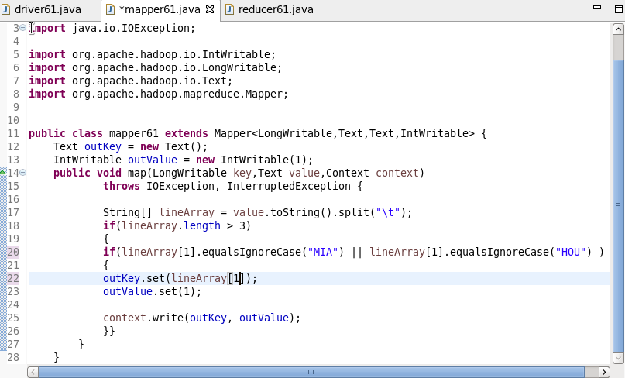

**Output :**

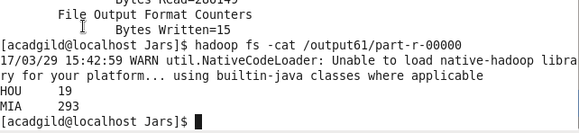

**3. Find out how many people has chosen airline mode of travel for the places LAS and LAX**

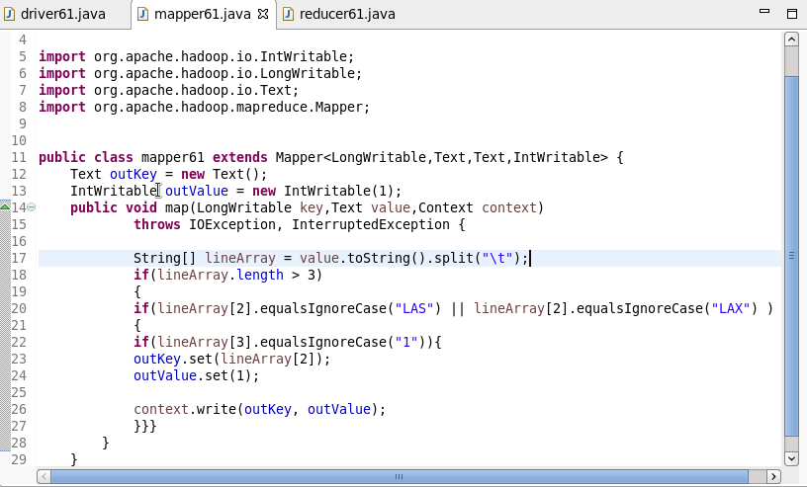

**Output :**

