**Problem Statement Use key value output format to save the output of Session 6 – Assignment 1(Travel Data analysis) and save the output as comma (,) separated instead of tab(\t) separated.**

**Driver class**

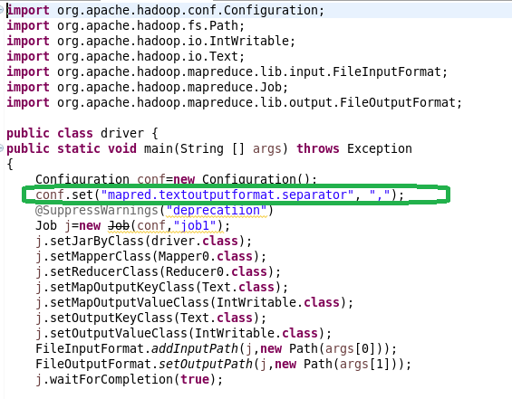

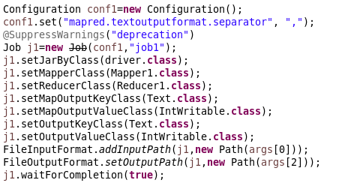

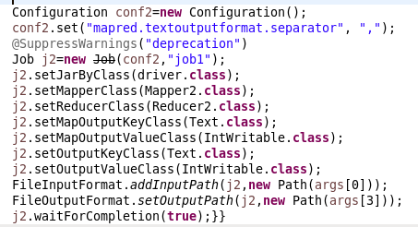

**Mapper 1**

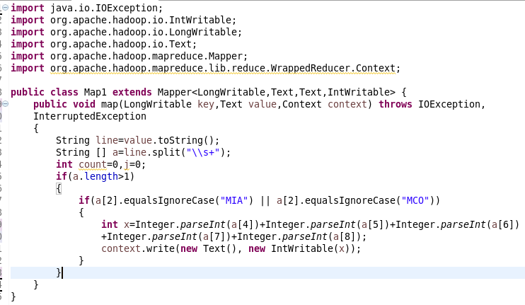

**Reducer 1**

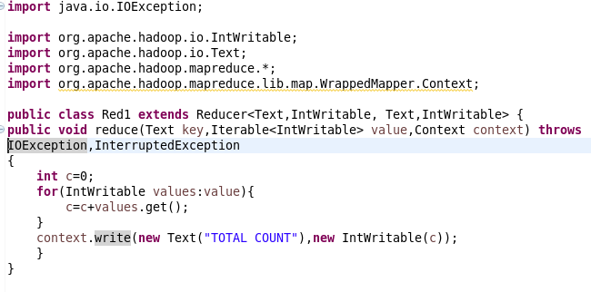

**Mapper 2**

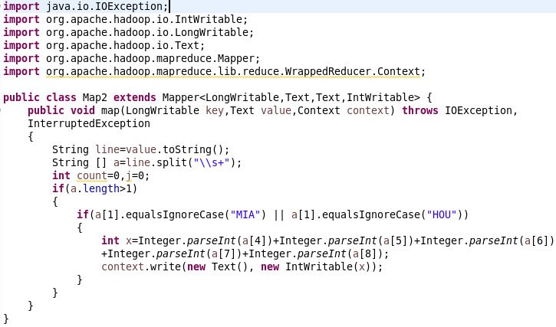

**Reducer 2**

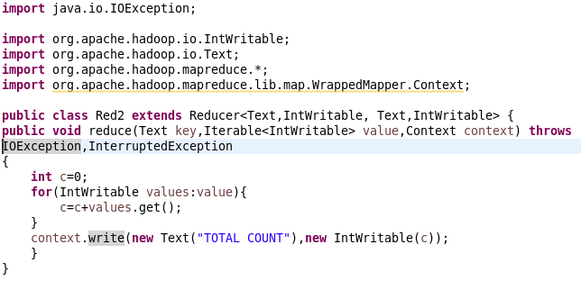

**Mapper 3**

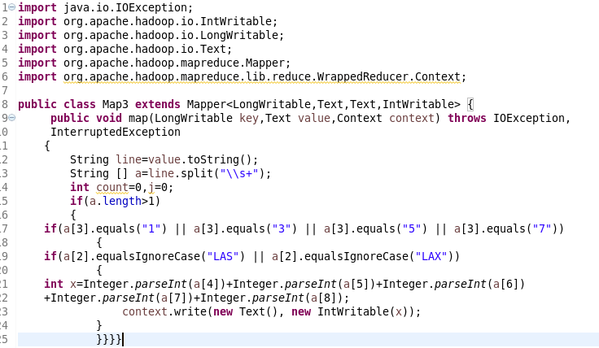

**Reducer 3**

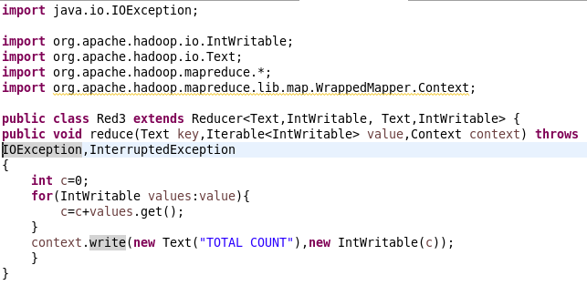

**Output 1**

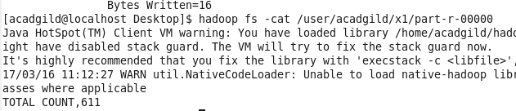

**Output 2**

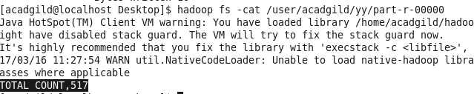

**Output 3**

