**Titanic Data Analysis**

**Write a mapreduce code to find out number of males and females survived in the titanic tragedy and save the output in sequence file output format.**

**Driver class**

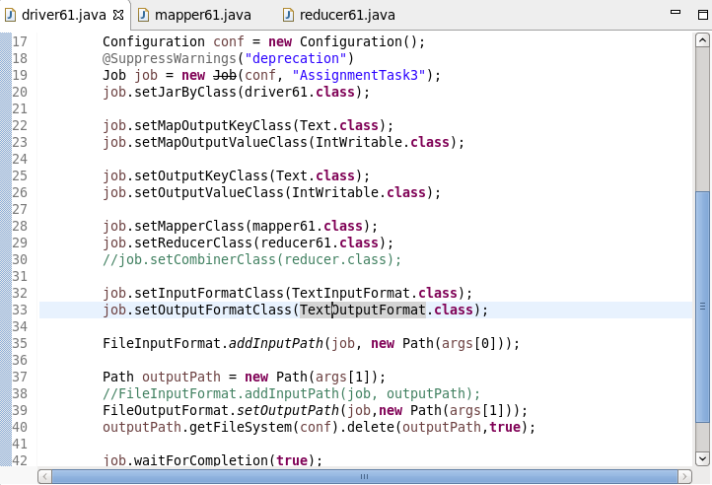

**Mapper class :**

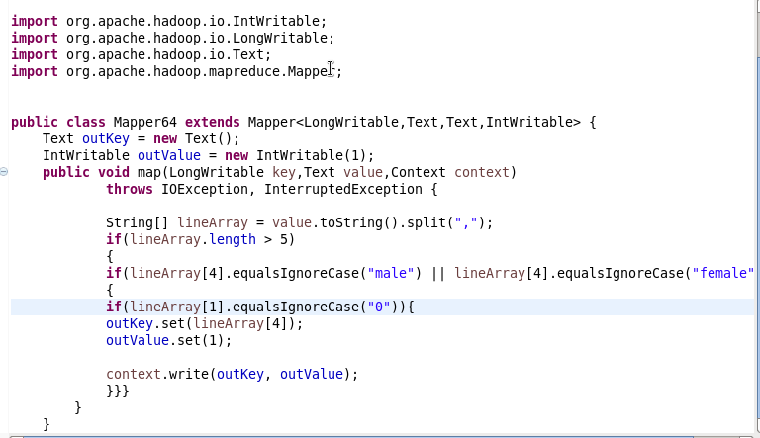

**Reducer class :**

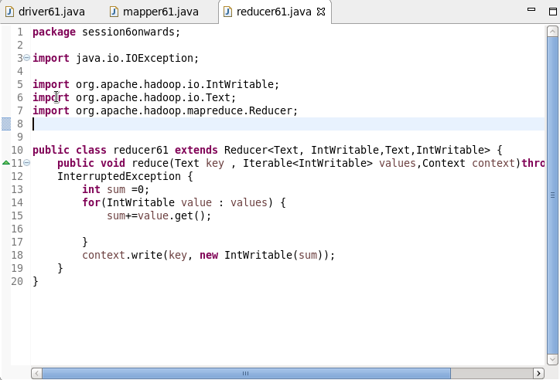

**Output :**

