**Write a custom key to evaluate the number of people who died and the number of people who survived, along with their genders.**

**CODE :**

**DRIVER CLASS**

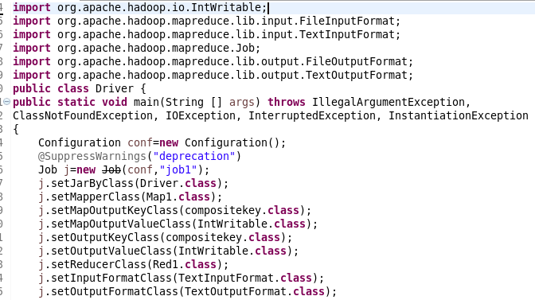

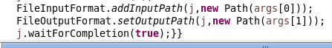

**MAPPER CLASS**

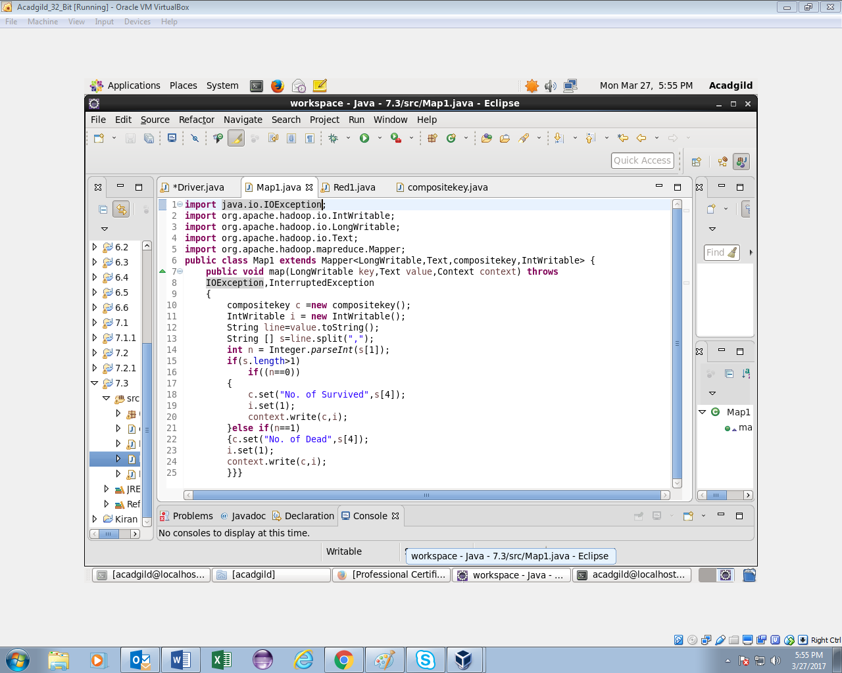

**REDUCER CLASS**

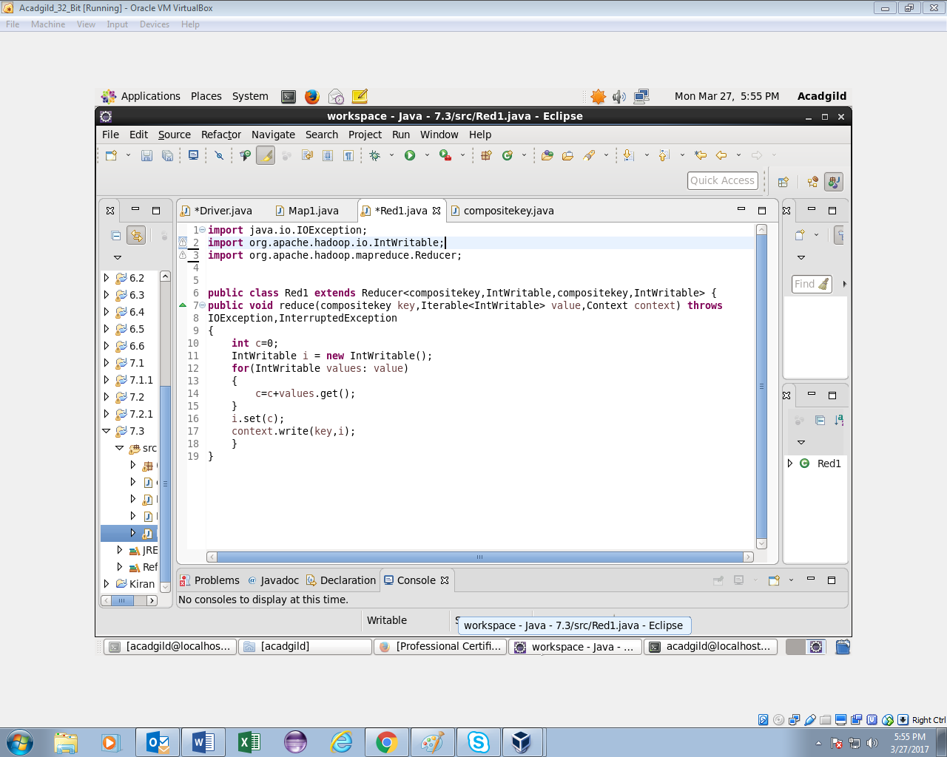

**COMPOSITEKEY CLASS :**

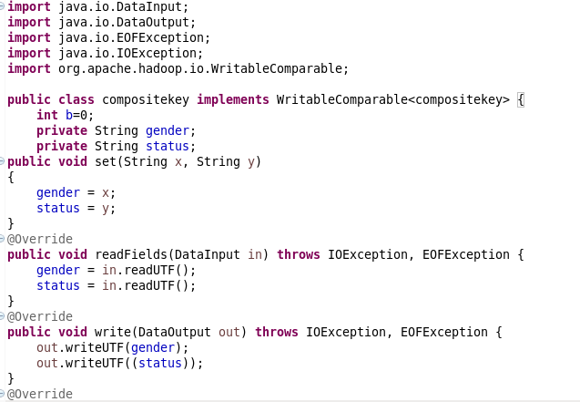 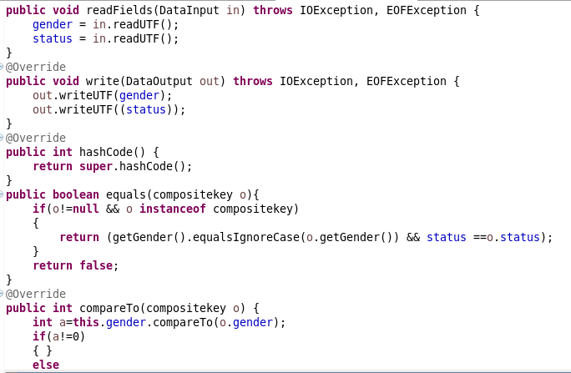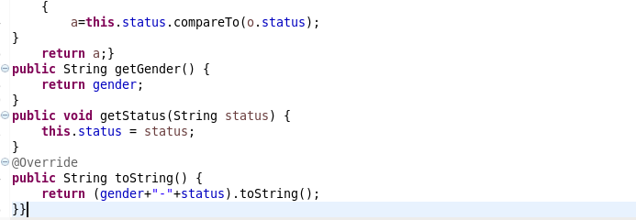

**OUTPUT:**

