**Write a map only job for the word count program and set the output format as sequence file**

**Driver class**

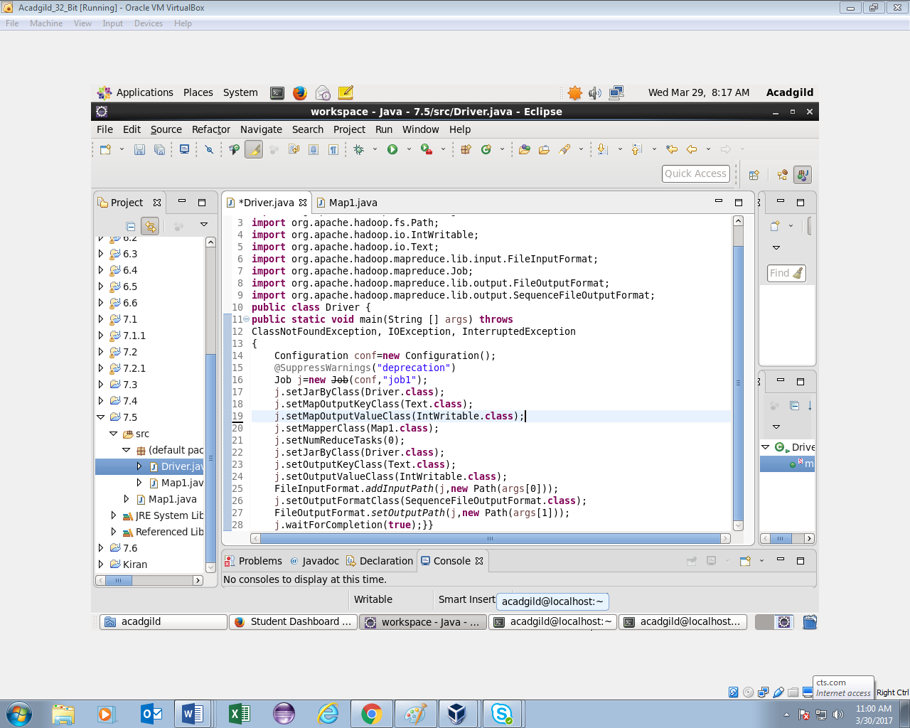

**Mapper class**

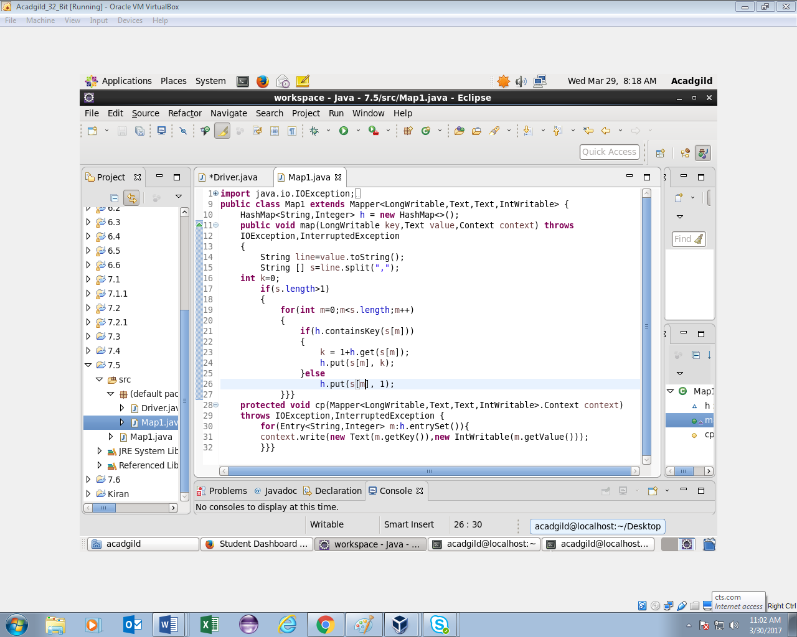

**Running jar and output**

