**Write a map reduce program save the output of the word count program in XML format. You need to write a custom writable to save the output in XML format.**

**CODE :**

**Driver Class**

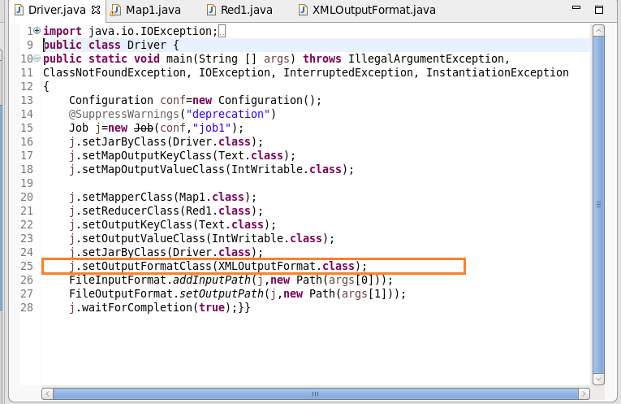

**Mapper Class**

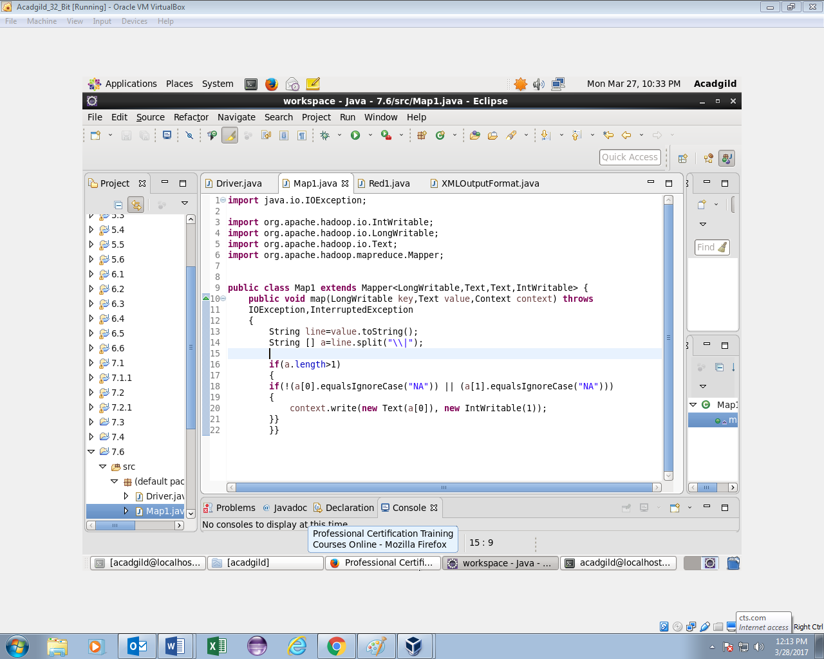

**Reducer Class**

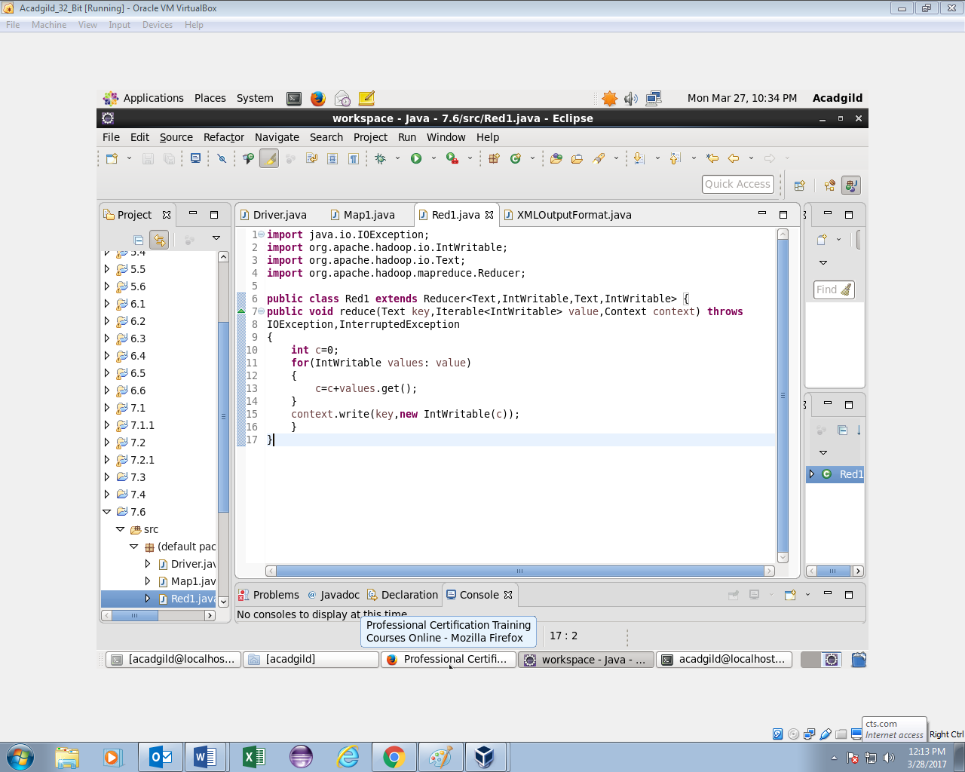

**XMLOUTPUTFORMAT Class**

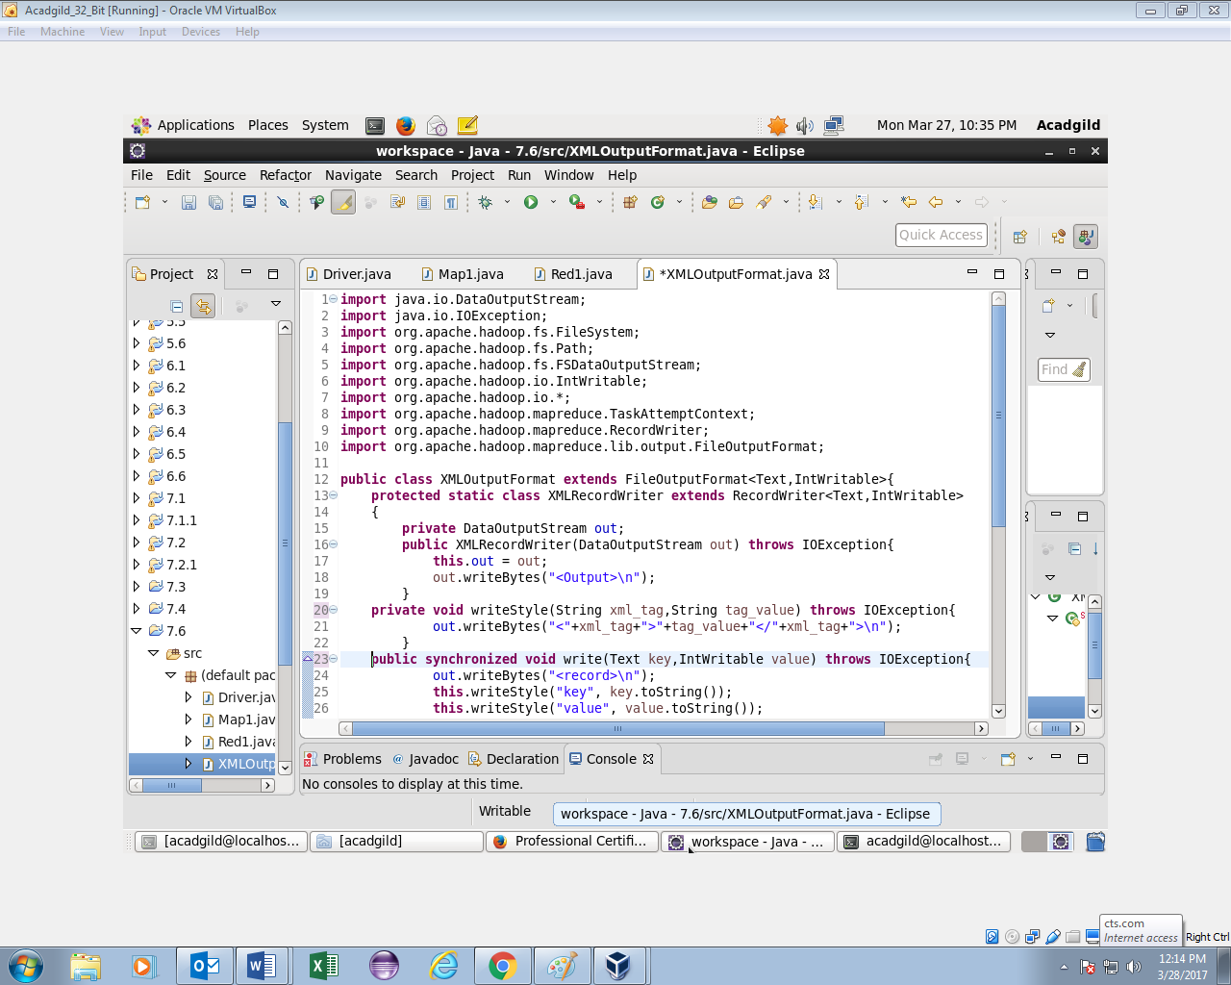 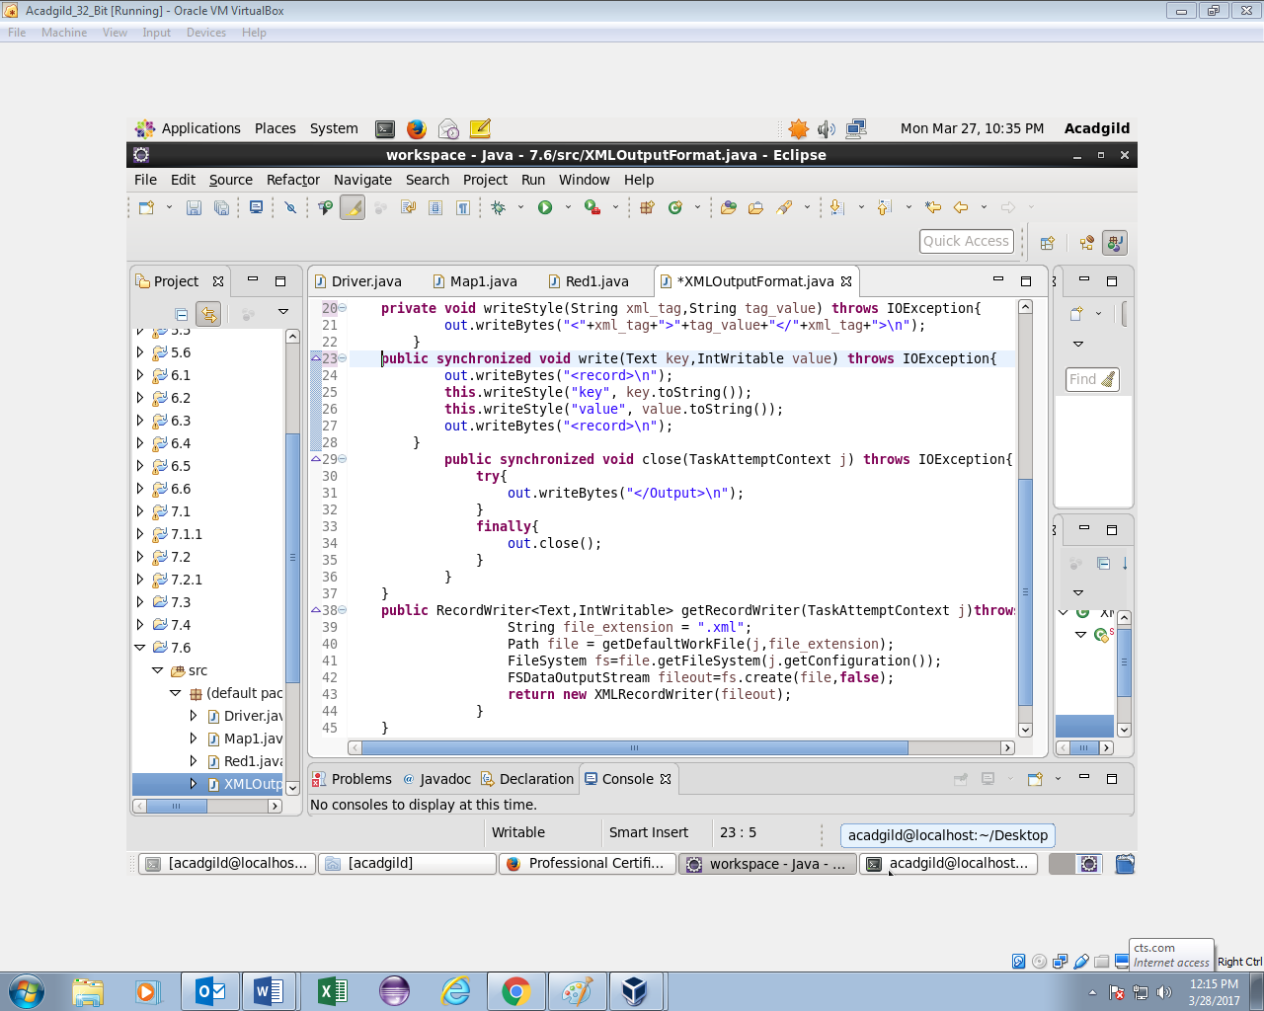

**OUTPUT :**

