**Ans. JOINS**

**Input :**

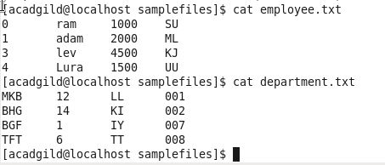

**Self Join –**

E and E1 are alias’ to same file employee.txt.

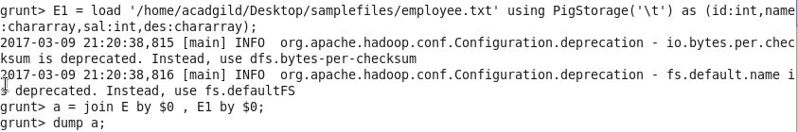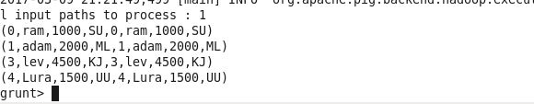

**Inner Join –**

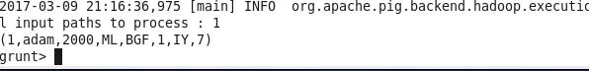

**Left Outer Join –**

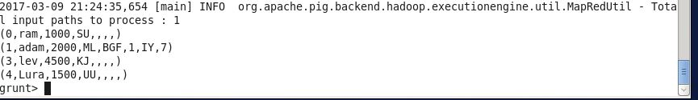

**Right Outer Join –**

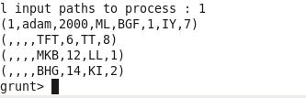

**Full Outer Join –**

