SIGN TO SPEECH

TEAM – SRS
TEAM ID – 100

We aim to create gloves that can recognize hand gestures that correspond to words and phrases and with the help of arduino translates these signs into speech.

These gloves would be lightweight, compact and worn on the hands, but ergonomic enough to use as an everyday accessory, similar to hearing aids or contact lenses .

MOTIVATION FOR PROJECT

They would provide an easy-to-use bridge between native speakers of sign language and the rest of the world

BASIC WORKING OF PROJECT :

We have used flex sensors (1 for each finger) to detect the flexing of fingers and MPU6050 sensor to detect the acceleration of hand and its orientation.

A bluetooth module was required for sending and receiving data onto the android device . The name of the new gesture added by user is sent to arduino using the app via bluetooth and while reading for gestures what sound is to be played is sent back .

We made a multiple activity application to change modes between read and calibrate .

All these things are integrated on the gloves in order to read users hand action and movement and give optimum results.

COMPONENTS :

Arduino uno
5 Flex Sensors
5- 12ohm Resistance
ADXL335 Accelerometer
4051 MUX - LM386
2-10uF Capacitor
Bread Board
P.C.B.
8 Ohm Speaker
Gloves
Jumpers Wires
SD Card Shield
SD Card
Bluetooth Module

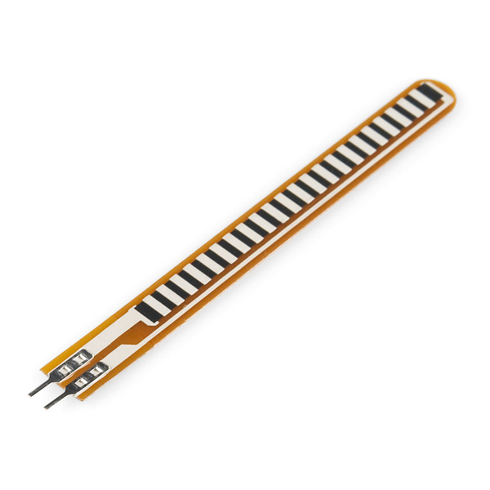
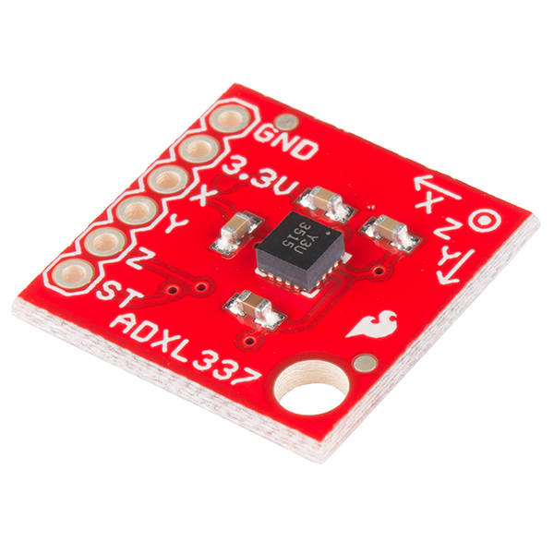
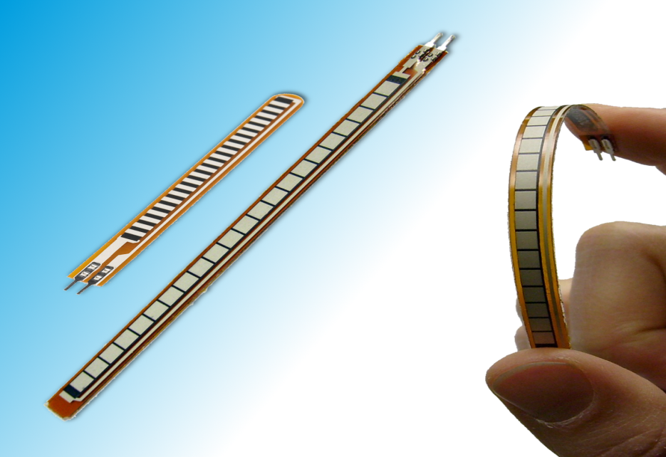
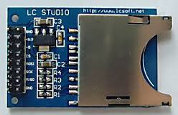
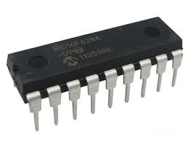

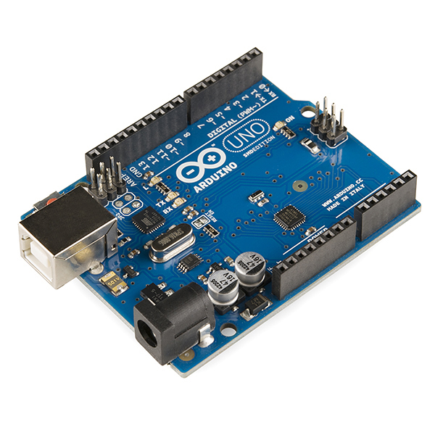
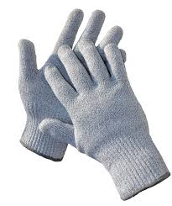

PLAN OF ACTION :

(27th May-2nd June):

1.Buying of components-accelerometer .
2.Discussion of how we are going to do the project.
3.Buying of gloves.
4.Did Brain storming.

(3rd -9th June):

1.Taking flex sensors readings,accelerometer and gyro-sensors readings.
2.Stiching sensors on gloves and calibrating them properly.
3.Documentation of sensors values and various hand movements (their corresponding sensors values)

(10th -19th June):

1.Working on arduino code for playing the audio using sd-card shield, amplifier and completing the structure of gloves.
2.Testing it and further debugging if required.
3.Coding for the words to be spoken using signs and adding their audio to sd-card.

(20th-30th June)

1.Working on arduino code so that user can add their own gestures .
2.Making an app for playing the sounds and the user interface for adding gestures.
3.Removing the sd-card shield and speakers.
4.Adding bluetooth module and bluetooth connectivity of arduino to android devices.

TEAM :

Mohit Madan 8879488927

Shrey Paharia 9967615288

Saqib Azim 8828290924

APPLICATION UI :

The application user interface is made intutive and easy to use so that anyone can easily use the app.

Screenshots of various activities of app and their use have been listed below :

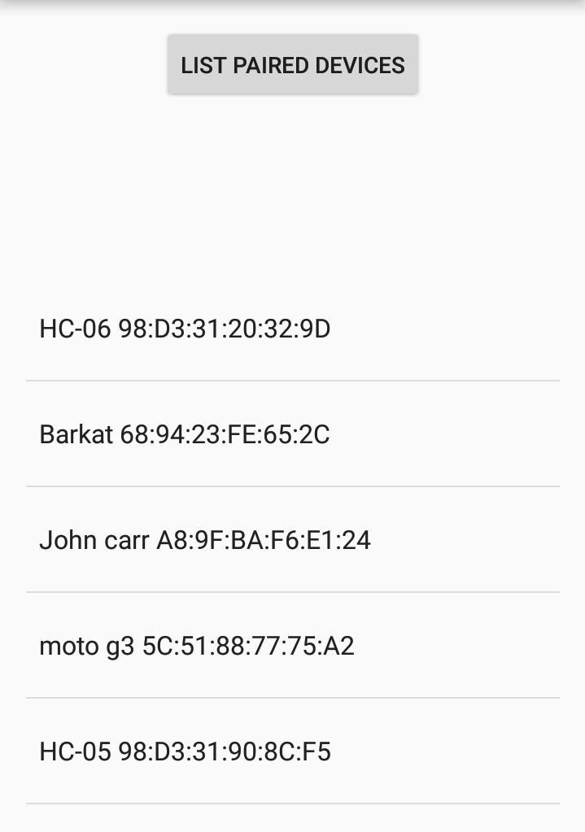
LIST PAIRED DEVICES :
List all the bluetooth devices nearby from which we can connect to any arduino device with blutooth module.

When we click on any item in the list android device gets connected and the activity shown below becomes visible if the connection is not failed.

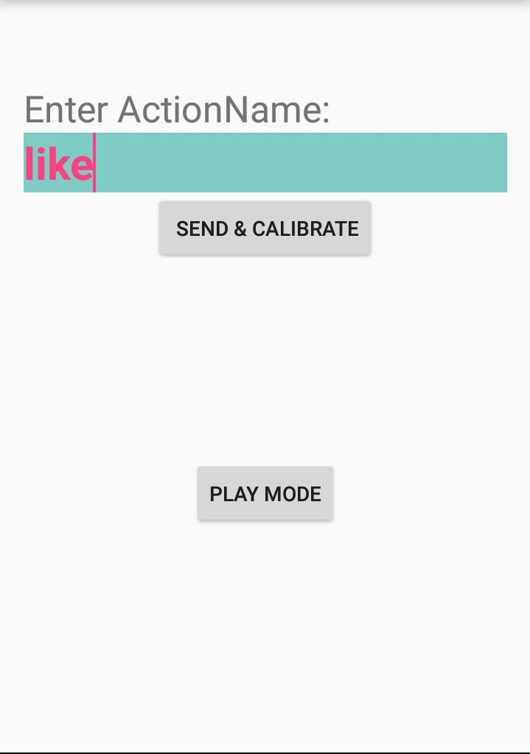
SEND & CALIBRATE :
Sends the word to be associated to the new action to arduino .

PLAY MODE :
Takes to the activity shown below .

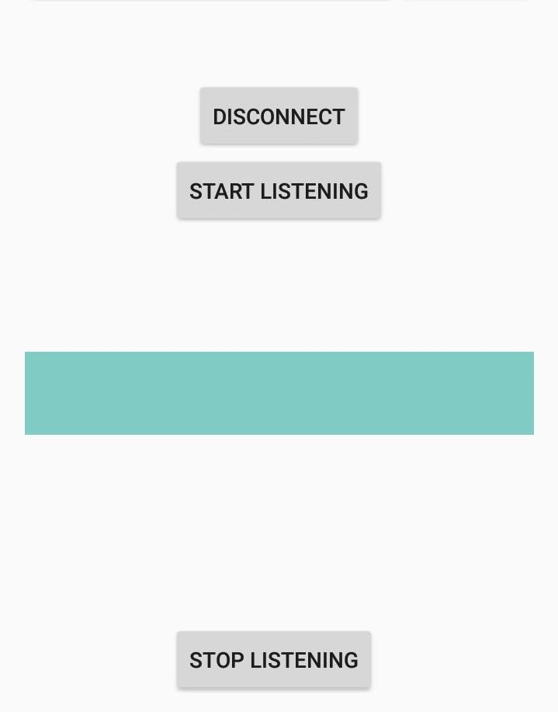
DISCONNECT :
Disconnects the connected bluetooth device .

START LISTENING :
Starts the listening of the gestures and giving audio output .

STOP LISTENING :
Stops the listening of the gestures.
REFERENCES :

For completion of our project we are thankful to TEAM STAB

We also reffered to following references :

https://github.com/maniacbug/StandardCplusplus - Standard c++ library for arduino
http://playground.arduino.cc/Code/DatabaseLibrary - Making database in the memory of arduino
https://www.arduino.cc/en/Tutorial/EEPROMClear - Arduino EEPROM details
http://forum.arduino.cc/index.php?topic=44260.0 -
To run multiple sketches in a program
http://playground.arduino.cc/Interfacing/Java -
Java interface with arduino
http://playground.arduino.cc/Main/InterfacingWithSoftware - Interface of arduino with other softwares
https://www.arduino.cc/en/Tutorial/Calibration - Caliberation of sensor Readings with a program in arduino using min max
https://www.pantechsolutions.net/sensors/user-manual-for-flex-sensor -
User manual for flex sensors
http://www.analog.com/en/products/mems/mems-accelerometers/adxl345.html -
ADXL335 accelerometer datasheet
https://www.youtube.com/watch?v=l01sdzJHCCM

