**Appendix-4**

**Bibliography**

Salvatierra, Jose. “GUI Development with Python and Tkinter.” *Udemy*, www.udemy.com/course/desktop-gui-python-tkinter. Accessed 17 May 2021.

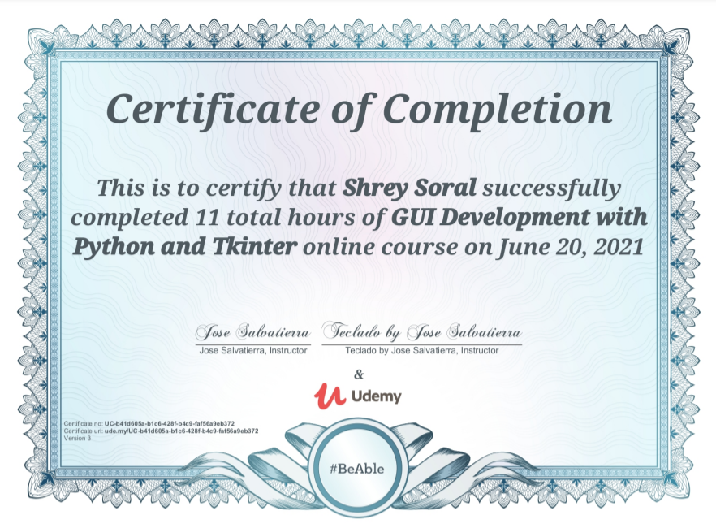

Portilla, Jose. “Python Bootcamps: Learn Python Programming and Code Training.” *Udemy*, www.udemy.com/course/complete-python-bootcamp. Accessed 6 July 2020.

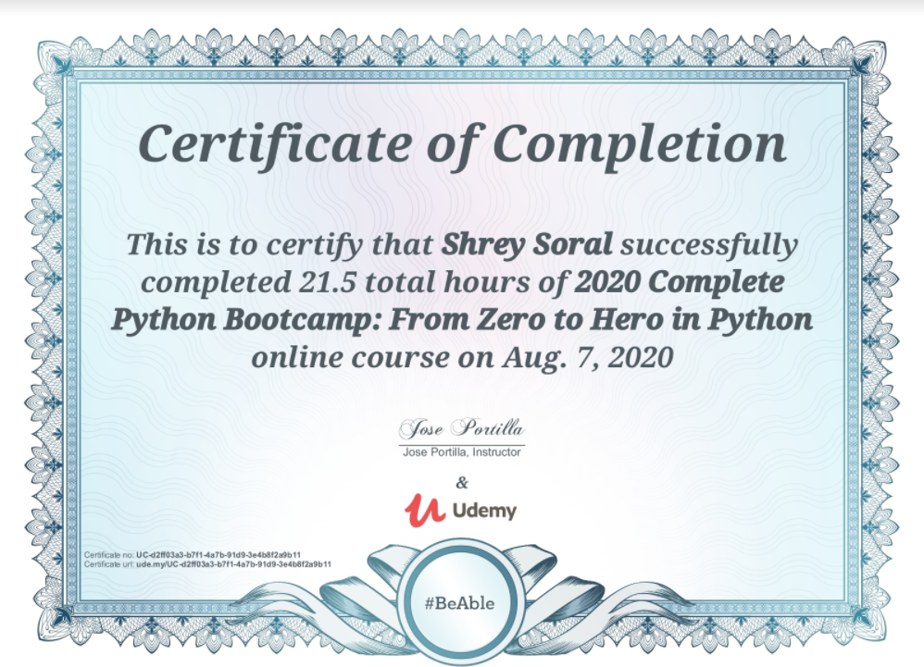

Yu, Dr Angela. “100 Days of Code: The Complete Python Pro Bootcamp for 2022.” *Udemy*, www.udemy.com/course/100-days-of-code. Accessed 17 July 2021.

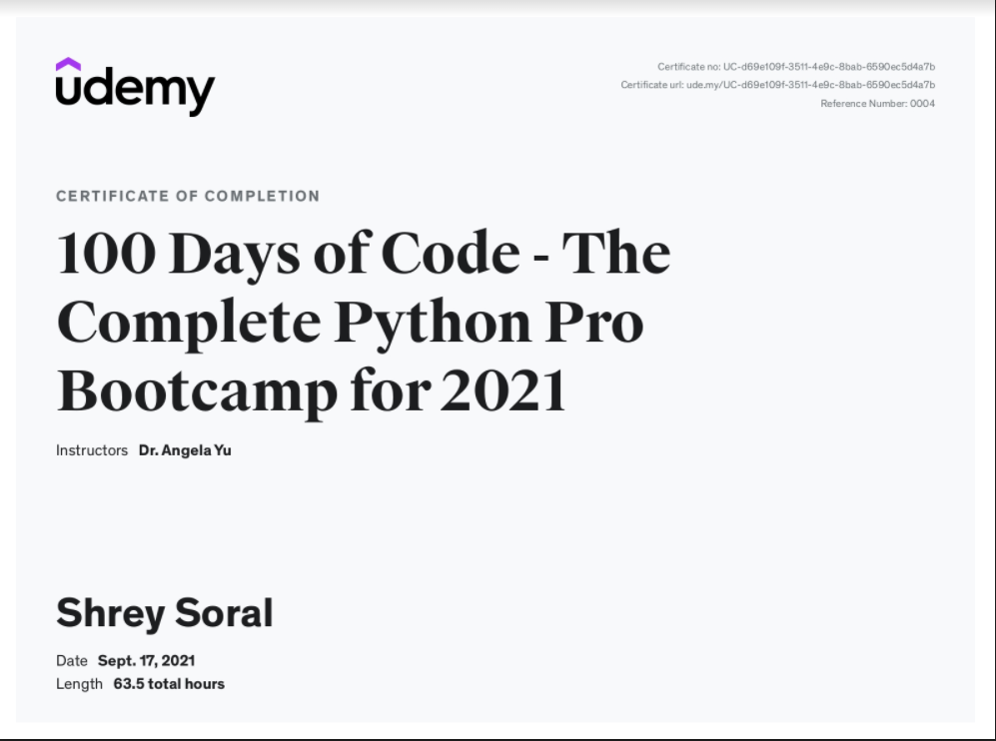

Video tutorials referred

https://www.youtube.com/playlist?list=PL4P8sY6zvjk5im_dA5SB3u45xQRLFd9CZ

https://www.youtube.com/playlist?list=PLu0W_9lII9agICnT8t4iYVSZ3eykIAOME