MLOps Experimental Learning Assignment: End-to-End ML Model Development, CI/CD, and Production Deployment Experimental Learning
Machine Learning Operations (MLOps) (AIMLCZG523) | Total marks: 50
Student: SHREYES RAM V. | BITS ID: 2025AE05177
Repository: https://github.com/ShreyStar02/MLOps_Assignment1_Shrey
Video recording: Not supplied

Objective
Design, develop, and deploy a scalable, reproducible machine learning solution using modern MLOps best practices, including practical automation, experiment tracking, CI/CD, containerization, deployment, and monitoring.

Contents
1. Data acquisition and exploratory analysis
2. Feature engineering and model development
3. Experiment tracking
4. Model packaging and reproducibility
5. CI/CD and automated testing
6. Containerized API
7. Kubernetes deployment
8. Monitoring and logging
9. Architecture
10. Local access and submission status

1. Data acquisition and exploratory analysis
The UCI Cleveland heart disease data contains 303 records. The target counts are 164 without disease and 139 with disease. `ca` has 4 missing values and `thal` has 2. The cleaning script preserves these records so the preprocessing pipeline can impute missing features.
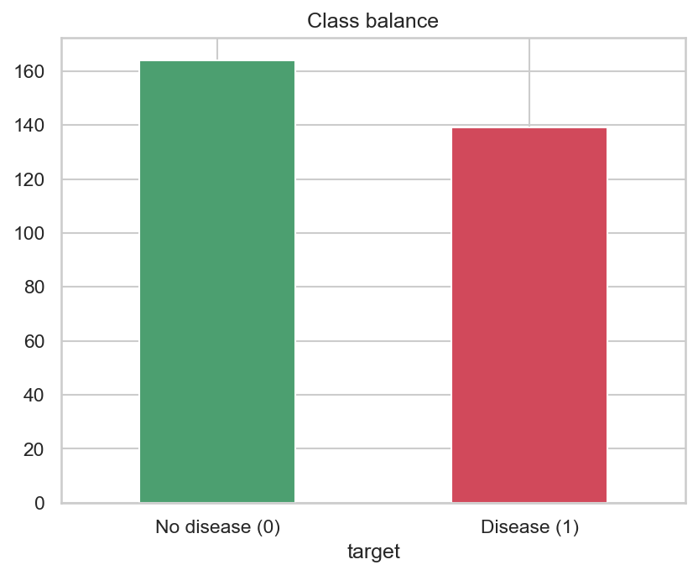
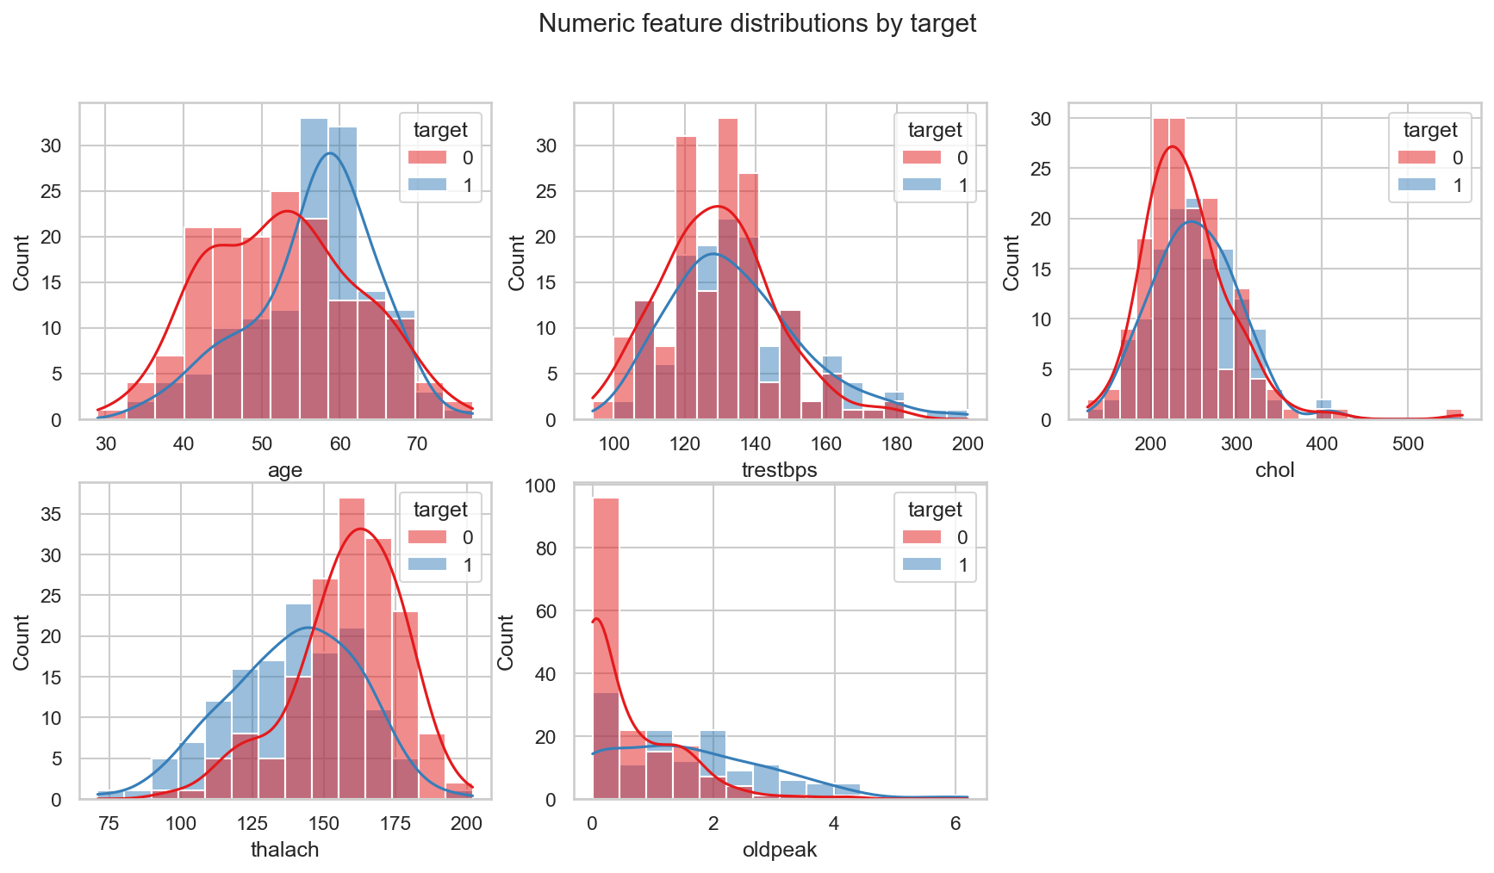
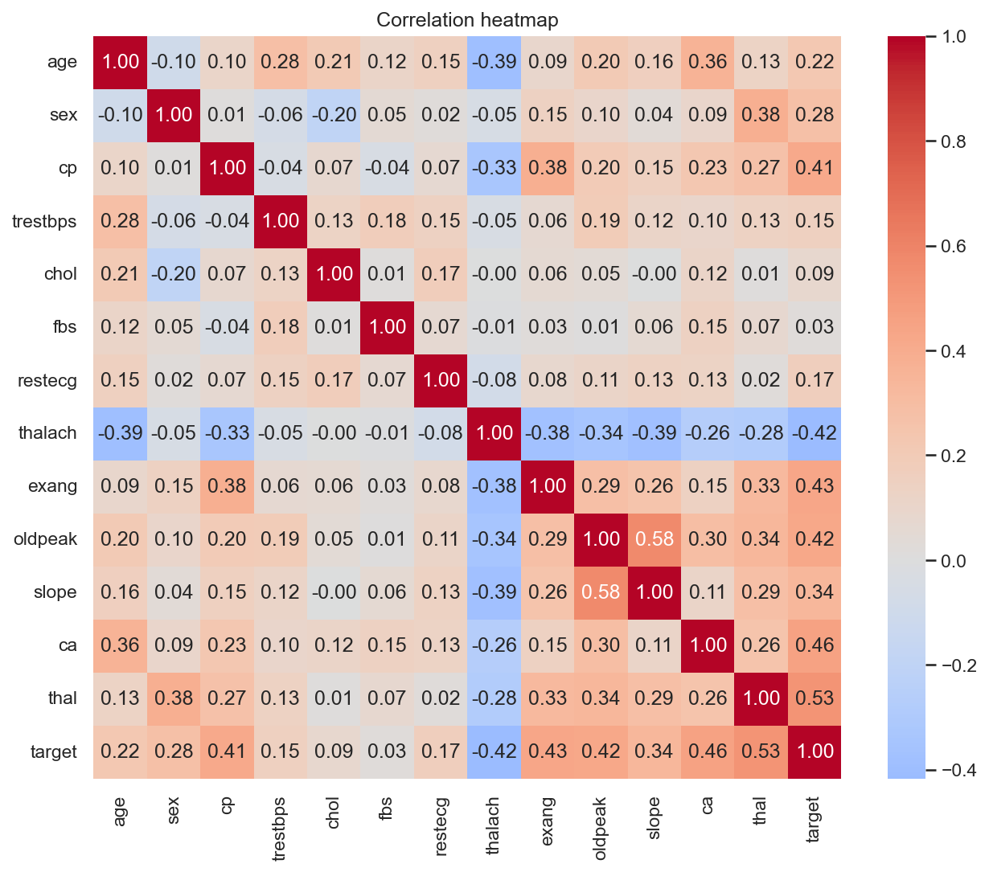
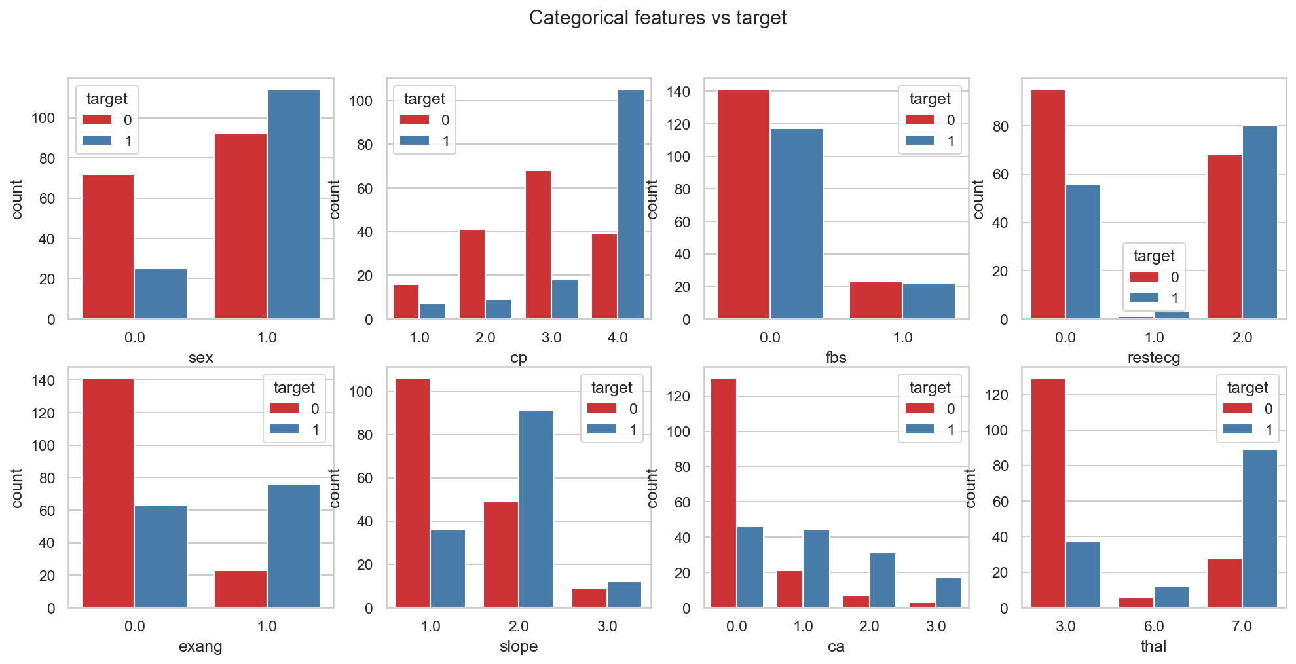
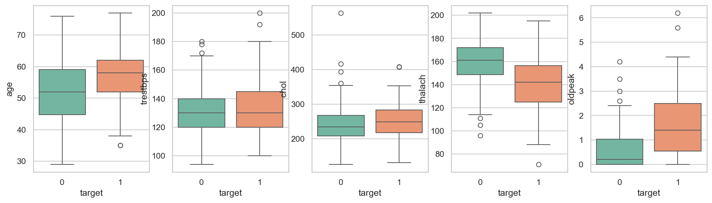

2. Feature engineering and model development
The pipeline engineers an age bucket, median-imputes and scales numeric features, and most-frequent-imputes and one-hot encodes categorical features. Logistic regression, random forest, and gradient boosting were tuned with GridSearchCV and evaluated with stratified five-fold CV.
Model | CV ROC-AUC | Test ROC-AUC | Test accuracy | Test F1
Logistic Regression | 0.901 | 0.965 | 0.885 | 0.881
Random Forest | 0.901 | 0.951 | 0.869 | 0.867
Gradient Boosting | 0.897 | 0.943 | 0.869 | 0.857
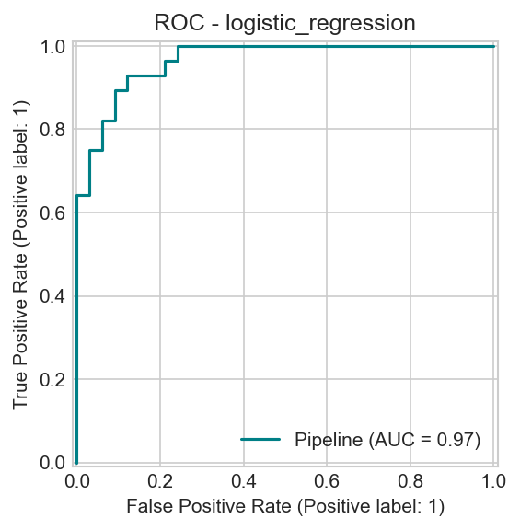
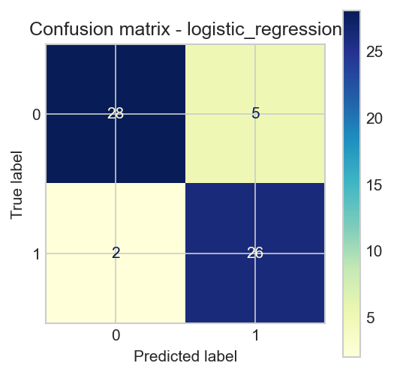
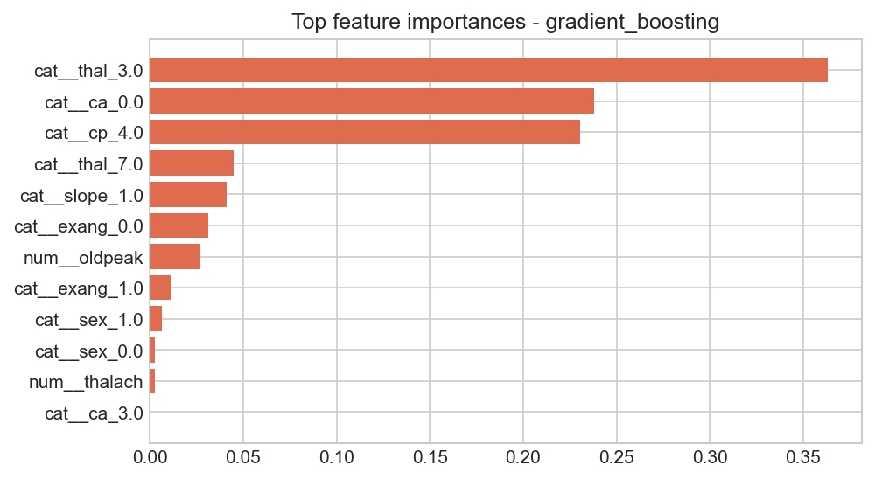

3. Experiment tracking
MLflow stores each candidate run, its parameters and CV/holdout metrics, plots, and model artifact in the local SQLite tracking store.
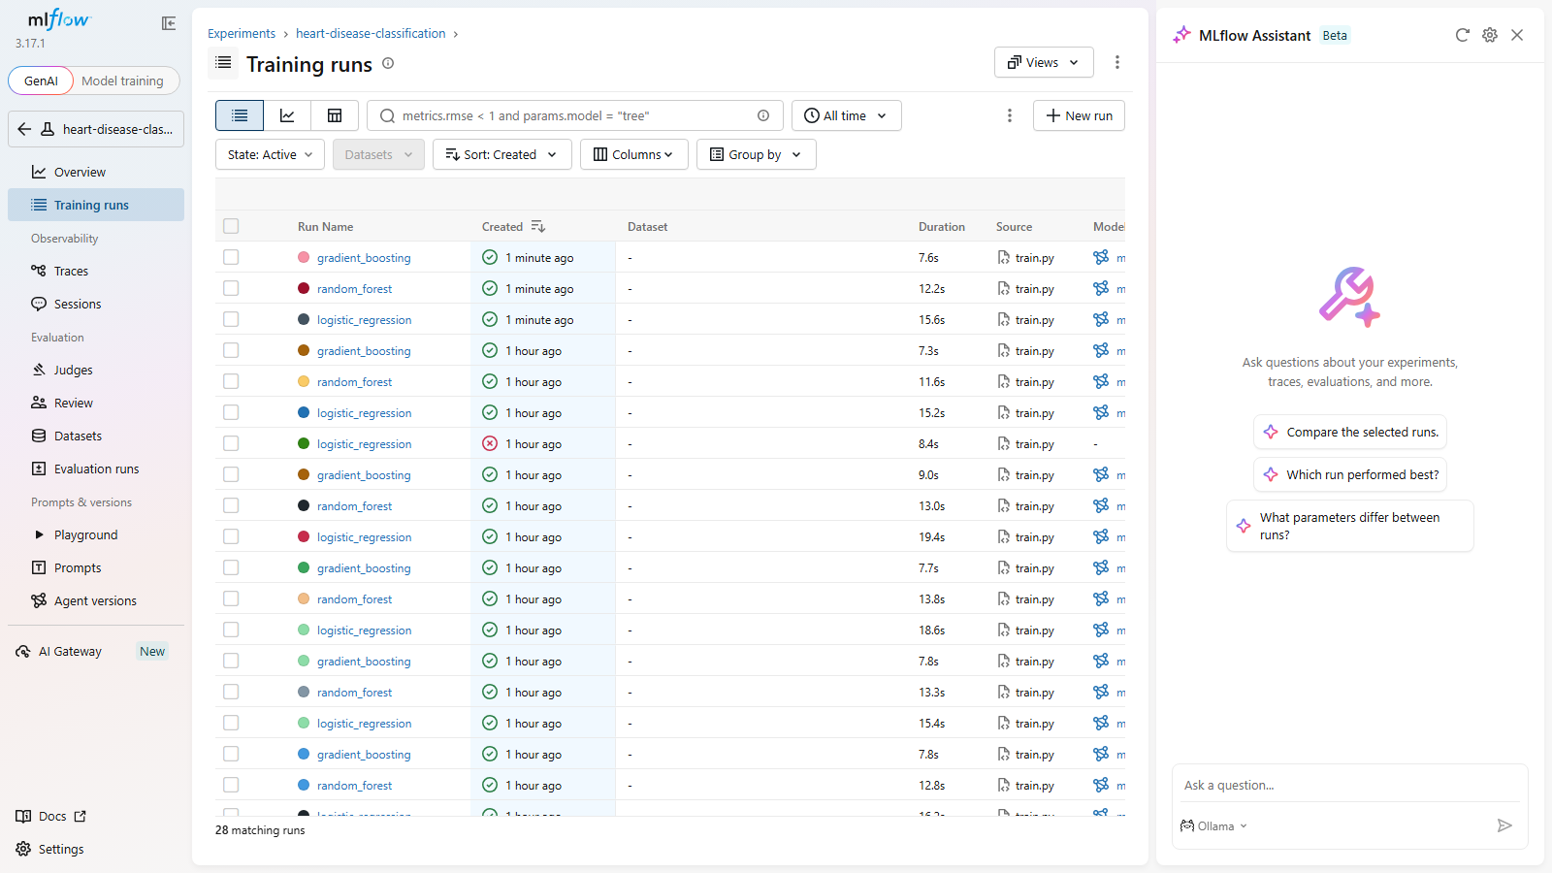
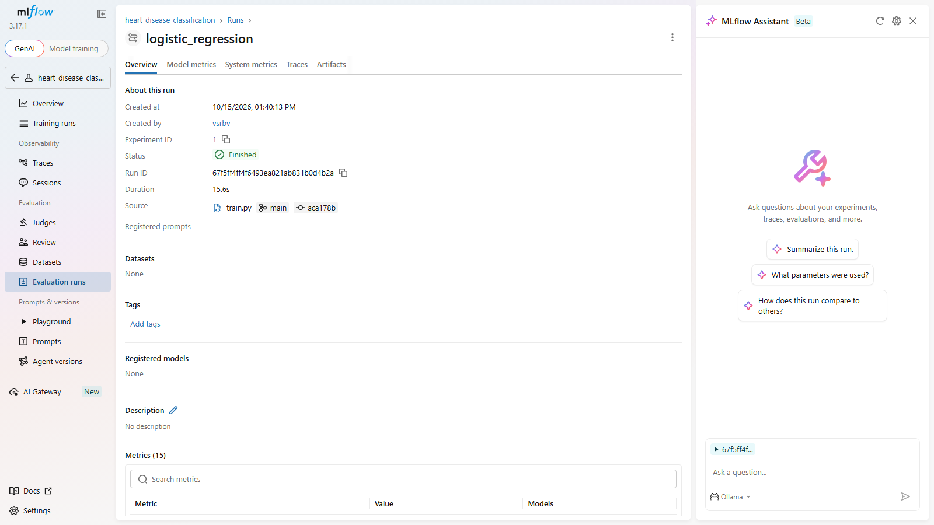

4. Model packaging and reproducibility
The selected logistic_regression pipeline uses scikit-learn 1.7.2 and is serialized to models/model.joblib. models/metadata.json records the selected parameters, feature names, metrics, and MLflow run ID. Training and serving share the same preprocessing pipeline.

5. CI/CD and automated testing
GitHub Actions runs linting, unit tests with coverage, data download, training, Docker build and API smoke tests, then uploads model and training artifacts. The final local run passed all 14 tests and Flake8.
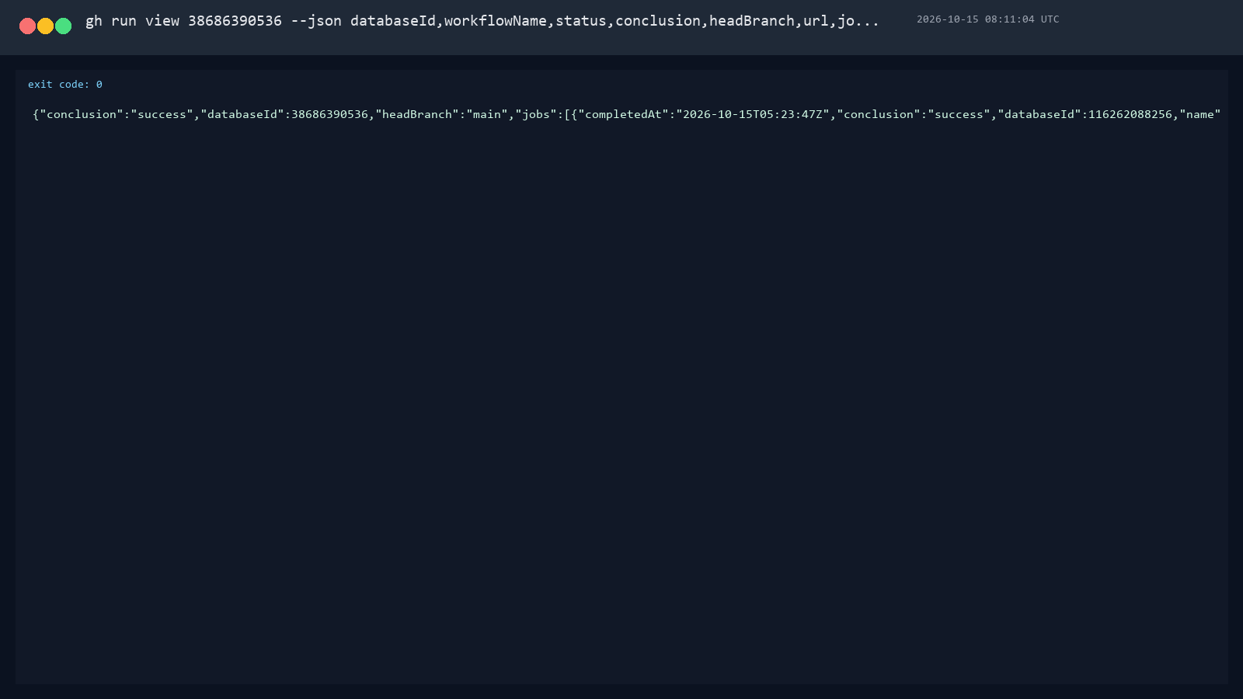
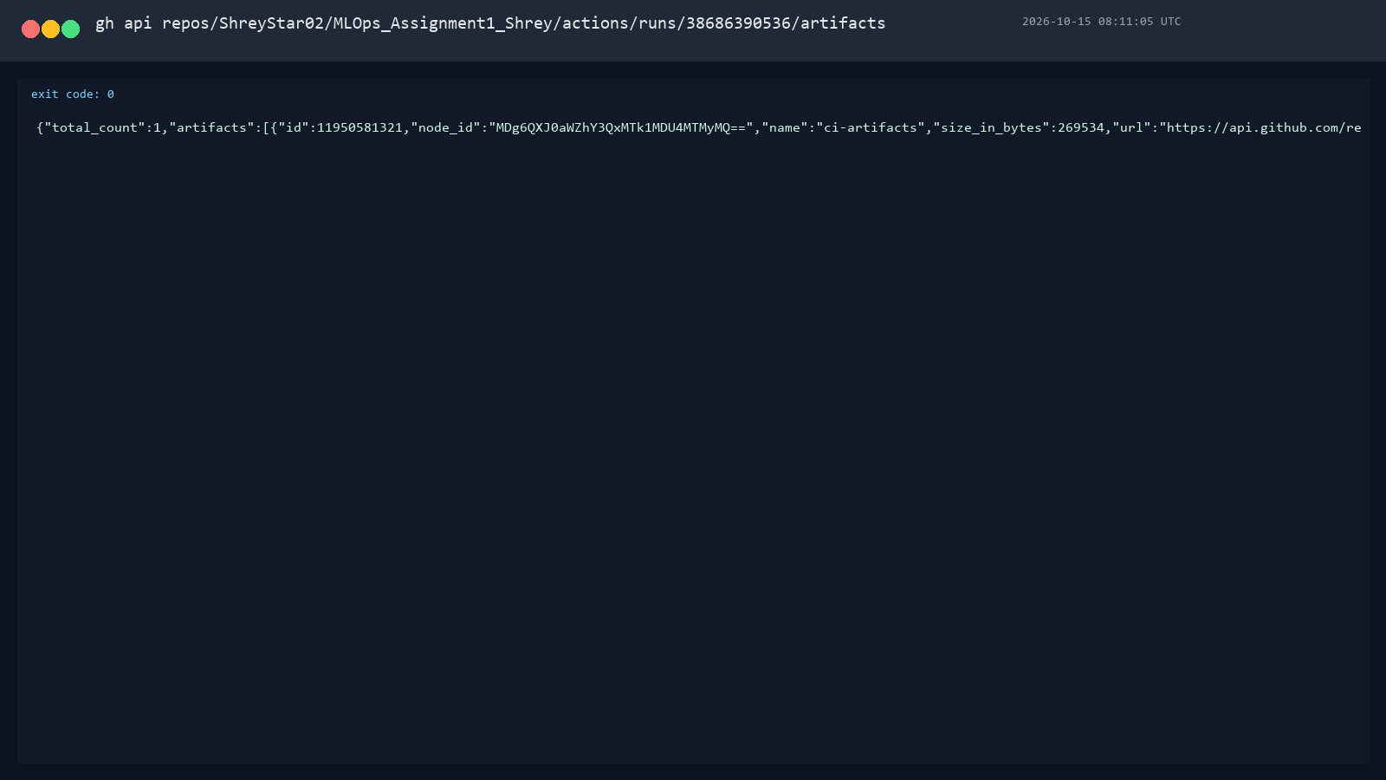

6. Containerized API
FastAPI accepts patient features at POST /predict and returns risk class, risk label, confidence, and disease probability. GET /health, GET /model-info, GET /metrics, and /docs support health checks, metadata, metrics, and API exploration. Request logging records status and latency.
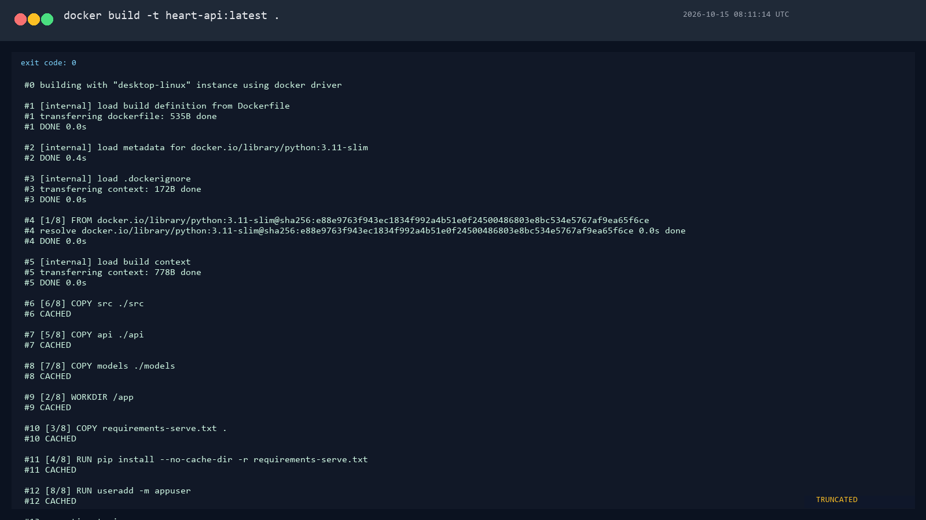
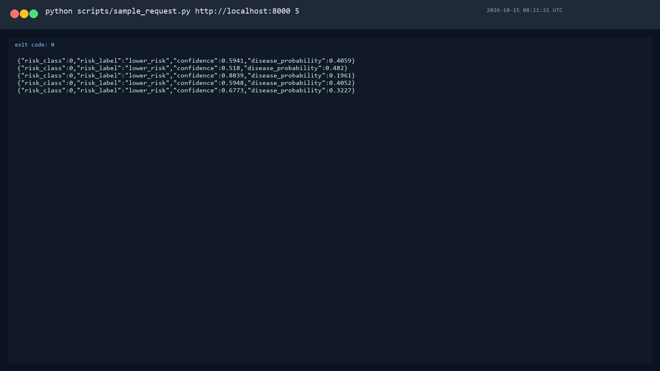
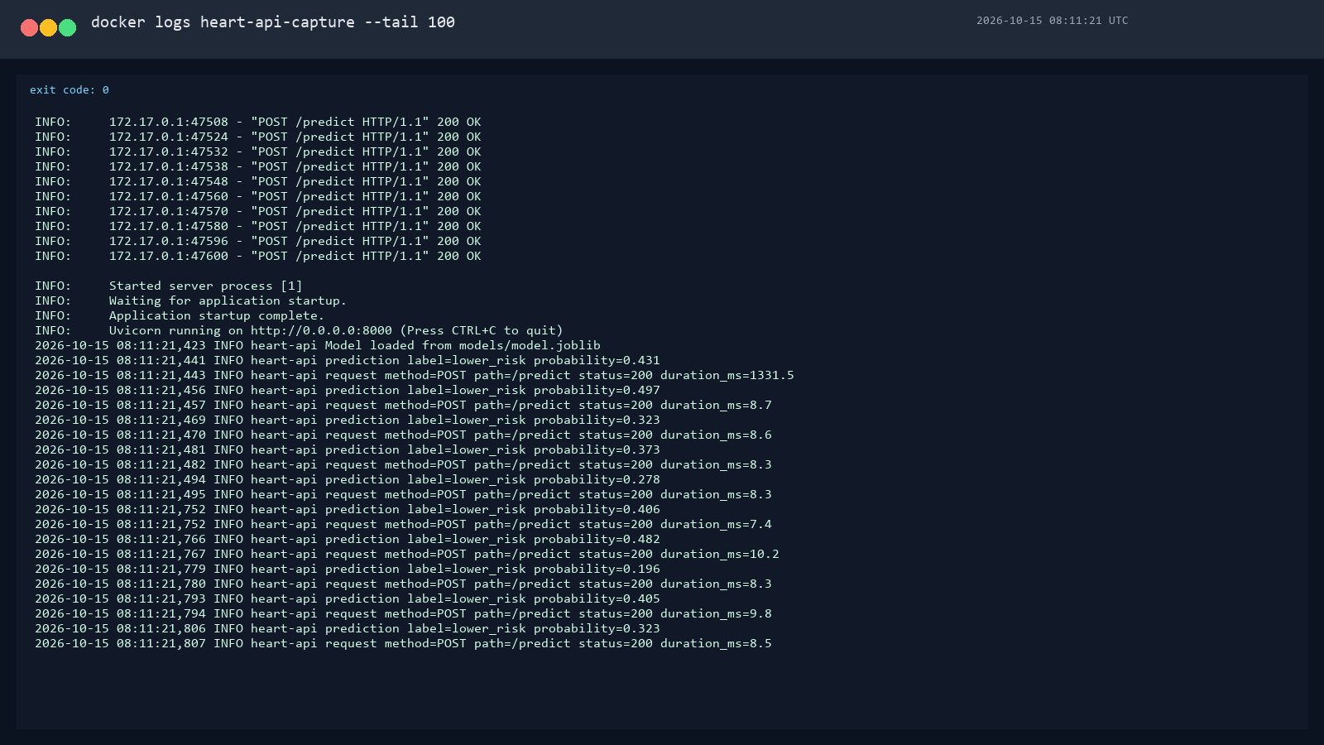

7. Kubernetes deployment
The Kubernetes deployment runs two replicas behind a LoadBalancer service. Readiness and liveness probes call /health. Both pods reached Ready and a sample prediction succeeded through a local port-forward.
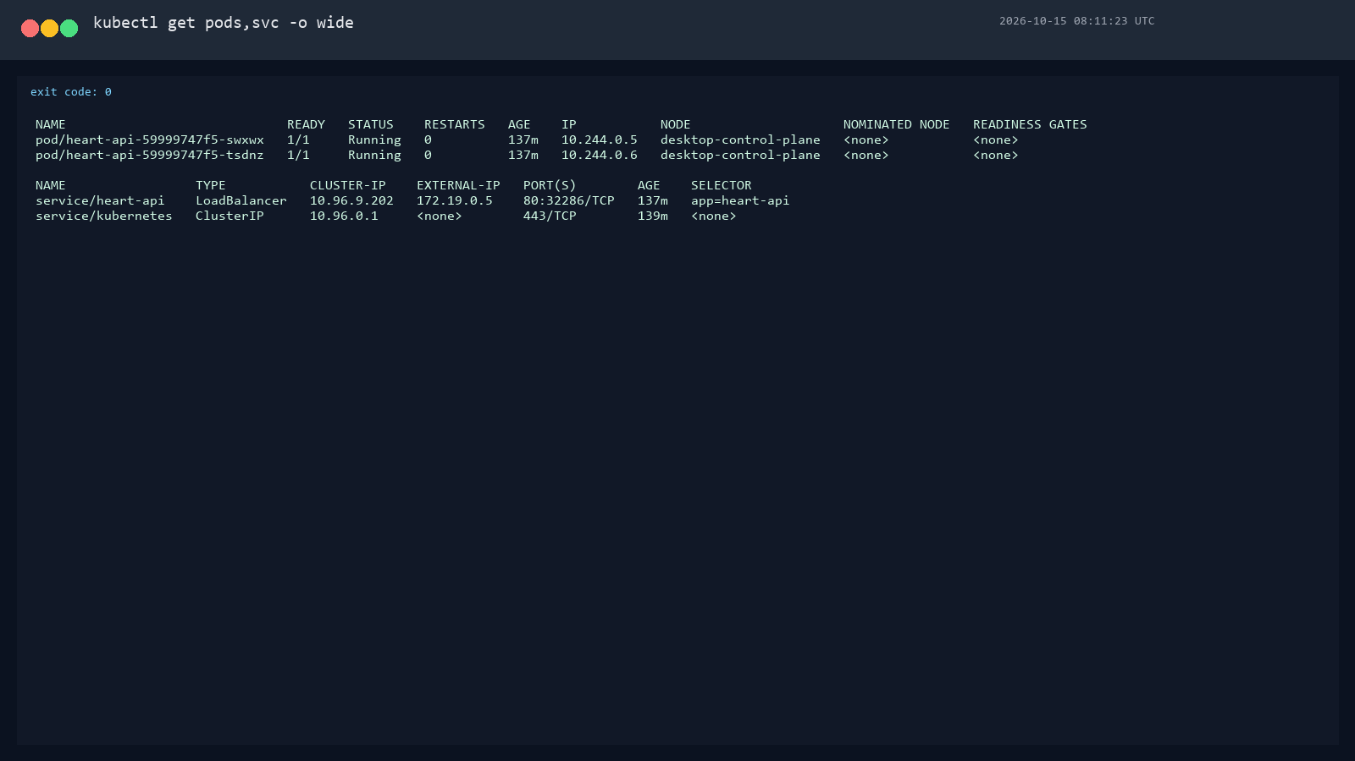
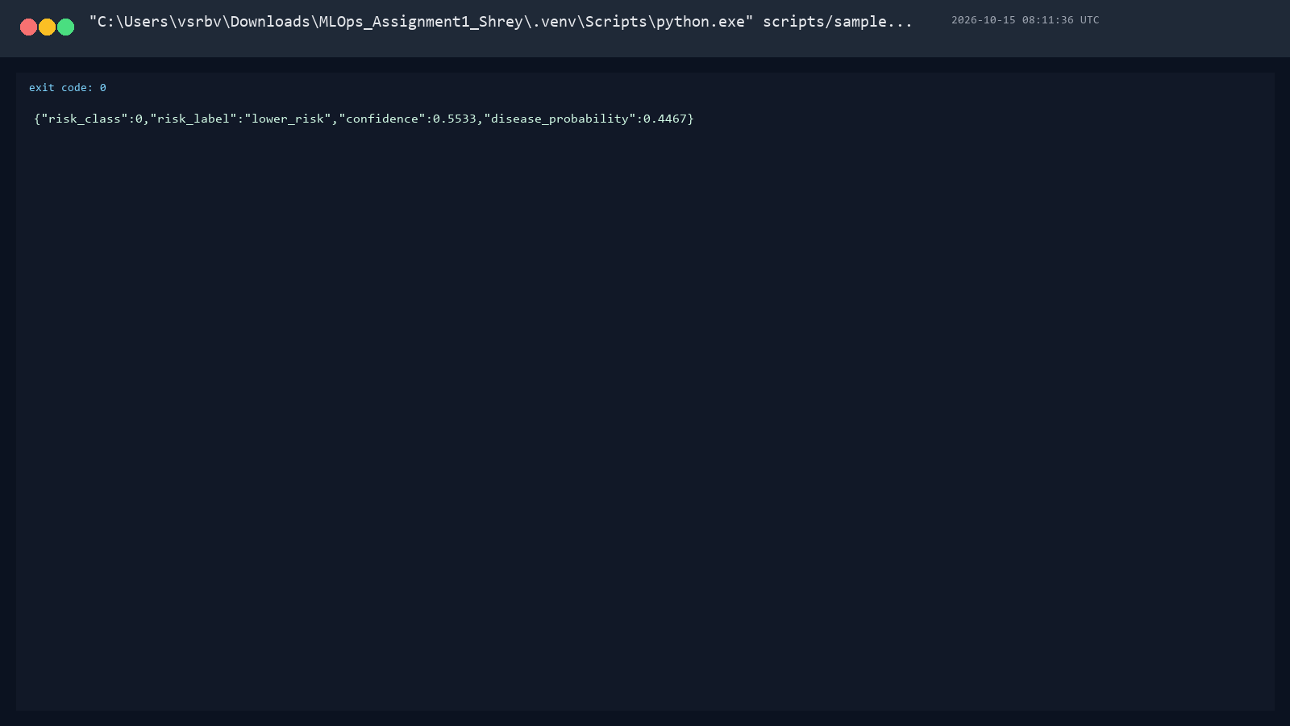

8. Monitoring and logging
Prometheus scrapes the API every five seconds. Its heart-api target was observed up. The provisioned Grafana dashboard displays request rate, p95 latency, predictions by label, and prediction failures.
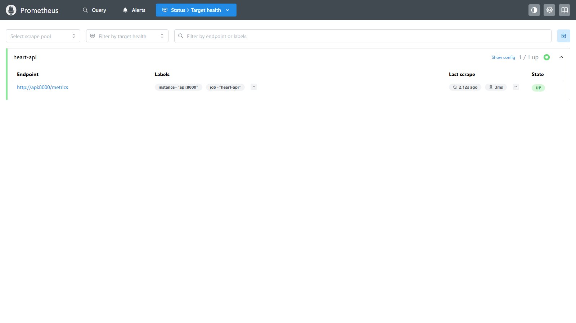
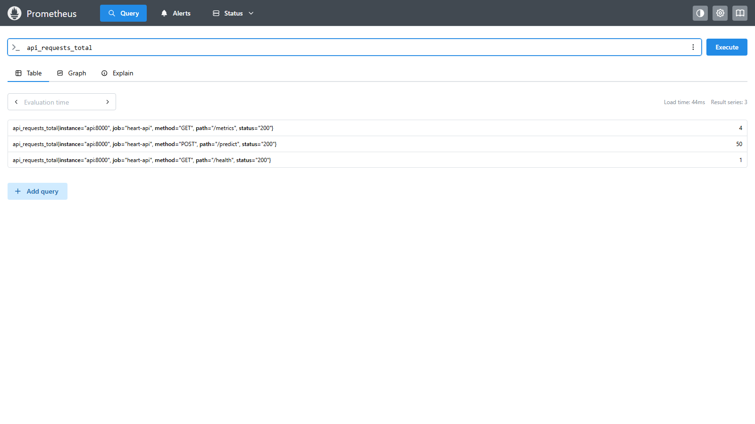
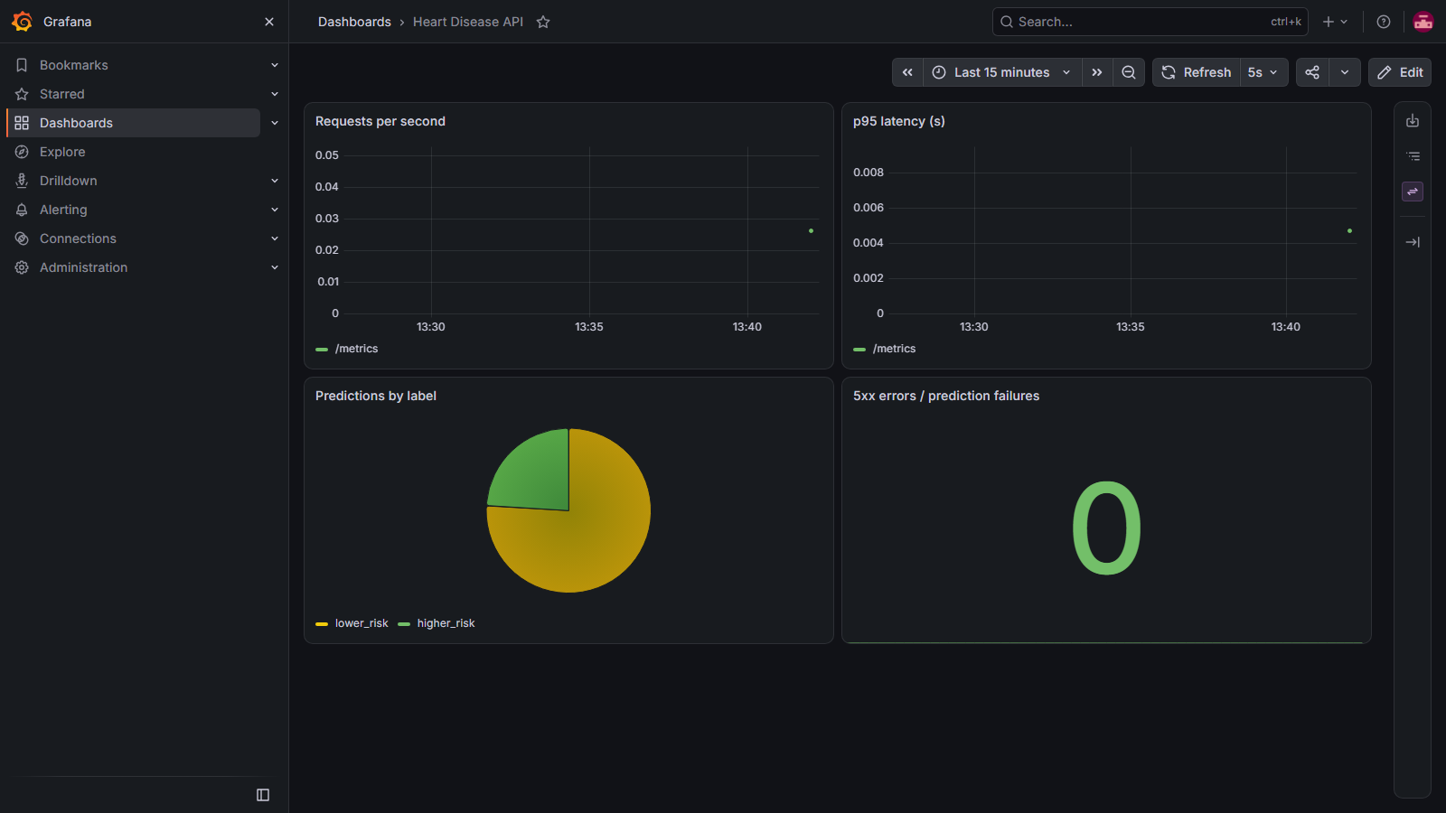
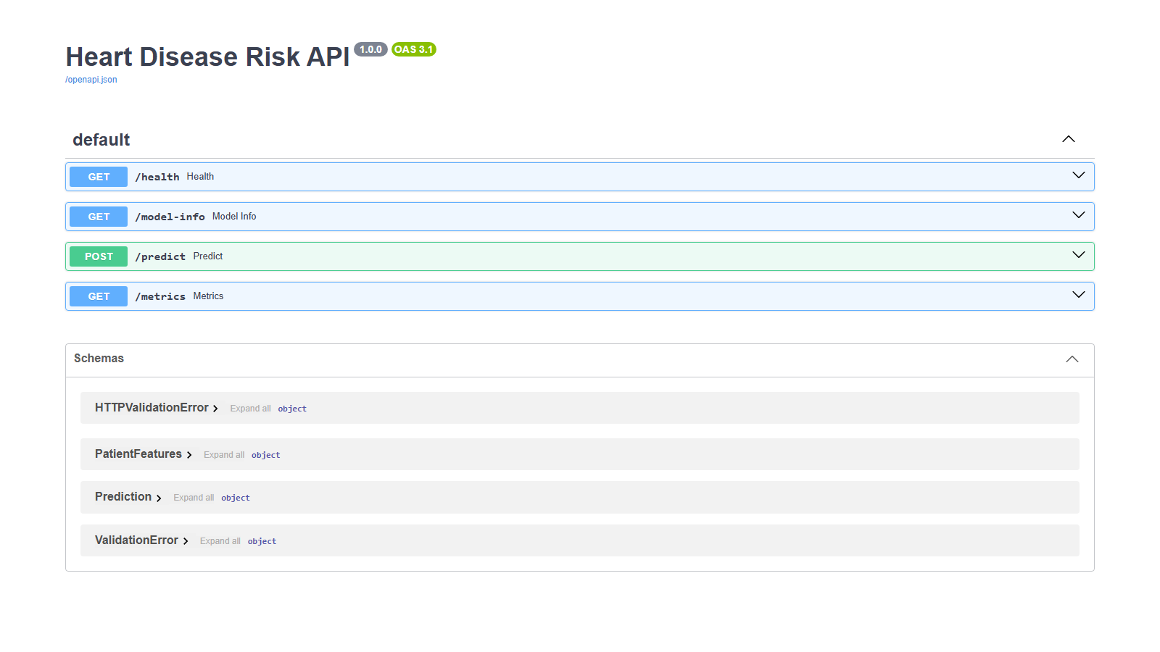

9. Architecture
The diagram follows data acquisition and EDA through model selection, MLflow tracking, FastAPI containerization, Kubernetes deployment, and Prometheus/Grafana monitoring.
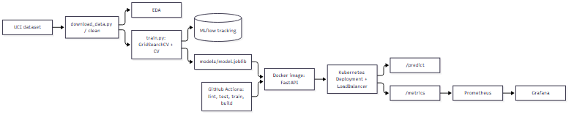

10. Local access and submission status
For local use, start the stack with docker compose up --build. The API, Prometheus, and Grafana are exposed on ports 8000, 9090, and 3000. Kubernetes access is available with kubectl port-forward svc/heart-api 8001:80. A video recording was not supplied in the report configuration.

