**DBMS Holiday Assignment**

**Name:K.Shreya**

**Roll no: 2311CS020367(omega)**

**TASK FROM LEETCODE:**

**1.Game Play Analysis (Solve it in LeetCode)**

**Table: Activity**

**Create a Activity table and Insert the given below values and Write a Query for below question :-**

1. Write a solution to find the **first login date** for each player from table .

2. Return the result table in **any order**

The result format is in the following example.

**Example 1:**

**Input:**

Activity table:

+-----------+-----------+------------+--------------+

| player_id | device_id | event_date | games_played |

+-----------+-----------+------------+--------------+

| 1 | 2 | 2016-03-01 | 5 |

| 1 | 2 | 2016-05-02 | 6 |

| 2 | 3 | 2017-06-25 | 1 |

| 3 | 1 | 2016-03-02 | 0 |

| 3 | 4 | 2018-07-03 | 5 |

+-----------+-----------+------------+--------------+

|

**Ans:**

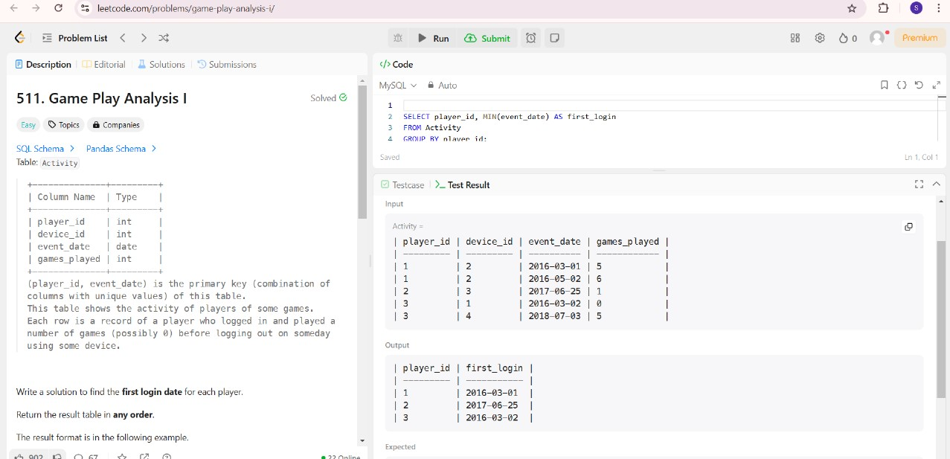

**TASK-2**

**Find Customer Referee(**(**Solve it in LeetCode**)

Find the names of the customer that are **not referred by** the customer with id = 2.

Return the result table in **any order**.

**Input:**

Customer table:

+----+------+------------+

| id | name | referee_id |

+----+------+------------+

| 1 | Will | null |

| 2 | Jane | null |

| 3 | Alex | 2 |

| 4 | Bill | null |

| 5 | Zack | 1 |

| 6 | Mark | 2 |

**Ans.**

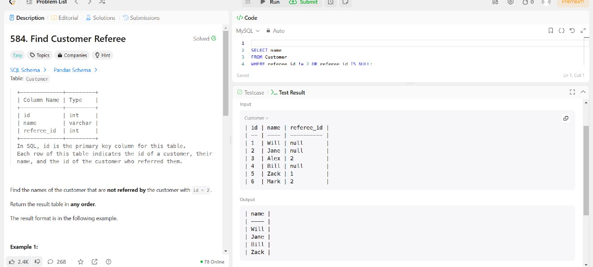

**TASK-3**

**Big Countries** **(Solve it in LeetCode**)

A country is **big** if:

* it has an area of at least three million (i.e., 3000000 km2), or
* it has a population of at least twenty-five million (i.e., 25000000).

Write a solution to find the name, population, and area of the **big countries**.

Return the result table in **any order**.

**Input:**

World table:

+-------------+-----------+---------+------------+--------------+

| name | continent | area | population | gdp |

+-------------+-----------+---------+------------+--------------+

| Afghanistan | Asia | 652230 | 25500100 | 20343000000 |

| Albania | Europe | 28748 | 2831741 | 12960000000 |

| Algeria | Africa | 2381741 | 37100000 | 188681000000 |

| Andorra | Europe | 468 | 78115 | 3712000000 |

| Angola | Africa | 1246700 | 20609294 | 100990000000 |

+-------------+-----------+---------+------------+--------------+

**Ans.**

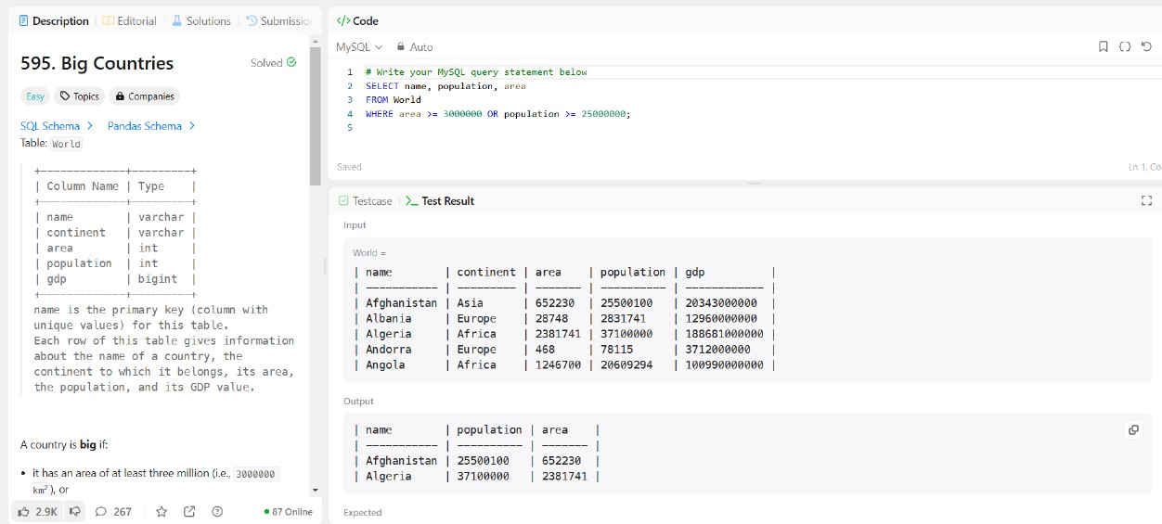

**TASK-4**

**Recyclable and low fat products (Solve it in LeetCode)**

Write a solution to find the ids of products that are both low fat and recyclable.

Return the result table in **any order**.

**Input:**

Products table:

+-------------+----------+------------+

| product_id | low_fats | recyclable |

+-------------+----------+------------+

| 0 | Y | N |

| 1 | Y | Y |

| 2 | N | Y |

| 3 | Y | Y |

| 4 | N | N |

+-------------+----------+------------+

**Ans.**

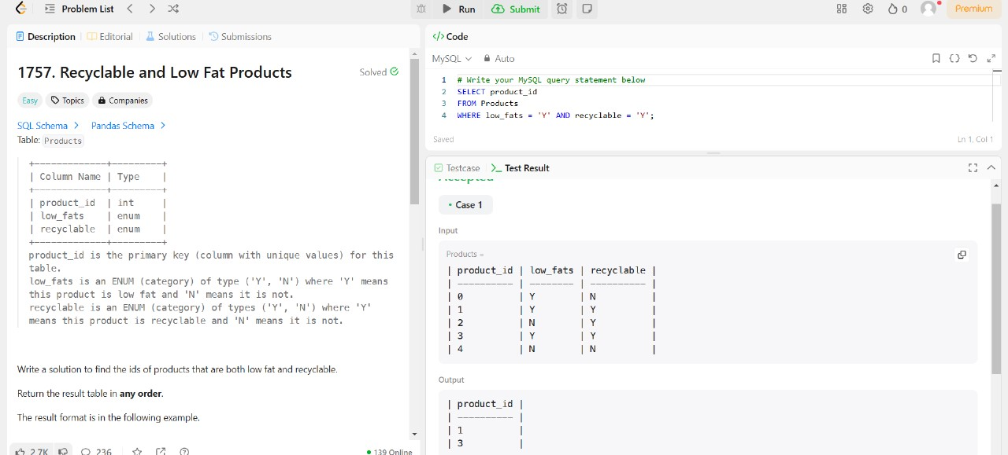

**TASK-5**

Write a solution to find the IDs of the invalid tweets. The tweet is invalid if the number of characters used in the content of the tweet is **strictly greater** than 15.

**Input:**

Tweets table:

+----------+-----------------------------------+

| tweet_id | content |

+----------+-----------------------------------+

| 1 | Let us Code |

| 2 | More than fifteen chars are here! |

+----------+-----------------------------------+

**Ans.**

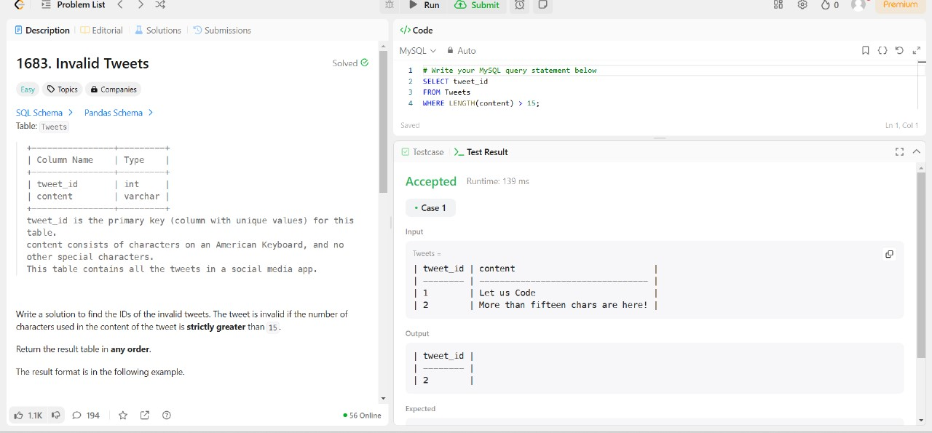

**Case Study Question: School Database**

**Scenario:**

You are tasked with designing a database for a small school. The school has students, teachers, and classes. The database should help manage the following information:

1. Students' details: Unique ID, name, age, and grade level.
2. Teachers' details: Unique ID, name, and subject specialization.
3. Classes: Each class has a unique ID, subject name, and a teacher assigned.
4. Enrollments: Students enrolled in specific classes.

**Tasks:**

1. **ER Diagram**: Design an ER diagram showing the relationships between Students, Teachers, Classes, and Enrollments.(**Use SmartDraw Tool**)
2. **Schema Design**:  
   Write SQL to create the following tables:
   * Students (StudentId, Name, Age, GradeLevel)
   * Teachers (TeacherId, Name, SubjectSpecialization)
   * Classes (ClassId, SubjectName, TeacherId)
   * Enrollments (EnrollmentId, StudentId, ClassId)

Ans.

1)

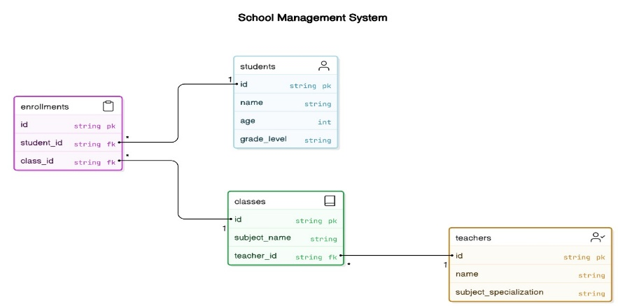

2)

