**Architecture-**

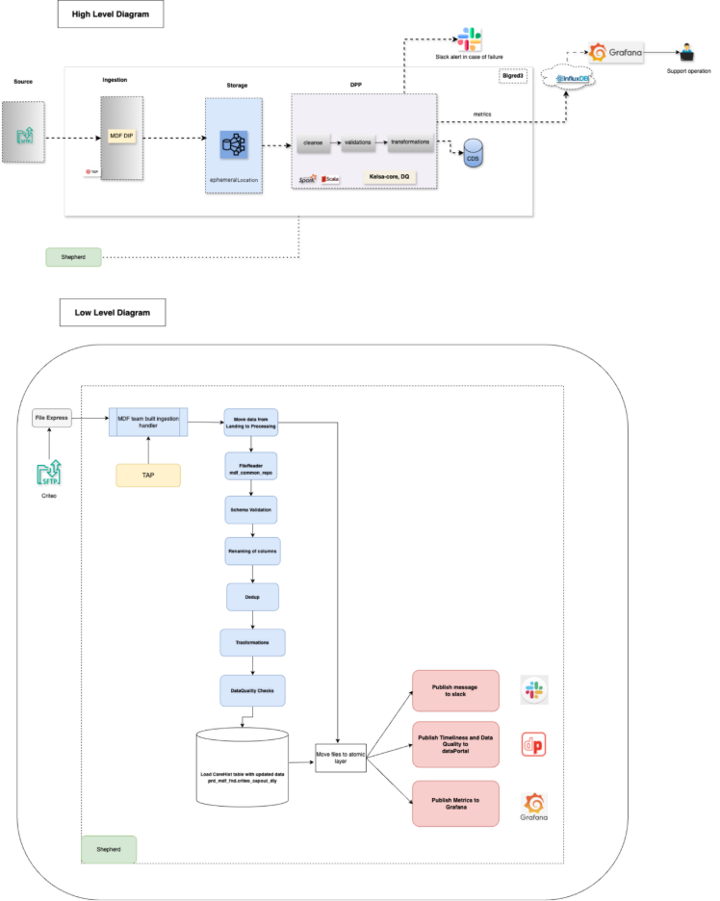

**Scheduling**

|  |  |  |  |
| --- | --- | --- | --- |
| **Shepherd job name** | **Shepherd Job** | **Frequency** | **SLA** |
| criteo_capout_api_dly_prd | <https://shepherd.prod.target.com/workflow/9565173> | Daily | 2:00 PM CST |