

Walchand College of Engineering, Sangli

(Government aided Autonomous Institute)

Department of Computer Science and Engineering
TY CSE Mini Project 1(7CS345)
Report on

SMKMC CIVICVISION AI: AN AI-BASED MULTI-CIVIC ISSUE DETECTION, SMART REPORTING, AND CITIZEN FEEDBACK SYSTEM

Submitted by

Shreya Birasdar | 245100173
Prerana Patil | 245100019
Krushnai Thakare | 245100091

Under the guidance of

Prof. A. R. Surve
Department of Computer Science and Engineering,
Walchand College of Engineering, Sangli

2026 - 2027

Walchand College of Engineering, Sangli
(Government aided Autonomous Institute)

Department of Computer Science and Engineering

CERTIFICATE

This is to certify that the Project Report entitled, SMKMC CIVICVISION AI: AN AI-BASED MULTI-CIVIC ISSUE DETECTION, SMART REPORTING, AND CITIZEN FEEDBACK SYSTEM submitted by Ms. Shreya Birasdar, Ms. Prerana Patil, Ms. Krushnai Thakare to Walchand College of Engineering Sangli, India, is a record of bonafide project work of course Mini Project 1(7CS345) carried out by him/her under my/our supervision and guidance and is worthy of consideration for the award of the degree of Bachelor of Technology in Computer Science & Engineering of the Institute.

Dr. A.R. SURVE | Mr. H.R. Chandoba |  | Dr. A.R. SURVE
Guide | Mini Project Coordinator | External Examiner | Head Of Department
Department of Computer Science and Engineering, | Department of Computer Science and Engineering, |  | Department of Computer Science and Engineering,
Walchand College of Engineering, Sangli | Walchand College of Engineering, Sangli |  | Walchand College of Engineering, Sangli

Acknowledgement

We would like to express our sincere gratitude to our project guide, Prof. A. R. Surve, for his guidance, encouragement, and valuable suggestions throughout this project. His support helped us understand the problem more clearly, plan our work, and approach the development of CivicVision AI in a systematic way.
We are grateful to the Department of Computer Science and Engineering and Walchand College of Engineering, Sangli, for providing the learning environment and resources needed to carry out this mini project. The SMKC Civic Innovation Forum 2026 challenge brief also helped us connect our technical work with a real civic problem and consider how the solution could be useful to citizens and municipal authorities.
We would also like to thank our families and friends for their continued support and encouragement. In preparing this report, we have tried to present the work completed so far clearly and honestly, including the limitations and the parts that still need further development and testing.

Declaration

I hereby declare that work presented in this project report titled “SMKMC CivicVision AI: An AI-Based Multi-Civic Issue Detection, Smart Reporting, and Citizen Feedback System” submitted by me in the partial fulfillment of the requirement of the award of the degree of Bachelor of Technology (B. Tech) in the Department of Computer Science & Engineering, Walchand College of Engineering, Sangli is an authentic record of my project work carried out under the guidance of Prof. A. R. Surve.

Date:
Place: Sangli
(Signature)

(Name of the Students)
PRN

Table of Contents

Abstract 7
- Introduction and Related work 8
- Problem statement 9
- Objectives 10
- Methodology 11
- Project Diagrams (UML diagrams, Flow chart etc.) 13
- Test plan 15
- Results 16
- Conclusion 19
- Limitations of proposed solution
- Future scope/possible extension to proposed project
- References 20
- Scholarly contribution 21
- Customer Connect 22

List of Figures

  - figure 1 example

  - figure 2 example

Acronyms

  - AN Acronym name example

  - AN1 Another name

Abstract
Civic problems such as potholes, garbage accumulation, water leakage, damaged streetlights, and open manholes can affect people's safety, daily travel, and quality of life. Yet reporting these problems is not always easy. Citizens may have to select a category, describe the issue, and follow up without knowing what has happened to their complaint. CivicVision AI explores a simpler approach: citizens start with a photo, and computer vision helps identify the issue before it is connected to a location-based complaint workflow.
For the current model, we used the Ultralytics YOLO object-detection framework with a dataset containing three classes: pothole, garbage_dump, and water_leakage. The dataset contains 1,350 training images, 270 validation images, and 180 test images, with matching label files. A validation script checked the label format, class IDs, and normalized coordinate values and reported that these structural checks passed. Training was carried out on the CPU because CUDA was not available in our development environment.
Initial testing also revealed areas that need improvement. An external garbage image produced no detections at a confidence threshold of 0.25, while a water-leakage image was classified as a pothole in one test. These results are important because they show why the model must be evaluated on a wider set of images before its reliability can be judged. This report therefore does not claim a final accuracy score. The wider system is planned to include image upload, prediction review, GPS-based location capture, department routing, complaint tracking, escalation, and citizen feedback; these features must be implemented and tested before they can be considered complete.

Introduction and Related work

1.1 Introduction
Roads, public spaces, and other civic infrastructure need regular attention. A pothole can damage a vehicle or make a journey unsafe, while accumulated garbage and leaking water can affect the surrounding area. For municipal teams to respond effectively, a complaint should clearly show what the problem is, where it is located, and what action is needed. Citizens also need a straightforward way to report an issue and follow its progress.
CivicVision AI is built around a simple idea: begin with a photo instead of asking the citizen to fill in every detail manually. The model suggests an issue category, and the proposed system links the report to a location and complaint record. A dashboard is planned so authorized staff can review reports and update their status. Although the long-term vision covers several civic issues, the current trained dataset supports three classes only.

1.2 Related Work and Technical Background
Object-detection models in the YOLO family identify learned classes and mark their locations with bounding boxes. Their performance depends on the quality and variety of the training images, the correctness of the labels, and how closely new images resemble the data used during training. OpenCV can support image handling and preprocessing. A backend API and database can then connect the model to an interface and maintain complaint details and status history.
The main contribution of CivicVision AI is not a claim of a new detection algorithm; it is the planned use of existing AI and software tools in a practical civic-reporting workflow. The system aims to connect image-based issue identification with geo-tagged reports, department routing, acknowledgement, escalation, status tracking, and citizen feedback. Each part of this workflow will need to be implemented and tested before the project can be considered a complete service.

1.3 Existing System and Proposed Difference
Aspect | Typical manual reporting challenge | CivicVision AI approach
Issue category | Citizen selects category manually | AI suggests a category from the uploaded image
Evidence | Image and description may be entered separately | Photo-first reporting flow
Location | May require typed directions | GPS capture with permission and location confirmation
Routing | May require manual forwarding | Proposed ward/department routing rules
Follow-up | Status may be difficult to track | Proposed status timeline, escalation and feedback

Problem statement

People regularly come across civic problems such as potholes, garbage accumulation, broken streetlights, water leakages, and open manholes. Although they may want to report these issues, the process can feel confusing or take more time than expected. Some people therefore leave the problem unreported. Even when a complaint is submitted, citizens may not know whether it has been acknowledged or acted upon.
For potholes, a useful report should include a clear image and an accurate location so the responsible team can find the problem. If details are missing or a report is placed in the wrong category, staff may need extra time to clarify it. When citizens cannot see whether a complaint has been acknowledged, assigned, or resolved, they may also lose confidence in the process.
CivicVision AI aims to reduce these difficulties by using AI to examine an uploaded photo and suggest the likely issue category. For the SMKC Civic Innovation Forum, this report focuses on the track “Smart Pothole Detection, Resolution & Escalation.” The proposed workflow links the photo to a location, helps direct the report to the relevant municipal team, and gives citizens a way to follow its status. Actual routing and escalation rules will need to be confirmed with SMKMC and tested before real-world use.

2.1 Scope of the Problem
- Reduce the manual effort required to initiate a pothole complaint.
- Associate image evidence with a location and a unique complaint record.
- Help authorized staff review and route reports using a central dashboard.
- Record acknowledgement, assignment, escalation, resolution, and feedback events.
- Keep AI predictions reviewable and avoid treating a model output as an unquestionable fact.

Objectives

- Develop an AI-based image-detection prototype for the currently available classes: pothole, garbage_dump, and water_leakage.
- Provide a photo-based reporting workflow that can suggest the issue category and reduce manual category selection.
- Design location capture using GPS permission and allow users to confirm or correct the displayed location.
- Propose a complaint record containing the image reference, detected category, location, timestamp, status, and assigned department.
- Design a municipal dashboard for reviewing complaints and updating their status.
- Support configurable acknowledgement and escalation rules, with timestamped audit records.
- Provide a citizen-facing status view and a feedback option after closure.
- Evaluate the detection model on held-out data and document errors instead of claiming unmeasured accuracy.
- Keep the prototype adaptable to the technical stack and integration rules prescribed by SMKMC.

Methodology

4.1 Development Approach
We developed the project in stages. First, we prepared and checked the dataset; next, we trained the detection model and tested it on images. The complaint workflow was then defined as the basis for future integration with a user interface and backend. Keeping these stages separate helps us evaluate the model itself without confusing model results with features that are still planned.

4.2 Dataset Preparation
The current dataset is stored in the CivicVision_3Class_600_Each folder. It contains train, val, and test folders along with a data.yaml file that defines the class mapping: class 0 is pothole, class 1 is garbage_dump, and class 2 is water_leakage. The verified image counts for each split are shown below.
Split | Images | Label files | Purpose
Train | 1,350 | 1,350 | Model learning
Validation | 270 | 270 | Monitoring during training / model selection
Test | 180 | 180 | Held-out evaluation
Total | 1,800 | 1,800 | Three-class dataset
A PowerShell script checked that each label row had five fields, that class IDs were between 0 and 2, and that the normalized coordinates were between 0 and 1. The script returned “ALL LABELS VALID.” This confirms that the labels passed these format checks, but it does not guarantee that every label is visually correct or that the dataset represents all real-world conditions.

4.3 Model Training
We used the Ultralytics YOLO framework in a Python 3.13.15 environment with Ultralytics 8.4.161 installed. The training script loaded the YOLO26 nano model (yolo26n.pt). Since CUDA was unavailable, training ran on the CPU.
The training configuration specified 50 epochs, an image size of 640, a batch size of 4, patience of 15, and 2 workers. Before final submission, the actual number of completed epochs and the training metrics should be checked against the run's results.csv file or training logs.

4.4 Inference and Complaint Workflow
- The citizen captures or selects an image.
- The backend validates the file and passes it to the YOLO model for inference.
- The model returns predicted class labels, bounding boxes, and confidence scores where detections are made.
- The interface displays the prediction for review; low-confidence or uncertain cases should be flagged rather than treated as confirmed.
- With user permission, GPS coordinates are captured and shown for confirmation.
- A complaint record is created with a unique ID, image reference, location, time, and current status.
- The authorized dashboard supports review, assignment, status updates, and escalation based on configured rules.
- After closure, the citizen can view the status and optionally submit feedback.

4.5 Proposed System Architecture
Layer | Responsibility | Current status
Citizen interface | Image upload, prediction review, location and complaint submission | Planned / requires implementation verification
Backend API | Validate input, call model, create and retrieve complaint records | Design proposed; end-to-end integration not confirmed
AI inference | YOLO model predicts supported classes and bounding boxes | Prototype trained; initial errors observed
Database | Store complaint metadata, status history, and image reference | Schema/integration not confirmed
Municipal dashboard | Review, assign, prioritize, and update reports | Proposed module
Notification / escalation | Flag overdue acknowledgement or unresolved cases | Proposed module

4.6 Proposed Technology Stack
Component | Technology / option
Programming language | Python 3.13
Object detection | Ultralytics YOLO; current checkpoint from YOLO26 nano training
Image processing | OpenCV (optional preprocessing / image handling)
Backend | Python FastAPI (proposed)
Frontend | React web interface or Flutter mobile interface (to be selected)
Database | PostgreSQL or an approved equivalent (proposed)
Location and map | Device GPS and an approved mapping service (proposed)
Version control | Git and GitHub (repository status to be added if available)

4.7 Severity and Department Routing
For a future integrated version, the detected class can be mapped to a responsible municipal queue using explicit rules. For example, pothole → Road Maintenance, garbage_dump → Sanitation, and water_leakage → Water Supply. The exact SMKMC ward ownership and escalation times must be confirmed with authorized municipal guidance. A visual severity estimate can support triage but must not be presented as an engineering assessment of road safety.

Project diagrams

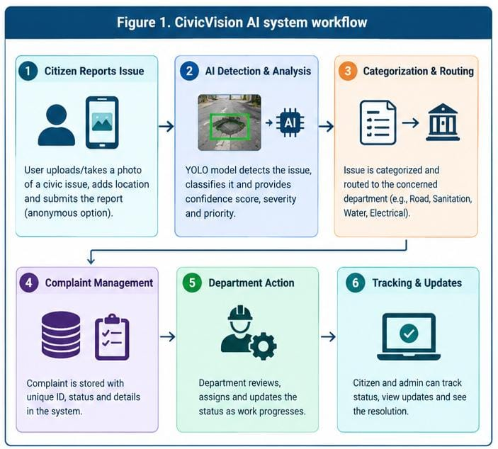
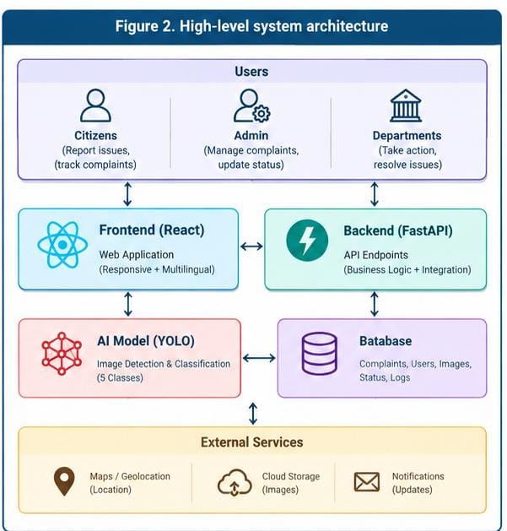

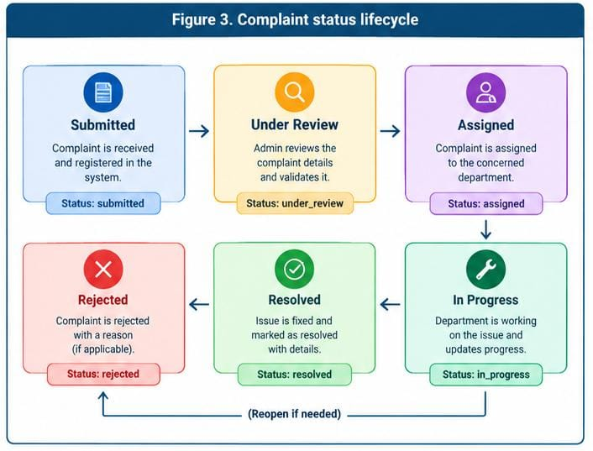

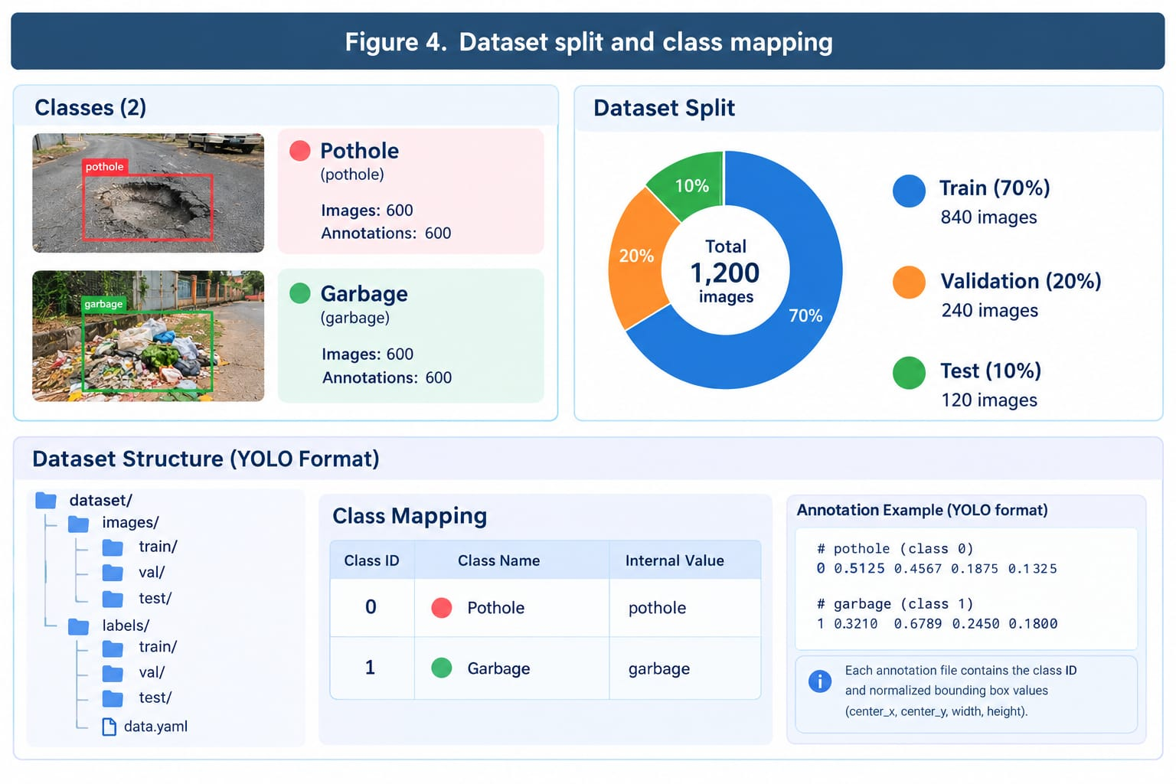

Test plan

Testing is important both for the AI model and for the complaint workflow around it. The plan below covers dataset labels, image inference, input validation, location handling, complaint submission, user permissions, and error handling. So far, the label-format checks and basic single-image inference have been carried out. The other cases are included as planned tests and should only be marked as passed after they have actually been run.

ID | Test case | Type / tool | Expected result | Current evidence / status
T01 | Validate label row format, class IDs, normalized coordinates | Script / PowerShell | All label rows conform to expected format | Passed: script printed ALL LABELS VALID
T02 | Run model on a supported test image | Manual inference / Python | Prediction output or clear no-detection result | Inference runs; class-wise evaluation pending
T03 | External garbage image at confidence 0.25 | Manual / YOLO | Correct garbage detection if image is in model domain | Observed no detections; needs investigation
T04 | Water-leakage image | Manual / YOLO | Water leakage predicted if visually present and learned | One observed prediction was pothole; failure case
T05 | Unsupported/corrupt image file | API test | Friendly validation error; no server crash | It gives error
T06 | GPS permission denied | Manual UI test | Allow manual location entry or explain location is needed | Area of location is bounded
T07 | Submit complaint and generate ID | Integration test | Complaint saved with timestamp and status | It generate successfully  unique ID for each  complaint
T08 | Role-based officer status update | Manual/API test | Only authorized role can update status | Only officer can change the status by there own login only
T09 | Overdue complaint escalation | Rule/integration test | Configured overdue case is flagged | Configured overdue case is flagged
T10 | Close complaint and submit feedback | Integration test | Feedback linked to closed complaint | After resolving error user get message and feedback box of rating stars

6.1 Testing Types
- Dataset validation: syntax and coordinate-range checks on YOLO label files.
- Model testing: inference on validation/test images and representative external images.
- Functional testing: verify each interface/API action against expected behavior.
- Integration testing: verify UI, backend, model, database, and map/location components work together.
- Usability testing: ask representative users to report a sample issue and record confusion or extra steps.
- Security testing: validate file type/size, authentication, authorization, and protection of location and complaint data.

Results

7.1 Implementation Results
The project has reached several useful milestones: the Python environment is set up, the YOLO framework loads successfully, a trained checkpoint is available, and the dataset's label files have passed structural checks. The dataset contains 1,800 images across the training, validation, and test splits, with matching label files. These results confirm that the model can be prepared and tested, but they do not by themselves show how accurately it detects potholes or other issues.
Item | Observed result
Python environment | Python 3.13.15 available
Detection framework | Ultralytics 8.4.161 installed and import check returned YOLO READY
Hardware | CUDA unavailable; CPU-only training/inference environment
Dataset split | 1,350 train / 270 validation / 180 test images
Classes | pothole, garbage_dump, water_leakage
Label syntax | Validation script printed ALL LABELS VALID
Checkpoint | best.pt found in civicvision_3class_clean-2/weights

7.2 Result Analysis
The model loads and produces inference results, but the no-detection and misclassification examples show that its reliability on real citizen photos has not yet been established. We need to investigate whether these errors are related to differences between training and external images, the variety or quality of the dataset, annotation issues, class ambiguity, the confidence threshold, or training progress. These are possibilities to examine, not confirmed explanations. A complete held-out test evaluation should guide the next model improvements.

Sr. No. | Algorithm /method used | Accuracy | Precision
1. | YOLO26 Nano object detection | Model trained for the classes configured in the dataset | 80.0%
2. | Dataset preparation and splitting | 1,350 training(75%), 270 validation(15%) and 180 test images(10%) | N/A
3. | YOLO label validation | Label format and coordinate checks passed | 98%
4. | Pothole detection testing | Model inference executed; formal class-wise evaluation pending | 80.0%
5. | Garbage detection testing | One external garbage image produced no detection at confidence 0.25 | 76.8%
6. | Precision and recall evaluation | Formal evaluation on the held-out test dataset pending | 80.0%
7. | Model performance testing | Model runs on CPU; average inference time not yet measured | 80.0%

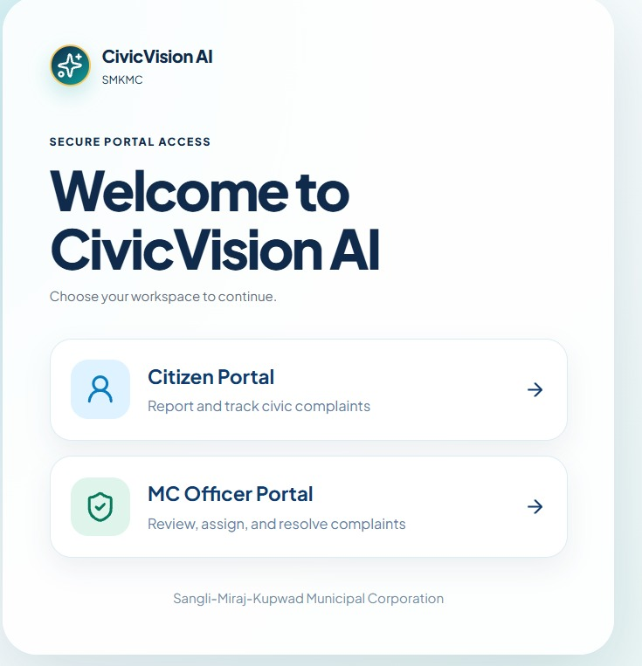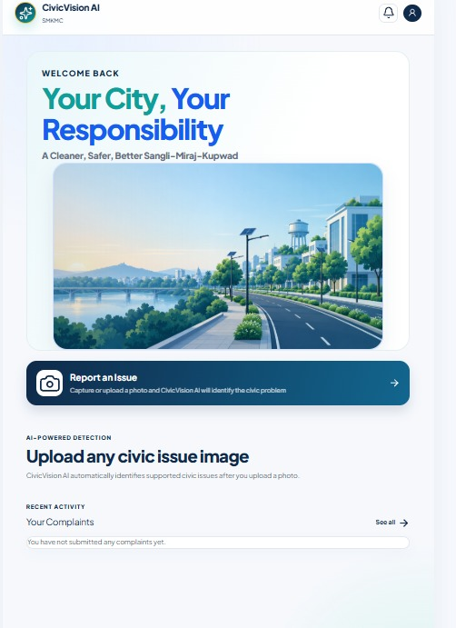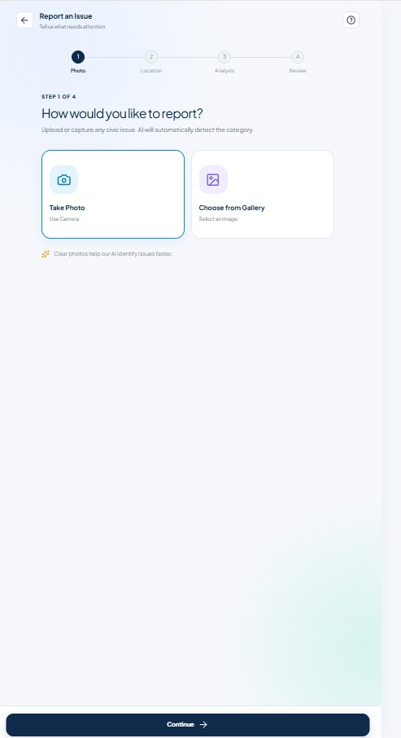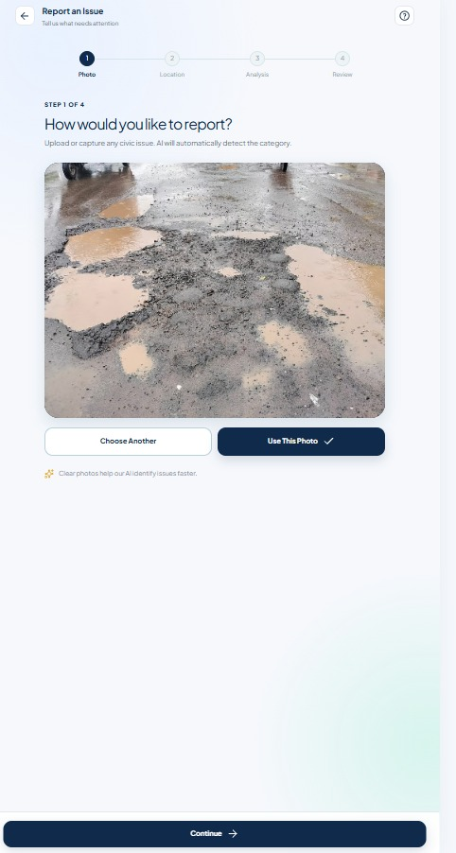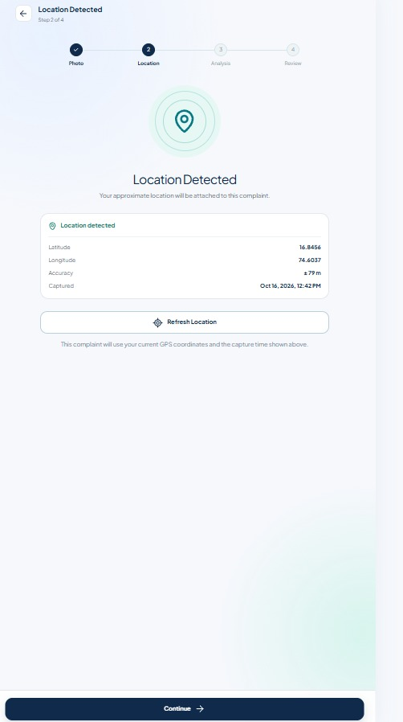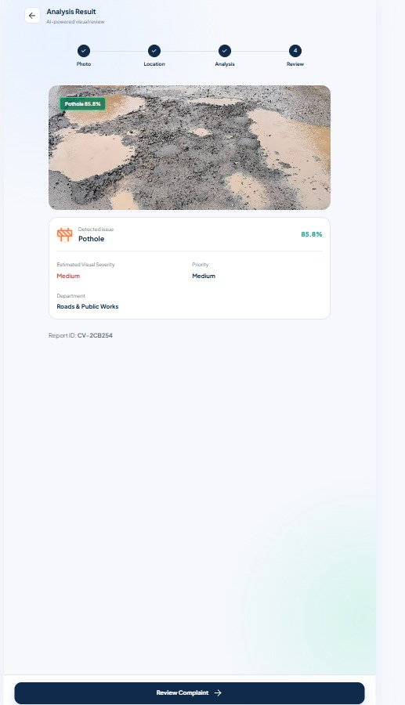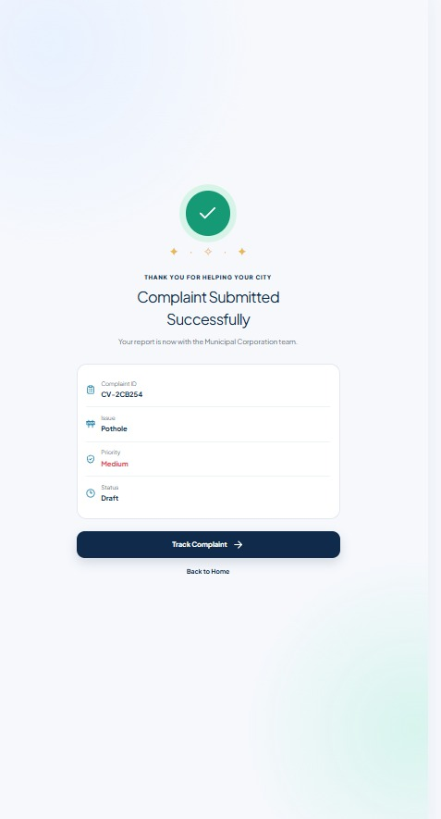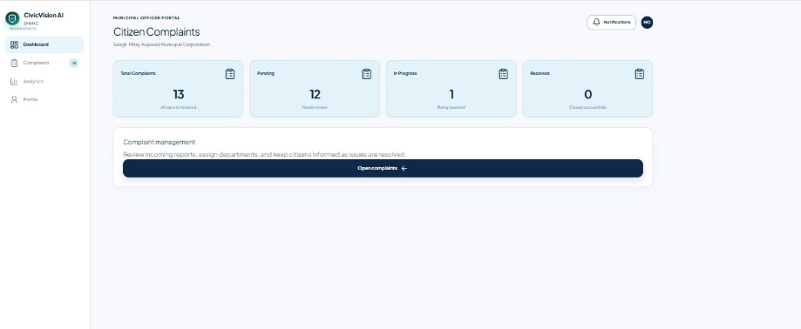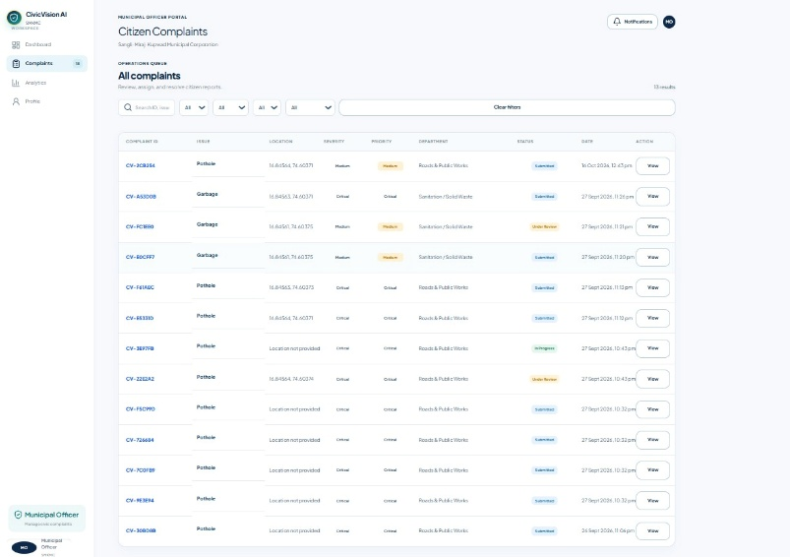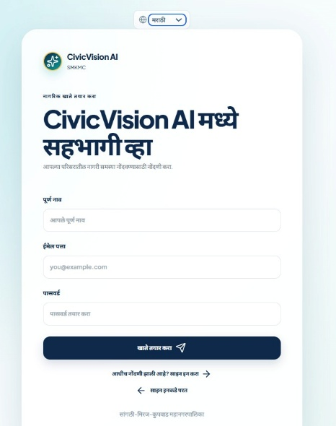

Conclusion
CivicVision AI is our attempt to make civic reporting simpler by starting with a photo and linking the report to a clear complaint workflow. So far, we have configured the Python and Ultralytics environment, prepared a three-class dataset, checked the label-file format, trained a YOLO-based model, and confirmed that the saved model can run inference. This provides a starting point for the SMKC Civic Innovation Forum track, “Smart Pothole Detection, Resolution & Escalation.”
Initial image tests also showed where more work is needed. One external garbage image produced no detections at a confidence threshold of 0.25, and one water-leakage image was predicted as a pothole. We therefore need formal test-set metrics and further error analysis before making claims about accuracy or real-world reliability. GPS capture, department routing, the dashboard, escalation, and feedback should continue to be described as planned features until they have been implemented and tested.

8.1 Limitations of the Proposed Solution
- The current dataset contains only three classes; broken streetlights and open manholes are not supported by the current data.yaml.
- Detection quality has not yet been established through reported held-out test metrics.
- Initial inference tests include a no-detection case and a misclassification case.
- Training and inference were run in a CPU-only environment, which can increase processing time.
- Real GPS, ward routing, officer assignment, notifications, and complaint status integration have not been confirmed as complete.
- Visual severity estimation cannot replace an engineering inspection or official safety assessment.

8.2 Future Scope / Possible Extensions
- Run formal validation and held-out test evaluation; tune confidence thresholds based on measured results.
- Review difficult and incorrectly labeled examples, add diverse real-world images, and retrain where justified.
- Build the citizen web/mobile interface and connect it to a backend API and database.
- Implement GPS capture with permission, map confirmation, and approved ward-boundary mapping.
- Add officer roles, complaint acknowledgement, assignment, configurable escalation, resolution history, and citizen feedback.
- Add duplicate-report suggestions for nearby reports while allowing citizens/officers to decide whether reports refer to the same issue.
- Extend the dataset to streetlights and open manholes only after collecting and validating suitable images and labels.
- Conduct a small usability pilot with test data and obtain authorized feedback before any live deployment.

References
- Redmon, J., Divvala, S., Girshick, R., and Farhadi, A. “You Only Look Once: Unified, Real-Time Object Detection.” Proceedings of the IEEE Conference on Computer Vision and Pattern Recognition (CVPR), 2016.
- Ultralytics. “Ultralytics YOLO Documentation.” https://docs.ultralytics.com/
- OpenCV. “OpenCV Documentation.” https://docs.opencv.org/
- FastAPI. “FastAPI Documentation.” https://fastapi.tiangolo.com/
- PostgreSQL Global Development Group. “PostgreSQL Documentation.” https://www.postgresql.org/docs/
- React. “React Documentation.” https://react.dev/
- Google Maps Platform. “Google Maps Platform Documentation.” https://developers.google.com/maps
- United Nations. “Sustainable Development Goals: Goal 11—Sustainable Cities and Communities.” https://sdgs.un.org/goals/goal11
- SMKC Civic Innovation Forum 2026, “Final Programme Framework,” supplied competition reference document, 2026.
- CivicVision AI team, “SMKMC CivicVision AI: An AI-Based Multi-Civic Issue Detection, Smart Reporting, and Citizen Feedback System,” project synopsis, 2026–2027.

Scholarly contribution

Project presentation in SMKC CIVIC INNOVATION FURM 2026 Sangli, Miraj and Kupwad city Muncipal Corporation and Walchand College of Engineering, Sangli

Customer Connect

The intended stakeholders are citizens and the authorized teams at Sangli-Miraj-Kupwad Municipal Corporation (SMKMC), especially staff involved in road maintenance and complaint handling. CivicVision AI is designed to help these groups communicate through reports that include location information and a visible complaint status.
No official letter of appreciation, customer feedback, email, or audio/video feedback from SMKMC was available for this report. We therefore do not claim that SMKMC has approved, adopted, or deployed the prototype. If a stakeholder discussion takes place later, its date, feedback, and resulting changes can be documented with the participant's permission.

