Module 2 — Unit Test Frameworks

Student Name | Shreya Ghosh
Course | B.Tech — Computer Science and Business Systems (CSBS) (4th Year)
Enrollment No. | 12023052018010
Programming Language | Python
Automation Tool | Selenium WebDriver
Academic Year | 2026

Experiment 7 — Page Object Model (POM) Restructure
1. Problem Statement
Take a working Selenium login script and restructure it using the Page Object Model (POM). Create separate page classes containing locator definitions and UI methods, while keeping test assertions outside the page classes.
2. Objective
To demonstrate a maintainable Selenium structure in which page-specific locators and UI operations are separated from the actual test validation.
3. Tools, Software and Concepts Used
- Python 3
- Selenium WebDriver
- Google Chrome and ChromeDriver
- SauceDemo practice application
- Page Object Model (POM)
- Locators: By.ID, By.NAME, By.XPATH
- Assertions and page validation
- time.sleep() for visible execution during this assignment
4. Source Code / Implementation
The following implementation was executed using Selenium WebDriver with Python.
from selenium import webdriver
from selenium.webdriver.common.by import By
import time

class LoginPage:
URL = "https://www.saucedemo.com/"
USERNAME = (By.ID, "user-name")
PASSWORD = (By.NAME, "password")
LOGIN_BUTTON = (
By.XPATH,
"//input[@type='submit' and @value='Login']"
)

def __init__(self, driver):
self.driver = driver

def open(self):
self.driver.get(self.URL)
time.sleep(3)

def enter_username(self, username):
self.driver.find_element(*self.USERNAME).send_keys(username)
print("Username entered using POM.")
time.sleep(3)

def enter_password(self, password):
self.driver.find_element(*self.PASSWORD).send_keys(password)
print("Password entered using POM.")
time.sleep(3)

def click_login(self):
self.driver.find_element(*self.LOGIN_BUTTON).click()
print("Login button clicked.")
time.sleep(5)

def login(self, username, password):
self.enter_username(username)
self.enter_password(password)
self.click_login()

class DashboardPage:
INVENTORY_CONTAINER = (By.ID, "inventory_container")

def __init__(self, driver):
self.driver = driver

def get_current_url(self):
return self.driver.current_url

def is_inventory_page_displayed(self):
time.sleep(3)
return self.driver.find_element(
*self.INVENTORY_CONTAINER
).is_displayed()

driver = webdriver.Chrome()

try:
driver.maximize_window()

login_page = LoginPage(driver)
dashboard_page = DashboardPage(driver)

print("Opening SauceDemo login page...")
login_page.open()
login_page.login("standard_user", "secret_sauce")

print("Checking dashboard...")
assert "/inventory.html" in dashboard_page.get_current_url()
assert dashboard_page.is_inventory_page_displayed()

print("Login successful!")
print("Current URL:", dashboard_page.get_current_url())
print("Dashboard displayed successfully.")
print("Assignment 7 completed successfully.")

time.sleep(5)

finally:
driver.quit()

5. Output
The login page opened, the username and password were entered through the LoginPage object, and the dashboard was validated through the DashboardPage object.

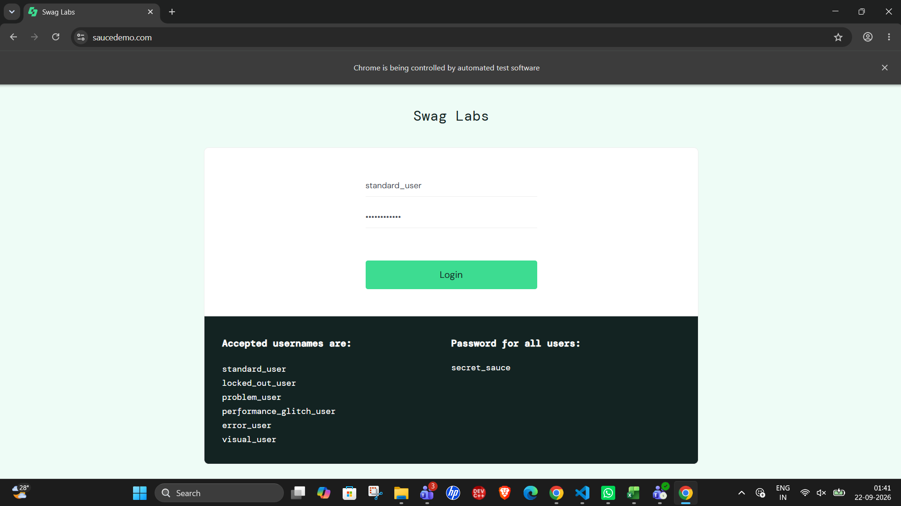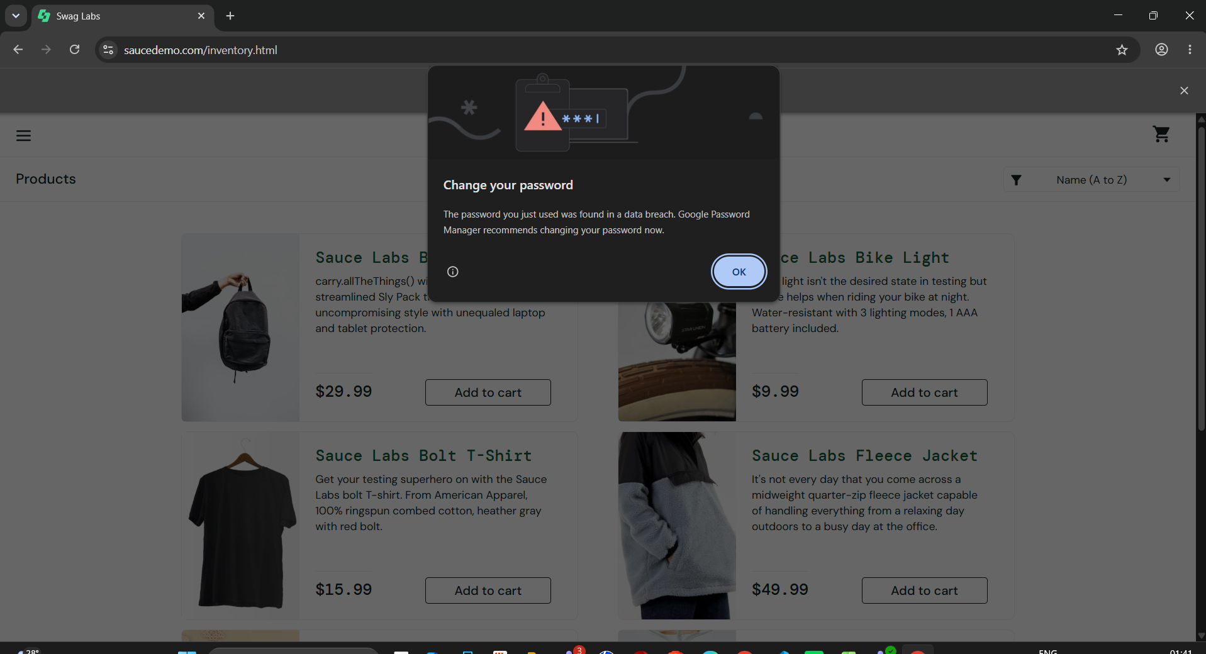

6. Result
The POM-based login automation completed successfully and the expected inventory page was reached.
7. Observation
The LoginPage and DashboardPage classes contain locators and UI-related methods, while the assertions remain outside the page classes.
8. Conclusion
The experiment demonstrated how Page Object Model separates page interaction from test validation and improves code organization.

Experiment 8 — Data-Driven Automation (DDT)
1. Problem Statement
Create a Selenium login automation script that reads multiple test cases from an external CSV file. Execute the same login flow with correct and incorrect username/password combinations and validate the expected result.
2. Objective
To demonstrate data-driven testing by separating test data from automation logic and executing multiple scenarios using the same Selenium workflow.
3. Tools, Software and Concepts Used
- Python 3
- Selenium WebDriver
- Pandas
- CSV test data
- Google Chrome and ChromeDriver
- Data-driven testing
- Assertions and validation
4. Source Code / Implementation
The following implementation was executed using Selenium WebDriver with Python.
from selenium import webdriver
from selenium.webdriver.common.by import By
import pandas as pd
import time
import os

file_path = os.path.join(
os.path.dirname(__file__),
"login_test_data.csv"
)

test_data = pd.read_csv(file_path)

print("Test data loaded successfully.")
print("\nNumber of test cases:", len(test_data))

driver = webdriver.Chrome()

try:
driver.maximize_window()

for index, row in test_data.iterrows():

test_case = row["test_case"]
username = row["username"]
password = row["password"]
expected_result = row["expected_result"]
expected_error = row["expected_error"]

print("\n----------------------------------------")
print("Test Case:", test_case)
print("Username:", username)
print("Password:", password)
print("----------------------------------------")

driver.get("https://www.saucedemo.com/")
time.sleep(3)

username_field = driver.find_element(By.ID, "user-name")
password_field = driver.find_element(By.NAME, "password")
login_button = driver.find_element(
By.XPATH,
"//input[@type='submit' and @value='Login']"
)

username_field.send_keys(username)
print("Username entered.")
time.sleep(2)

password_field.send_keys(password)
print("Password entered.")
time.sleep(2)

login_button.click()
print("Login button clicked.")
time.sleep(3)

if expected_result == "success":
assert "/inventory.html" in driver.current_url
print("Expected result: Successful login")
print("Actual result: Login successful")
print("Test case passed.")

else:
error_message = driver.find_element(
By.CSS_SELECTOR,
"h3[data-test='error']"
).text

print("Expected error:", expected_error)
print("Actual error:", error_message)

assert error_message == expected_error
print("Validation error matched.")
print("Test case passed.")

time.sleep(3)

print("\n========================================")
print("All data-driven test cases passed.")
print("Assignment 8 completed successfully.")
print("========================================")

time.sleep(5)

finally:
driver.quit()

5. Output
The script reads login_test_data.csv and loops through the supplied test cases. Successful login is validated using the inventory URL, while invalid cases are validated against the displayed error message.

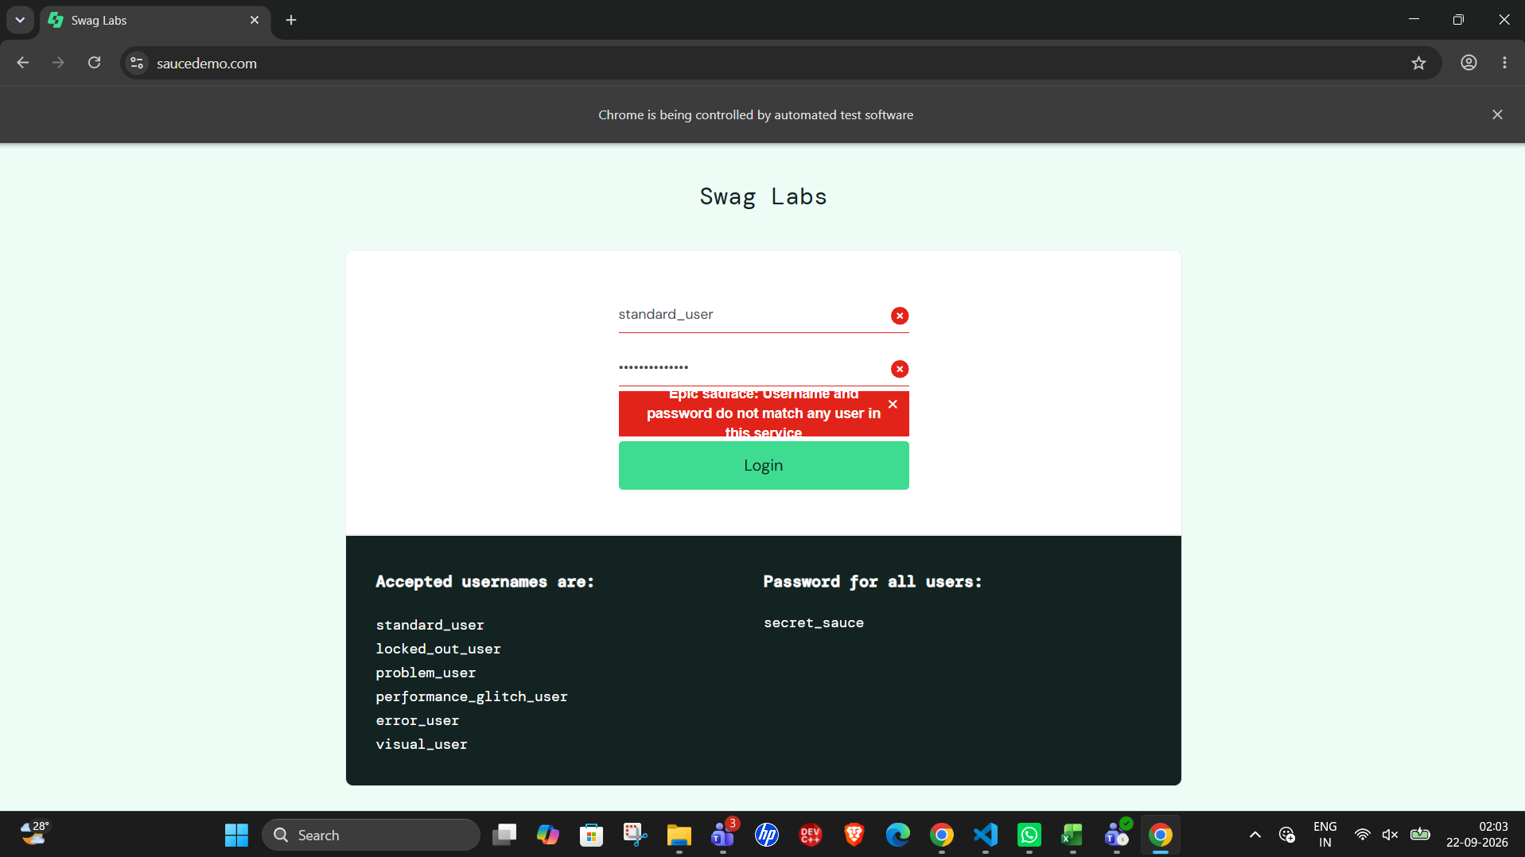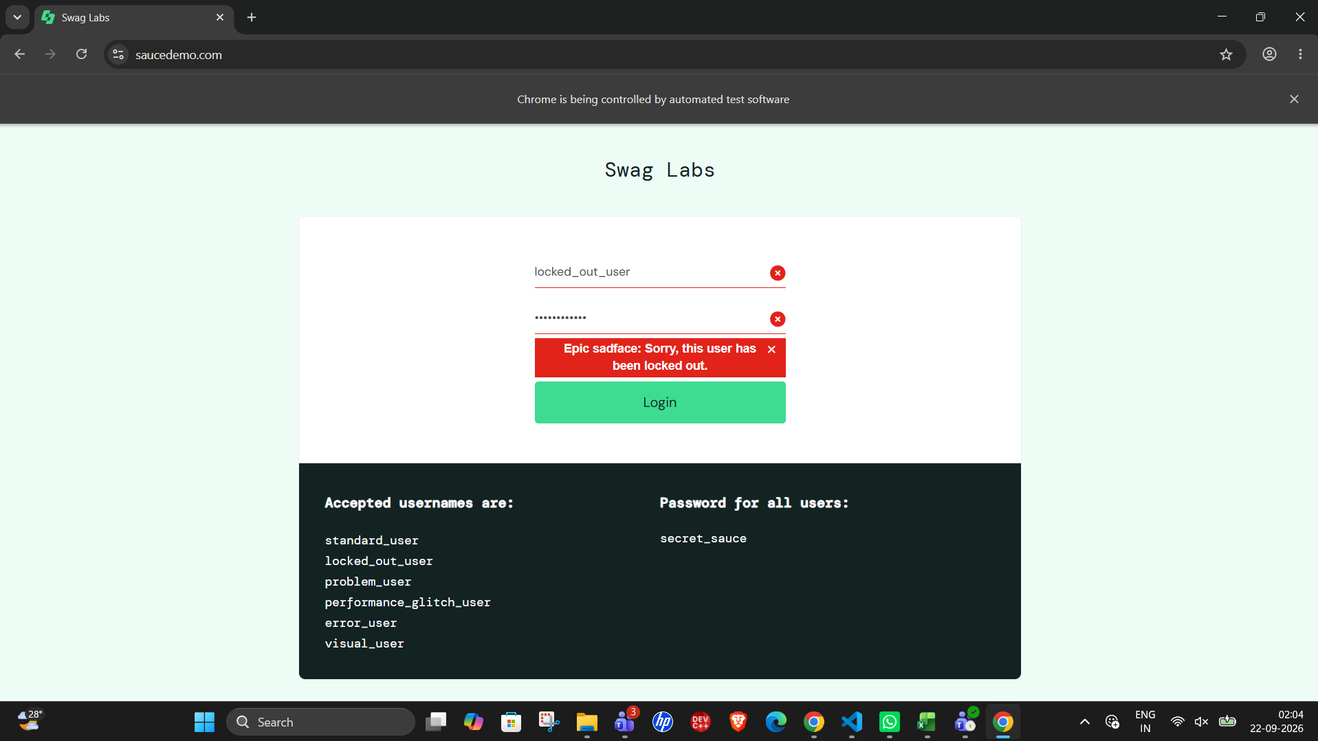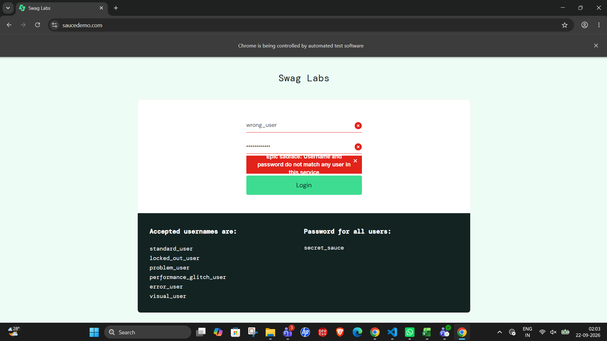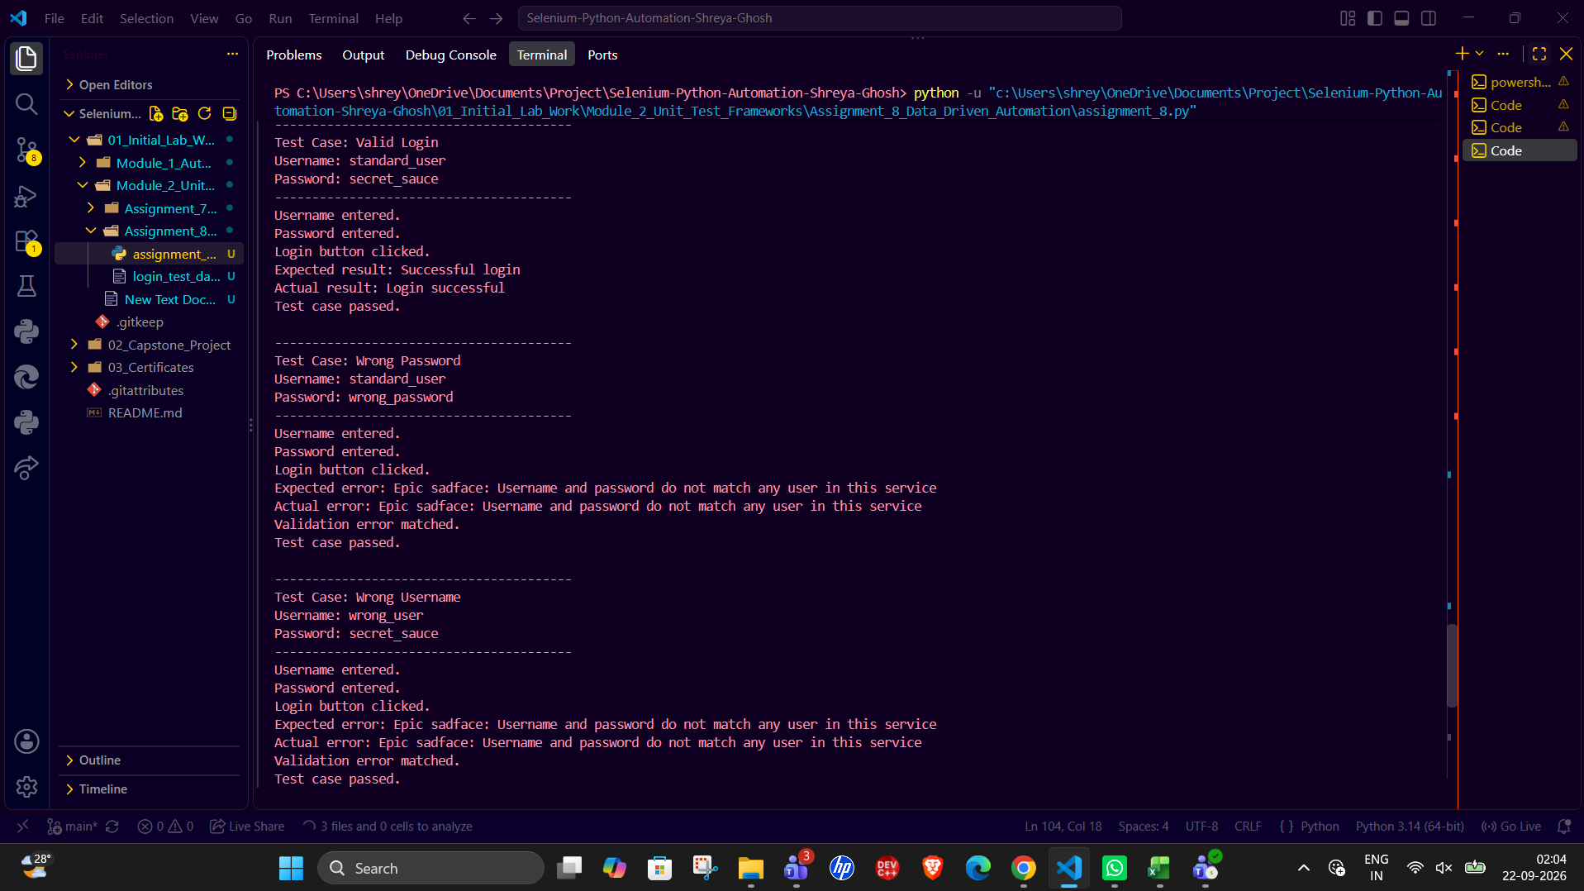

6. Result
The login automation is structured as a data-driven test using an external CSV file.
7. Observation
Separating test data from the automation script allows additional login scenarios to be added without rewriting the main Selenium flow.
8. Conclusion
The experiment demonstrated how external test data can drive repeated Selenium test execution and validation.

Experiment 9 — PyTest Integration with HTML Reporting
1. Problem Statement
Convert the Selenium login automation into a PyTest-based test suite. Use a PyTest fixture for browser initialization and teardown, execute the suite from the terminal, and generate an HTML execution report.
2. Objective
To demonstrate Selenium integration with PyTest, reusable browser setup and teardown through fixtures, and HTML test reporting.
3. Tools, Software and Concepts Used
- Python 3
- Selenium WebDriver
- PyTest
- pytest-html
- pytest-metadata
- Google Chrome and ChromeDriver
- PyTest fixtures
- HTML reporting
4. Source Code / Implementation
The following implementation was executed using Selenium WebDriver with Python.
from selenium.webdriver.common.by import By
import time

def test_valid_login(driver):
driver.get("https://www.saucedemo.com/")
time.sleep(2)

username = driver.find_element(By.ID, "user-name")
password = driver.find_element(By.NAME, "password")
login_button = driver.find_element(
By.XPATH,
"//input[@type='submit' and @value='Login']"
)

username.send_keys("standard_user")
time.sleep(1)

password.send_keys("secret_sauce")
time.sleep(1)

login_button.click()
time.sleep(3)

assert "/inventory.html" in driver.current_url
print("Valid login test passed.")

def test_login_page_title(driver):
driver.get("https://www.saucedemo.com/")
time.sleep(3)

assert "Swag Labs" in driver.title
print("Login page title test passed.")

5. Output
The PyTest suite executed two tests successfully. The HTML report was generated using pytest-html with the --self-contained-html option. 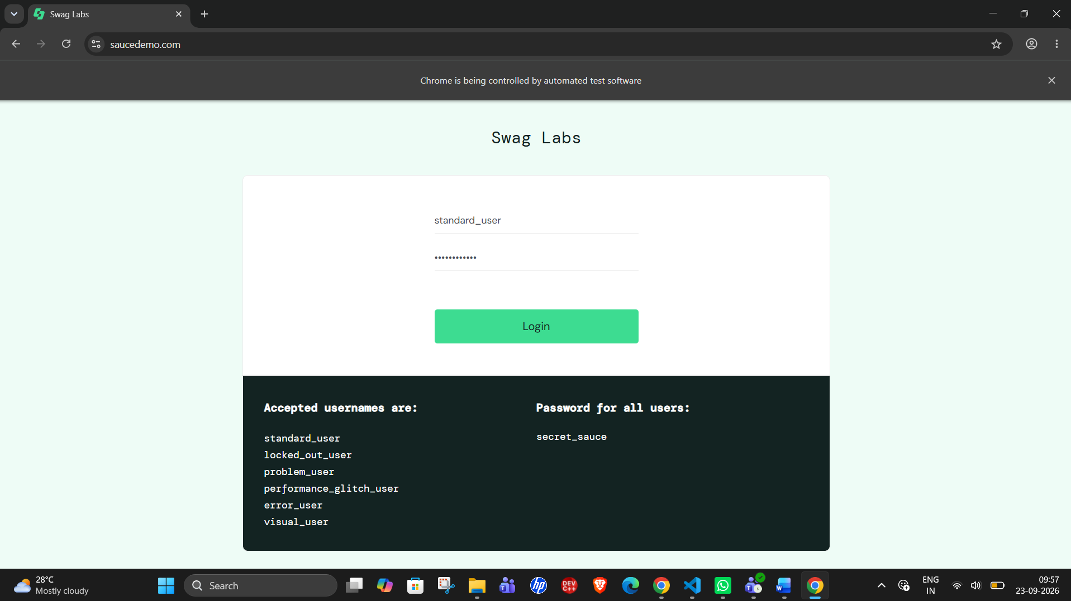
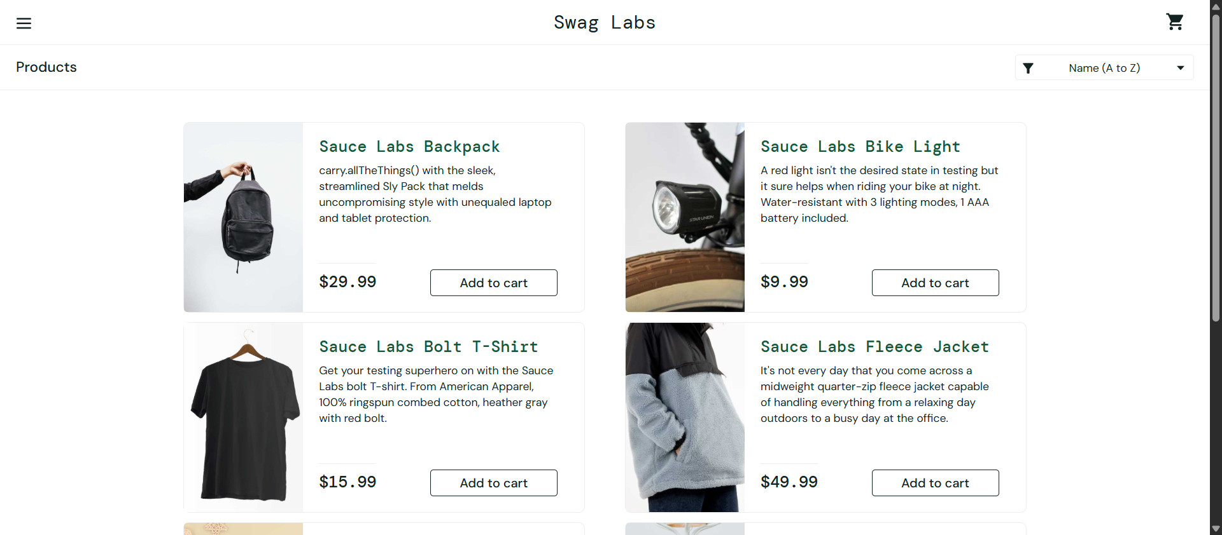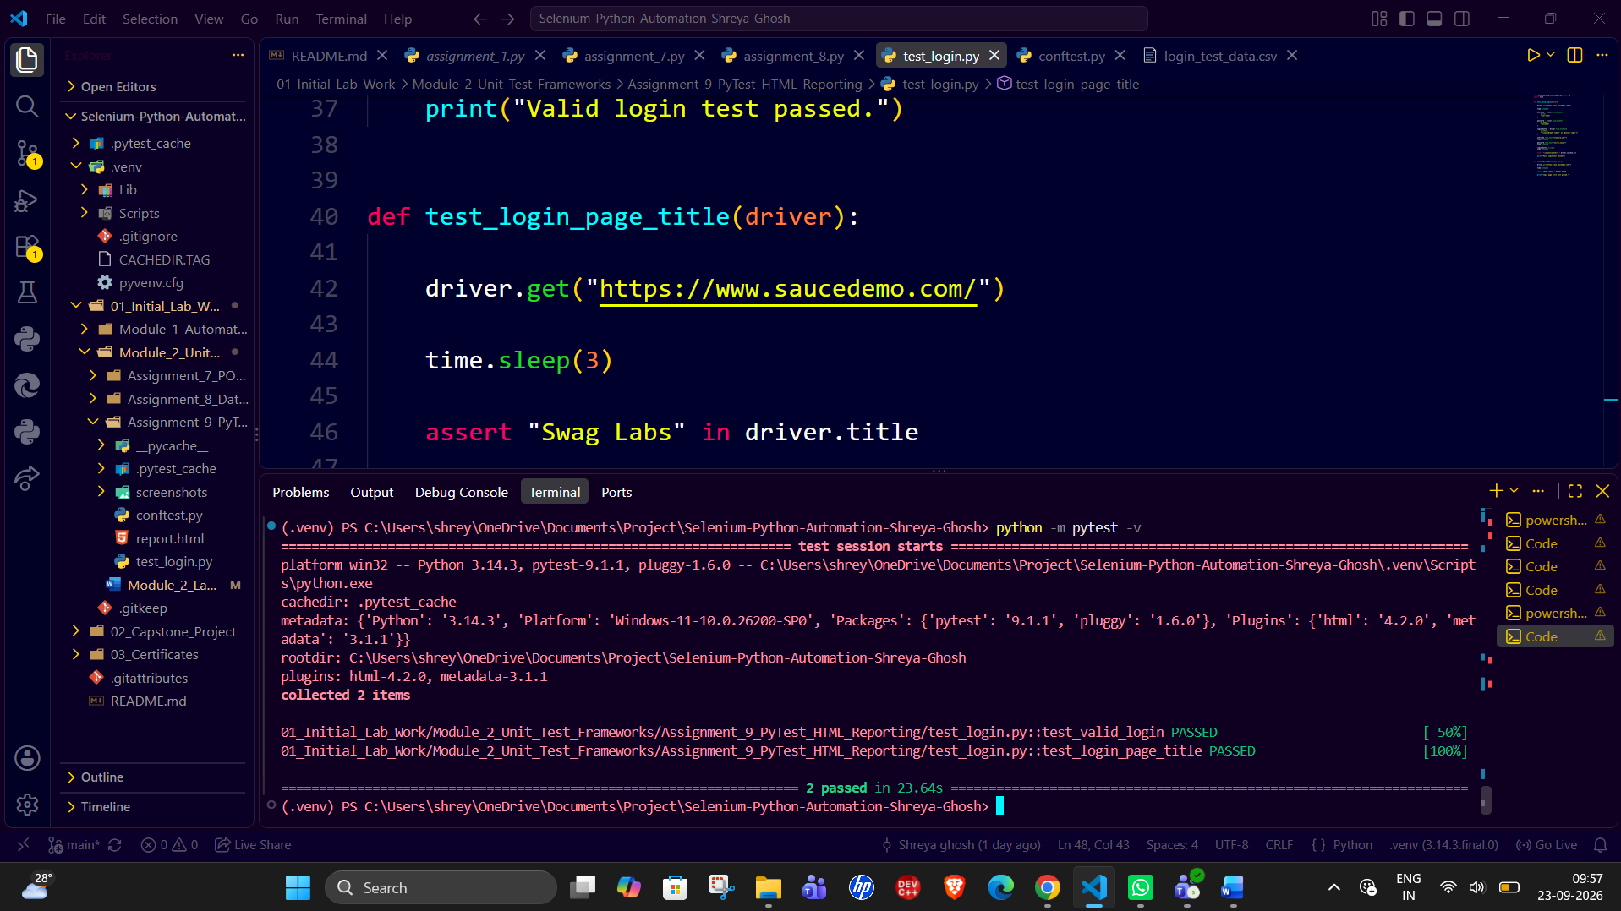
6. Result
The Selenium tests were successfully integrated with PyTest and the browser lifecycle was handled through a fixture.
7. Observation
The fixture provides centralized browser setup and teardown, while PyTest organizes the tests and pytest-html generates a readable execution report.
8. Conclusion
The experiment demonstrated structured Selenium test execution using PyTest and HTML reporting.
Fixture File — conftest.py
import pytest
from selenium import webdriver
import os

@pytest.fixture
def driver(request):

driver = webdriver.Chrome()
driver.maximize_window()

yield driver

report = getattr(request.node, "rep_call", None)

if report and report.failed:

os.makedirs("screenshots", exist_ok=True)

screenshot_path = os.path.join(
"screenshots",
f"{request.node.name}.png"
)

driver.save_screenshot(screenshot_path)

driver.quit()

@pytest.hookimpl(hookwrapper=True)
def pytest_runtest_makereport(item, call):

outcome = yield
report = outcome.get_result()

setattr(item, "rep_" + report.when, report)

Terminal Commands
python -m pytest -v
python -m pytest -v --html=report.html --self-contained-html

