# Ouput

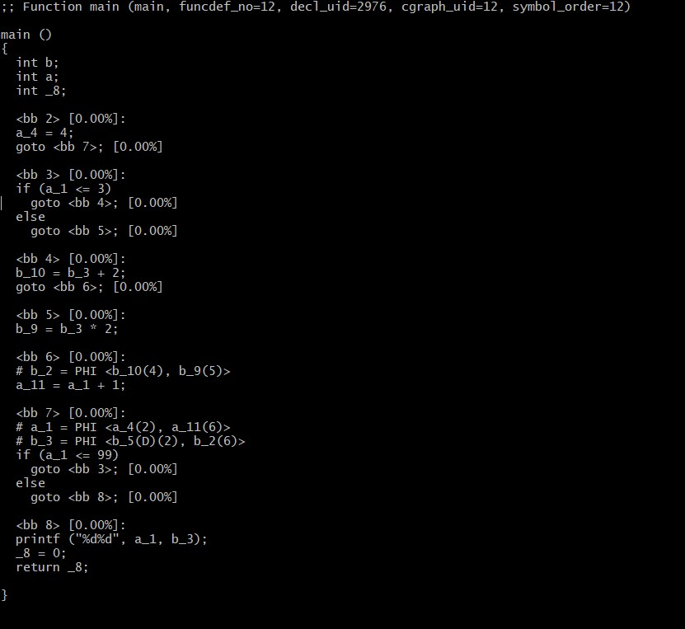

# Input

#include <stdio.h>

int main ()

{

int a, b;

for (a=4 ; a<100; a++) {

if (a < 4)

b = b + 2;

else

b = b * 2;

}

printf ("%d%d", a, b);

}

1]Variable `a' can take the values 4 to 99. Since, the `if' condition will never be true for the give loop bounds, [b = b + 2] is never executed. Therefore, the optimized code has eliminated this program statement.