NirBug
An AI-Assisted Software Bug Tracking and Issue Management System
Software Engineering – Group Project Report

Member | Name | Roll Number | Primary Responsibility
Member 1 | Anamika Chauhan | IIT2025151 | Requirements, UML modelling, AI module, Front-end
Member 2 | Shreya Kumbar | IIT2025178 | Architecture, Database, Back-end services, Security, Testing

Technology: Python 3.11 · Flask · SQLite · scikit-learn · HTML/JavaScript · Tailwind CSS · Chart.js · pytest
Academic Year 2026

Table of Contents
1. Introduction
2. Software Development Life Cycle (SDLC) – Model, Phases & Sprints
3. Software Requirements Specification (SRS)
4. Requirement Analysis & Use Cases
5. Software Modelling (UML)
6. Software Architecture & Design
7. Database Design
8. Implementation
9. AI / Machine-Learning Module
10. Security Design
11. Software Testing
12. Software Quality Assurance
13. Project Planning & Management
14. Risk Management
15. Software Maintenance
16. Conclusion & Future Scope
Appendix A – How to Run
Appendix B – REST API Reference

1. Introduction

1.1 Problem Statement
Software teams discover hundreds of defects during development and after release. When bugs are reported through e-mail, chat or spreadsheets they get lost, duplicated, assigned to the wrong person or forgotten. Managers cannot see which bugs block a release, developers are overloaded unevenly, and nobody knows the history of who changed what. This causes delayed releases, poor software quality and unhappy users.

1.2 Proposed Solution
NirBug is a web-based bug tracking and issue management system that provides one central place to report, classify, assign, fix, test and close software bugs. It enforces a well-defined bug life cycle, uses machine learning to predict bug severity and detect duplicate reports, automatically assigns bugs to the most suitable developer, tracks versions and releases, and keeps a tamper-evident audit log.

1.3 Objectives
- Provide structured bug reporting with severity classification and priority derivation.
- Enforce a role-controlled bug life cycle (state machine).
- Assign developers manually or automatically based on skills and workload.
- Track version found / target release and compute release readiness.
- Track testing status (FIXED → IN_TESTING → VERIFIED / REOPENED).
- Use AI to reduce triage effort (severity prediction, duplicate detection).
- Apply software engineering practices across the full SDLC.

1.4 Scope
In scope: multi-project bug tracking, five user roles, AI triage, assignment, comments, history, notifications, releases, dashboard analytics, audit log, REST API and a responsive web UI. Out of scope (future work): e-mail delivery, Git/CI integration, file attachments and multi-tenant SaaS hosting.

2. Software Development Life Cycle (SDLC)
The SDLC is the structured sequence of phases a software product goes through, from the first idea to maintenance. For NirBug we used the Iterative Incremental model, run in an Agile / Scrum style.

2.1 Model Chosen: Iterative Incremental (Agile / Scrum-based)
The whole system is not built in one go. It is divided into small increments, and each increment is developed in a short time-box called a sprint. Every sprint goes through all the SDLC phases (plan, analyse, design, implement, test, review), so at the end of every sprint there is a working, tested part of the product. The next sprint adds more features on top of it (incremental) and improves what already exists using feedback (iterative).
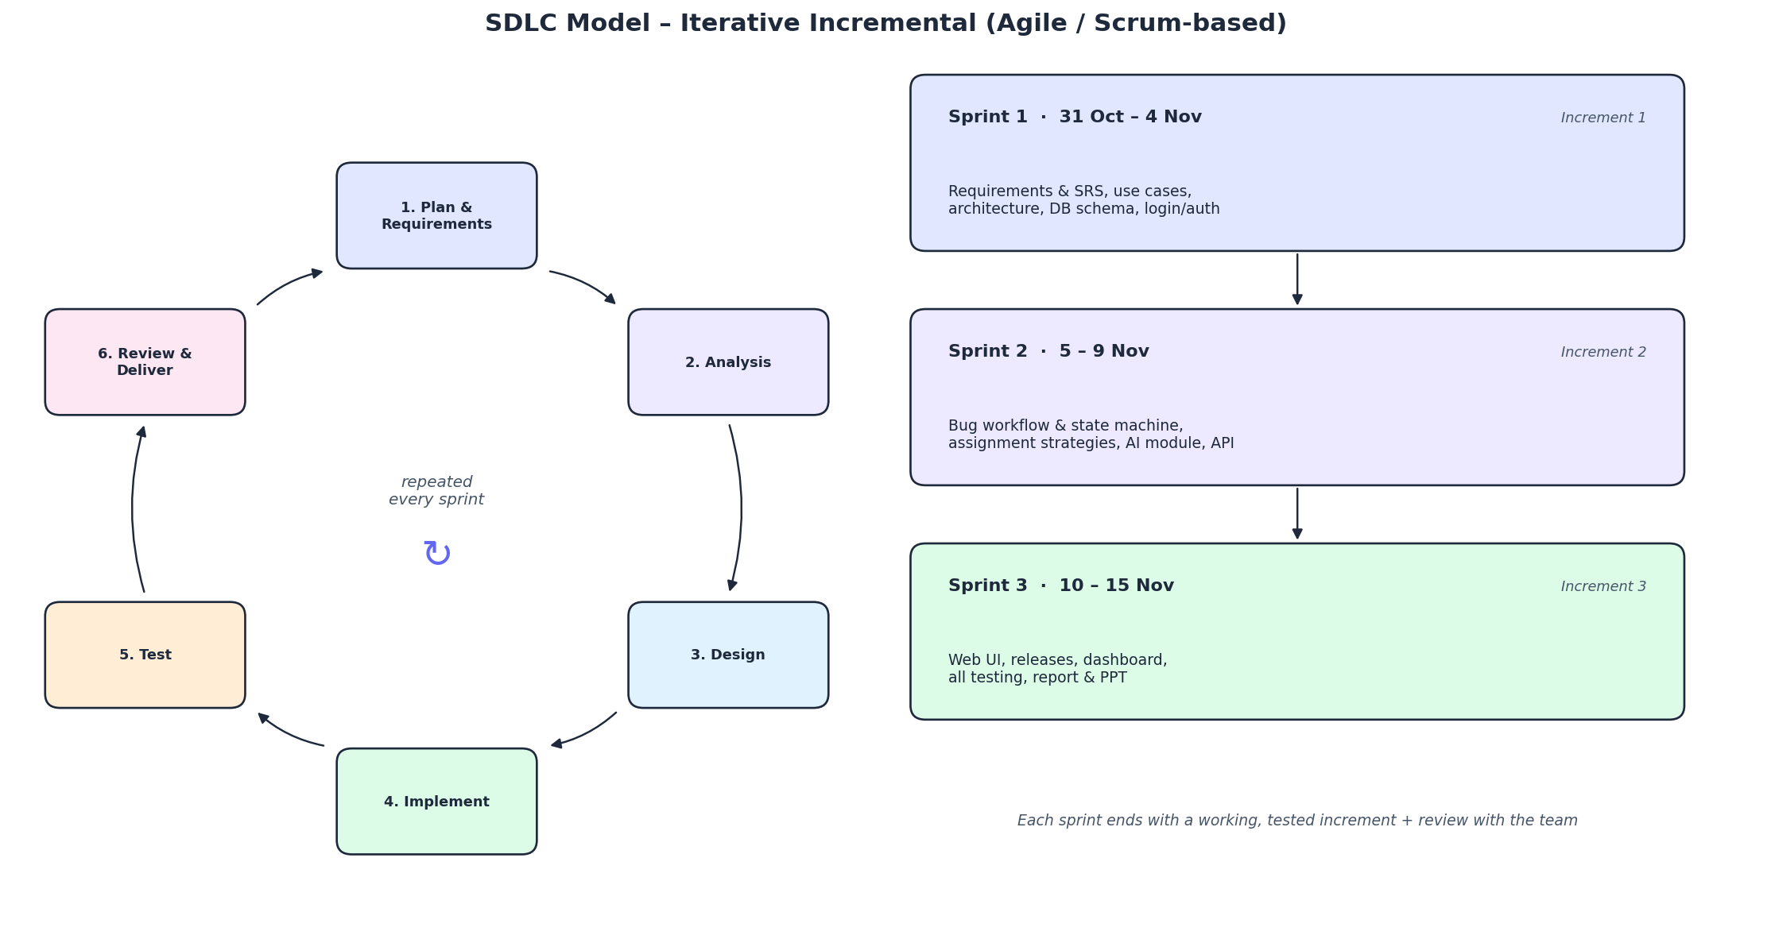
Figure 2.1 – SDLC model: each sprint runs the full cycle and adds one increment

2.2 Phases of the Life Cycle (as applied in NirBug)
Phase | What happens | Output / artefact in this project
1. Planning & Requirements | Understand the problem, identify users and features, fix scope and schedule | Problem statement, SRS (Section 3), Gantt chart, risk table
2. Analysis | Study stakeholders, use cases, feasibility; refine and prioritise requirements | Stakeholder list, use-case diagram & descriptions, feasibility study (Section 4)
3. Design | Decide architecture, modules, database and UI; model the system with UML | Layered architecture, class/sequence/activity/state diagrams, ER diagram, design patterns (Sections 5–7)
4. Implementation (Coding) | Write the code module by module following the design | Flask back-end, SQLite DB, AI module, web front-end (Sections 8–10)
5. Testing | Verify each part and the whole system against the requirements | 63 automated unit, integration and system tests, traceability matrix (Sections 11–12)
6. Deployment & Review | Run the increment, demo it, collect feedback, plan the next sprint | Working increment at the end of each sprint, final demo on 15 Nov
7. Maintenance | Fix, adapt and improve the system after delivery | Maintenance plan (Section 15)

2.3 Sprints (Increments) on Our Timeline
Sprint | Dates | Increment delivered | Phases covered
Sprint 1 | 31 Oct – 4 Nov 2026 | SRS, use cases, architecture, DB schema, login & registration | Planning, Analysis, Design, first Implementation + tests
Sprint 2 | 5 – 9 Nov 2026 | Bug life cycle (state machine), assignment strategies, AI module, REST API | Design refinement, Implementation, unit & integration tests
Sprint 3 | 10 – 15 Nov 2026 | Web UI, releases, dashboard, notifications, audit log, report & PPT | Implementation, system testing, review, deployment/demo

Scrum practices we followed (scaled down for a two-person team): a product backlog (the list of functional requirements FR-01 to FR-16), sprint planning at the start of each sprint, short daily check-ins between the two members, and a sprint review/demo at the end of each sprint where the increment was tested and the next sprint was planned.

2.4 Why This Model? (Comparison with Other SDLC Models)
Model | How it works | Suitable for NirBug?
Waterfall | Phases done once, strictly one after another; no going back | No – requirements (e.g. AI features, UI) changed during the project; nothing works until the very end
V-Model | Waterfall with a test phase planned for each development phase | Partly – good testing discipline (we borrowed this idea), but still rigid
Spiral | Iterations driven by risk analysis; suited to large, high-risk projects | No – too heavy for a 16-day student project
Prototype | Build a throw-away prototype to discover requirements | Partly – we used a quick UI prototype for the report-bug flow
Iterative Incremental (Agile/Scrum) ✔ | Small time-boxed sprints, each delivers a working increment | Yes – short deadline, small team, changing requirements, early working product, continuous testing

2.5 Advantages Observed
- A working version existed after Sprint 1, so the risk of having nothing to submit was low.
- Requirement changes (e.g. adding duplicate detection and release readiness) were absorbed in the next sprint.
- Testing happened in every sprint, so bugs were found early and cheaply.
- Work was divided clearly between the two members per sprint, making progress easy to track.

3. Software Requirements Specification (SRS)
This section follows the structure of IEEE 830 / ISO/IEC/IEEE 29148.

3.1 Users (Actors) and Characteristics
Role | Description | Key permissions
Reporter | Any end user / client who finds a bug | Register, report bugs, comment, view own bugs
Developer | Fixes bugs; has skills (ui, api, auth …) | Start work, mark FIXED, comment
Tester (QA) | Verifies fixes | Move FIXED → IN_TESTING → VERIFIED / REOPENED, mark DUPLICATE
Manager | Team lead / project manager | Assign bugs, manage projects & releases, view audit log
Admin | System administrator | All manager rights + create users with any role

3.2 Functional Requirements
ID | Requirement | Priority
FR-01 | The system shall allow users to register and log in with username and password. | High
FR-02 | The system shall support five roles and restrict actions by role (RBAC). | High
FR-03 | A user shall be able to report a bug with project, title, description, component, version found and target release. | High
FR-04 | The system shall predict the bug severity (CRITICAL/HIGH/MEDIUM/LOW) using ML when the user does not choose one. | High
FR-05 | The system shall derive priority (P1–P4) from severity, raising it if the bug targets a release. | High
FR-06 | The system shall show possible duplicate bugs while a bug is being written. | Medium
FR-07 | A manager shall assign a bug to a developer manually or automatically (skill + workload strategy). | High
FR-08 | The system shall enforce the bug life cycle; illegal transitions shall be rejected. | High
FR-09 | Developers shall only change the status of bugs assigned to them. | High
FR-10 | Users shall comment on bugs; every field change shall be stored in bug history. | Medium
FR-11 | The system shall notify the assignee/reporter when a bug is assigned, commented or changes status. | Medium
FR-12 | Managers shall create projects and releases (versions) and ship a release only if no critical/high bug is open. | High
FR-13 | Users shall search and filter bugs by text, project, status and severity. | Medium
FR-14 | The system shall show a dashboard (counts by status/severity, workload, mean time to close, AI agreement). | Medium
FR-15 | The system shall record security-relevant actions in an audit log viewable by managers/admins. | High
FR-16 | A Kanban board shall allow changing bug status by drag-and-drop. | Low

3.3 Non-Functional Requirements
ID | Category | Requirement
NFR-01 | Security | Passwords hashed with PBKDF2-SHA256 (600 000 iterations, salted); never stored in plain text.
NFR-02 | Security | Account locked for 15 min after 5 failed logins; login endpoint rate-limited to 10 req/min/IP.
NFR-03 | Security | All SQL uses parameterised queries; all output HTML-escaped; CSP & anti-clickjacking headers.
NFR-04 | Performance | API responses < 300 ms for 10 000 bugs on a laptop (indexes on status, assignee, project).
NFR-05 | Usability | Responsive UI usable on mobile (≥ 360 px) and desktop; dark/light theme; ≤ 3 clicks to report a bug.
NFR-06 | Reliability | Foreign-key constraints and CHECK constraints guarantee data integrity; invalid input returns 4xx, never 500.
NFR-07 | Maintainability | Layered architecture, design patterns, ≥ 60 automated tests, PEP-8 code.
NFR-08 | Portability | Runs on Windows/Linux/macOS with Python 3.10+; no external DB server needed.
NFR-09 | Accountability | Every create/assign/status change is written to bug_history and audit_log with timestamp and actor.
NFR-10 | Availability | Stateless API (token auth) so it can be scaled horizontally behind a load balancer.

3.4 Constraints and Assumptions
- Development time of 16 days (31 Oct – 15 Nov 2026) and a team of 2 students.
- Free/open-source technologies only (Python, Flask, SQLite, scikit-learn).
- The AI model is trained on a small labelled dataset; humans can always override its prediction.
- Users access the system with a modern browser (Chrome, Edge, Firefox, Safari).

4. Requirement Analysis

4.1 Stakeholders
Stakeholder | Interest / Goal
End users / clients | Report problems easily and know when they are fixed
Developers | Clear, prioritised list of work; fair workload
QA / Testers | Know what to test; reopen failed fixes
Project managers | Visibility of progress, blockers and release readiness
System administrator | Security, user management, audit
Course instructor / evaluator | Demonstration of SE principles

4.2 Requirement Elicitation Techniques
- Study of existing tools (Jira, Bugzilla, GitHub Issues) – document analysis.
- Brainstorming sessions within the team and informal interviews with fellow students who work on projects.
- Prototyping: an early UI mock-up was used to validate the bug-reporting flow.

4.3 Feasibility Study
Type | Assessment
Technical | Feasible – mature open-source stack the team knows (Python, Flask, SQL).
Economic | Feasible – zero licence cost; runs on a laptop or a low-cost cloud VM.
Operational | Feasible – familiar web UI, role-based workflow mirrors real teams.
Schedule | Feasible – scope fixed to 16 FRs across 3 sprints.

4.4 Use-Case Diagram
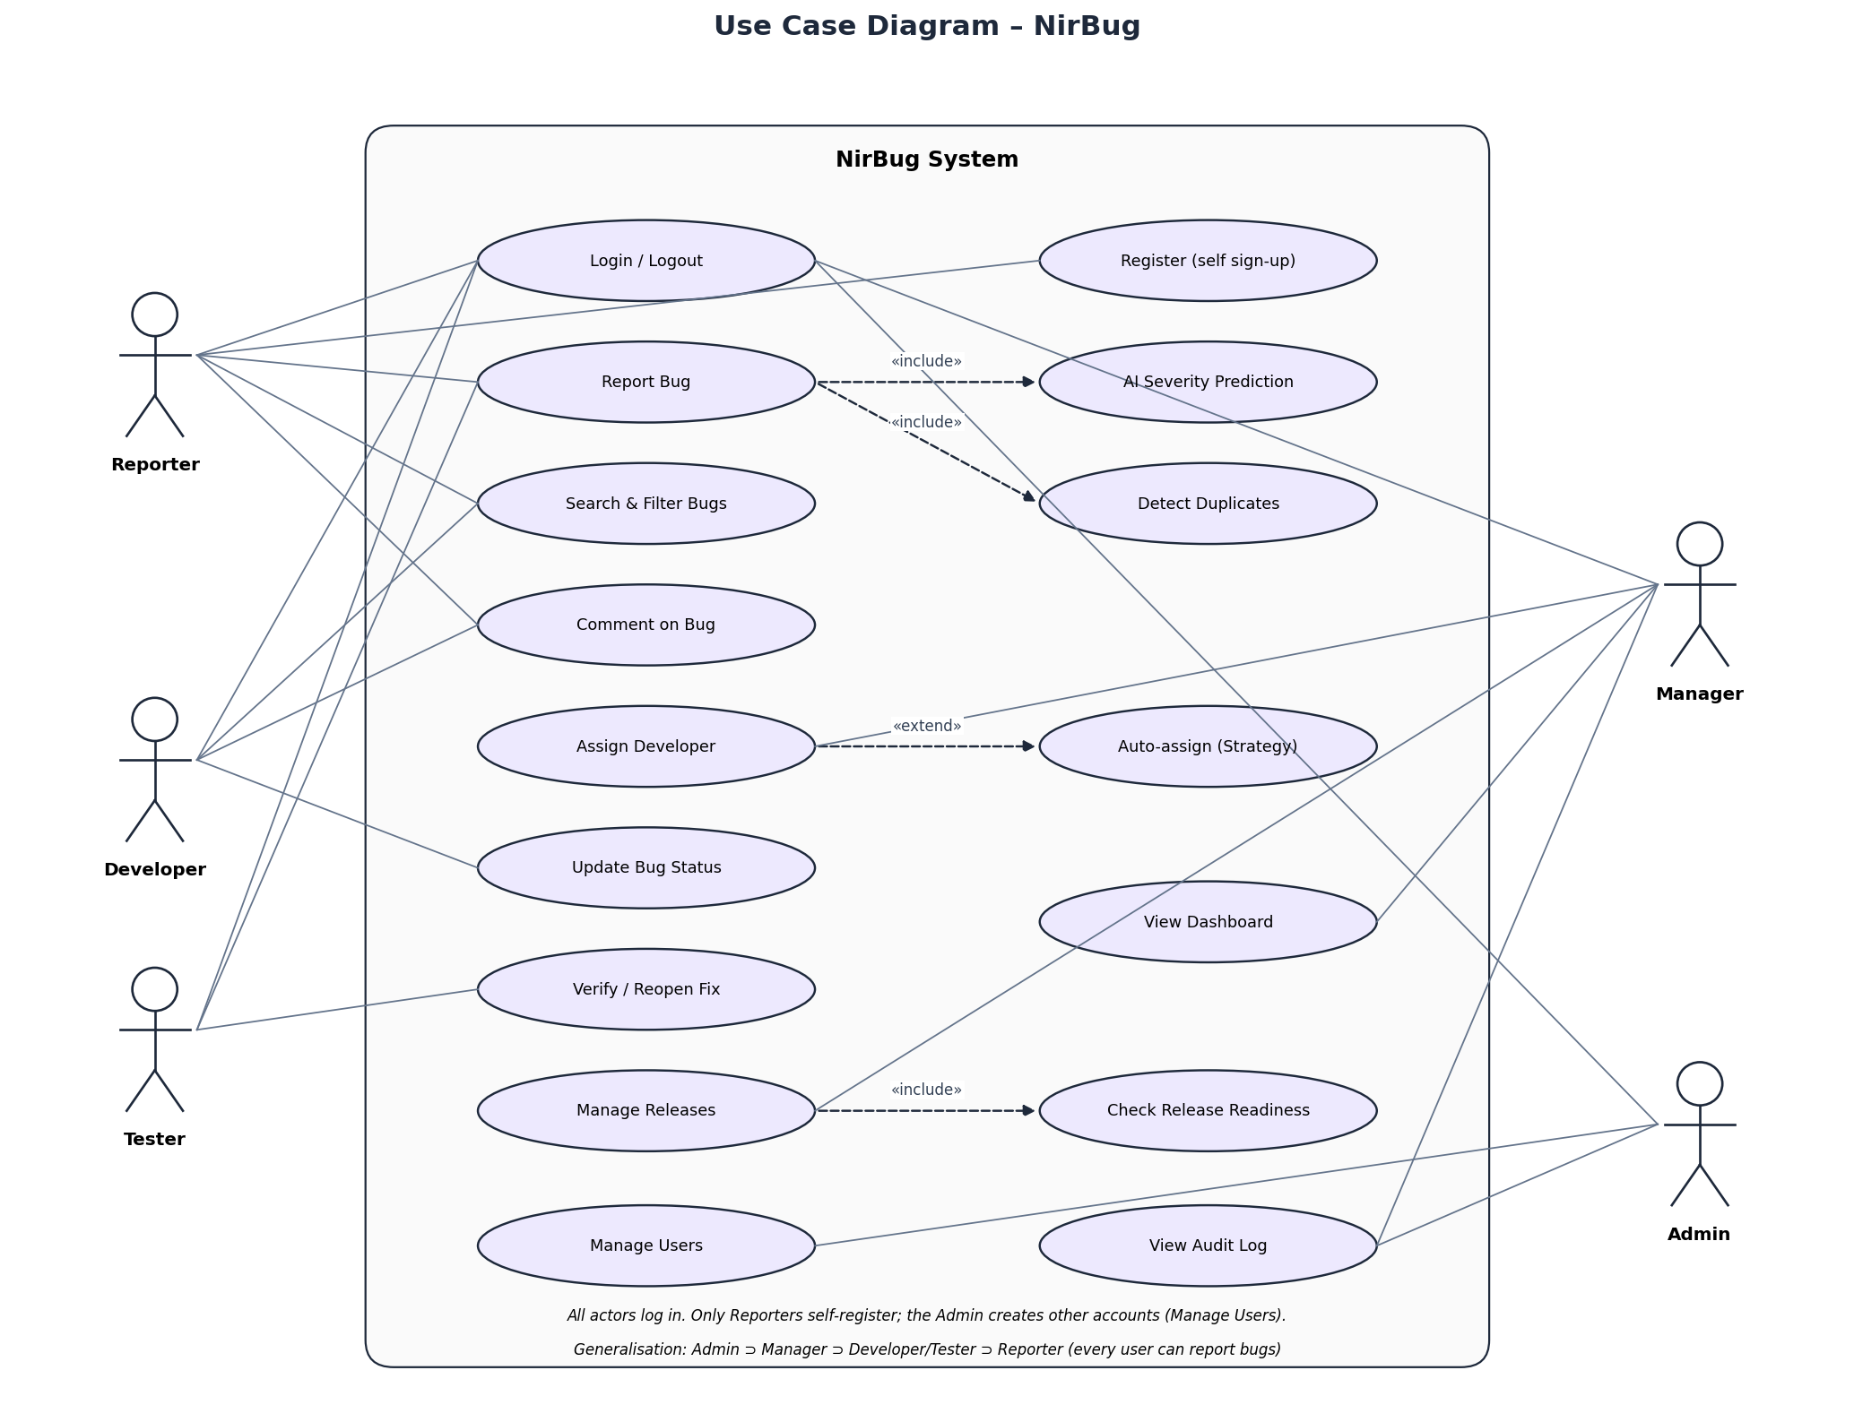
Figure 1 – Use-case diagram

4.5 Use-Case Descriptions
UC-02 Report Bug
Field | Description
Actor | Reporter (any logged-in user)
Pre-condition | User is logged in; at least one project exists
Main flow | 1. User opens Report Bug. 2. Enters title & description. 3. System shows AI-predicted severity, component and duplicates. 4. User submits. 5. System validates, derives priority, stores bug with status NEW, writes history & audit, returns bug id.
Alternate flow | 3a. Duplicate found → user may cancel and comment on the existing bug. 5a. Validation fails → error message, nothing stored.
Post-condition | Bug exists with status NEW and an AI severity value.

UC-05 Assign Developer
Field | Description
Actor | Manager / Admin
Pre-condition | Bug status NEW or REOPENED
Main flow | 1. Manager opens a bug. 2. Chooses a developer or 'Auto'. 3. Auto: SkillBasedStrategy picks the developer whose skills match the component with the lowest weighted workload. 4. Status → ASSIGNED, developer notified.
Exception | Non-manager → 403 Forbidden. No developers → error.

UC-07 Verify / Reopen Fix
Field | Description
Actor | Tester
Pre-condition | Bug status FIXED
Main flow | 1. Tester moves bug to IN_TESTING. 2. Tests the fix. 3a. Pass → VERIFIED → CLOSED. 3b. Fail → REOPENED, developer notified.

5. Software Modelling (UML)
The following UML 2.x diagrams model the static structure and dynamic behaviour of NirBug.

5.1 Class Diagram
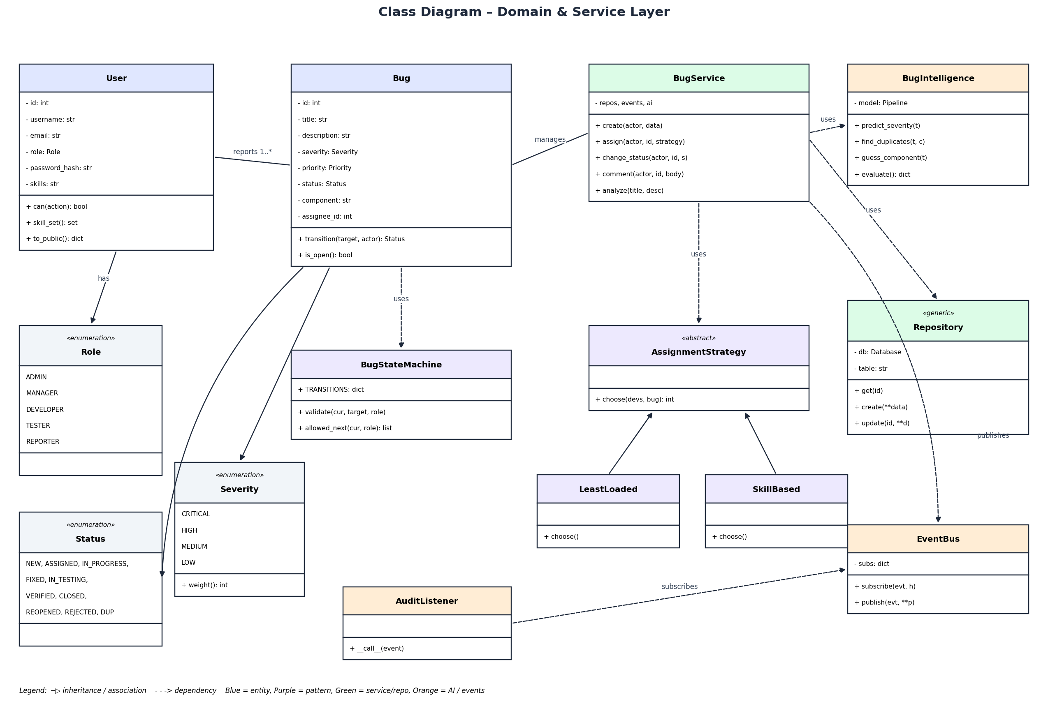
Figure 2 – Class diagram (domain + service layer)
User, Bug and the enumerations form the domain model. BugStateMachine encapsulates life-cycle rules. BugService is the main control class; it depends on the abstract AssignmentStrategy (Strategy pattern), BugIntelligence (AI) and Repository (data access). EventBus with AuditListener implements the Observer pattern.

5.2 Sequence Diagram
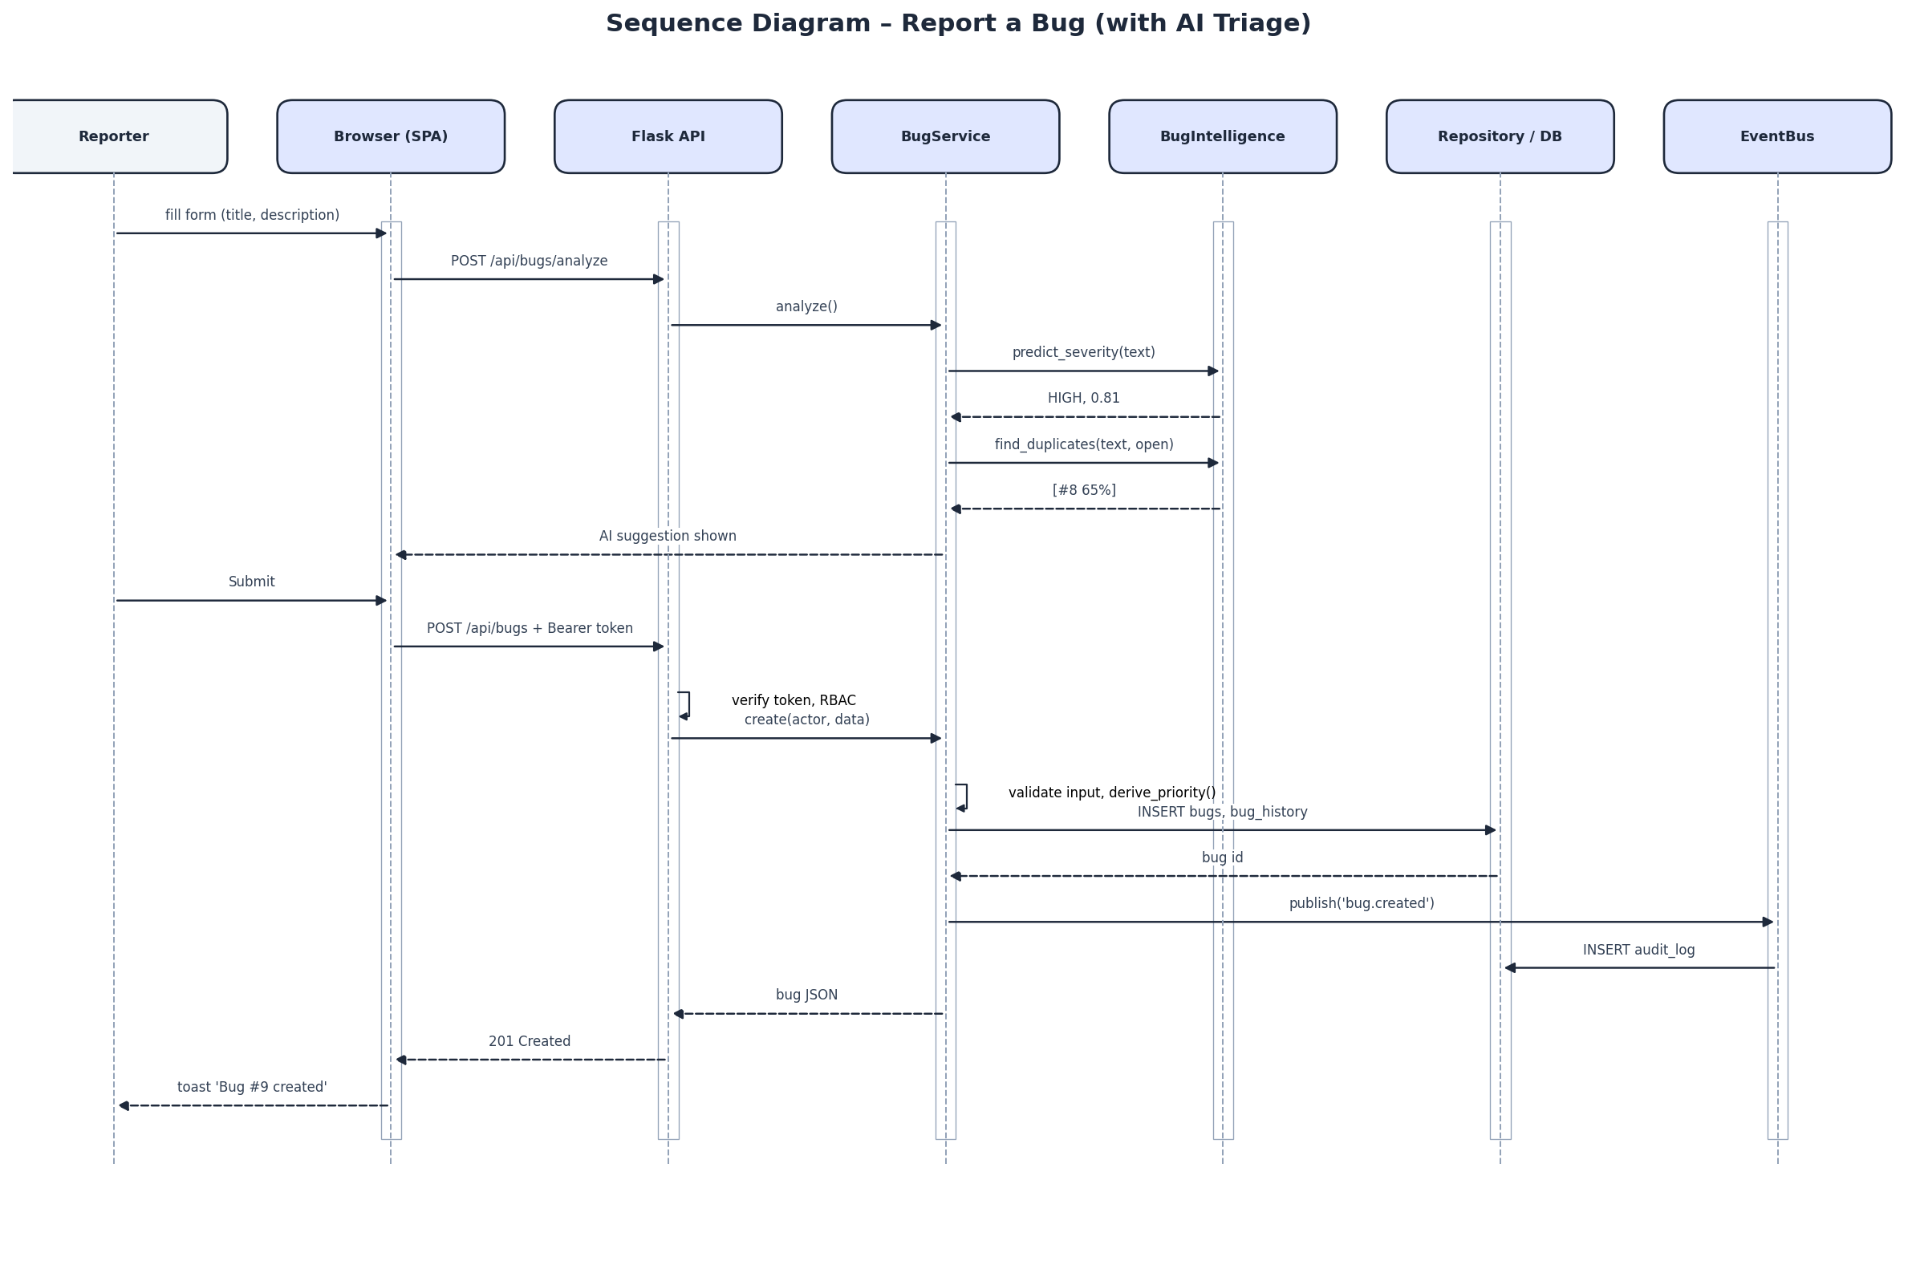
Figure 3 – Sequence diagram for reporting a bug

5.3 Activity Diagram
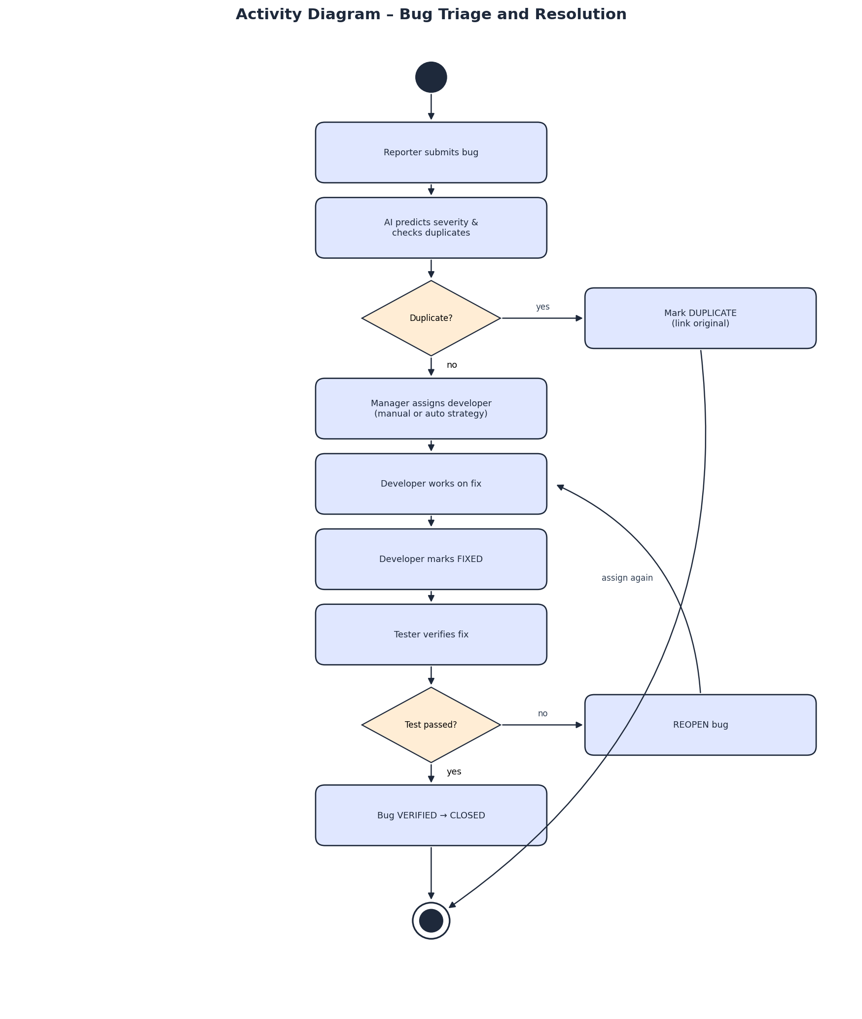
Figure 4 – Activity diagram: triage and resolution

5.4 State Machine Diagram
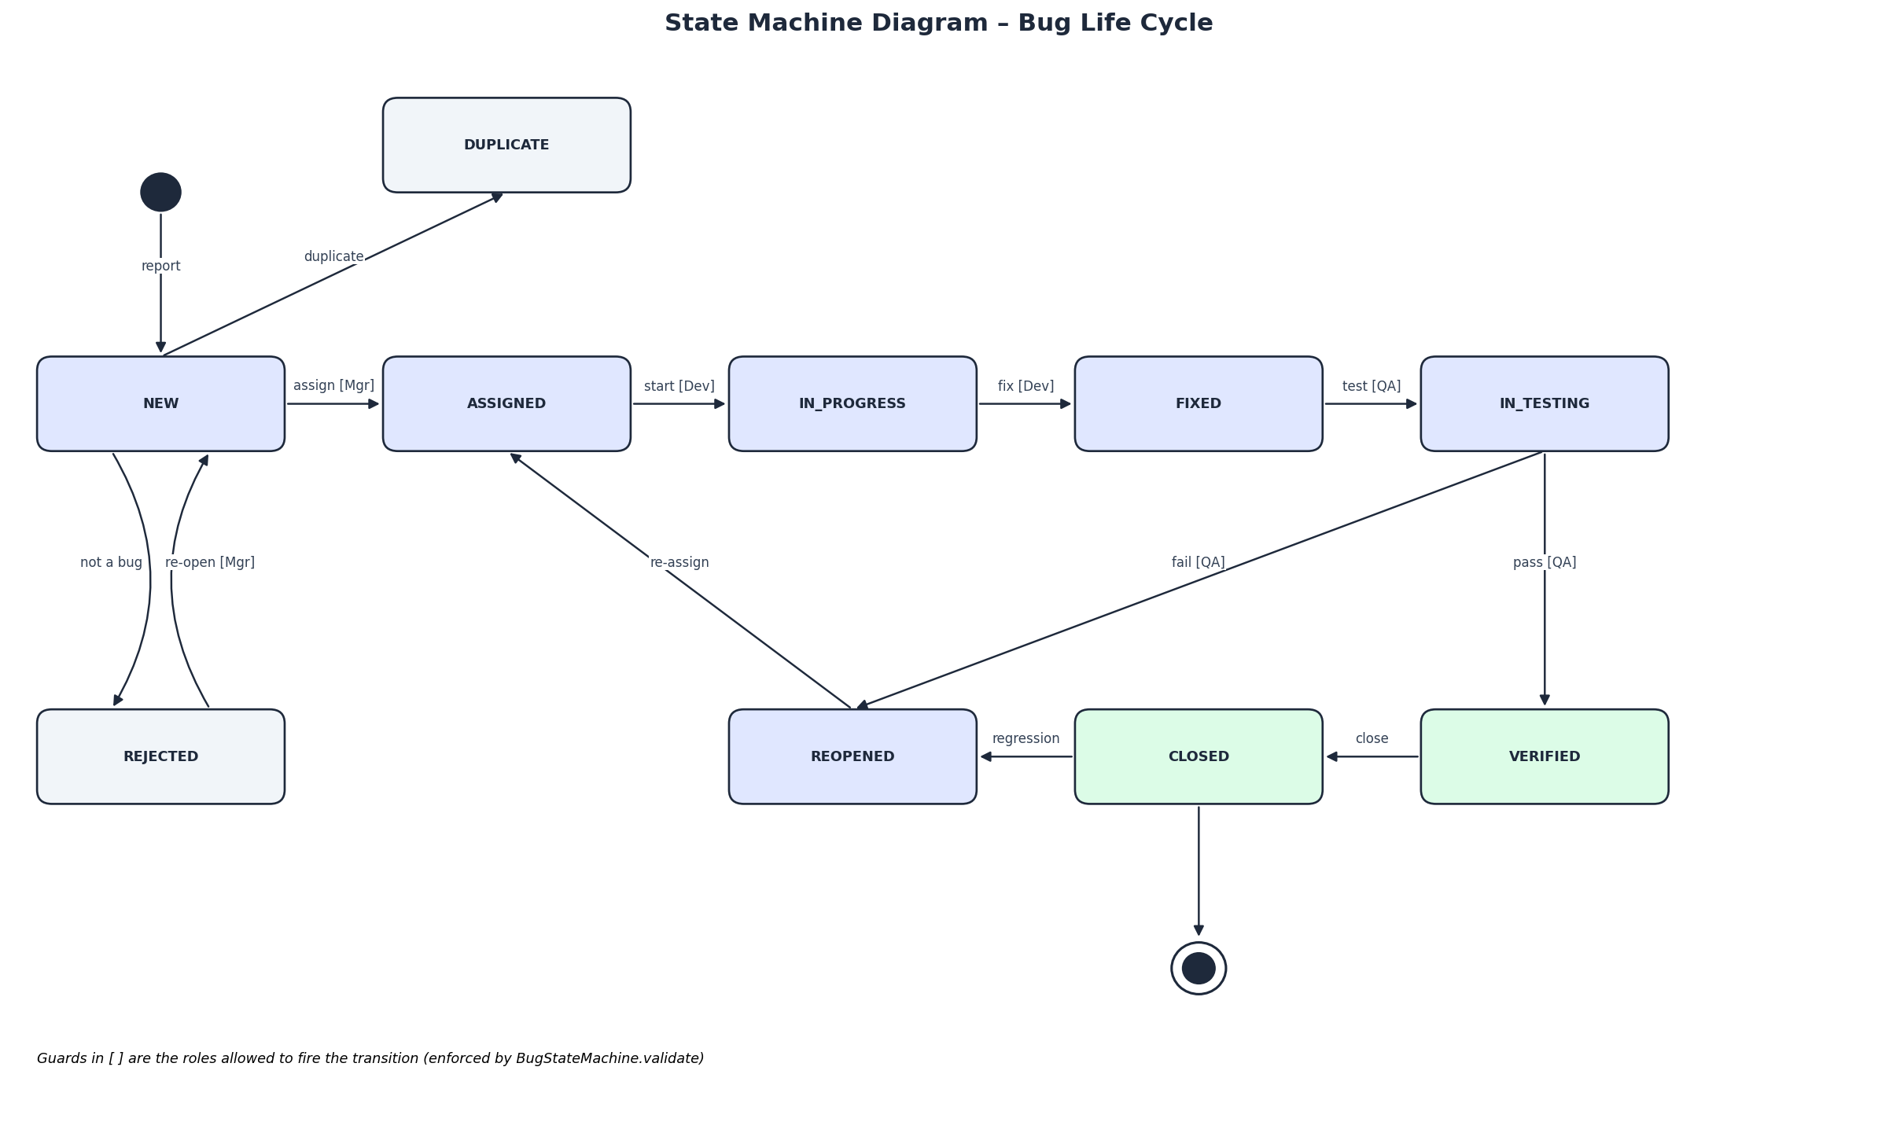
Figure 5 – Bug life-cycle state machine
From | To | Allowed roles
NEW | ASSIGNED / REJECTED / DUPLICATE | Manager, Admin (Tester for DUPLICATE)
ASSIGNED | IN_PROGRESS / REJECTED | Developer (assignee), Manager
IN_PROGRESS | FIXED | Developer
FIXED | IN_TESTING | Tester
IN_TESTING | VERIFIED / REOPENED | Tester
VERIFIED | CLOSED | Tester, Manager
CLOSED | REOPENED | Tester, Manager
REOPENED | ASSIGNED / IN_PROGRESS | Manager / Developer

5.5 Data Flow Diagram
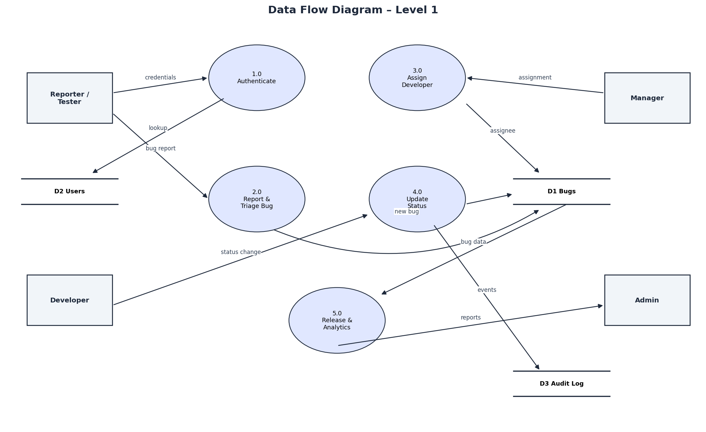
Figure 6 – Level-1 DFD

6. Software Architecture and Design

6.1 Architectural Style – Layered (3-tier, MVC-style)
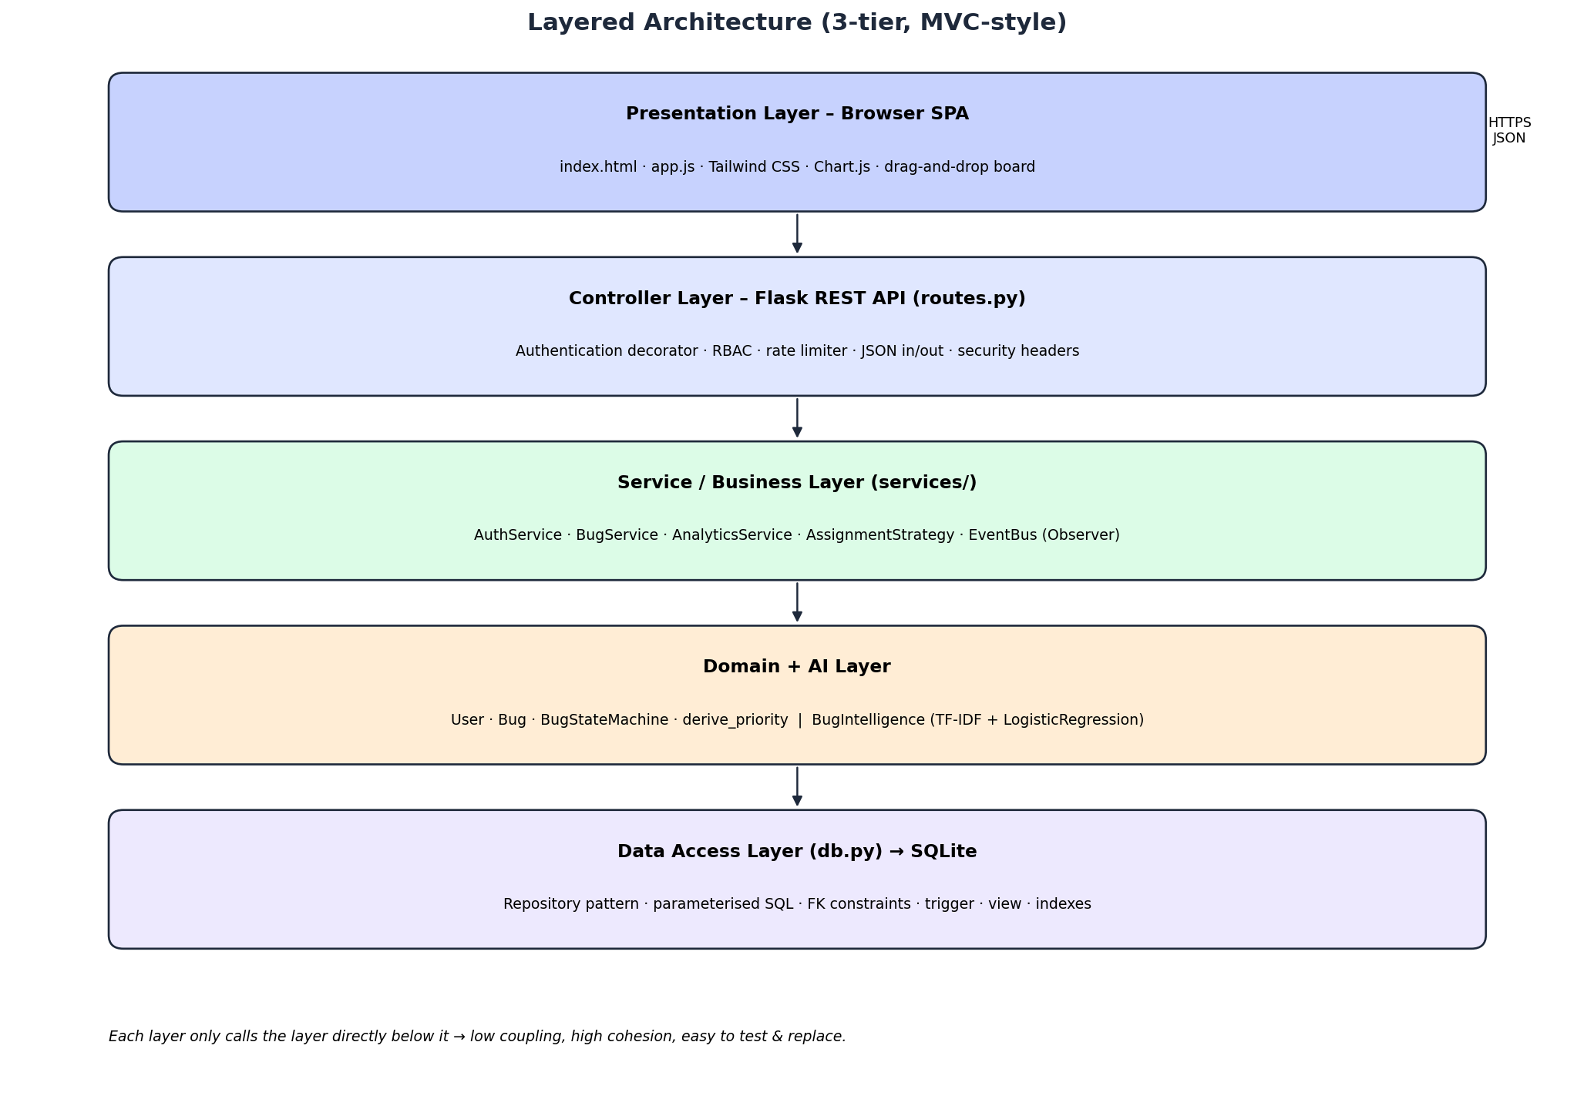
Figure 7 – Layered architecture
Justification: a layered architecture separates presentation, business logic and data access. Each layer can be tested independently (we unit-test the domain without a database), replaced independently (SQLite → PostgreSQL only touches db.py) and understood by new developers quickly. The front-end is a single-page application that talks to a stateless JSON REST API, which also allows a future mobile app to reuse the same back-end.

6.2 Module / Component Responsibilities
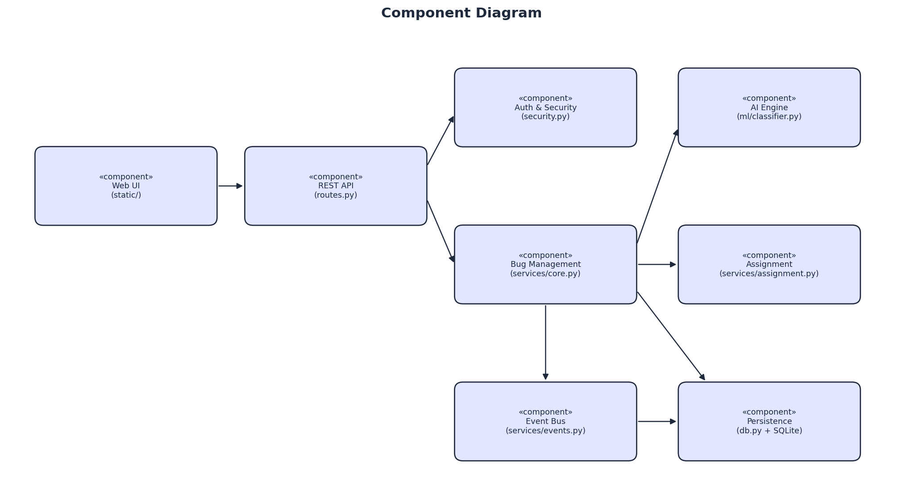
Figure 8 – Component diagram
Module | File | Responsibility
Web UI | static/index.html, app.js, style.css | Screens, forms, charts, Kanban board, XSS-safe rendering
REST API | routes.py | HTTP endpoints, authentication decorator, RBAC check, error mapping
Security | security.py | Hashing, password policy, tokens, rate limiter, security headers
Domain | domain.py | Entities, enums, state machine, priority rule, permission matrix
Services | services/core.py | Use-case logic: auth, bugs, analytics, release readiness
Assignment | services/assignment.py | Strategy pattern – least-loaded & skill-based algorithms
Events | services/events.py | Observer pattern – audit & notification listeners
AI Engine | ml/classifier.py | Severity classifier, duplicate detection, component guess
Persistence | db.py | Schema, repositories, parameterised SQL

6.3 Design Patterns Used
Pattern | Where | Why
Repository | db.py | Hides SQL from business logic; easy to swap database
Strategy | AssignmentStrategy | Interchangeable assignment algorithms (Open/Closed principle)
State (table-driven) | BugStateMachine | Central, testable life-cycle rules
Observer / Pub-Sub | EventBus | Audit log & notifications decoupled from services
Factory | create_app() | Builds configured app instances (prod, test with in-memory DB)
Facade / DI | Services class | Wires dependencies in one place, injects them into services
Decorator | @login_required | Cross-cutting authentication & authorisation

6.4 Design Principles
- SOLID: Single responsibility per module; Open/Closed via strategies; Liskov – both strategies substitutable; Interface segregation – small repository classes; Dependency inversion – services depend on abstractions.
- High cohesion, low coupling: each layer only calls the layer below it; events remove direct dependencies.
- DRY: generic Repository CRUD reused by all tables.
- Fail-safe defaults: self-registration can never grant privileged roles; unknown actions are denied.

6.5 Deployment
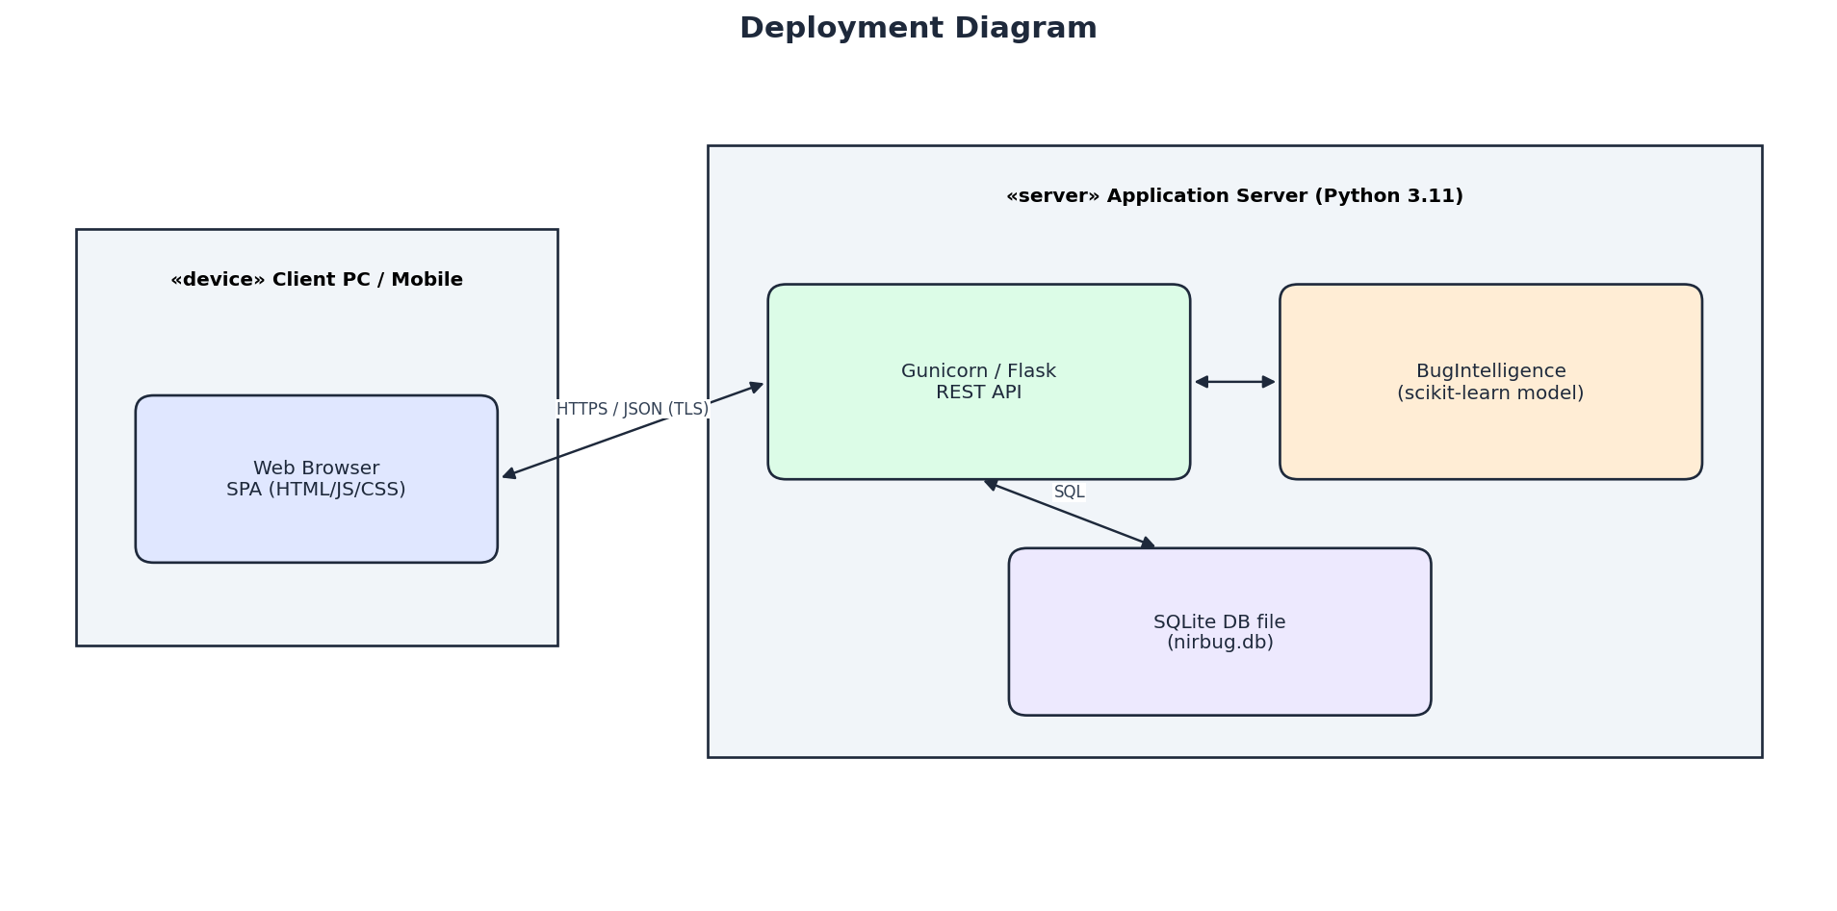
Figure 9 – Deployment diagram

7. Database Design (DBMS)
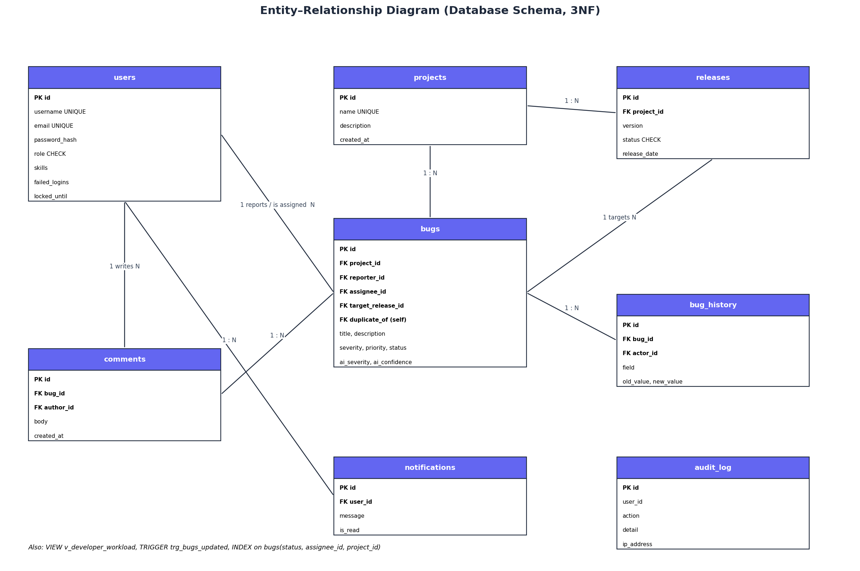
Figure 10 – ER diagram
The schema is in Third Normal Form: every non-key attribute depends only on the primary key (e.g. project name lives only in projects, not repeated in bugs). Relationships are enforced with FOREIGN KEY constraints, and domain rules with CHECK constraints (role, release status) and UNIQUE constraints (username, email, project name, (project, version)).
- Indexes: idx_bugs_status, idx_bugs_assignee, idx_bugs_project speed up the most frequent filters.
- Trigger: trg_bugs_updated automatically maintains bugs.updated_at.
- View: v_developer_workload aggregates open bugs and severity-weighted load per developer (used by auto-assignment).
- Self-relationship: bugs.duplicate_of references bugs.id.
- Transactions: each write is committed atomically; ON DELETE CASCADE keeps child rows consistent.

8. Implementation

8.1 Technology Stack
Layer | Technology | Reason
Front-end | HTML5, JavaScript (ES2020), Tailwind CSS, Chart.js, Lucide icons | Modern responsive UI without a build step
Back-end | Python 3.11, Flask 3 | Lightweight, readable, great for REST APIs
Database | SQLite 3 | Zero configuration, ACID, SQL standard
AI / ML | scikit-learn (TF-IDF, Logistic Regression, cosine similarity) | Industry-standard ML library
Security | werkzeug (PBKDF2), itsdangerous (HMAC tokens) | Well-audited primitives
Testing | pytest | Concise tests, fixtures, parametrisation
Docs | matplotlib, python-docx, python-pptx | Diagrams and documents generated from code

8.2 Project Structure
bugtracker/
app.py application factory, security headers
routes.py REST API (controller layer)
domain.py entities, enums, state machine, RBAC
db.py schema + repositories
security.py hashing, tokens, rate limiter
seed.py demo data
services/ core.py, assignment.py, events.py
ml/ classifier.py, training_data.py
static/ index.html, app.js, style.css
tests/ test_unit.py, test_integration.py, test_system.py
docs/ diagrams, screenshots, report & PPT generators

8.3 OOP Concepts Applied
- Encapsulation: Bug.transition() is the only way to change a Bug's status; it validates internally.
- Abstraction: AssignmentStrategy is an abstract base class (abc.ABC) with abstract method choose().
- Inheritance: LeastLoadedStrategy and SkillBasedStrategy inherit AssignmentStrategy; every XxxRepository inherits Repository.
- Polymorphism: BugService calls strategy.choose() without knowing which concrete strategy it is.
- Enumerations & data classes: Role, Severity, Status, Priority as Enum; User and Bug as @dataclass.

8.4 Key Algorithm – Skill-based Auto-assignment
For every developer d: score(d) = 10 × [bug.component ∈ d.skills] − load(d), where load(d) = Σ severity weight (CRITICAL 4, HIGH 3, MEDIUM 2, LOW 1) of d's open bugs. The developer with the highest score is chosen. This balances expertise and workload. Complexity: O(n) in the number of developers.

9. AI / Machine-Learning Module
- Problem: manual triage is slow and inconsistent; duplicates waste developer time.
- Severity classifier: text = title + description → TF-IDF features (word 1-2 grams + character 2-5 grams) → multinomial Logistic Regression → probability for each class. Output: predicted label + confidence.
- Hybrid rule layer: keywords such as 'crash', 'data loss', 'SQL injection' force CRITICAL (safety first).
- Duplicate detection: TF-IDF vectors of the new report and all open bugs of the project; cosine similarity ≥ 0.45 is shown as a possible duplicate (top 3).
- Component guess: keyword-based expert rules (auth, ui, api, database, payment, performance, notifications).
- Human-in-the-loop: the user can override severity; both the AI value and the final value are stored so the dashboard shows the AI/human agreement rate, which is used to monitor model quality in production.

9.1 Evaluation
Metric | Value
Training samples | 80
Validation | Stratified 5-fold cross-validation
ML-only accuracy | 0.438
Hybrid (rules + ML) accuracy | 0.45
Random baseline (4 classes) | 0.25

Discussion: with only 80 labelled examples the model is clearly better than random but not perfect, which is why it is used as a suggestion, not a decision. Accuracy is expected to improve as real bugs (with human-corrected labels) are added to the training set – this retraining is part of the maintenance plan (Section 15).

10. Security Design (Cyber-security)
Threat (STRIDE) | Mitigation in NirBug
Spoofing – stolen / guessed passwords | PBKDF2-SHA256 salted hashes, password policy, account lockout, login rate limit
Tampering – forged tokens | HMAC-signed, time-limited tokens (itsdangerous); signature checked on every request
Repudiation | Audit log with user, action, detail, IP and timestamp; bug_history for every field change
Information disclosure | Password hashes never returned by API; generic 'invalid username or password' message
Denial of service | Rate limiter; MAX_CONTENT_LENGTH 1 MB request size
Elevation of privilege | RBAC on every endpoint + in services; self-registration fixed to REPORTER role
SQL injection | Only parameterised queries (?) – verified by test IT-15
Cross-site scripting | Front-end escapes all server data (esc()); Content-Security-Policy header
Clickjacking / MIME sniffing | X-Frame-Options: DENY, X-Content-Type-Options: nosniff, Referrer-Policy

10.1 Networking Aspects
The client and server communicate over HTTP using a REST architecture with JSON payloads and standard status codes (200, 201, 400, 401, 403, 404, 409, 423, 429). Authentication is stateless (Bearer token in the Authorization header), so any number of server instances can run behind a load balancer. In production the API must be served over HTTPS (TLS) by a reverse proxy such as Nginx, with the WSGI server Gunicorn.

11. Software Testing

11.1 Test Strategy
We followed the testing pyramid: many fast unit tests, fewer integration tests and a set of black-box system tests through the HTTP API. All 63 automated tests are written with pytest and run with one command (python -m pytest). Techniques used: equivalence partitioning, boundary value analysis (priority rules, password length), state-transition testing (life cycle), negative / security testing.
Level | File | Count | What is tested
Unit | tests/test_unit.py | 35 | State machine, priority rule, RBAC, hashing, tokens, rate limiter, strategies, AI
Integration | tests/test_integration.py | 15 | Services + repositories + SQLite: workflow, history, observer, lockout
System | tests/test_system.py | 13 | Full HTTP API: auth, end-to-end life cycle, RBAC, XSS/SQLi, headers, releases

11.2 Selected Test Cases
ID | Description | Input | Expected | Result
UT-02 | Invalid transition | NEW → CLOSED | InvalidTransition raised | Pass
UT-07 | Priority boundary | HIGH + blocks release | P1 | Pass
UT-10 | Password hashing | 'Secret123' twice | Different salted hashes; verify OK | Pass
UT-12 | Token tampering | Modified token | Rejected (None) | Pass
UT-16 | Skill-based assignment | component = auth | Developer with auth skill | Pass
UT-22 | Duplicate detection | Similar login bug | Bug #1 returned, unrelated → none | Pass
IT-05 | Full life cycle | NEW…CLOSED | 7 history entries in order | Pass
IT-06 | Developer edits others' bug | dev_bob on chen's bug | 403 | Pass
IT-11 | Brute force | 5 wrong passwords | Account locked (423) | Pass
IT-12 | Privilege escalation | register role=ADMIN | Role stays REPORTER | Pass
IT-15 | SQL injection | ' OR 1=1; DROP TABLE bugs | No rows, table intact | Pass
ST-02 | No token | GET /api/bugs | 401 | Pass
ST-05 | End-to-end with reopen | 9 transitions by 3 roles | CLOSED, ≥ 10 history rows | Pass
ST-06 | RBAC | Reporter → /api/audit | 403 | Pass
ST-10 | Rate limit | 12 rapid logins | 429 returned | Pass
ST-11 | Release gate | Ship with open CRITICAL | 409, then 200 after resolution | Pass

11.3 Test Results
63 passed, 0 failed (python -m pytest -q). Manual exploratory testing of the UI was also performed on Chrome and Edge in light and dark mode at desktop and mobile widths.

12. Software Quality Assurance
Quality attribute (ISO/IEC 25010) | How it is achieved | How it is measured
Reliability | Validation in services, DB constraints, error handler returning JSON 4xx | Integration/system tests, no 500s in tests
Maintainability | Layered architecture, patterns, small modules, docstrings | Module size, test coverage of core logic
Security | See Section 10 | Security test cases (UT-10..14, IT-11/12/15, ST-02/06/08/09/10)
Usability | Consistent UI, colour-coded badges, AI hints, toasts, dark mode, responsive | Task: report a bug in ≤ 3 clicks
Performance | Indexes, SQL view, model trained once at start-up | API timing; analyze() < 50 ms
Functional suitability | Requirements traceability (below) | All FRs covered by tests

12.1 Requirements Traceability Matrix
Requirement | Design element | Test case(s)
FR-01 Register/login | AuthService, TokenManager | ST-03, UT-12
FR-02 RBAC | PERMISSIONS, @login_required | UT-08, ST-06
FR-04 AI severity | BugIntelligence.predict_severity | UT-19..21, UT-24
FR-05 Priority | derive_priority | UT-07
FR-06 Duplicates | find_duplicates | UT-22, ST-07
FR-07 Assignment | AssignmentStrategy | UT-15..18, IT-03/04
FR-08 Life cycle | BugStateMachine | UT-01..06, IT-05/07, ST-05
FR-09 Own bugs only | BugService.change_status | IT-06
FR-11 Notifications | NotificationListener | IT-08, ST-13
FR-12 Releases | release_readiness, ship | IT-10, ST-11
FR-13 Search | BugRepository.search | ST-12, IT-15
FR-15 Audit | AuditListener | IT-08

12.2 Quality Practices
- Coding standard: PEP 8, type hints, docstrings in every module.
- Version control with Git; feature branches and pull-request review between the two members.
- Definition of Done: code + tests passing + reviewed + documented.
- Peer code reviews and a final walkthrough before submission.

13. Project Planning and Management

13.1 Milestones
Milestone | Deliverable | Date
M0 | Project assigned, topic chosen | 31 Oct 2026
M1 | Approved SRS and use cases | 2 Nov 2026
M2 | Architecture, UML & DB design complete | 6 Nov 2026
M3 | Feature-complete prototype + tests | 12 Nov 2026
M4 | Final report, PPT, demo, submission | 15 Nov 2026

13.2 Schedule (Gantt Chart)
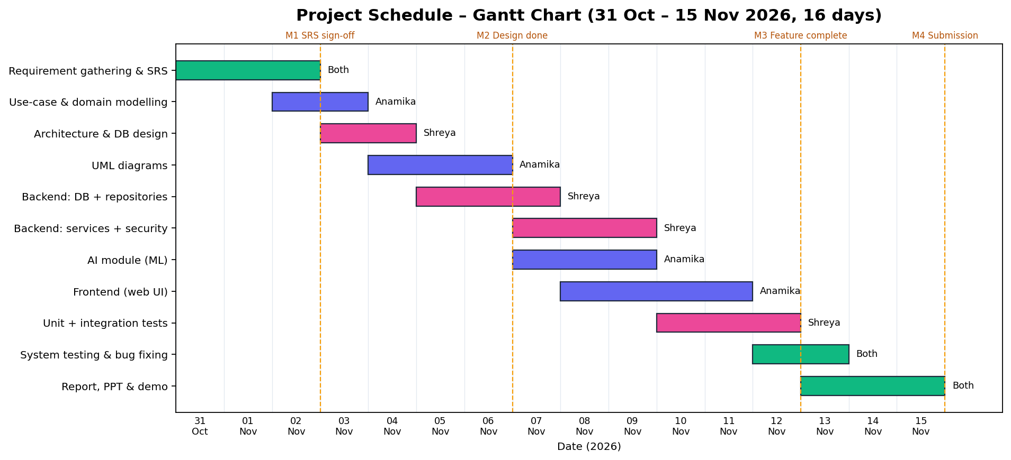
Figure 11 – Gantt chart

13.3 Work Breakdown and Responsibilities
Work package | Anamika Chauhan | Shreya Kumbar
Requirements & SRS | ✔ (lead) | ✔
UML diagrams | ✔
Architecture & DB design |  | ✔
Back-end (DB, services, API) |  | ✔
Security |  | ✔
AI / ML module | ✔
Front-end UI | ✔
Testing | ✔ (system) | ✔ (unit/integration)
Report & PPT | ✔ | ✔

13.4 Effort Estimation (COCOMO – Basic, Organic)
Size ≈ 2.2 KLOC (Python + JavaScript). Effort E = 2.4 × (2.2)^1.05 ≈ 5.6 person-months; Development time D = 2.5 × (5.6)^0.38 ≈ 4.8 months for a professional team. The estimate is higher than our 16-day schedule because students worked part-time on a reduced scope, reused open-source libraries heavily and generated documentation from code; the estimate is shown to demonstrate the technique.

14. Risk Management
Risk | Probability | Impact | Mitigation
Scope creep (too many features) | High | High | Fixed FR list; extra ideas moved to Future Scope
Low AI accuracy | Medium | Medium | Hybrid rules, human override, measure agreement
Team member unavailable | Medium | High | Shared Git repo, documented code, both know all modules
Security flaw | Low | High | Security checklist (STRIDE) and dedicated tests
Integration problems between UI and API | Medium | Medium | API contract defined early, system tests

15. Software Maintenance
Type | Example in NirBug
Corrective | Fix defects reported through NirBug itself (dog-fooding); regression tests added for every fix
Adaptive | Move from SQLite to PostgreSQL (only db.py changes); deploy in Docker / cloud
Perfective | Add e-mail/Slack notifications as a new EventBus listener; file attachments; Git commit linking
Preventive | Periodic dependency updates, retraining the ML model, refactoring, increasing test coverage

15.1 How the System Can Be Extended
- New assignment algorithm → create a subclass of AssignmentStrategy and register it in STRATEGIES.
- New notification channel → subscribe a new listener to the EventBus; no service code changes.
- New workflow state → add one entry to BugStateMachine.TRANSITIONS and the Status enum.
- Better AI → add labelled rows (exported from closed bugs with human-corrected severity) and retrain; the evaluate() method reports the new accuracy before deployment.
- Mobile app → reuse the same REST API.

15.2 Maintenance Process
Change requests are themselves logged as issues in NirBug, prioritised by the manager, implemented on a branch, tested by the automated suite (all tests must pass), reviewed, and released with a new version number (semantic versioning MAJOR.MINOR.PATCH). The audit log and bug history support impact analysis.

16. Conclusion and Future Scope
NirBug meets all the required features – bug reporting, severity classification, developer assignment, version tracking, testing status and release management – and adds AI-assisted triage, a Kanban board and analytics. More importantly, it was produced with a systematic SDLC: requirements were specified and traced, the system was modelled with UML, designed with a layered architecture and design patterns, implemented with OOP, secured with defence-in-depth, verified with 63 automated tests, and planned with milestones, a Gantt chart and risk analysis.
Future scope: e-mail/Slack integration, Git and CI/CD integration (auto-close bugs from commit messages), attachments and screenshots, SLA timers, transformer-based NLP models, and multi-tenant cloud deployment.

Appendix A – How to Run
pip install -r requirements.txt
python -m bugtracker.app # open http://127.0.0.1:5000
python -m pytest -v # run all tests
python docs/generate_diagrams.py # regenerate diagrams
python docs/build_report.py && python docs/build_ppt.py
Demo accounts: admin, manager, dev_alice, dev_bob, dev_chen, tester, reporter – password Demo@1234.

Appendix B – REST API Reference
Method | Endpoint | Role | Purpose
POST | /api/auth/register | public | Create reporter account
POST | /api/auth/login | public | Get token
GET | /api/auth/me | any | Current user
GET/POST | /api/users | any / admin | List / create users
GET/POST | /api/projects | any / manager | List / create projects
POST | /api/projects/{id}/releases | manager | Create release
GET | /api/releases/{id}/readiness | any | Release readiness
POST | /api/releases/{id}/ship | manager | Ship release
GET | /api/bugs?status&severity&project_id&q&mine | any | Search bugs
POST | /api/bugs/analyze | any | AI preview
POST | /api/bugs | any | Report bug
GET/PATCH | /api/bugs/{id} | any / mgr+reporter | Detail / edit
POST | /api/bugs/{id}/assign | manager | Assign (manual/auto)
POST | /api/bugs/{id}/status | by state machine | Change status
POST | /api/bugs/{id}/comments | any | Comment
GET | /api/dashboard | any | Analytics
GET | /api/audit | manager | Audit log
GET | /api/notifications | any | Notifications

