OBJECT-ORIENTED METHODOLOGIES (OOM)
Course Project Report
ArogyaNova
An Intelligent, Object-Oriented Prescription Management System
Submitted by
Shreya Kumbar — IIT205178
Anamika Chauhan — IIT2025151
Soumili Ghosh — IIT2025163

Academic Year 2026–27

Abstract
Paper prescriptions are easy to lose, hard to read and impossible to check automatically for dangerous drug combinations. Patients also forget doses, and doctors rarely learn whether a treatment was actually followed. ArogyaNova is a full-stack web application that digitises the complete prescription lifecycle: a doctor drafts a prescription, screens it for drug–drug interactions, finalises it, and the system then generates a medication schedule that the patient follows and logs, while pharmacists verify and administrators oversee the platform.
The project was built using Object-Oriented Analysis and Design (OOAD). Requirements were captured as use cases, the domain was modelled as classes with UML, and the design was implemented in Python (FastAPI) and TypeScript (React) with a strict layered architecture. All four pillars of OOP — encapsulation, abstraction, inheritance and polymorphism — appear in real, tested business code, together with composition, generics, SOLID principles and design patterns such as Repository, Strategy, State, Observer-style notification and Dependency Injection.
Beyond core OOM, the project integrates Database Management Systems (a normalised 3NF relational schema with ACID transactions through an ORM), Computer Networks (a REST client–server design over HTTP/TCP with CORS), Cybersecurity (Argon2id hashing, JWT in HttpOnly cookies, role-based access control, rate limiting and security headers) and AI (a rule-based drug-interaction checker and a Tesseract OCR provider). It ships with a graphical user interface with light and dark themes and an automated test suite of 54 passing tests.
Keywords: OOAD, UML, encapsulation, polymorphism, SOLID, design patterns, FastAPI, React, RBAC, drug-interaction checking.

Table of Contents
Abstract
Table of Contents
1. Introduction
1.1 Background
1.2 Problem Statement
1.3 Objectives
1.4 Scope
1.5 Technology Stack
2. Requirement Analysis
2.1 Actors
2.2 Functional Requirements
2.3 Non-Functional Requirements
3. Object-Oriented Methodology
3.1 Phases Followed
3.2 Why an Object-Oriented Approach
4. System Architecture
5. UML Modelling
5.1 Use Case Diagram
5.2 Class Diagram — Domain Model
5.3 Class Diagram — Repository and Service Layer
5.4 Sequence Diagram
5.5 State Machine Diagram
5.6 Activity Diagram
6. OOP Concepts and Where They Are Used
6.1 Encapsulation
6.2 Abstraction
6.3 Inheritance
6.4 Polymorphism
6.5 Composition, Aggregation and Association
6.6 Generics, Enums and Data Classes
7. Design Principles and Design Patterns
7.1 SOLID Principles
7.2 Design Patterns
8. Advanced Concepts I — Database Management System
8.1 Normalisation
8.2 Integrity and Transactions
8.3 Sample Query (generated by the ORM)
9. Advanced Concepts II — Computer Networks
10. Advanced Concepts III — Cybersecurity
11. Advanced Concepts IV — Artificial Intelligence and Analytics
11.1 Drug–Drug Interaction Checker
11.2 Prescription OCR
11.3 Adherence Analytics
12. Graphical User Interface
13. Testing
14. Conclusion and Future Scope
14.1 Conclusion
14.2 Future Scope
References

(If page numbers are missing, right-click the table in Word and choose Update Field.)

1. Introduction

1.1 Background
A prescription is a legal, clinical and logistical document at the same time. In many clinics it is still handwritten, which leads to transcription errors, illegible dosages, lost records and no protection against harmful drug combinations. After the patient leaves, there is no reliable way to know whether the medicines were taken as directed.

1.2 Problem Statement
Design and implement a secure, role-aware system that manages the full prescription lifecycle — creation, safety checking, issuing, dispensing review, scheduled intake and adherence tracking — using object-oriented methodologies, so that the business rules of a prescription are enforced by the software itself rather than by user discipline.

1.3 Objectives
- Model the clinical domain (users, prescriptions, medications, schedules) with well-encapsulated classes.
- Use UML (use case, class, sequence, state, activity, ER and deployment diagrams) to analyse and document the system.
- Demonstrate every core OOP concept in working code, and apply SOLID principles and recognised design patterns.
- Provide a usable graphical interface for four roles: Doctor, Patient, Pharmacist and Administrator.
- Integrate DBMS, computer-networking, cybersecurity and AI concepts into one coherent product.
- Verify behaviour with automated unit tests.

1.4 Scope
The system covers authentication, user and role management, a medication catalogue, prescription authoring with line items, a drug-interaction safety check, prescription OCR, automatic schedule generation, dose logging, notifications and analytics. Billing, insurance and live integration with pharmacy inventory are out of scope.

1.5 Technology Stack
Table 1: Technology stack
Layer | Technology | Why it was chosen
GUI (frontend) | React 19, TypeScript, Vite, Tailwind CSS, Recharts | Component-based, typed, fast development server, charts for analytics
API (backend) | Python 3.11, FastAPI, Uvicorn (ASGI) | Asynchronous, type-hinted, automatic OpenAPI docs
Validation | Pydantic v2 schemas | Declarative data contracts between layers
Persistence | SQLAlchemy 2.0 (async ORM), SQLite / PostgreSQL, Alembic | Object-relational mapping, portable SQL, schema migrations
Security | argon2-cffi, python-jose (JWT), SlowAPI | Modern password hashing, stateless auth tokens, rate limiting
AI | Rule-based interaction engine, pytesseract OCR | Explainable clinical checks, offline text extraction
Testing | pytest, pytest-asyncio | Unit tests for domain, repositories and RBAC

2. Requirement Analysis

2.1 Actors
Table 2: System actors
Actor | Description | Key goals
Doctor | Licensed prescriber | Create, check, finalise and cancel prescriptions; view patients
Patient | Receiver of care | View prescriptions, follow schedule, log doses
Pharmacist | Dispensing professional | Review and verify prescriptions, screen interactions
Administrator | System owner | Manage users and roles, view analytics and audit logs

2.2 Functional Requirements
Table 3: Functional requirements
ID | Requirement
FR-1 | Users register and log in; the system issues a signed session token.
FR-2 | Each role sees only the screens and data it is permitted to access.
FR-3 | A doctor creates a draft prescription for a patient with one or more medication items.
FR-4 | Items can be added or removed only while the prescription is a draft.
FR-5 | The doctor can run an AI drug-interaction check on the selected medicines.
FR-6 | Finalising a prescription requires at least one item and generates a medication schedule.
FR-7 | Prescriptions can be cancelled with a reason; completed or expired ones cannot change.
FR-8 | Patients log each scheduled dose as taken or skipped; adherence is computed.
FR-9 | Users receive in-app notifications about prescription events.
FR-10 | Administrators manage users and view analytics; reports can be exported as CSV.

2.3 Non-Functional Requirements
- Security: passwords never stored in plain text; every API call authenticated and authorised.
- Maintainability: layered architecture, single-responsibility classes, automated tests.
- Portability: runs with zero configuration on SQLite, or on PostgreSQL via Docker.
- Usability: responsive GUI with light and dark themes and one-click demo logins.
- Performance: asynchronous I/O end to end; paginated list endpoints.

3. Object-Oriented Methodology
Object-oriented methodology views a system as a collection of collaborating objects, each combining data with the behaviour that operates on that data. The project followed the Object-Oriented Analysis and Design (OOAD) process, which unifies ideas from Booch, Rumbaugh's Object Modelling Technique (OMT) and Jacobson's use-case driven Objectory approach — the same ideas later merged into UML and the Unified Process.

3.1 Phases Followed
Table 4: OOAD phases
Phase | Activity in this project | Artefact produced
Inception / Analysis | Identified actors and use cases from the clinical workflow | Use case diagram, requirement tables
Domain modelling | Found nouns (Prescription, Medication, Doctor…) and their responsibilities | Class diagram, ER diagram
Dynamic modelling | Traced how objects collaborate per use case; modelled lifecycle states | Sequence, state and activity diagrams
Design | Assigned layers, applied SOLID and patterns, defined interfaces | Architecture & repository diagrams
Implementation | Coded domain classes first, then services, repositories, API and GUI | Python and TypeScript source
Testing & deployment | Unit tests for domain rules and RBAC; Docker deployment | 54 passing tests, deployment diagram

3.2 Why an Object-Oriented Approach
A prescription has rules that must always hold — for example, an issued prescription must never be silently edited. In a procedural design these checks are scattered across every screen that touches the data. In an object-oriented design the rule lives inside the Prescription class, which is the only thing allowed to change its own status. This is the central reason the project uses OOM: correctness is guaranteed by the structure of the code, not by remembering to call a validation function.

4. System Architecture
ArogyaNova uses a clean layered architecture. Each layer depends only on the layer beneath it, and the domain layer depends on nothing external. This makes the business rules testable without a database or web server.
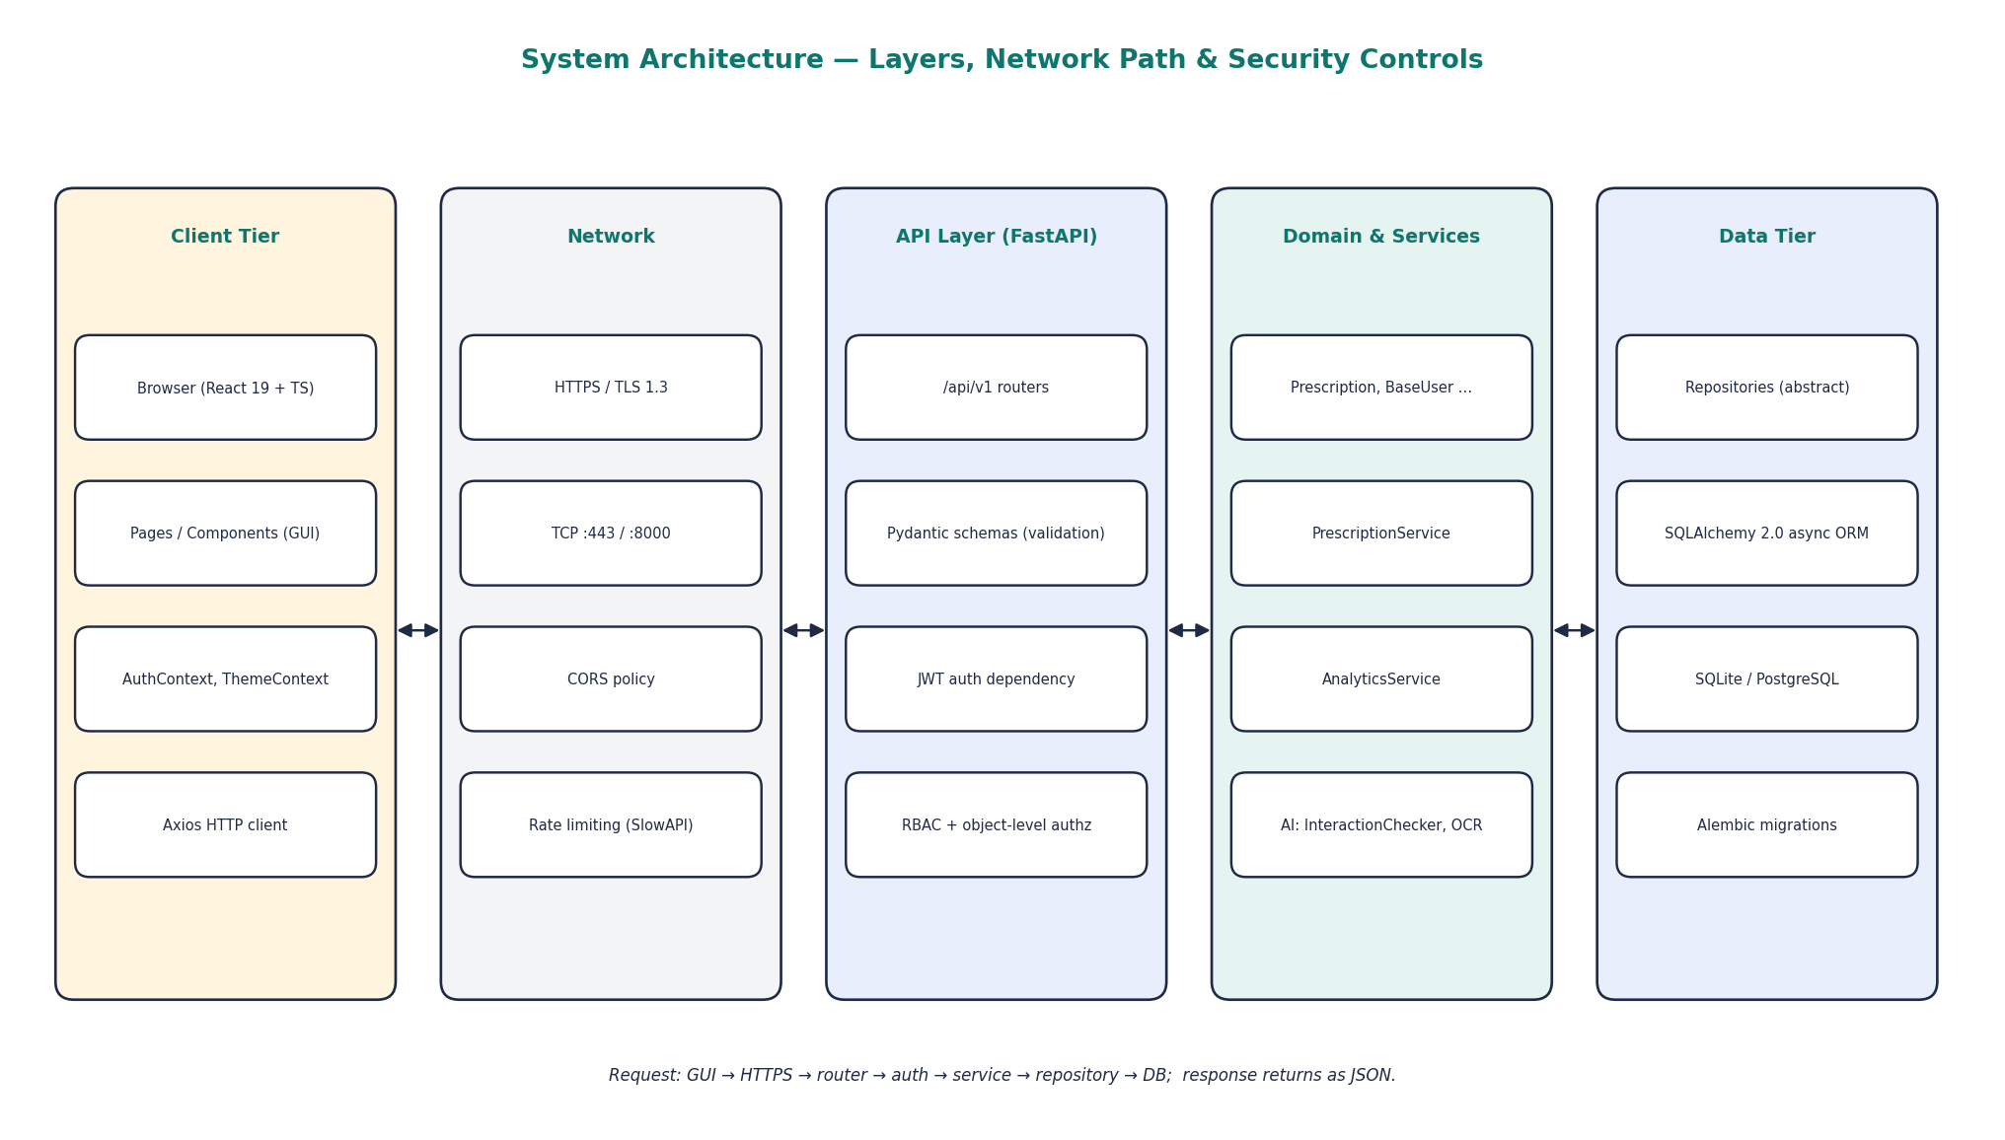
Figure 1: Layered architecture and request path
Table 5: Layers and their responsibilities
Layer | Folder | Responsibility
Presentation (GUI) | frontend/src | Pages, components, contexts (auth, theme), HTTP service classes
API / Controller | backend/app/api/v1 | HTTP routing, request parsing, response formatting
Schemas | backend/app/schemas | Pydantic data-transfer objects and validation
Services | backend/app/services | Application workflows (finalise, cancel, analytics)
Domain | backend/app/domain | Pure business objects and rules: users, prescription, AI, notifications
Repositories | backend/app/repositories | Abstract data-access contracts and SQLAlchemy implementations
Persistence | backend/app/models, db | ORM models, database engine, seed data
Security | backend/app/security | Password hashing, JWT handling, RBAC dependencies

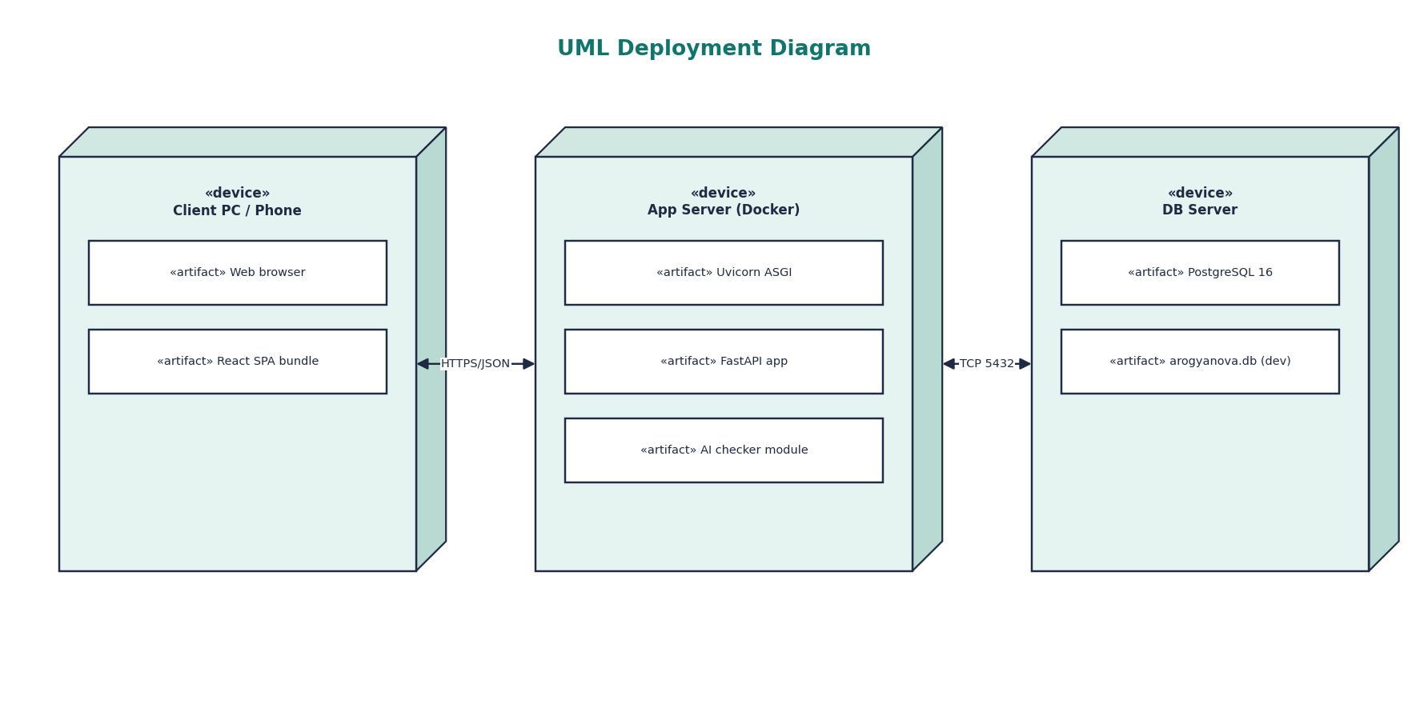
Figure 2: UML deployment diagram

5. UML Modelling

5.1 Use Case Diagram
The use case diagram captures the functional view from the four actors' perspective. «include» shows that finalising always sends a notification; «extend» shows that the AI interaction check optionally extends finalisation.
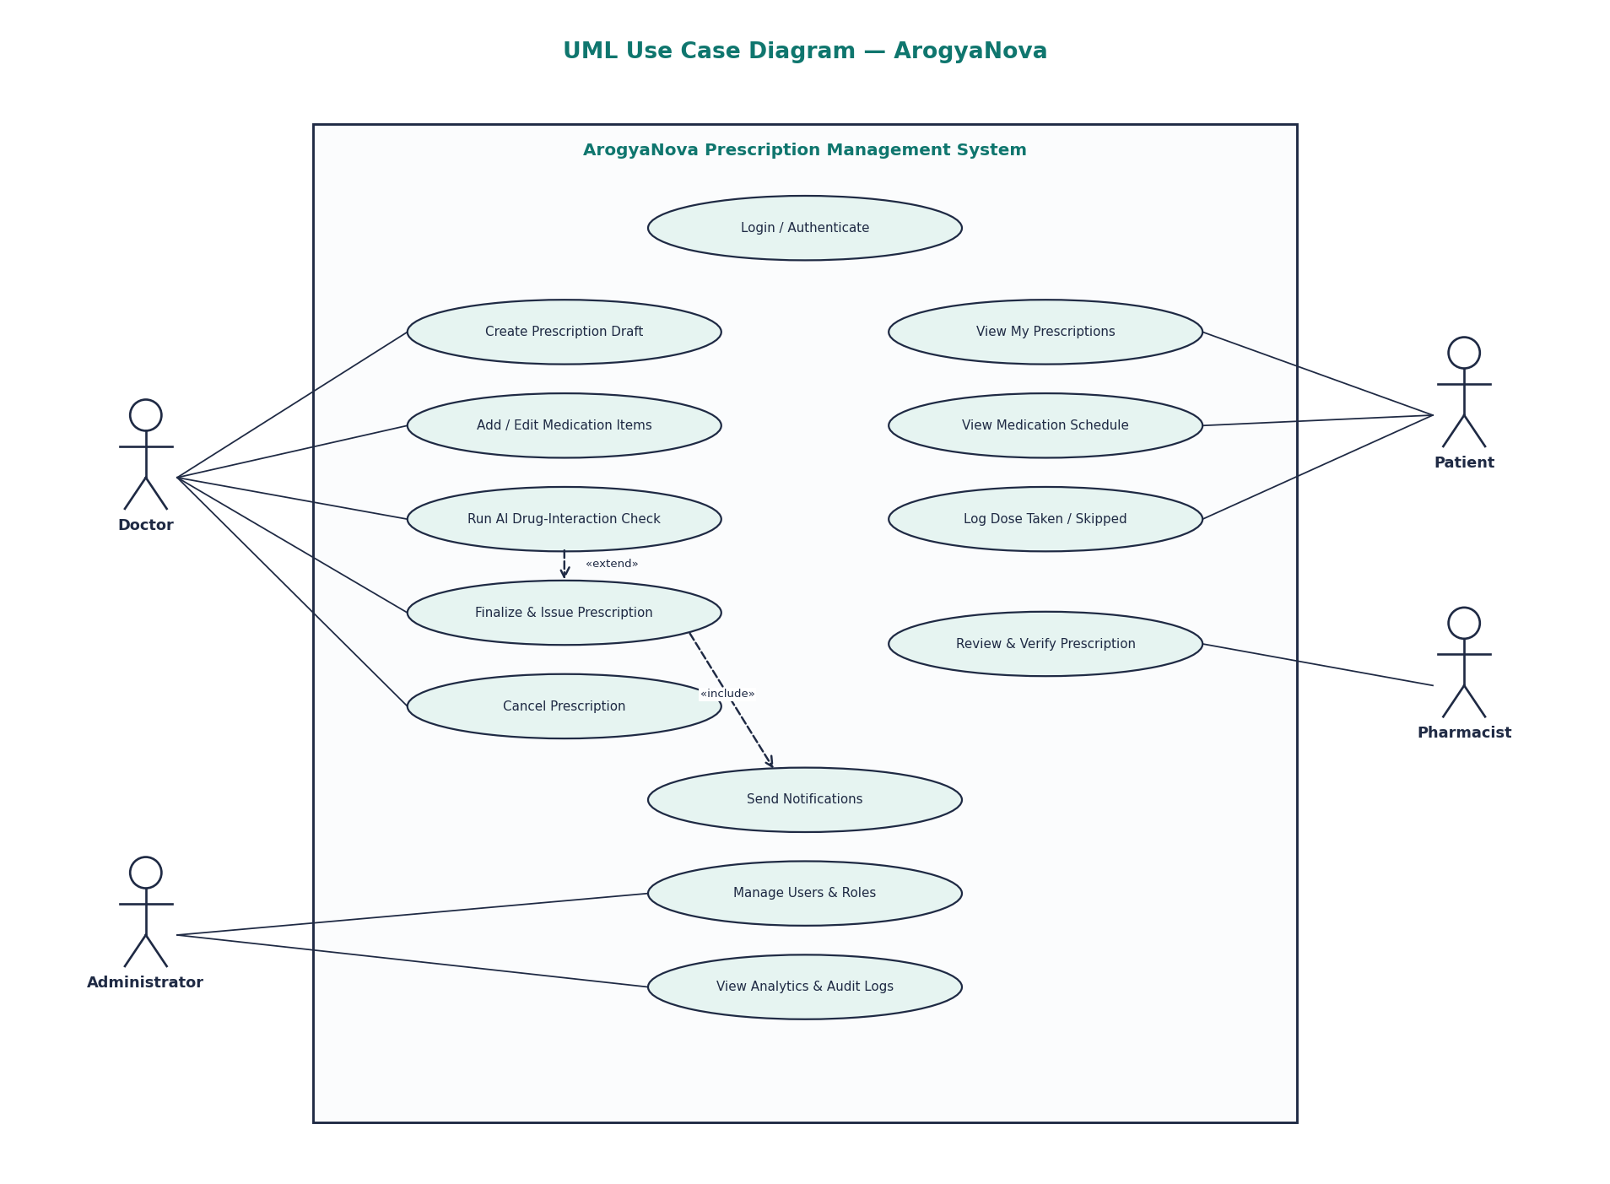
Figure 3: Use case diagram

5.2 Class Diagram — Domain Model
The domain class diagram is the heart of the design. BaseUser is an abstract class specialised by four roles (generalisation). Prescription owns its PrescriptionItem objects (composition — items cannot exist without their prescription), and each item references a Medication from the catalogue (association). The AI and notification capabilities are expressed as interfaces with several interchangeable implementations.
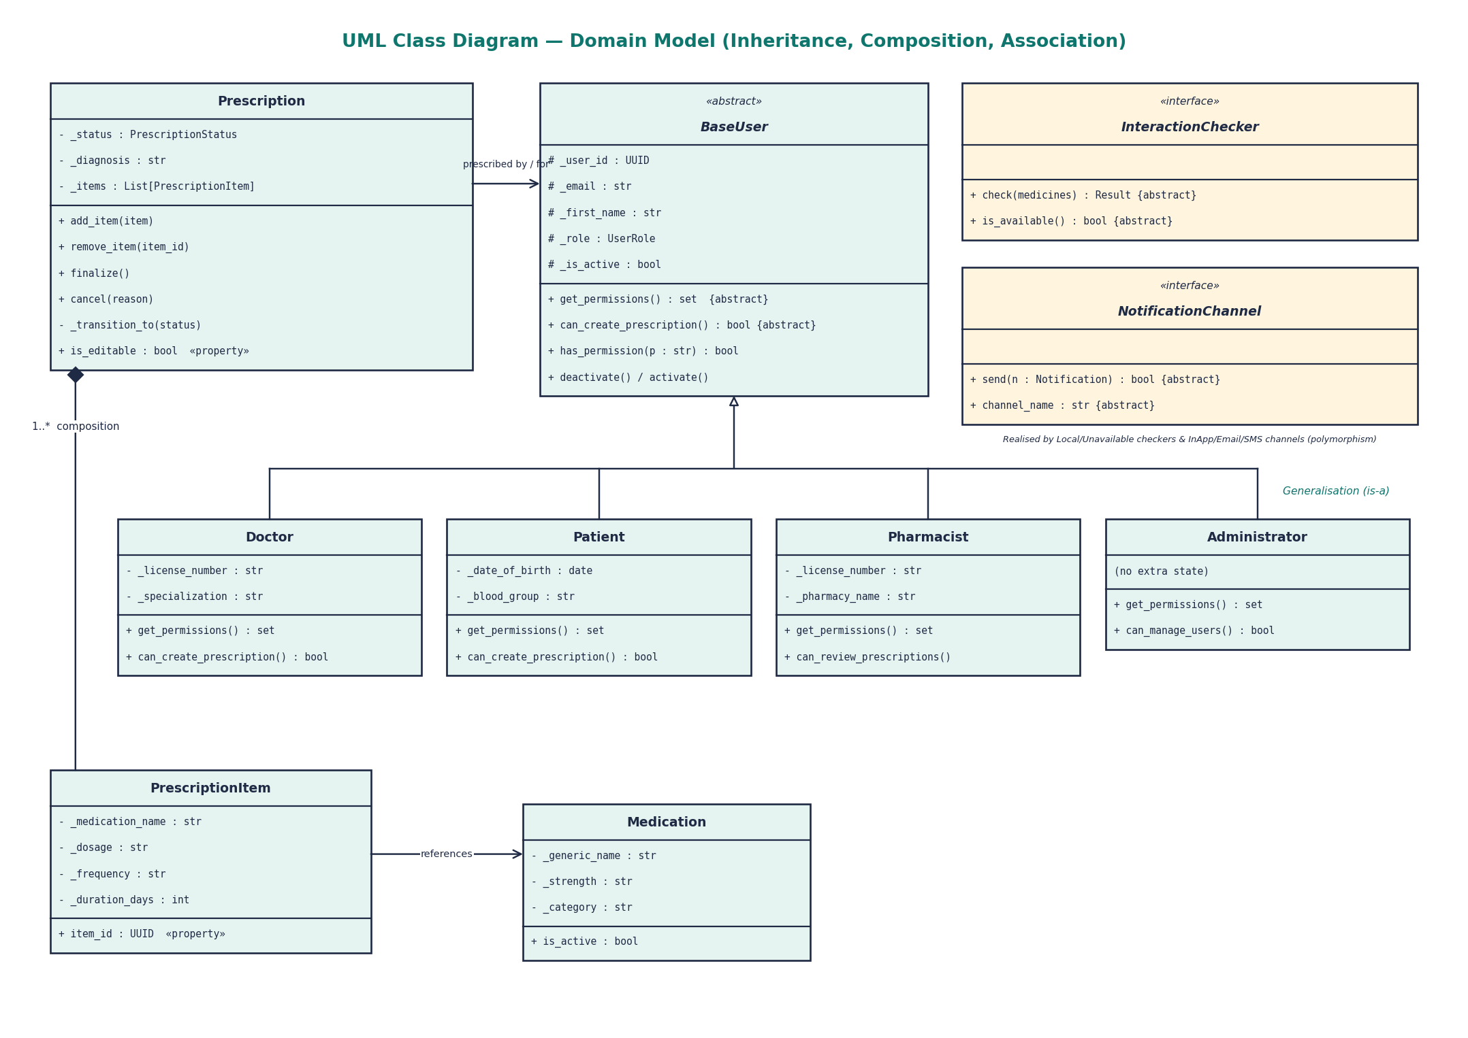
Figure 4: Domain class diagram

5.3 Class Diagram — Repository and Service Layer
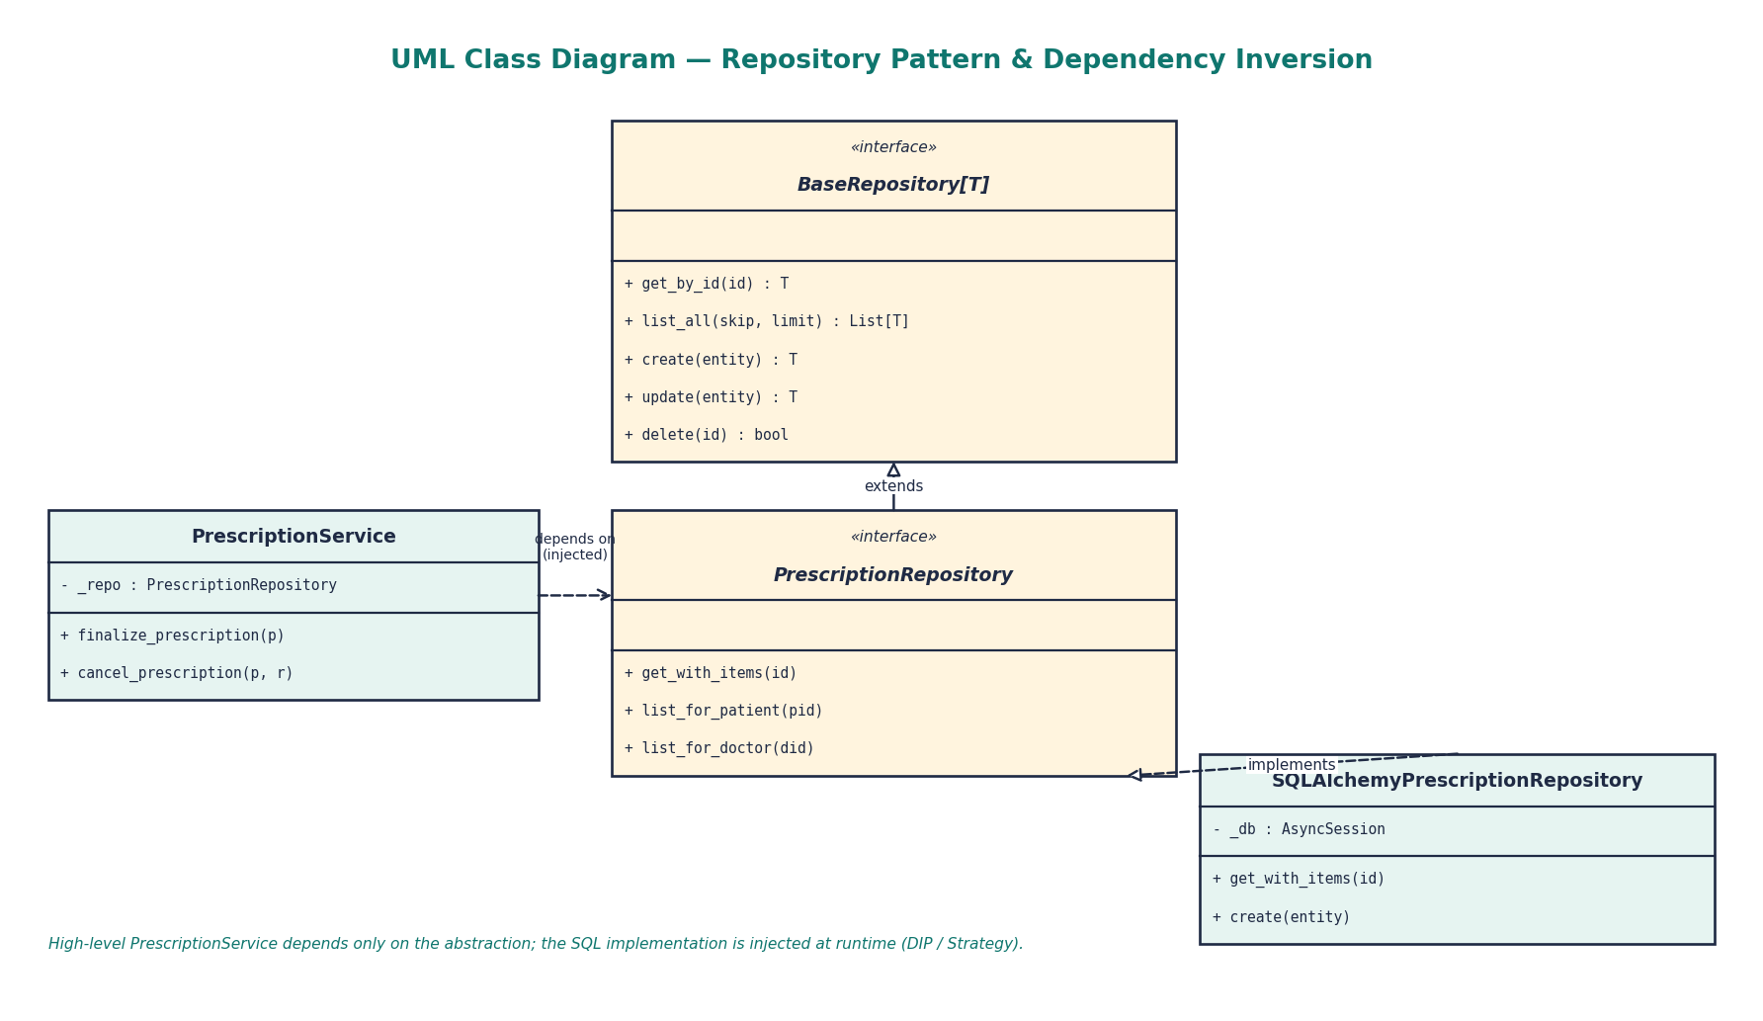
Figure 5: Repository pattern and dependency inversion

5.4 Sequence Diagram
The sequence diagram shows the message flow when a doctor finalises a prescription — from the GUI, across the network to the API, through authentication, the AI checker, the service, the repository and the database, and finally to the notification service.
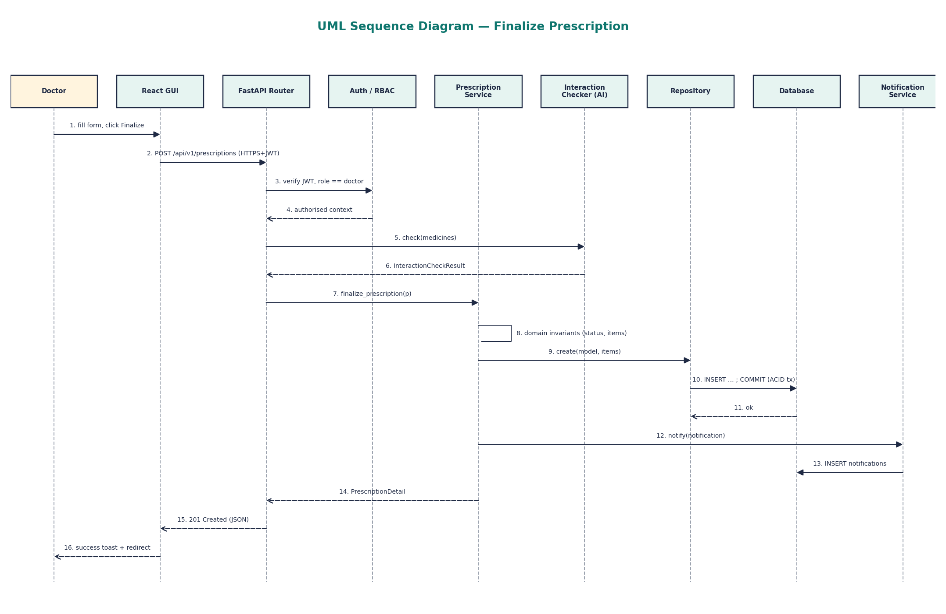
Figure 6: Sequence diagram: finalise prescription

5.5 State Machine Diagram
A prescription moves through five states. The allowed transitions are stored in a class-level table, _VALID_TRANSITIONS, and checked by the private method _transition_to(). Any illegal move raises an error, so the diagram is enforced by code rather than just documented.
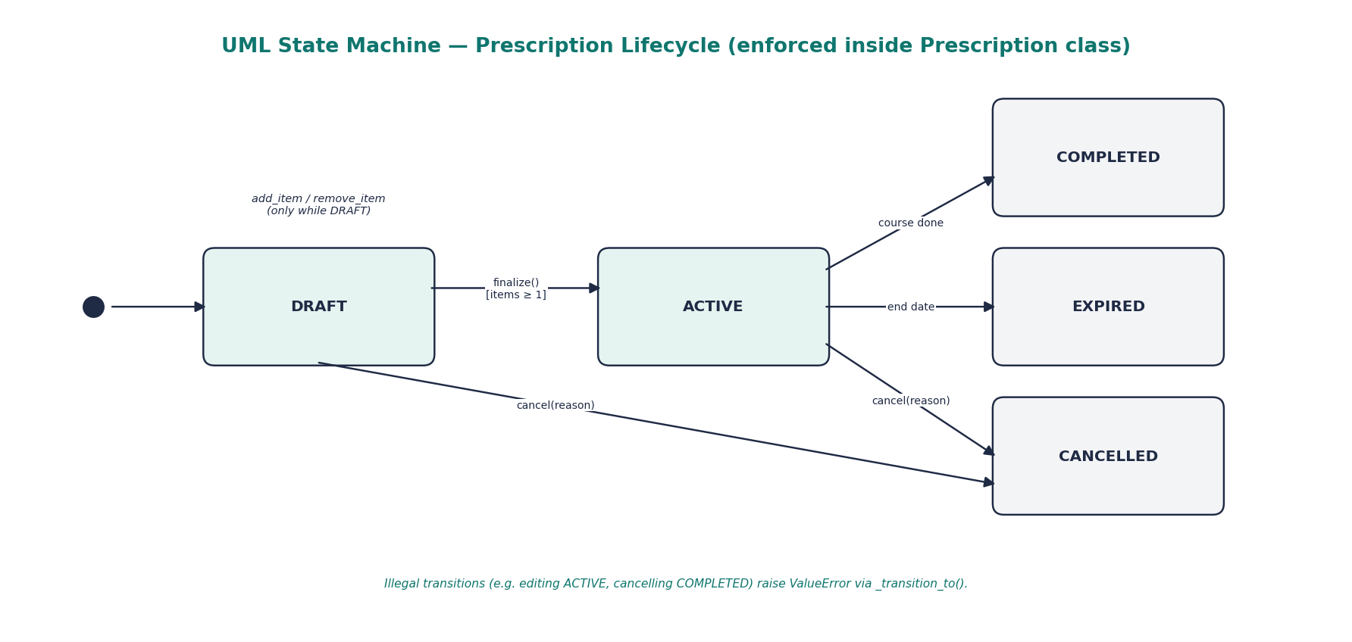
Figure 7: Prescription state machine

5.6 Activity Diagram
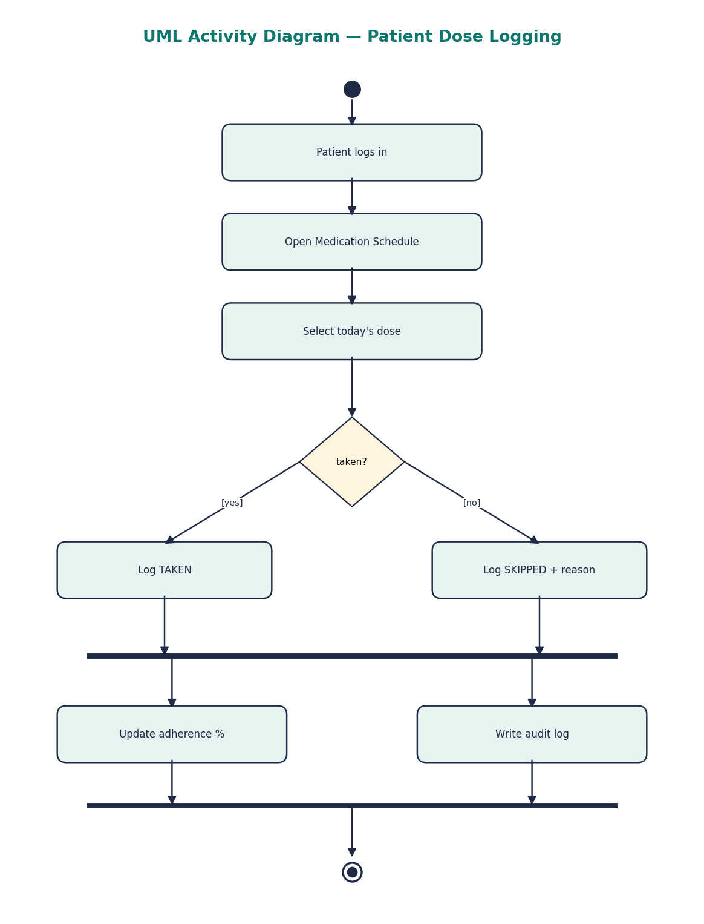
Figure 8: Activity diagram: patient logs a dose

6. OOP Concepts and Where They Are Used
This chapter maps each object-oriented concept to the exact class and file where it is implemented. All file paths are relative to arogyanova/backend/app unless stated.
Table 6: OOP concept map
Concept | Where in the code | How it is used
Class & Object | domain/prescription.py, domain/users.py | Prescription, PrescriptionItem, Doctor, Patient… are instantiated per record
Encapsulation | Prescription, BaseUser | Private _ attributes, read-only @property accessors, controlled mutators
Abstraction | BaseUser, BaseRepository, InteractionChecker, OCRProvider, NotificationChannel | ABC classes with @abstractmethod define what, not how
Inheritance | Doctor / Patient / Pharmacist / Administrator ← BaseUser | Shared identity fields reused through super().__init__()
Polymorphism (overriding) | get_permissions(), can_create_prescription(), send(), check() | Same call, different behaviour per subclass at runtime
Composition | Prescription ◆— PrescriptionItem; NotificationService ◆— channels | Whole owns parts; lifetime bound to the owner
Association | Prescription → Patient, Doctor; Item → Medication | Objects reference each other by identity
Generics | BaseRepository(ABC, Generic[T]) | One typed CRUD contract reused for every entity
Enumerations | UserRole, PrescriptionStatus, RouteOfAdministration, InteractionSeverity | Type-safe closed sets of values
Data classes | Notification (frozen), DrugInteraction, OCRResult | Immutable value objects with auto-generated methods
Magic methods | __repr__, __post_init__ | Readable debugging output and post-construction validation
Exception handling | _transition_to(), add_item(), FastAPI handlers | Invalid operations raise errors translated to HTTP 4xx
Interfaces (TypeScript) | frontend/src/types/index.ts | Typed contracts for API data on the GUI side

6.1 Encapsulation
Encapsulation bundles data with the methods that protect it. In Prescription, every attribute is private by convention (leading underscore). Outside code can read the status through a property but cannot assign it; the only way to change state is through intention-revealing methods that enforce the rules. The items property even returns a defensive copy so callers cannot modify the internal list.
class Prescription:
@property
def status(self) -> PrescriptionStatus:
return self._status # read-only

@property
def items(self) -> list[PrescriptionItem]:
return list(self._items) # defensive copy

def add_item(self, item: PrescriptionItem) -> None:
if not self.is_editable:
raise ValueError(f"Cannot add items to a prescription in '{self._status}' status.")
self._items.append(item)
self._touch()

def finalize(self) -> None:
if not self._items:
raise ValueError("A prescription must have at least one medication before it can be finalized.")
self._transition_to(PrescriptionStatus.ACTIVE)

6.2 Abstraction
Abstraction hides implementation detail behind a contract. BaseUser is an abstract base class: it cannot be instantiated, and every concrete role must implement get_permissions() and can_create_prescription(). The same idea appears in BaseRepository[T] (data access), InteractionChecker and OCRProvider (AI) and NotificationChannel (messaging).
class BaseUser(ABC):
@abstractmethod
def get_permissions(self) -> set[str]: ...

@abstractmethod
def can_create_prescription(self) -> bool: ...

def has_permission(self, permission: str) -> bool: # concrete, shared
return permission in self.get_permissions()

6.3 Inheritance
Inheritance models an is-a relationship. A Doctor *is a* user, so Doctor extends BaseUser, reuses its constructor through super().__init__(), and adds only what is specific to doctors — a licence number, a specialisation and a permission set. Patient, Pharmacist and Administrator follow the same pattern, which removes duplicated identity code.
class Doctor(BaseUser):
PERMISSIONS = {"prescription:create", "prescription:finalize",
"prescription:cancel", "ai:interaction_check", ...}

def __init__(self, user_id, email, first_name, last_name,
license_number, specialization=None, ...):
super().__init__(user_id, email, first_name, last_name, UserRole.DOCTOR, ...)
self._license_number = license_number
self._specialization = specialization

6.4 Polymorphism
Polymorphism lets one interface have many forms. Runtime (subtype) polymorphism is used throughout: the calling code holds a reference typed as the abstract class and calls a method, and the correct override runs depending on the actual object.
- user.has_permission("prescription:finalize") returns True for a Doctor and False for a Patient, because each overrides get_permissions().
- NotificationService.notify() loops over a list of NotificationChannel objects and calls send() on each; in-app, email and SMS channels each deliver differently.
- InteractionChecker.check() is served by LocalInteractionChecker normally, or by UnavailableInteractionChecker when the engine is offline — the caller never changes.
class NotificationService:
def __init__(self, channels: list[NotificationChannel]) -> None:
self._channels = channels # composition + DIP

async def notify(self, notification: Notification) -> dict[str, bool]:
results = {}
for channel in self._channels:
if channel.is_available():
results[channel.channel_name] = await channel.send(notification) # polymorphic call
return results
Compile-time style polymorphism appears as optional/default parameters (e.g. cancel(reason=None)) and in TypeScript through union types and generic API helpers in the frontend.

6.5 Composition, Aggregation and Association
- Composition: a Prescription owns a private list of PrescriptionItem objects. Items are only added through the prescription and are deleted with it (cascade delete in the database).
- Aggregation: NotificationService holds a collection of channels that exist independently and are passed in from outside.
- Association: a prescription refers to a patient and a doctor; an item refers to a catalogue Medication.
- Dependency: PrescriptionService uses a PrescriptionRepository received through its constructor.

6.6 Generics, Enums and Data Classes
T = TypeVar("T")

class BaseRepository(abc.ABC, Generic[T]):
@abc.abstractmethod
async def get_by_id(self, entity_id: uuid.UUID) -> Optional[T]: ...
@abc.abstractmethod
async def create(self, entity: T) -> T: ...

class PrescriptionStatus(str, Enum):
DRAFT = "draft"; ACTIVE = "active"; COMPLETED = "completed"
CANCELLED = "cancelled"; EXPIRED = "expired"

@dataclass(frozen=True)
class Notification: # immutable value object
notification_id: uuid.UUID
user_id: uuid.UUID
title: str
message: str
priority: NotificationPriority = NotificationPriority.NORMAL

7. Design Principles and Design Patterns

7.1 SOLID Principles
Table 7: SOLID principles
Principle | Application in ArogyaNova
Single Responsibility | Prescription only guards its own state; repositories only run queries; services orchestrate; routers only handle HTTP.
Open / Closed | A new channel (e.g. WhatsApp) or a new AI checker is added by writing a new subclass — existing service code is unchanged.
Liskov Substitution | Any BaseUser subclass, InteractionChecker or NotificationChannel can replace its parent without breaking callers.
Interface Segregation | Small, focused interfaces: OCRProvider is separate from InteractionChecker; PrescriptionRepository adds only prescription queries.
Dependency Inversion | PrescriptionService and NotificationService depend on abstractions that are injected, not on concrete database or SMTP classes.

7.2 Design Patterns
Table 8: Design patterns used
Pattern | Type | Where | Benefit
Repository | Architectural | repositories/base.py and implementations | Business code is independent of SQL and the database engine
Strategy | Behavioural | InteractionChecker, OCRProvider implementations | Algorithm swapped at runtime (local vs unavailable)
State (table-driven) | Behavioural | Prescription._VALID_TRANSITIONS | Lifecycle rules centralised and enforced
Observer / Publish–subscribe | Behavioural | NotificationService fan-out to channels | Many subscribers notified of one event
Null Object | Behavioural | UnavailableInteractionChecker, UnavailableOCRProvider | Safe, honest fallback instead of crashes or fake results
Dependency Injection | Creational | FastAPI Depends(), service constructors | Loose coupling; easy test doubles
Template Method | Behavioural | BaseUser.has_permission() calls abstract get_permissions() | Shared algorithm, customised step
Data Transfer Object | Structural | Pydantic schemas | Validated boundary between API and domain
Context / Provider (GUI) | Structural | AuthContext, ThemeContext (React) | Shared state without prop drilling

8. Advanced Concepts I — Database Management System
Persistent data is stored in a relational database accessed through SQLAlchemy 2.0, an object-relational mapper (ORM). The ORM maps each table to a Python class, bridging the object world of the domain with the relational world of SQL. The same code runs on SQLite (zero-configuration development) and PostgreSQL (production / Docker).
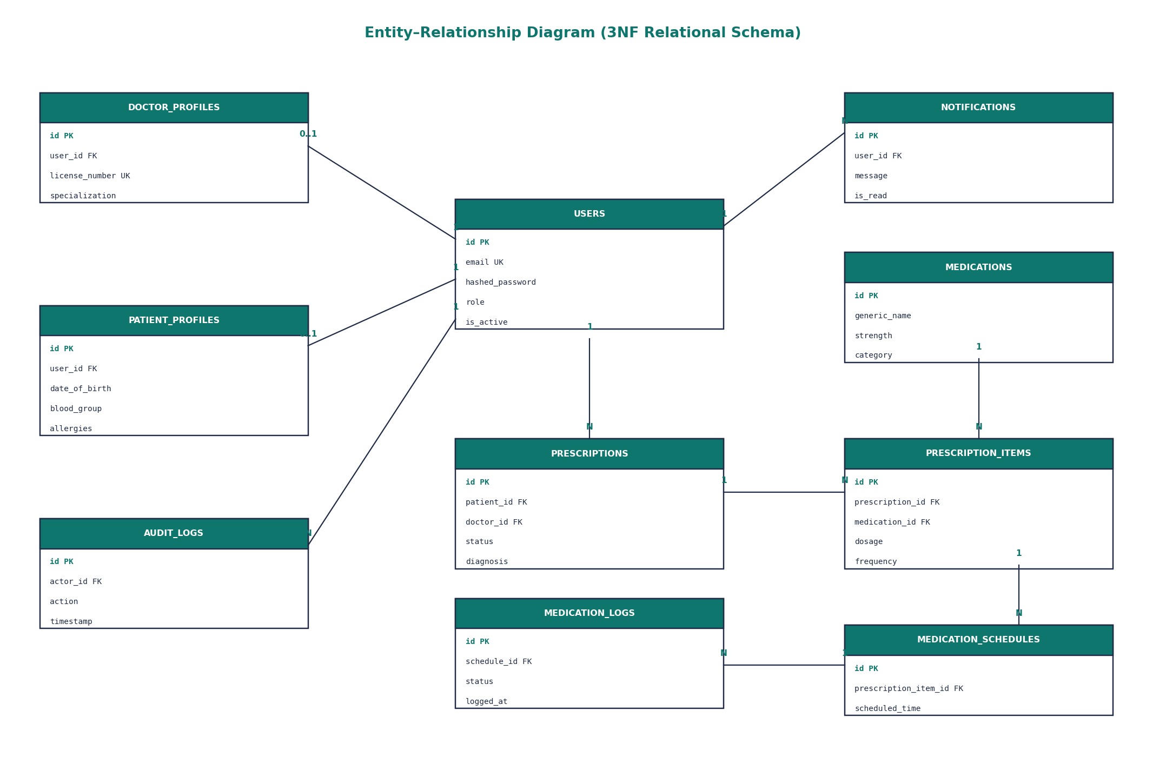
Figure 9: Entity–relationship diagram

8.1 Normalisation
- 1NF: every column holds a single atomic value; medicines of a prescription are rows in PRESCRIPTION_ITEMS, not a comma-separated list.
- 2NF: every table has a single-column surrogate primary key (UUID), so no partial dependencies exist.
- 3NF: role-specific data lives in separate profile tables (DOCTOR_PROFILES, PATIENT_PROFILES…), and medication details live once in MEDICATIONS, removing transitive dependencies.

8.2 Integrity and Transactions
- Primary keys (UUID), foreign keys and unique constraints (e.g. email, licence number) enforce entity and referential integrity.
- Finalising a prescription inserts items and schedule rows inside one transaction — either everything is committed or nothing is (atomicity), keeping the database consistent.
- Asynchronous sessions with a connection pool give isolation between concurrent requests; committed data is durable on disk.
- Eager loading (selectinload) avoids the N+1 query problem when lists of users or prescriptions are returned.
- Alembic migrations version the schema like source code.

8.3 Sample Query (generated by the ORM)
SELECT users.* FROM users
WHERE users.role = 'patient' AND users.is_active = 1
ORDER BY users.last_name
LIMIT 20 OFFSET 0;

SELECT patient_profiles.* FROM patient_profiles
WHERE patient_profiles.user_id IN (...); -- selectinload: one extra query, not N

9. Advanced Concepts II — Computer Networks
ArogyaNova is a client–server system. The React GUI runs in the browser (client) and talks to the FastAPI server over the network using a RESTful interface.
Table 9: Networking concepts by layer
OSI / TCP-IP layer | How it appears in the project
Application | HTTP/1.1 methods (GET, POST, PATCH, DELETE), JSON bodies, status codes 200/201/401/403/404/422/429/500, REST resources under /api/v1
Presentation | JSON serialisation; TLS encryption (HTTPS) in deployment
Session | JWT session token carried in an HttpOnly cookie across requests
Transport | TCP connections to port 5173 (GUI dev server), 8000 (API), 5432 (PostgreSQL)
Network | IPv4 loopback (127.0.0.1) in development; routable addresses in deployment

- REST principles: stateless requests, resource-oriented URLs (e.g. /api/v1/prescriptions/{id}), uniform interface.
- CORS: the API explicitly allows only the GUI's origin, so other websites cannot call it from a user's browser.
- Asynchronous I/O: Uvicorn (ASGI) handles many concurrent connections on an event loop.
- Pagination: list endpoints accept page and per_page, limiting payload size.
- API documentation: OpenAPI/Swagger is generated automatically at /docs.

10. Advanced Concepts III — Cybersecurity
Medical data is sensitive, so security follows defence in depth and the principle of least privilege.
Table 10: Security controls (aligned with OWASP Top 10)
Threat | Control implemented | Location
Password database leak | Argon2id hashing (memory-hard, unique salt per user) | security/passwords.py
Session theft via XSS | JWT stored in HttpOnly cookie, not readable by JavaScript | api/v1/auth.py
Cross-site request forgery | SameSite cookie policy + strict CORS origin list | main.py
Privilege escalation | Role-based access control via permission sets on each role class | domain/users.py, security/dependencies.py
Insecure direct object reference | Object-level checks (a patient may only read their own record) | api/v1/routes.py
Brute-force login | SlowAPI rate-limiter registered on the app (per-route limits listed as future work) | main.py
Clickjacking / MIME sniffing | X-Frame-Options: DENY, X-Content-Type-Options: nosniff, Referrer-Policy | main.py
Injection | ORM parameterised queries; Pydantic input validation | repositories, schemas
Secret exposure | Secrets loaded from environment (.env), not hard-coded | core/config.py

Table 11: RBAC permission matrix
Operation | Doctor | Patient | Pharmacist | Admin
Create / finalise prescription | Yes | No | No | No
View own prescriptions | Yes | Yes | — | Yes
Review prescriptions | Yes | No | Yes | Yes
Log a dose | No | Yes | No | No
Run AI interaction check | Yes | No | Yes | No
Manage users | No | No | No | Yes

11. Advanced Concepts IV — Artificial Intelligence and Analytics

11.1 Drug–Drug Interaction Checker
LocalInteractionChecker is a knowledge-based (rule-based) expert system. It holds a curated knowledge base of medicine pairs with a severity level (minor, moderate, major, contraindicated) and a clinical explanation, for example warfarin + aspirin → increased bleeding risk. Given the list of medicines on a prescription, it evaluates every pair against the rules and returns a structured InteractionCheckResult with the highest severity. Rule-based AI was chosen deliberately: in healthcare, results must be explainable and must not be invented.

11.2 Prescription OCR
LocalOCRProvider uses the Tesseract OCR engine (an LSTM neural-network recogniser) to extract text from a scanned prescription image, then parses medicine names, strengths and frequencies with pattern matching. If Tesseract is not installed, the UnavailableOCRProvider null object reports this honestly instead of returning fake data.

11.3 Adherence Analytics
AnalyticsService computes adherence as taken doses ÷ logged doses × 100 and classifies patients as Good (≥ 80%), Needs Attention (≥ 50%) or Poor. The GUI visualises prescription volume trends and compliance with charts. This data is the natural foundation for a future machine-learning model that predicts which patients are likely to miss doses.
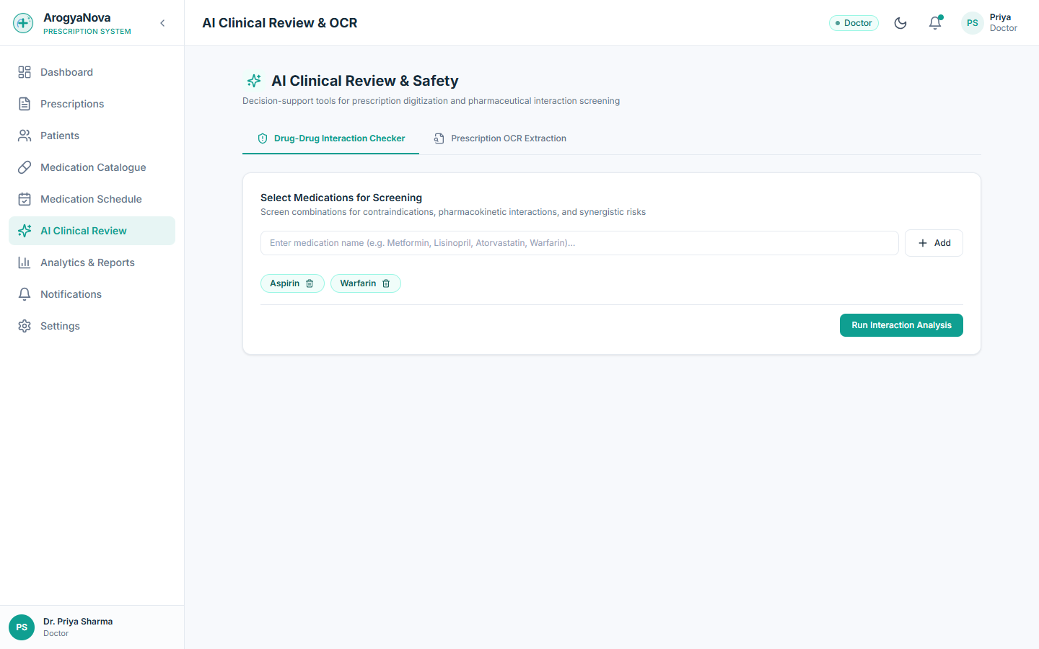
Figure 10: AI Clinical Review screen (interaction checker and OCR)

12. Graphical User Interface
The GUI is a single-page application built with React and TypeScript. It is itself object-oriented in structure: reusable components encapsulate their own markup and state, props act as each component's public interface, React contexts (AuthContext, ThemeContext) provide shared services, and the services folder wraps the HTTP API in typed service modules. The interface supports light and dark themes, responsive layouts and role-specific navigation.
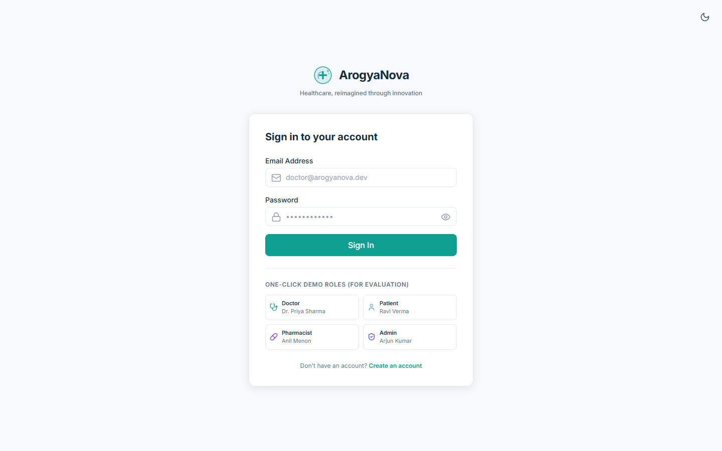
Figure 11: Login screen with one-click demo roles
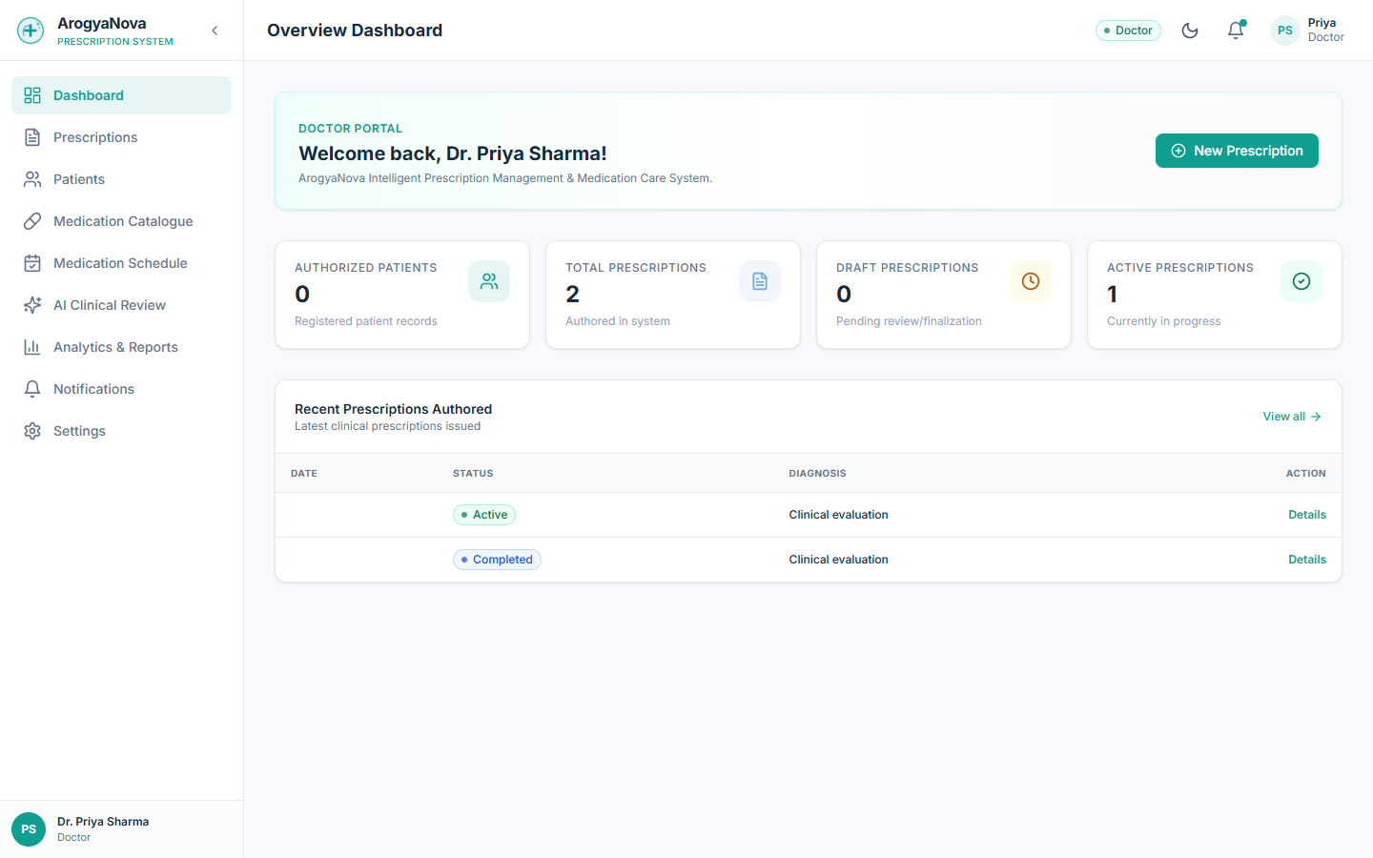
Figure 12: Doctor dashboard (light theme)
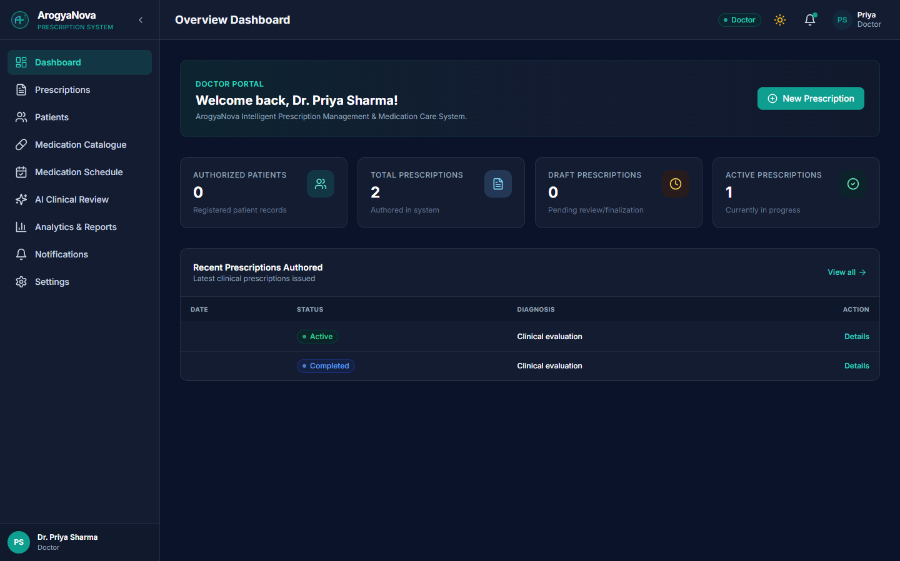
Figure 13: Doctor dashboard (dark theme)
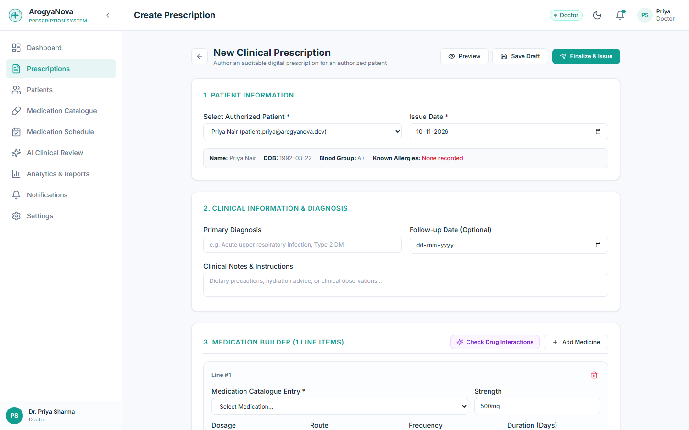
Figure 14: Create prescription form with medication builder
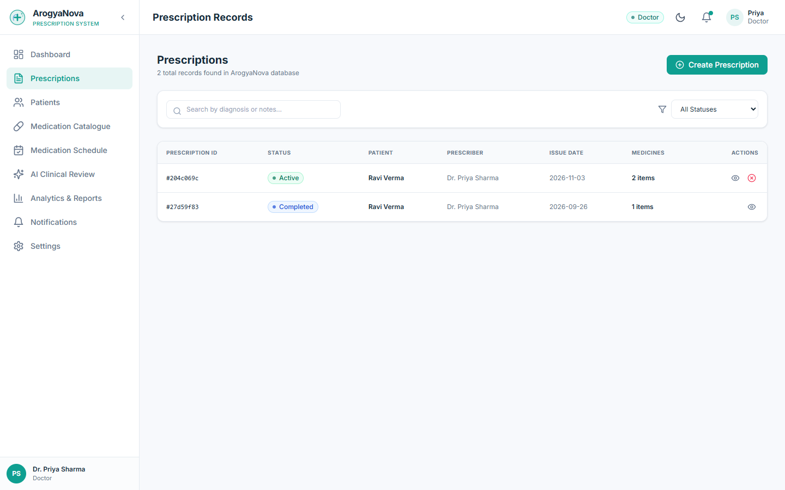
Figure 15: Prescription records list
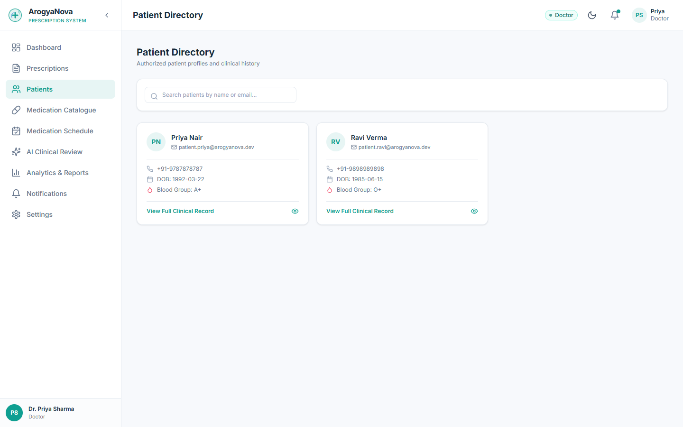
Figure 16: Patient directory
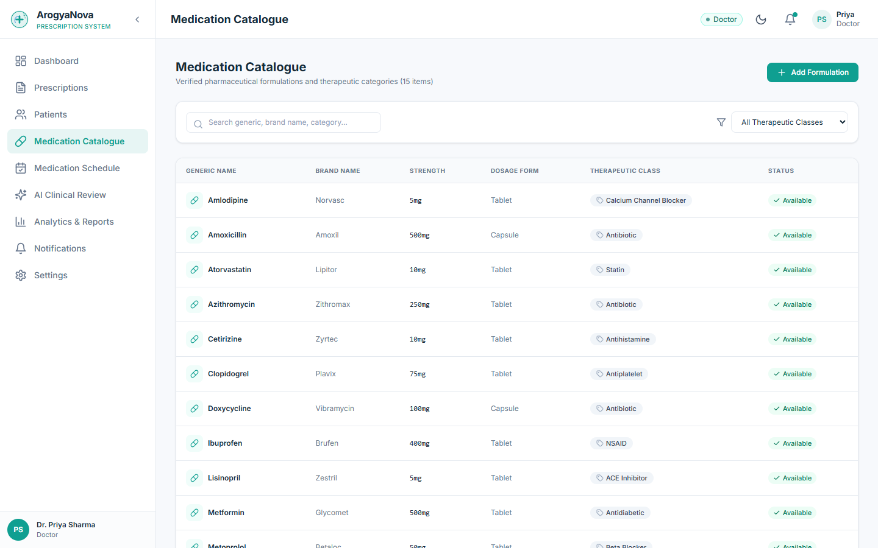
Figure 17: Medication catalogue
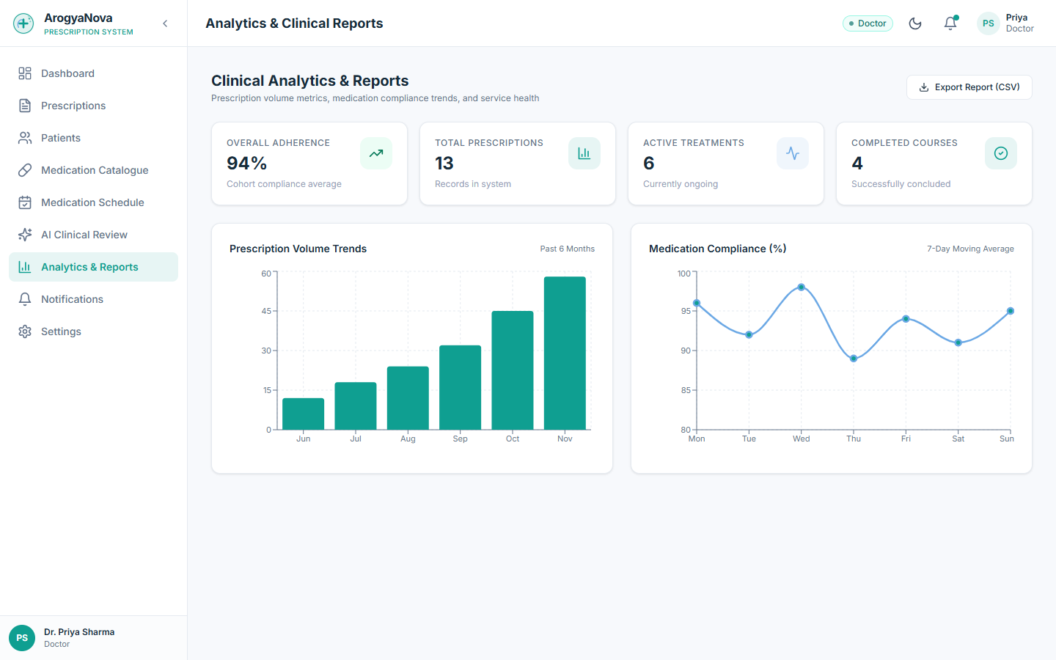
Figure 18: Analytics and clinical reports

13. Testing
The backend has an automated pytest suite. Because business rules live in plain domain classes, they can be tested quickly without a web server or database.
Table 12: Automated test results
Test file | Tests | What is verified
tests/test_domain.py | 48 | Encapsulation of Prescription, legal and illegal state transitions, role permissions, polymorphic AI and notification behaviour
tests/test_repositories.py | 2 | Repository CRUD contract against a database session
tests/test_security_rbac.py | 4 | Password hashing and role-based access rules
Total | 54 | All passing (pytest, 1.5 s)

def test_cannot_add_item_to_active_prescription(self):
p = self._make_prescription(PrescriptionStatus.ACTIVE)
with pytest.raises(ValueError, match="Cannot add items"):
p.add_item(self._make_item()) # encapsulation protects the rule

def test_cannot_finalize_empty_prescription(self):
p = self._make_prescription()
with pytest.raises(ValueError, match="at least one medication"):
p.finalize()
Manual GUI testing was carried out for each role using the seeded demo accounts. During this testing a defect was found and fixed: the patient list endpoint returned users without loading their related profile objects, which caused a server error in asynchronous mode; adding eager loading for all profile relationships resolved it.

14. Conclusion and Future Scope

14.1 Conclusion
ArogyaNova shows that object-oriented methodology is not only a modelling exercise but a practical way to make software safer. By placing clinical rules inside encapsulated domain objects, depending on abstractions, and modelling behaviour with UML before coding, the team produced a system in which illegal operations — such as editing an issued prescription — are structurally impossible. The project also demonstrates how OOM integrates naturally with databases, networking, security and AI in a real application.

14.2 Future Scope
- Train a machine-learning model on adherence logs to predict missed doses and alert doctors early.
- Apply per-route rate limits (e.g. 5 login attempts per minute) using the SlowAPI limiter already registered.
- Integrate a licensed drug-interaction database (e.g. via a standard medical API) behind the same InteractionChecker interface.
- Add WhatsApp and push-notification channels — new subclasses only, thanks to the Open/Closed design.
- Digital signatures on prescriptions using public-key cryptography.
- A mobile app reusing the same REST API.

References
- G. Booch, J. Rumbaugh, I. Jacobson — The Unified Modeling Language User Guide, 2nd ed., Addison-Wesley.
- E. Gamma, R. Helm, R. Johnson, J. Vlissides — Design Patterns: Elements of Reusable Object-Oriented Software.
- R. C. Martin — Clean Architecture: A Craftsman's Guide to Software Structure and Design.
- R. Elmasri, S. Navathe — Fundamentals of Database Systems.
- A. S. Tanenbaum — Computer Networks.
- OWASP Foundation — OWASP Top 10 Web Application Security Risks.
- FastAPI, SQLAlchemy 2.0, React and Pydantic official documentation.

