Stress Analysis of Process Pipe Line Systems (ASME B 31.3) In a Plant Using Caeser-II

A.sivanagaraju1, S.Krugon2, Dr.M.Venkateswararao3

1M-Tech Student, 2Assistant Professor, 3Professor and Head

Mechanical Department, Bapatla Engineering College, Bapatla, Guntur, India.

________________________________________________________________________________________________________

***Abstract -* Process Pipe Line system Designs are governed by Industrial/International Codes and Standards to transport the fluid, steam or air in Industries & in many plants. The piping system involves the components like pipes, flanges, gaskets, elbows, different fittings, valves and other specialties. The design code ASME B31.3 Process Piping is used in this paper which is applied in petroleum refineries, Oil & Gas Industries, chemical plants, textile plants, paper plants, semiconductor plant and in many Industrial Plants. The objective of this paper is to explain the flexibility characteristics, elemental forces & displacements and also stress intensification factor (SIF) referring to this code and ensuring that they are kept in the allowable limits as per the standards at different load conditions such as HYDROSTATIC, SUSTAINED, OPERATING and EXPERIMENTAL Cases.**

***Index Terms -* Introduction, Stress Analysis, Materials, Codes & Standards, Flexibility, SIF Calculations, Experimental Results Using CAESER-II, Outputs from the software, Piping Softwares, Stress Analysis Report**

________________________________________________________________________________________________________

# I. INTRODUCTION

Pipe Design mainly depends upon stress analysis. Process piping and power piping are typically checked by pipe stress engineers to verify that the routing, nozzle loads, hangers, and supports are properly placed and selected such that allowable pipe stress is not exceeded under different loads such as sustained loads, operating loads, pressure testing loads, etc., as

Stipulated by the ASME B31, EN 13480 or any other applicable codes and standards. It is necessary to evaluate the mechanical behaviour of the piping under regular loads (internal pressure and thermal stresses) as well under occasional and intermittent loading cases such as earthquake, high wind or special vibration, and water hammer. This evaluation is usually performed with the assistance of a specialized finite element pipe stress analysis computer program CAESER-II.

**CAESER-II** which is the Bidirectional software developed for the Design and comprehensive analysis of complex systems. This software make use of Finite Element Methods to carry out stress analysis in order to find the sorted code stresses, code compliance stresses, element forces and moments in coordinates and displacement at all nodes in the piping layout in different cases such as **HYDROSTATIC, SUSTAINED, OPERATING** and **EXPERIMENTAL** Cases.

# II. STRESS ANALYSIS

Piping Stress analysis is a term applied to calculations, which address the static and dynamic loading resulting from the effects of gravity, temperature changes, internal and external pressures, changes in fluid flow rate and seismic activity. A hot piping system will expand or elongate. A cold piping system will contract or shrink. Both these create stress problems. Stress analysis determines the forces exerted in the pipe, anchor points, restraints in piping system, stress induced in pipe must be checked against the allowable limits as per the respective codes and standards.

# III. MATERIALS, CODES & STANDARDS

For design of piping systems, selection of proper material for construction and to detail out the material specifications like length, Diameter, wall thickness, temperature, pressure, elastic modulus, poissions ratio, pipe density, fluid density, etc., knowledge of codes and standards is essential. The Materials such as Grey cast iron, Lead Tin Bronze, copper-nickel, wrought Iron, etc., are used for designing the pipe lines.

A code is basically a standard of government acceptance to ensure public and industry safety in any activity.

Standardization can reduce cost, inconvenience and confusion that results from unnecessary and undesirable differences in systems, components and procedures.

## A. Piping Codes

* ASME B31.1 - Power Piping ASME B31.2 - Fuel Gas Piping
* ASME B31.3 - Process Piping
* ASME B31.4 - Liquid Piping
* ASMEB31.5-Refrigeration Piping
* ASME B31.8-Gas Distribution and Transportation
* ASME B31.9 - Building Service Piping
* ASME B31.11-Slurry Piping

## B. Procedure for Stress Analysis

* Identify the possible loads that occur in piping systems during the life of the plant. (Self weight, wind, seismic etc.) ➢ Relate each of these loads to the stresses developed.
* Get the cumulative effect of the possible loads in the system.
* As per allowable load at connections find the stress and compensate the effect of place supports & loops if required.
* As per allowable limits find the deformation (using Caesar) and place the supports as per requirements. ➢ After the system is designed, to ensure that the stresses are within the safe limits.

# IV. FLEXIBILITY

Piping systems should have sufficient flexibility so that piping movements and movements of supports will not cause a. Failure of piping from overstress/ fatigue.

1. Leak at joints.
2. Detrimental loads on connecting equipment, resulting from excessive thrusts and movements in piping. d. Failure of pipe supports.

# V. SIF CALCULATIONS

The SIF calculation is the most crucial step and careful considerations are required. The In plane and Out plane moments need to be considered. The stresses developed are more in the cases like direction change, inside diameter change, sudden obstructions,

etc.,

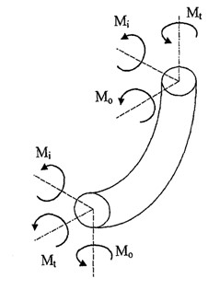

Fig.1. Moments in bends

Stresses are calculated in the nodes located at the ends of each element. For the shear stresses, the maximum tension in the outer surface of the pipe, is given by

𝜏 = 𝑆𝑡 = 𝑀𝑇/2𝑍

Where,

* 𝑀𝑇 is the shear moment. And • 𝑍 is the section modulus.

The bending stress acting on the two different planes can be combined; consequently the combined bending stress 𝑆𝑏 acting on the longitudinal direction is given by

𝑆𝑏 = √(IiMi)2 + (IoMo)2/𝑍

Where

* 𝑀𝑖 and *M0*, are the inner and outer plane bending moments.
* 𝑖𝑖 and 𝑖𝑜 are respectively the inner and outer plane stress intensification factors.

The flexibility analysis is done by the comparison between the combined effect of multidimensional tensions and the allowable stress.

The ASME B31.3 codes use the Tresca criterion to obtain the combined tension effect 𝑆, also called expansion stress:



According to the ASME B31.3 Code, the stresses to which a piping system is subjected may be separate in three main classes, for which the codes establish limits:

1. The stresses caused by Hydrostatic loads
2. The stresses caused by sustained loads
3. The stresses caused by Operating loads

d)The stresses caused by Experimental loads

# VI. DIFFERENT LOAD CASES

**a) Hydrostatic Loads** (W+Pf). pipe weight and fluid pressure. b) **Sustained Loads** (W+Pi ) pipe weight and internal pressure. c) **Operating Loads** (W+T+P) weight, thermal expansions and pressures. d) **Experimental Loads** (W+T+P+S) weight, pipe thermal expansion, Pressures and terminal point displacements.

**e) Occasional Loads**

This load is as the name implies, are those that do not occur on a regular basis but do happen during operation.

# VII. EXPERIMENTAL RESULTS USING CAESER-II

## A. (i) Inputs to the software

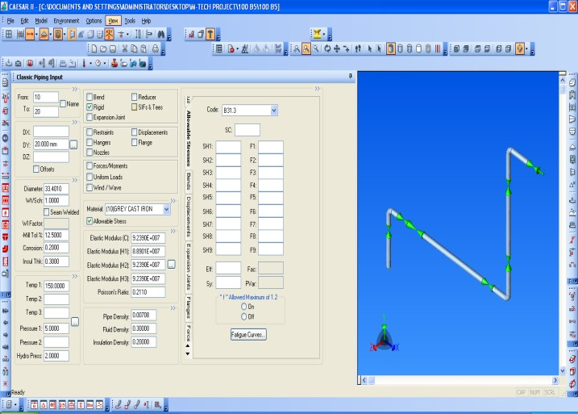

Fig2. Classic Input to CAESER software

## ii) Nodal Visualization of the Piping Input

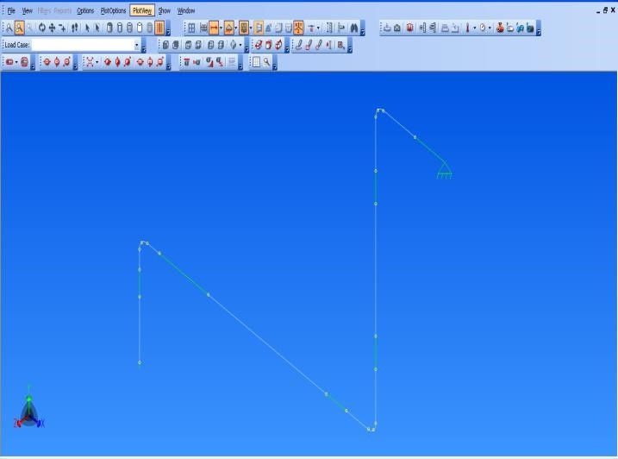

Fig3. Finite Elemental Model Input to the software

## B. Global Distribution of Forces and Moments in different Load Conditions

Table 1. Distribution of Forces and Moments

|  |  |  |  |  |  |  |
| --- | --- | --- | --- | --- | --- | --- |
| RESTRAINT SUMMARY REPORT: Loads On Restraints | | | | | |  |
| Various Load Cases | | | | | |  |
| LOAD CASE DEFINITION KEY | | | | | |  |
| CASE(HYD) WW+HP | | | | | |  |
| CASE (OPE) W+T1+P1 | | | | | |  |
| CASE (SUS) W+P1 | | | | | |  |
| CASE (EXP) L6=L2-L4 | | | | | |  |
| NODE  10 |  | Rigid ANC | |  |  |  |
|  | FX N.m | FY N.m | FZ N.m | MX  N.m | MY  N.m | Mz N.m |
| (HYD) | 26 | -190 | 0 | 0 | 0 | -230.9 |
| (OPE) | 70 | -574 | 0 | 0 | 0 | -660.4 |
| (SUS) | 83 | -563 | 0 | 0 | 0 | -705.5 |
| (EXP) | -14 | -11 | 0 | 0 | 0 | 45.1 |
| MAX | 83/3 | -574/2 | 0 | 0 | 0 | -705.5/3 |
|  | Rigid ANC | |  |  |  |  |
| NODE: 190 | FX N.m | FY N.m | FZ N.m | MX  N.m | MY  N.m | Mz N.m |
| (HYD) | -26 | -336 | 0 | 0 | 0 | 902 |
| (OPE) | -70 | -935 | 0 | 0 | 0 | 967.1 |
| (SUS) | -83 | -947 | 0 | 0 | 0 | 174.9 |
| (EXP) | 14 | 11 | 0 | 0 | 0 | -7.8 |
| MAX | -83/4 | -947/3 | 0 | 0 | 0 | 58.3 |

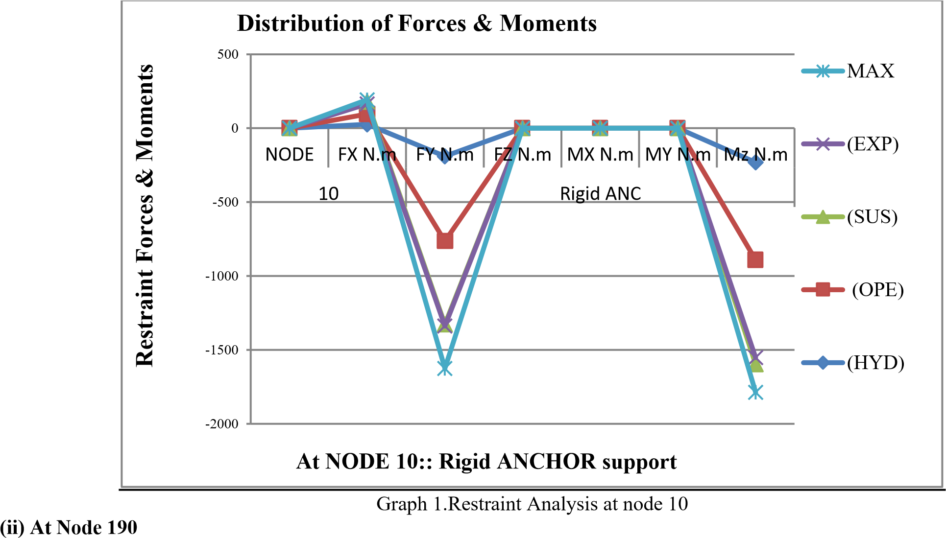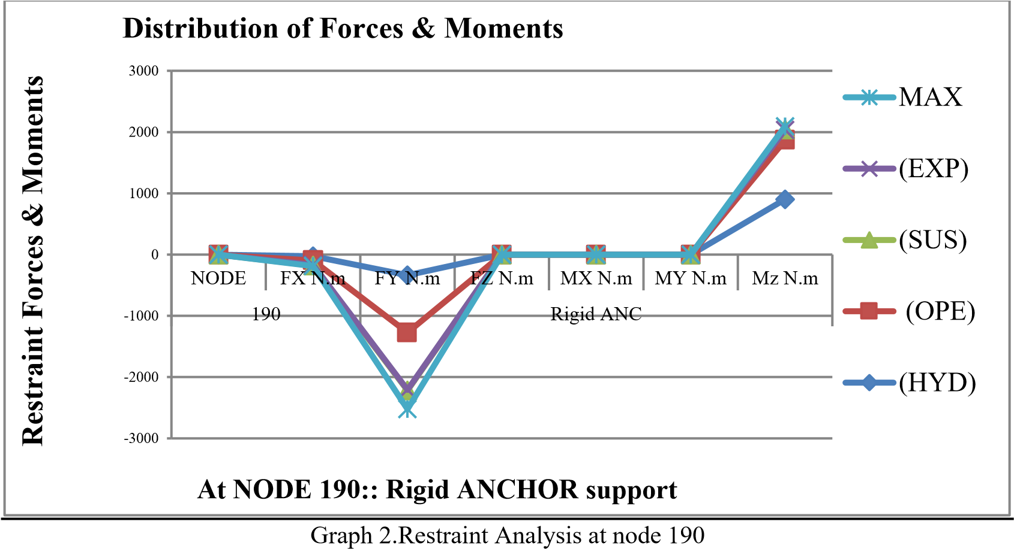**VI.C.Graphical Analysis of Forces &Displacements in all Load cases (i) At Node 10**

# VIII. OUTPUTS FROM THE SOFTWARE

## A. Stress distribution in the process piping

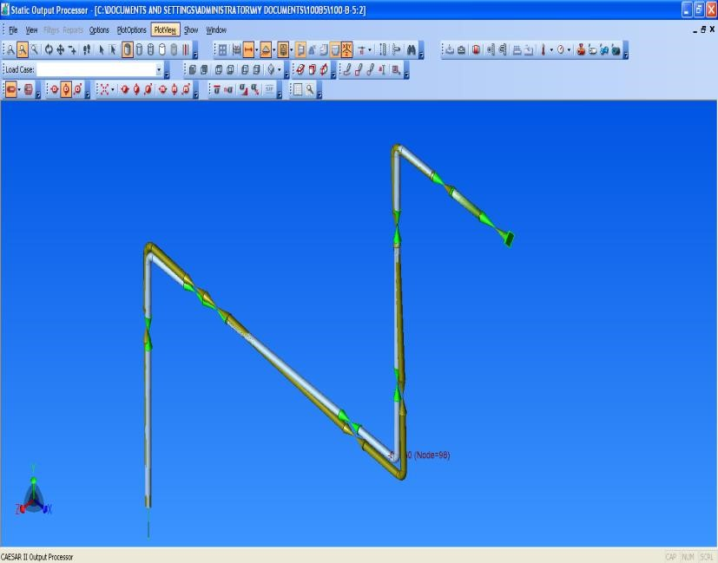

Fig.4. SIF results in Finite Element Method in CEASER-II solid creature.

## B. Stress distribution in the process piping nodal representation

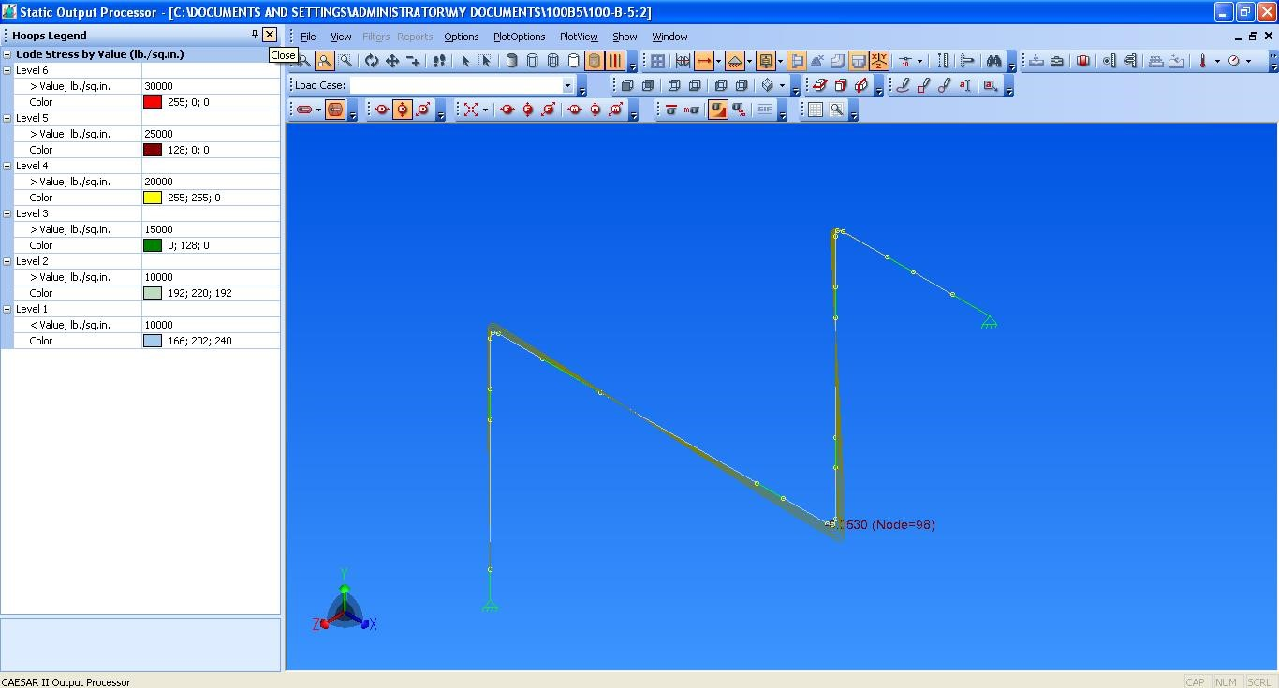

Fig.5. Stress induced output result in element creature

# IX. PIPING SOFTWARE

Piping stress analysis is a vital part of the Industrial plants condition assessment. At present, there are many software’s for piping stress analysis, viz.-CAEPIPE, CAESAR-II, AUTOPLANT, PIPE PACK, check STRESS, PDMS, etc. In this paper, piping stress analysis is carried out using CAESER-II software. The result provide displacements, stresses, loads, stress intensification factor (SIF), etc. at different node points along the pipe.

# X. STRESS ANALYSIS REPORT

## A. SIF Analysis Report (Stress Analysis)

|  |  |  |  |  |  |
| --- | --- | --- | --- | --- | --- |
|  | CAESAR II Ver.5.10.00, (Build 070917) | | | |  |
|  | STRESSES REPORT: Stresses on Elements | | | |  |
|  | STRESS CHECK PROCESSED: LOADCASE | | | |  |
| NODE | Bending Stress lb/sq.in | Torsion Stress.  lb/sq.in | Code Stress lb/sq.in | SIF In Plane | SIF Out Plane |
| 10 | 0 | 0 | 0 | 0 | 0 |
| 20 | 0 | 0 | 0 | 0 | 0 |
|  |  |  |  |  |  |
| 20 | 5498.2 | 0 | 5631.0 | 1 | 1 |
| 30 | 2841.6 | 0 | 2935.1 | 1 | 1 |
|  |  |  |  |  |  |
| 30 | 0 | 0 | 0 | 0 | 0 |
| 40 | 0 | 0 | 0 | 0 | 0 |
|  |  |  |  |  |  |
| 40 | 2310.3 | 0 | 2392.3 | 1 | 1 |
| 50 | 592.0 | 0 | 608.3 | 1 | 1 |
|  |  |  |  |  |  |
| 50 | 592.0 | 0 | 608.3 | 1 | 0 |
| 60 | 2676.0 | 0 | 2692.3 | 1 | 0 |
|  |  |  |  |  |  |
| 60 | 0 | 0 | 0 | 0 | 0 |
| 70 | 0 | 0 | 0 | 0 | 0 |
|  |  |  |  |  |  |
| 70 | 0 | 0 | 0 | 1 | 1 |
| 80 | 3660.2 | 0 | 0 | 1 | 1 |
|  |  |  |  |  |  |
| 80 | 0 | 0 | 0 | 0 | 0 |
| 90 | 0 | 0 | 0 | 0 | 0 |
|  |  |  |  |  |  |
| 90 | 371.5 | 0 | 2440.3 | 1 | 1 |
| 100 | 784.3 | 0 | 844.8 | 1 | 1 |
|  |  |  |  |  |  |
| 100 | 784.3 | 0 | 844.8 | 0 | 1 |
| 110 | 119.0 | 0 | 192.8 | 0 | 1 |
|  |  |  |  |  |  |
| 110 | 0 | 0 | 0 | 0 | 0 |
| 120 | 0 | 0 | 0 | 0 | 0 |
|  |  |  |  |  |  |
| 120 | 650.3 | 0 | 735.6 | 1 | 0 |
| 130 | 2775.6 | 0 | 2892.3 | 1 | 0 |
|  |  |  |  |  |  |
| 130 | 0 | 0 | 0 | 0 | 0 |
| 140 | 0 | 0 | 0 | 0 | 0 |
|  |  |  |  |  |  |
| 140 | 3306.9 | 0 | 3435.1 | 1 | 1 |
| 150 | 2952.2 | 0 | 2968.5 | 1 | 1 |
|  |  |  |  |  |  |
| 150 | 2952.2 | 0 | 2968.5 | 1 | 0 |
| 160 | 5526.6 | 0 | 5542.9 | 1 | 0 |
|  |  |  |  |  |  |
| 160 | 0 | 0 | 0 | 0 | 1 |
| 170 | 0 | 0 | 0 | 0 | 1 |
|  |  |  |  |  |  |
| 170 | 10922 | 0 | 10938 | 1 | 0 |
| 180 | 19589 | 0 | 19605 | 1 | 0 |
|  |  |  |  |  |  |
| 180 | 0 | 0 | 0 | 0 | 0 |
| 190 | 0 | 0 | 0 | 0 | 0 |

Table 2

.

Stress

analysis in operational case

**B.**

**Graphical Analysi**

**s of Stresses in all Load cases**

Graph

3

. Experimental Results of stresses.

0

100

200

300

400

500

600

700

800

1

4

7

10

13

16

19

22

25

28

31

34

37

40

43

46

49

52

SIF Out

Plane

SIF In

Plane

Code

Stress

Torsion

Stress.

Bending

Stress

NODE

**STRESS**

**RESULT IN OPERATION**

**STRESSES IN lb/sq.in**

**NODE**

**NUMBERS**

# XI. FUTURE SCOPE

* Pipe Span calculations.
* Design of pipe supports.
* Stiffness & flexibility.
* Expansion & stresses.
* Line expansion & flexibility.

# XII. CONCLUSION

The experimental results confirm the prior design and analysis of a Process Plant Piping System using CAESER. This CAD package provides a systematic and efficient methodology for designing and analysis with far less effort. Compare the SIF results against the results obtained with CAESER which are documented in table 2, by using some observations on SIF equations are found to be same. The colour coded SIF distributions are displayed in figure5 and the results are plotted in graph3. So, the analysis of a piping system using CAESER gives more accurate and precise results.

# XIII. REFERENCES

1. Basavaraju, W. S. Sun (1996), Stress Analysis of Piping System. McGraw-Hill, USA.
2. Roy A. Parisher, Pipe Drafting & Design, Gulf Professional Publishing.
3. Payal Sharma , Mohit Tiwari and Kamal Sharma Design and Analysis of a Process Plant Piping System, International Journal of Current Engineering and Technology, Department of Mechanical Engineering, GLA University, Mathura, India. 4) CAESAR II Design Manuals, ASME Standards, B 31.3, BS 7159.
4. COADE Pipe stress Analysis notes
5. Gaurav Bhende, Girish Tembhare, “Stress Intensification and Flexibility in Pipe Stress Analysis”, International Journal of Modern Engineering Research, Vol.3, Issue 3, 2013.
6. CAESER and CAEPIPE manual Book for calculations.
7. L. Miranda (2011), Piping Design: The Fundamentals, Paper Presented at Short Course on Geothermal Drilling, Resource Development and Power Plant organized by UNU-GTP and LaGeo, in Santa Tecla, El Salvador.