DBMS

# **Join Operations**

create table employee(

Emp_ID int ,

Emp_Name varchar(25) not null,

Emp_No varchar(10) not null

);

alter table employee add primary key(Emp_ID) ;

alter table employee add unique key(Emp_No) ;

INSERT INTO employee VALUES (101, 'Ashish Kaktan', '9450425345');

INSERT INTO employee VALUES (102, 'Raj Choudhary', 8462309621);

INSERT INTO employee VALUES (103, 'Vivek Oberoi', 7512309034);

INSERT INTO employee VALUES (104, 'Shantanu Khandelwal', 9020330023);

INSERT INTO employee VALUES (105, 'Khanak Desai', 8451004522);

create table Employment(

Emp_ID int ,

Emp_Profile varchar(25),

Emp_Country varchar(30),

Emp_Join_Date date not null,

primary key(Emp_ID)

);

INSERT INTO Employment (Emp_ID, Emp_Profile, Emp_Country, Emp_Join_Date) VALUES

(101, 'Content Writer', 'Germany', '2021-04-20'),

(104, 'Data Analyst', 'India', '2022-12-11'),

(105, 'Software Engineer', 'India', '2022-01-03'),

(108, 'Development Executive', 'Europe', '2023-02-15'),

(109, 'Marketing Manager', 'Mexico', '2020-05-23');

/*

## join these two tables together using a SELECT statement

*/

select Emp_Name,Emp_No, Emp_Profile, Emp_Country from employee, employment where employee.Emp_ID=employment.Emp_ID;

[O/P]:

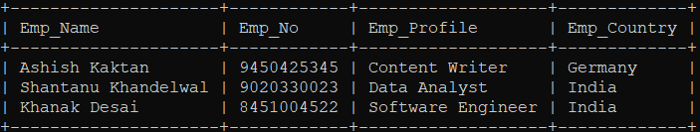

/*

## perform INNER JOIN on these two tables using a SELECT statement

*/

select Emp_Name,Emp_No, Emp_Profile, Emp_Country from employee inner join employment on employee.Emp_ID=employment.Emp_ID;

[O/P]:

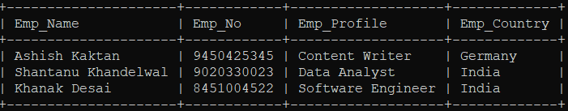

/*

## perform LEFT JOIN on these two tables using a SELECT statement

*/

select Emp_Name,Emp_No, Emp_Profile, Emp_Country from employee left join employment on employee.Emp_ID=employment.Emp_ID;

[O/P]:

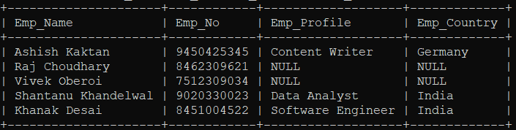

/*

## perform RIGHT JOIN on these two tables using a SELECT statement

*/

select Emp_Name,Emp_No, Emp_Profile, Emp_Country from employee right join employment on employee.Emp_ID=employment.Emp_ID;

[O/P]:

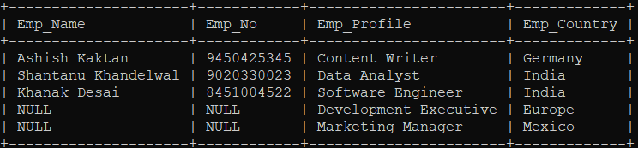

create table employee(

Emp_ID int ,

Emp_Name varchar(25) not null,

Emp_No varchar(10) not null

);

alter table employee add primary key(Emp_ID) ;

alter table employee add unique key(Emp_No) ;

INSERT INTO employee VALUES (101, 'Ashish Kaktan', '9450425345');

INSERT INTO employee VALUES (102, 'Raj Choudhary', 8462309621);

INSERT INTO employee VALUES (103, 'Vivek Oberoi', 7512309034);

INSERT INTO employee VALUES (104, 'Shantanu Khandelwal', 9020330023);

INSERT INTO employee VALUES (105, 'Khanak Desai', 8451004522);

CREATE TABLE Employment (

Emp_ID int,

Emp_Profile varchar(255),

Emp_Email varchar(255),

primary key(Emp_ID)

);

INSERT INTO Employment (Emp_ID, Emp_Profile, Emp_Email) VALUES

(101, 'Content Writer', 'ashish@scaler.com'),

(104, 'Data Analyst', 'shantanu@scaler.com'),

(105, 'Software Engineer', 'khanak@scaler.com'),

(109, 'Development Executive', 'akshay@scaler.com'),

(108, 'Marketing Manager', 'nikita@scaler.com');

CREATE TABLE EmpDetail (

Emp_Country VARCHAR(255),

Emp_Email VARCHAR(255) ,

Emp_JoinDate DATE,

primary key(Emp_Email)

);

INSERT INTO EmpDetail (Emp_Country, Emp_Email, Emp_JoinDate) VALUES

('Germany', 'ashish@scaler.com', '2021-04-20'),

('India', 'shantanu@scaler.com', '2022-12-11'),

('India', 'khanak@scaler.com', '2022-01-03'),

('Europe', 'akshay@scaler.com', '2023-02-15'),

('Mexico', 'nikita@scaler.com', '2020-05-23');

/*

## join three tables

*/

select e.Emp_Name, e.Emp_No, m.Emp_Profile, d.Emp_Country, d.Emp_JoinDate from employee e inner join employment m on e.Emp_ID = m.Emp_ID inner join EmpDetail d on m.Emp_Email = d.Emp_Email;

[O/P]:

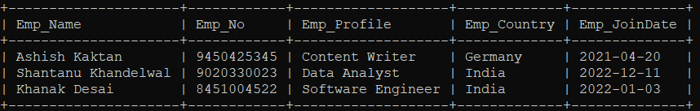

/*

## Natural join

*/

select * from employee natural join employment;

[O/P]:

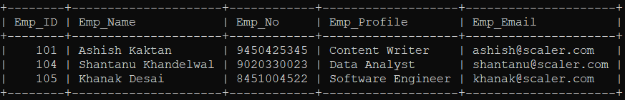

# Create Student table with the fields(rollno,sname,semail,saddress,gender) apply all possible constraints on Student table

create table Student (

rollno int,

sname varchar(25) not null,

semail varchar(255) not null,

saddress varchar(255) not null,

gender varchar(20) not null,

primary key(rollno)) ;

alter table Student add constraint UC_Student unique(semail);

alter table Student alter saddress set default 'Kolkata';

alter table Student add constraint chk_constraint check(gender in('F','M'));

desc Student;

[O/P]:

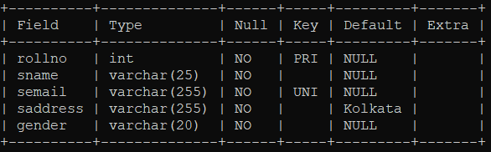

insert into student(rollno,sname,semail,gender) values(1,'shr','shr@shr.com','Female');

[O/P]:



insert into student(rollno,sname,semail,gender) values(1,'shr','shr@shr.com','F');

[O/P]:



select * from student;

[O/P]:

