Creating a Git Repository

**Step 1 :** Create account

# Go on to this official website of Github and make a free account if you don’t already have one.

Url : <https://github.com/>

**Step 2 :** Create a new repository

# Click on the green button with text “new” to create a new repository.

Enter the name and description for your repository.

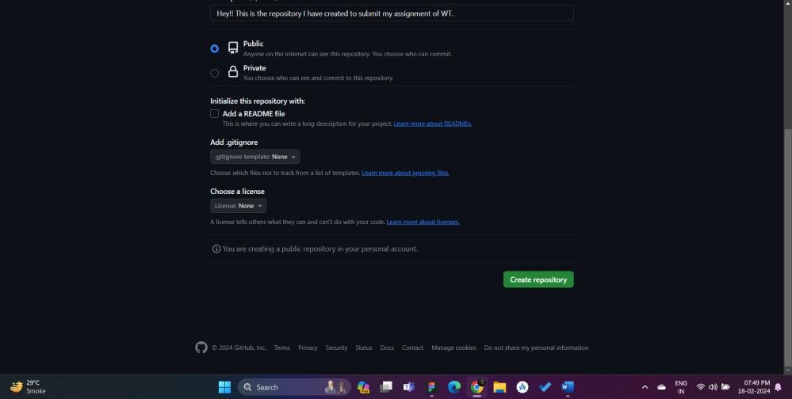

Click on the green button with text “Create repository”.

**Step 3 :** Create folder.

# Create a empty folder in any name on you local device.

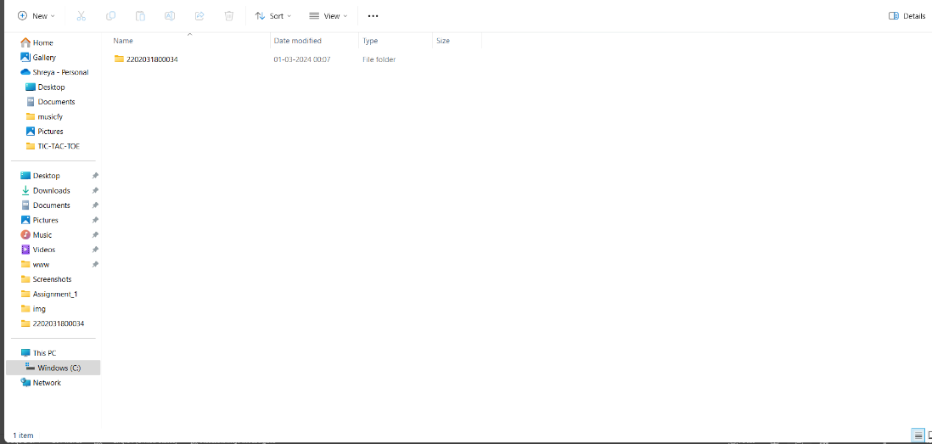

I have given it the name Assignment(WT).

Make two folders in this folders with name Assignment_1 and Assingment_2.

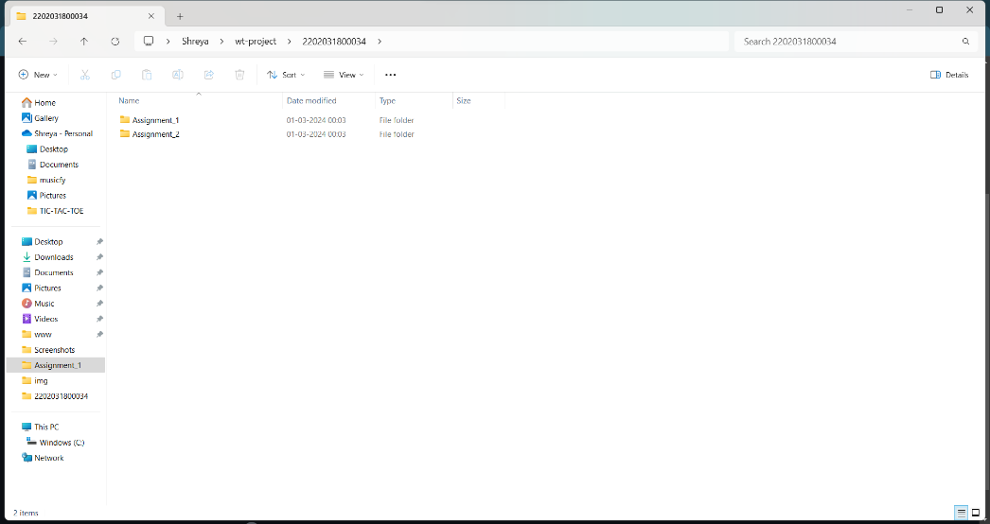

Right click anywhere and select “Open in Terminal”

Following terminal should be opened :

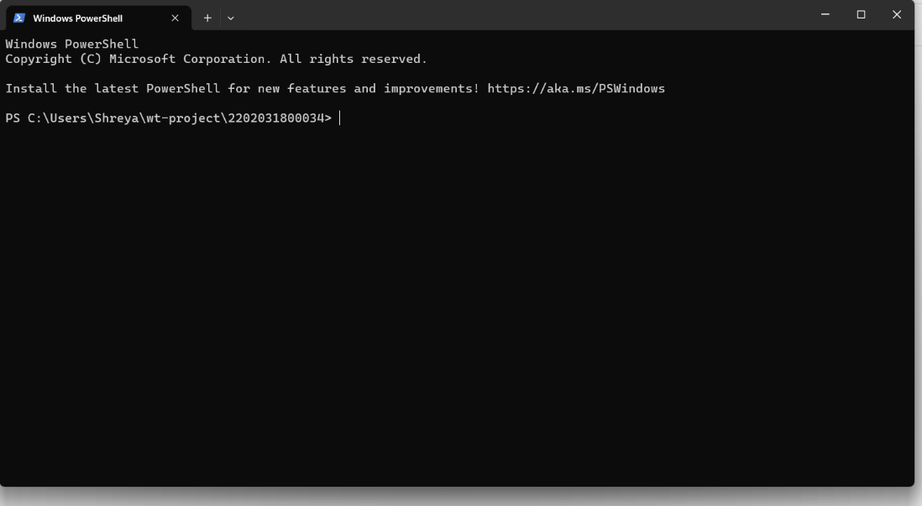

Run the following command one by one :

1. git init : This will create an empty git repository but on your local device. But before this place make sure that you have downloaded git on your local device.
2. git commit –m “your example message” : This will commit all the current changes in your local repository with some message or info about the commit.
3. git branch –M main : This will now move the git’s focus on the main branch.
4. git remote add orign your_repository’s url here. : This will connect your local repository with the remote one which we have created.
5. git push –u origin main : This will upload all the files you have kept inside the folders along with folders to the remote repository on github.
6. refresh the page on github to see changes.

Task completed.