A
Mini-Project Report
On

DIGI - DINE
Wireless E-Menu and Kitchen Feedback System for Restaurants

SUBMITTED BY

Student Name Exam. Seat No.
1. Shreya Chandrakant Patil T1900803133
2. Chinmay Surendra Bhintade T1900803032
3. Yash Rajendra Ranware T1900803146

PROJECT GUIDE

Dr. Mrs. Sarika Patil
Mrs. Mrunali Pant


DEPARTMENT OF ELECTRONICS AND TELECOMMUNICATION

D.Y. PATIL COLLEGE OF ENGINEERING
AKURDI, PUNE – 411044

2024-2025
D.Y. PATIL COLLEGE OF ENGINEERING
AKURDI, PUNE – 411044

DEPARTMENT OF ELECTRONICS AND TELECOMMUNICATION
CERTIFICATE
This is to certify that
1. Shreya Chandrakant Patil T1900803133
2. Chinmay Surendra Bhintade T1900803032
3. Yash Rajendra Ranware T1900803146

of T.E. E&TC has completed the mini-project on
DIGI - DINE
Wireless E-Menu and Kitchen Feedback System for Restaurants

satisfactorily under my supervision and guidance and submitted the project report in complete fulfillment of requirement for the award of TE (E&TC) Degree of Engineering course under the Savitribai Phule Pune University, Pune during the academic year 2024-2025.

Dr. Mrs. Sarika Patil Mrs. Mrunali Pant Dr. Rutuja Deshmukh
Project Guide Project Guide H.O.D. E&TC
D.Y.PATIL COLLEGE OF ENGINEERING
AKURDI, PUNE – 411044

DEPARTMENT OF ELECTRONICS AND TELECOMMUNICATION

CERTIFICATE

This is to certify that following students of T.E. Electronics & Telecommunication have completed the mini-project on ‘DIGI-DINE: Wireless E-Menu and Kitchen Feedback System for Restaurants’ satisfactorily under my supervision and guidance and submitted the project report in complete fulfillment of requirement for the award of Bachelors Degree of Engineering course under the Savitribai Phule Pune University, Pune during the academic year 2024-2025.

Student name Exam. Seat No.
1. Shreya Chandrakant Patil T1900803133
2. Chinmay Surendra Bhintade T1900803032
3. Yash Rajendra Ranware T1900803146

Dr. Mrs. Sarika Patil Mrs. Mrunali Pant Dr. Rutuja Deshmukh
Project Guide Project Guide H.O.D. E&TC

ACKNOWLEDGEMENT

We express our sincere gratitude towards the faculty members who makes this project a successful.

We would like to express our thanks to our guide Dr. Mrs. Sarika Patil & Mrs. Mrunali Pant for their whole hearted co-operation and valuable suggestions, technical guidance throughout the project work.

Special thanks to our H.O.D. Dr. Rutuja Deshmukh for her kind official support and encouragement.

We are also thankful to our mini-project coordinators Mrs. Usha Biradar/Jadhav for her valuable guidance.

Finally, we would like to thank all staff members and faculty members of E&TC Department who helped us directly or indirectly to complete this work successfully.

INDEX
Sr. No. | Contents | Page No.
 | Introduction | 1
- ` | Literature Survey | 2
 | Problem Statement with Objectives | 5
 | Specifications of Project | 7
 | Block Diagram | 12
 | Circuit Diagram | 13
 | Selection of components, calculations | 14
 | Simulation Results | 17
 | Testing Procedures | 18
 | Enclosure Design | 23
 | Test Results | 24
 | Conclusion | 27
 | References | 28

List of Figures:

Sr. No. | Title | Page No.
1. | NodeMCU ESP32 | 7
2. | OLED Display | 8
3. | 4x4 Matrix Display | 9
4. | Red LED | 10
5. | Green LED | 10
6. | Jumper Wires | 11
7. | Customer Side Block Diagram | 12
8. | Chef Side Block Diagram | 12
9. | Circuit Diagram | 13
10. | Simulation Results | 17
11. | Customer Side Design 1 | 23
12. | Customer Side Design 2 | 23
13. | Customer Side Test Results 1 | 24
14. | Customer Side Test Results 2 | 24
15. | Customer Side Test Results 3 | 25
16. | Chef Side Test Results | 25
17. | Test Results | 26

List of Tables:

Sr. No. | Title | Page No.
1. | Research Paper Literature Survey | 2
2. | Books Literature Survey | 3
3. | Website Paper Literature Survey | 4
4. | NodeMCU ESP32 Description | 7
5. | OLED Display Description | 8
6, | 4x4 Matrix Keypad Description | 9
7. | LED Description | 10
8. | Jumper Wires Description | 11

CHAPTER – 01
INTRODUCTION

In the dynamic and fast-paced environment of modern dining, enhancing customer experience while improving service efficiency has become a key focus in the hospitality industry. Traditional paper-based menu systems and manual order-taking by staff are often prone to human errors, delays in service, miscommunication between customers and kitchen staff, and limited real-time interaction. These issues not only hinder the quality of service but also lead to customer dissatisfaction and operational inefficiencies.

To address these challenges, this mini project introduces Digi-Dine: Wireless E-Menu and Kitchen Feedback System for Restaurants. This system enables customers to view a digital menu, place their food orders directly from their table, and receive real-time responses from the kitchen — all without the need for a waiter. It is designed to streamline communication between customers and the kitchen staff using wireless technology for seamless order processing and status updates.

The system operates in a simple and efficient loop: the customer browses and places an order from a digital menu interface; the order is then sent wirelessly to the kitchen, where the chef receives and reviews it. The chef responds by accepting or rejecting the order, and this response is immediately reflected back to the customer interface, providing real-time order status with visual and audio feedback.

This solution brings multiple advantages to the modern dining setup. It minimizes dependency on waitstaff, reduces order errors, and eliminates delays caused by manual communication. Customers are empowered with better clarity and real-time feedback, helping them make faster and more informed decisions.

Additionally, by eliminating traditional paper menu cards, the system reduces recurring costs of menu reprints, improves table hygiene, and avoids wear-and-tear or food stains on physical menus. With fewer physical menus needed, there’s less clutter and better maintenance. The digital system also helps cater to more customers efficiently, reducing crowd buildup and wait times during peak hours, thus optimizing table turnover and improving overall restaurant flow. This project helps reduce the burden on restaurant staff, eliminates handwriting or communication mistakes, minimizes time delays, and ensures more transparent interaction between the customer and kitchen. It streamlines the food ordering workflow, improves table turnover, and enhances the overall dining experience.

CHAPTER – 02
LITERATURE SURVEY

- RESEARCH PAPERS: -

Table 2.1.1. Research Paper Literature Survey
Sr. No. | Author and Year | Paper Title | Journal/  Conference | Method Used | Performance
1. | P. A. Gbadega et al., 2025 | Design and Implementation of a Smart Restaurant Menu Ordering System Using a WiFi Module and RFID Technology | Proc. SEB4SDG 2024. | WiFi and RFID-based ordering system integrated for contactless menu selection | Enhanced customer convenience and reduced wait time by automating the order process
2. | A. R. Iyanda and T. A. Azeez, 2025 | A Multilingual Restaurant Serving Robot Request Management System | Ife Journal of Technology | Robot-enabled order processing with multilingual voice command interface | Improved accessibility and streamlined customer-robot interaction for food service
3. | S. N. Sutar et al., 2025 | Smart Ordering System Using Android and Internet of Things | IRJET | Android app connected via IoT to send orders to the kitchen wirelessly | Reduced manual order taking and improved order processing speed
4. | D. Ramadevi et al., 2024 | Menu Ordering System Using IoT | IJERST | IoT-enabled digital system to automate restaurant ordering | Promoted hygiene, reduced human effort, and offered seamless operation
5. | A. Ingle et al., 202 | IoT Based Menu Ordering System | IJERST | ESP8266-based system with an interactive menu and kitchen interface | Enabled real-time order tracking and user-friendly interface
6. | X. Ju et al., 2022 | MenuAI: Restaurant Food Recommendation System via a Transformer-based Deep Learning Model | arXiv | Deep learning model to recommend food items based on user preferences | Delivered personalized suggestions, improving user satisfaction and ordering time
7. | M. Roe et al., 2022 | Drivers and Challenges of Internet of Things Diffusion in Smart Stores | arXiv | Qualitative research and field interviews on IoT adoption in retail | Identified barriers and motivations for IoT adoption, applicable to smart dining
8. | S. B. Chidrawar et al., 2022 | Smart Menu Card System | IJIERT | Digital menu interface with touch display linked to kitchen display | Reduced reliance on human staff and introduced an eco-friendly approach
9. | A. A. T. Talukder et al., 2022 | A Customer Satisfaction Centric Food Delivery System Based on Blockchain and Smart Contract | arXiv | Blockchain-backed food order and delivery verification model | Improved trust, transparency, and reliability in order processing
10. | J. L. Ramiah and S. Nagowah, 2021 | Implementation of a Smart Canteen System for a University Campus | ICSTM 2021 | Smart card and automated billing system for student cafeterias | Facilitated fast, cashless transactions and systematic order tracking

- BOOKS: -
Table 2.2.1. Books Literature Survey
Sr. No. | Author | Title | Publisher & Edition | Description
1. | Raj Kamal | Internet of Things: Architecture and Design Principles | McGraw Hill, 2nd Ed. | Provides foundational concepts on IoT architecture, design strategies, and real-world applications, critical for smart system development
2. | Muhammad Ali Mazidi | The 8051 Microcontroller and Embedded Systems: Using Assembly and C | Pearson, 2nd Ed. | Offers detailed understanding of microcontroller interfacing and embedded C programming, useful for system logic and hardware integration
3. | Udaya Shankar | Wireless Communication | Tata McGraw Hill, 1st Ed. | Covers the basics of wireless communication technologies, relevant for implementing ESP modules in smart systems
4. | Shibu K. V. | Introduction to Embedded Systems | McGraw Hill, 1st Ed. | Explains embedded design methodologies and software-hardware co-design applicable to smart menu systems

- WEBSITES: -
Table 2.3.1. Website Literature Survey
Sr. No. | URL | Description
1. | https://docs.espressif.com/projects/esp-idf/en/latest/esp32/ | Official documentation for ESP32. Crucial for understanding peripheral configurations, Wi-Fi stack, and interfacing guides
2. | https://create.arduino.cc/projecthub/smartsystem/smart-restaurant-menu-ordering-system-f9e40c | Official documentation for ESP32. Crucial for understanding peripheral configurations, Wi-Fi stack, and interfacing guides
3. | https://randomnerdtutorials.com/esp32-ssd1306-oled-display-arduino-ide/ | Guide for interfacing SSD1306 OLED with ESP32, which is useful for displaying menu and order status
4. | https://circuitdigest.com/microcontroller-projects/interfacing-keypad-with-esp32-using-arduino-ide | Step-by-step tutorial for connecting a 4x4 keypad to ESP32 using Arduino IDE, critical for user input in menu selection

CHAPTER – 03
PROBLEM STATEMENT WITH OBJECTIVES

Problem Statement: -
Traditional food ordering methods in restaurants often suffer from inefficiencies that impact both customer satisfaction and operational performance. Orders are typically taken manually by waitstaff and conveyed verbally or in writing to the kitchen, introducing multiple points of failure—especially during peak hours.

Common issues include:
- Time Delays due to waitstaff dependency and crowded service periods
- Hygiene Concerns from physical menus and repeated person-to-person contact
- Communication Errors such as misheard orders or illegible handwriting
- Miscommunication of customizations and special requests
- Customer Dissatisfaction from incorrect orders and poor responsiveness
- Operational Inefficiencies from heavy staff reliance and limited scalability

These challenges underscore the need for a modern, contactless, and interactive system. Digi - Dine addresses these problems by offering a wireless, two-way digital food ordering and kitchen feedback system using embedded hardware and real-time communication.

Objectives: -
The primary objective of the Digi - Dine: Wireless E-Menu and Kitchen Feedback System for Restaurants is to enhance the efficiency, accuracy, and hygiene of the food ordering process in restaurants by replacing traditional manual methods with a smart, interactive, and automated solution.

The objectives are as follows:

- To develop a digital platform that allows customers to view and interact with a dynamic menu, enabling them to browse different categories of food items and place their orders independently without relying on restaurant staff.

- To establish a direct and real-time communication link between the customer and kitchen staff, eliminating the need for intermediate handling of orders and thereby reducing the chances of miscommunication, delays, and human error.

- To improve overall order accuracy by enabling customers to make selections themselves and review their orders before confirming, thus minimizing issues related to unclear handwriting, forgotten requests, or misheard instructions.

- To enable the kitchen staff to respond to customer orders by accepting or rejecting individual items and sending back suggestions or modifications, creating a two-way interactive system that ensures clarity and avoids confusion.
- To reduce service time and enhance operational efficiency by allowing orders to be processed faster, especially during busy hours, resulting in quicker table turnover and better customer flow.

- To maintain hygiene standards by minimizing physical contact through the use of a digital menu and a contactless order communication system, thereby aligning with modern health and safety expectations.

- To enhance customer satisfaction by providing clear feedback on order status and allowing users to customize or delete selected items before final submission, leading to a more controlled and personalized dining experience.

- To support smooth and automated workflow management by reducing dependency on staff for routine interactions, thereby allowing the team to focus more on service quality and food preparation.

- To provide a scalable and user-friendly system that can be easily adapted for different restaurant environments, from small cafés to large dine-in establishments, and can accommodate menu changes or future feature upgrades.

CHAPTER - 04
SPECIFICATIONS OF PROJECT

ESP32 MICROCONTROLLER

The ESP32 is a low-cost, low-power system on a chip (SoC) microcontroller with integrated Wi-Fi and Bluetooth capabilities. It serves as the primary controller on the customer side of the Digi - Dine project, managing all interactions between the keypad, OLED display, Wi-Fi communication, buzzer, and LEDs. The ESP32 is responsible for menu navigation, order placement, and receiving chef-side feedback over the network.

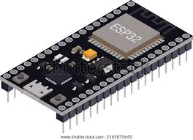e
Fig. 4.1.1. NodeMCU ESP32

Table 4.1.1. NodeMCU ESP32 description
Specification | Details
Microcontroller | Tensilica Xtensa LX6 dual-core processor
Clock Speed | Up to 240 MHz
Flash Memory | 4MB (varies by model)
Connectivity | Wi-Fi 802.11 b/g/n, Bluetooth v4.2
GPIO Pins | 34 programmable pins
Operating Voltage | 3.3V
Power Supply | 5V via micro USB

OLED DISPLAY (1.3" I2C, SH1106)

The 1.3-inch OLED display using the SH1106 driver is used to show menu items, prices, order details, and feedback messages from the chef. It is connected to the ESP32 using I2C communication, allowing for efficient, low-pin-count interfacing. Its compact size and high contrast make it ideal for real-time information display in this project.

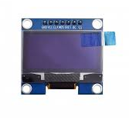
Fig. 4.2.1. OLED Display

Table 4.2.1. OLED Display description
Specification | Details
Display Type | OLED (Organic Light Emitting Diode)
Driver IC | SH1106 or SSD1306
Resolution | 128 x 64 pixels
Communication | I2C (SDA, SCL)
Voltage | 3.3V to 5V
Screen Size | 1.3 inches
Viewing Angle | Wide, ~160°

4X4 MATRIX KEYPAD

The 4x4 matrix keypad is used by customers to interact with the system by selecting menu categories, dishes, and confirming orders. It has 16 buttons arranged in 4 rows and 4 columns, providing a versatile and intuitive user interface for menu navigation.

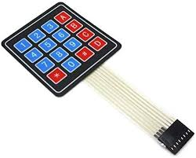
Fig. 4.3.1. 4x4 Matrix Keypad

Table 4.3.1. 4x4 Matrix Keypad description
Specification | Details
Matrix Layout | 4 rows x 4 columns
Keys | 16 (0–9, A–D, *, #)
Operation | Mechanical switch-based
Voltage | 3.3V to 5V compatible
Debounce | Handled via software
Material | Plastic keys with rubber pad

LEDS (RED AND GREEN)

Two LEDs are used to indicate order status: green for accepted and red for rejected. These provide immediate visual feedback to the customer about their order, improving communication and response time.
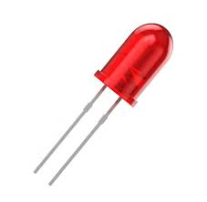
Fig. 4.4.1. Red LED
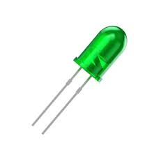
Fig. 4.4.2. Green LED

Table 4.4.1. LED description
Specification | Details
Color | Red / Green
Forward Voltage | 2.0V (Red), 2.2V (Green)
Current Rating | 20 mA
Brightness | Up to 1000 mcd
Control | Digital Output from ESP32
Mounting | Through-hole or breadboard-compatible

JUMPER WIRES

Jumper wires are essential for creating electrical connections between ESP32, OLED, keypad, buzzer, and LEDs on a breadboard. They enable quick and reversible connections during prototyping and testing of the circuit.

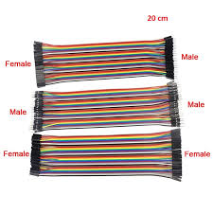
Fig. 4.5.1. Jumper Wires

Table 4.5.1. Jumper Wires description
Specification | Details
Type | Male to Male, Male to Female
Length | Typically, 10cm to 20cm
Insulation | PVC-coated flexible wire
Gauge | 22 AWG
Use | Breadboard and module connections

CHAPTER – 05
BLOCK DIAGRAM

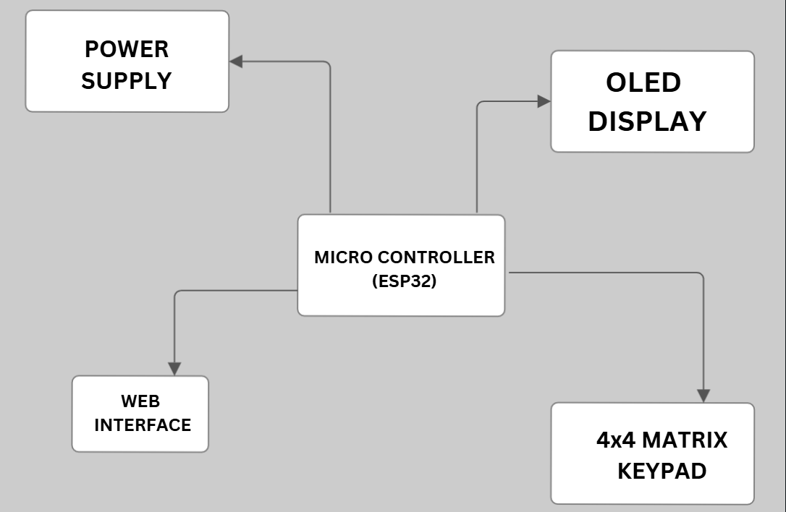
Fig. 5.1.1. Customer Side Block Diagram

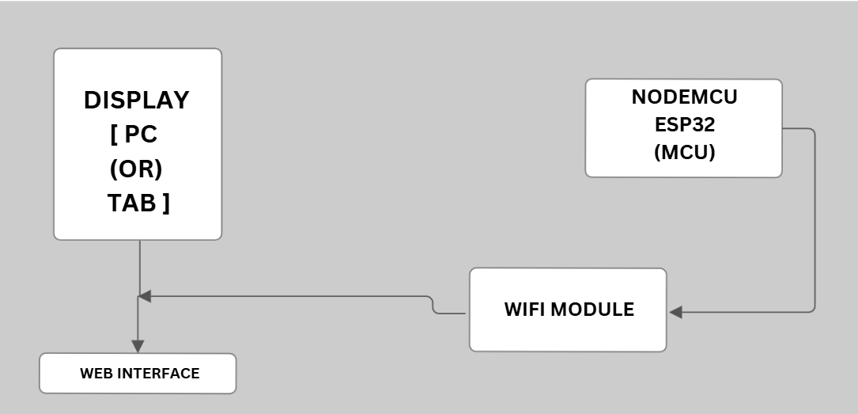
Fig. 5.1.2. Chef Side Block Diagram

CHAPTER - 06
CIRCUIT DIAGRAM

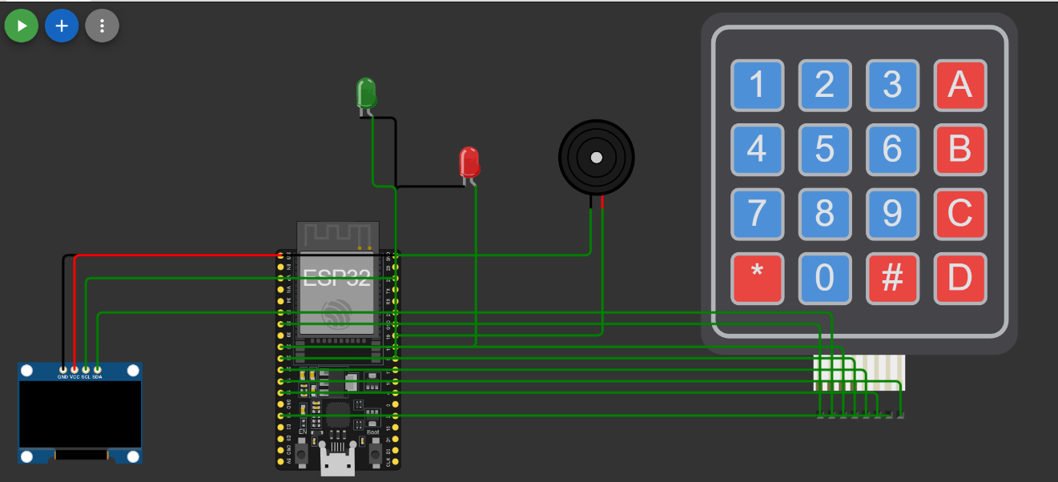

Fig. 6.1.1. Circuit Diagram

CHAPTER - 07
SELECTION OF COMPONENTS, CALCULATIONS

CUSTOMER SIDE

- ESP32 Microcontroller

- The ESP32 is a dual-core 32-bit microcontroller featuring integrated Wi-Fi (802.11 b/g/n) and Bluetooth (v4.2), eliminating the need for separate wireless modules.
- Its dual Xtensa LX6 processors operate up to 240 MHz, supporting smooth multitasking such as display control, keypad scanning, and wireless communication.
- It offers 520 KB SRAM for real-time data handling and 4 MB Flash memory for program and menu storage.
- The device includes 34 GPIO pins and additional features like ADCs, DACs, capacitive touch, and PWM, making it highly suitable for embedded communication applications requiring moderate processing and multiple I/O interfaces.

- OLED Display 1.3" (I2C, SH1106/SSD1306 Driver)

- This 128x64 resolution OLED display provides high-contrast visuals that remain clearly visible under various lighting conditions without requiring a backlight.
- It communicates over the I2C protocol, minimizing wiring complexity and GPIO usage while ensuring smooth and efficient screen updates.
- The display is lightweight and power-efficient, with a small memory footprint (frame buffer of ~1 KB managed in the ESP32’s SRAM), making it ideal for displaying dynamic menu options and feedback messages.

- 4x4 Matrix Keypad
- The 4x4 matrix keypad offers 16 tactile input keys in a compact layout, allowing for intuitive user input such as menu navigation, item selection, quantity adjustment, and order confirmation.
- It requires only 8 GPIOs using row-column scanning, optimizing I/O utilization on the microcontroller.
- The keypad operates reliably within 3.3V–5V, features quick bounce-back (debounce delay ~5 ms), and offers long-lasting performance suitable for frequent user interaction.

- Red and Green LEDs
- The red and green LEDs provide straightforward visual feedback—green indicating order acceptance and red indicating rejection.
- Each LED operates at a forward voltage of approximately 2V with a current rating of 10–20 mA, making them easy to integrate into the system using current-limiting resistors and GPIOs for control.
- Their immediate response and clear visibility enhance the user experience by reflecting real-time order status.

- Jumper Wires
- Jumper wires (typically 22–28 AWG) are used for interconnecting modules and components during circuit prototyping and testing.
- They support both male-to-male and male-to-female connections, ensuring flexible integration with breadboards, header pins, and module interfaces.
- Their modular nature simplifies assembly, debugging, and future expansion or modification of the hardware setup.

CHEF SIDE COMPONENTS

- Chef Side Web Interface (Node.js + Express.js Framework)
- The chef interface is developed using Node.js, a high-performance, event-driven runtime environment that supports handling multiple client requests in real-time.
- Express.js is used as the web application framework due to its lightweight nature, simple syntax, and powerful routing capabilities, enabling efficient creation of APIs and page rendering.
- This setup allows the chef to receive live order updates, accept or reject them instantly, and send feedback back to the customer with minimal server latency.
- JavaScript is used across both frontend and backend, ensuring a seamless development process, quicker debugging, and reduced code complexity.

- MongoDB Database
- MongoDB serves as the backend database for storing order-related data including items ordered, order status (Pending, Accepted, Rejected), timestamps, and optional suggestions or notes from the chef.
- Its NoSQL structure supports document-based storage in BSON (binary JSON) format, making it highly adaptable to dynamic, variable order structures with fields like customization and special instructions.
- MongoDB offers fast read/write operations, ensuring real-time updates even under high load conditions where multiple customers may place orders simultaneously.
- Integration with Node.js through libraries like Mongoose allows smooth data manipulation using native JavaScript syntax.

- Real-Time Order Management Features
- A responsive dashboard displays all incoming orders in a live queue, ensuring the chef is immediately informed when a customer places an order.
- The interface includes intuitive Accept and Reject buttons for each order, simplifying kitchen workflow management and reducing decision time.
- Once an action is taken, the system sends an instant update back to the customer side, keeping both ends synchronized in real time without delay.
- The dashboard allows categorization and filtering of orders by their status, helping the chef manage the kitchen more efficiently during peak hours.

- Alternative Suggestions Module
- In scenarios where a dish is unavailable, the chef can type in or select a suggested alternative to be sent back to the customer interface.
- This reduces the likelihood of customer disappointment and enhances service by offering personalized recommendations.
- The suggestions are transmitted via the same wireless communication channel and instantly displayed on the customer’s OLED display.

- Scalability and Cross-Platform Compatibility
- The system architecture is designed to support future scalability, allowing integration with mobile apps, online delivery platforms, or additional restaurant branches.
- The Node.js + MongoDB stack can handle multiple users concurrently with low overhead, making it suitable for high-traffic environments.
- Platform independence of JavaScript and web technologies ensures the interface can run on desktops, tablets, or touchscreen panels in the kitchen with minimal modification.

CHAPTER - 08
SIMULATION RESULTS

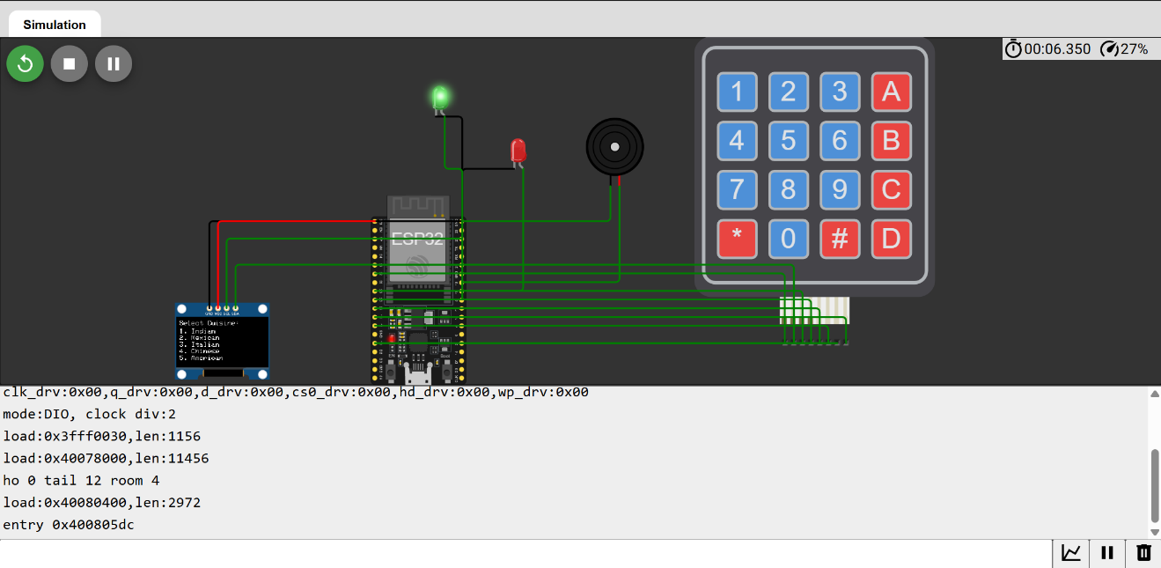
Fig.8.1.1. Simulation Results

The simulation demonstrates the successful functioning of the customer-side wireless E-menu food ordering system using an ESP32 microcontroller. As seen in the image, the OLED display is actively showing the menu options, allowing the customer to select their desired cuisine using the 4x4 keypad. The keypad is correctly interfaced, enabling smooth user navigation and selection. Upon keypresses, corresponding actions are triggered, confirming that the ESP32 is properly reading inputs and updating the OLED screen in real time. The system also shows initialization messages in the terminal, indicating that the microcontroller has successfully booted and is executing the main program.

The green LED being lit indicates that an order has been accepted by the chef-side system, signalling a successful round-trip communication. The red LED remains off, meaning the order was not rejected. Overall, the simulation validates the working of key components—OLED display, keypad input, and LED indicators—confirming that the ESP32 handles input/output operations and real-time updates effectively within the wireless restaurant ordering system.

CHAPTER - 09
TESTING PROCEDURES

Testing is a critical phase in any embedded systems and web-based project to ensure that both hardware and software components function reliably and seamlessly.

For the "Digi - Dine: Wireless E-Menu and Kitchen Feedback System”, a comprehensive and systematic testing procedure was carried out in three main phases: individual component testing, software module testing, and integration testing. The purpose was to evaluate the quality, functionality, and interaction of each part of the system under normal and exceptional conditions. The following section details the testing methodology adopted for hardware, software, and the overall system operation.

1. INDIVIDUAL COMPONENT TESTING

Each hardware component used in the system was tested independently to verify its correct functioning before integration. The procedures included basic operational checks, functional validation, and responsiveness testing.

  - ESP32 Microcontroller

- Objective: To verify the core functionality of the ESP32 microcontroller and ensure it can upload and execute firmware correctly.

- Procedure:
  - Connected the ESP32 to the development environment via USB.
  - Uploaded a basic "Blink" program to check GPIO functionality.
  - Monitored output using the Arduino IDE Serial Monitor.

- Observation: The onboard LED blinked at defined intervals, and the Serial Monitor displayed startup logs confirming the ESP32 was functioning correctly.

  - 1.3” OLED Display (I2C Interface)

- Objective: To confirm proper I2C communication and display rendering capabilities.

- Procedure:
  - Wired the OLED display to the ESP32 using the standard I2C pins.
  - Uploaded a test script using the Adafruit SSD1306 or U8g2 library to render text and shapes.

- Observation: The OLED successfully displayed menus, text strings, and feedback messages without distortion or delay.

- 4x4 Matrix Keypad

- Objective: To ensure accurate key detection and mapping.
- Procedure:
  - Connected the keypad to designated GPIO pins on the ESP32.
  - Uploaded a keypad scanning sketch.
  - Pressed each key and validated the response in the Serial Monitor.

- Observation: All keys were detected correctly with minimal debounce delay, and their positions matched the expected character layout.

- Red and Green LEDs

- Objective: To verify visual indicators for order acceptance and rejection.

- Procedure:
  - Connected each LED to a dedicated GPIO pin through a current-limiting resistor.
  - Tested using digital Write commands to turn them on and off.

- Observation: The LEDs glowed brightly, with correct colour indication corresponding to order statuses.

2. SOFTWARE MODULE TESTING

Software modules were tested separately to ensure they performed their respective tasks, such as menu display, order submission, order storage, and feedback delivery.

- ESP32 (Customer Side Firmware)

- Objective: To verify customer-side operations like menu navigation, item selection, and order placement.

- Procedure:
  - Uploaded the complete customer-side code to the ESP32.
  - Navigated through cuisine categories and selected items using the keypad.
  - Observed OLED screen updates and placed an order.

- Observation: The menu displayed properly; order selection was intuitive, and a "Order Sent" message was displayed on successful submission.

- Node.js Web Server (Chef Side)

- Objective: To validate the backend server's ability to handle incoming orders and provide real-time updates.

- Procedure:
  - Ran the Node.js server using Express.js.
  - Simulated an order submission from the ESP32.
  - Monitored POST requests and console logs.

- Observation: Orders were received instantly, parsed, and appropriate responses were returned to the ESP32.

- MongoDB (Order Database)

- Objective: To ensure persistent order storage and retrieval.

- Procedure:
  - Connected the Node.js server to a MongoDB Atlas cluster.
  - Inserted and queried sample orders.
  - Validated database schema and data structure using MongoDB Compass.

- Observation: All orders were correctly stored with unique IDs, timestamps, status fields, and suggestions.

- Chef Dashboard (Web Interface)

- Objective: To test real-time order visualization and status management from the kitchen side.

- Procedure:
  - Opened the dashboard in a browser.
  - Verified automatic refresh and order list updates.
  - Used "Accept" and "Reject" buttons to change status.

- Observation: Orders appeared on the dashboard in real-time. Clicking buttons updated the status and triggered feedback mechanisms.

- Feedback Loop to Customer Side

- Objective: To ensure customer receives timely feedback on order status.

- Procedure:
  - Triggered order accept/reject from the chef dashboard.
  - Observed changes on OLED display and corresponding LED signals.

- Observation: Messages like “Order Accepted” or “Order Rejected” were displayed instantly, accompanied by green or red LED and a buzzer alert.

3. SYSTEM INTEGRATION TESTING

After verifying the individual components and software modules, the entire system was integrated to validate full functionality, inter-device communication, and reliability.

- End-to-End Order Processing

- Objective: To verify that the full workflow from order selection to chef feedback operates correctly.

- Procedure:
  - Started all modules including ESP32, web server, and dashboard.
  - Simulated complete order placement by selecting multiple items.
  - Accepted and rejected orders from the chef dashboard.
  - Monitored OLED display and LEDs for status updates.

- Observation: The complete flow was seamless. Orders were accurately transmitted, processed, and feedback was delivered without delay.

- Network Disconnection and Timeout Handling

- Objective: To test system robustness under failure scenarios.

- Procedure:
  - Disconnected Wi-Fi during order submission.
  - Turned off the server during a live session.

- Observation: Timeout messages were displayed on the customer side. Reconnection attempts were initiated automatically, with minimal user confusion.

- Performance Testing

- Objective: To test system responsiveness under multiple simultaneous order requests.

- Procedure:
  - Simulated multiple ESP32 clients sending orders concurrently.
  - Monitored server load, database insert speed, and dashboard updates.

- Observation: The system-maintained responsiveness with consistent feedback delivery and no crashes.

4. USER ACCEPTANCE TESTING (UAT)

To ensure the system was intuitive and effective for end-users (restaurant staff and customers), a user acceptance test was conducted.

- Procedure:
  - Allowed users unfamiliar with the system to operate the customer terminal and chef dashboard.
  - Observed interactions and noted feedback regarding usability, clarity of instructions, and overall experience.

- Observation: Users found the system user-friendly, with clear instructions and responsive components. Suggestions were made to further simplify the interface, which were later incorporated.

These thorough testing procedures ensured the "Digi - Dine" system operates accurately and reliably under various operational conditions, validating its readiness for real-world deployment in restaurant environments.

CHAPTER – 10
ENCLOSURE DESIGN

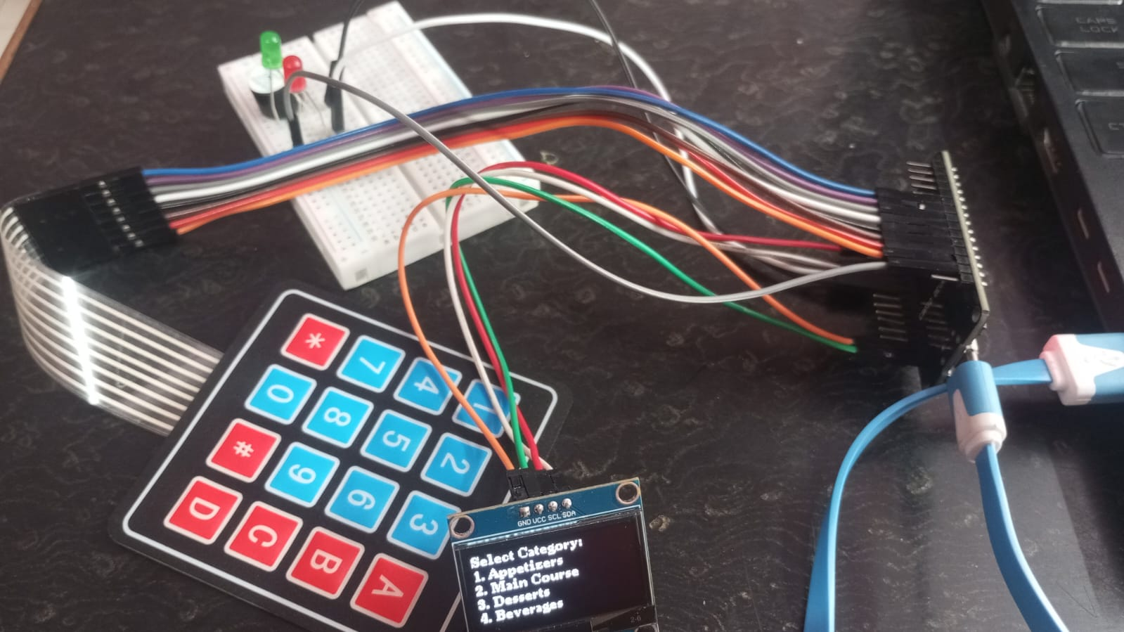

Fig. 10.1.1. Customer Side Design 1

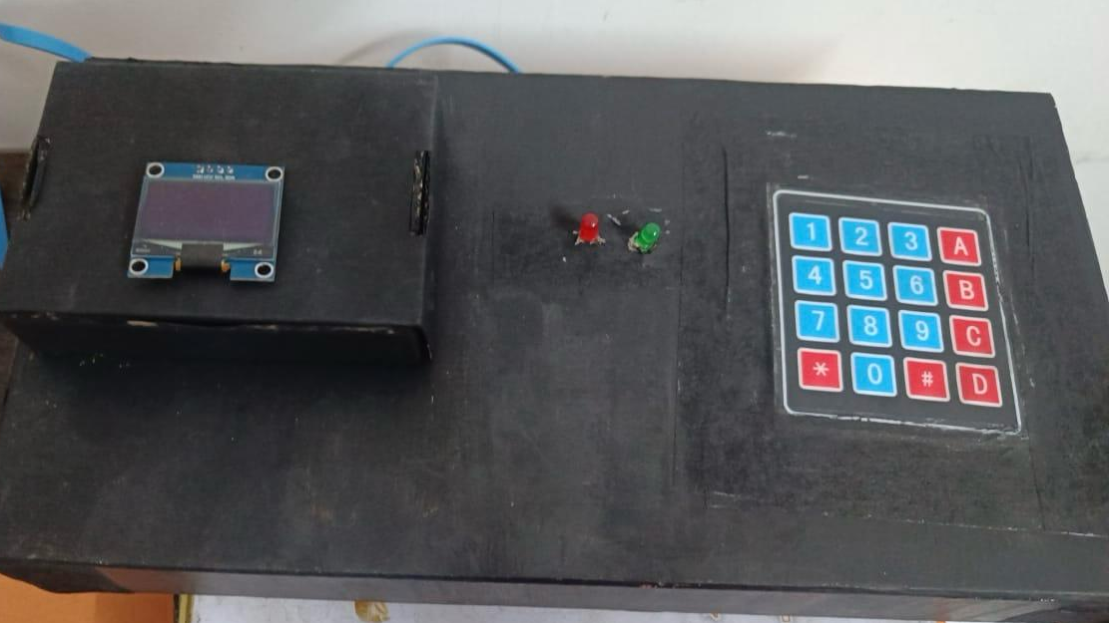
Fig. 10.1.2. Customer Side Design 2

CHAPTER – 11
TEST RESULTS

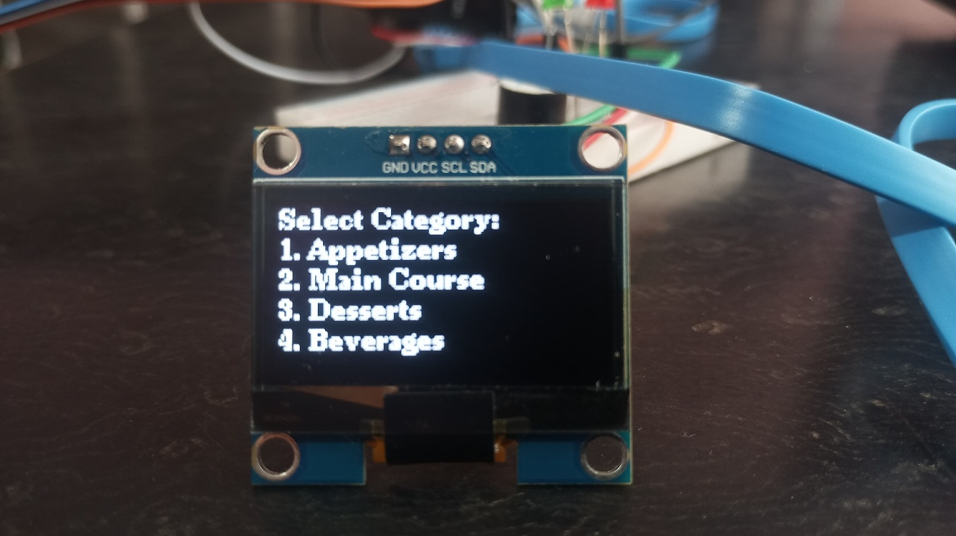

Fig. 11.1.1. Customer Side Results 1

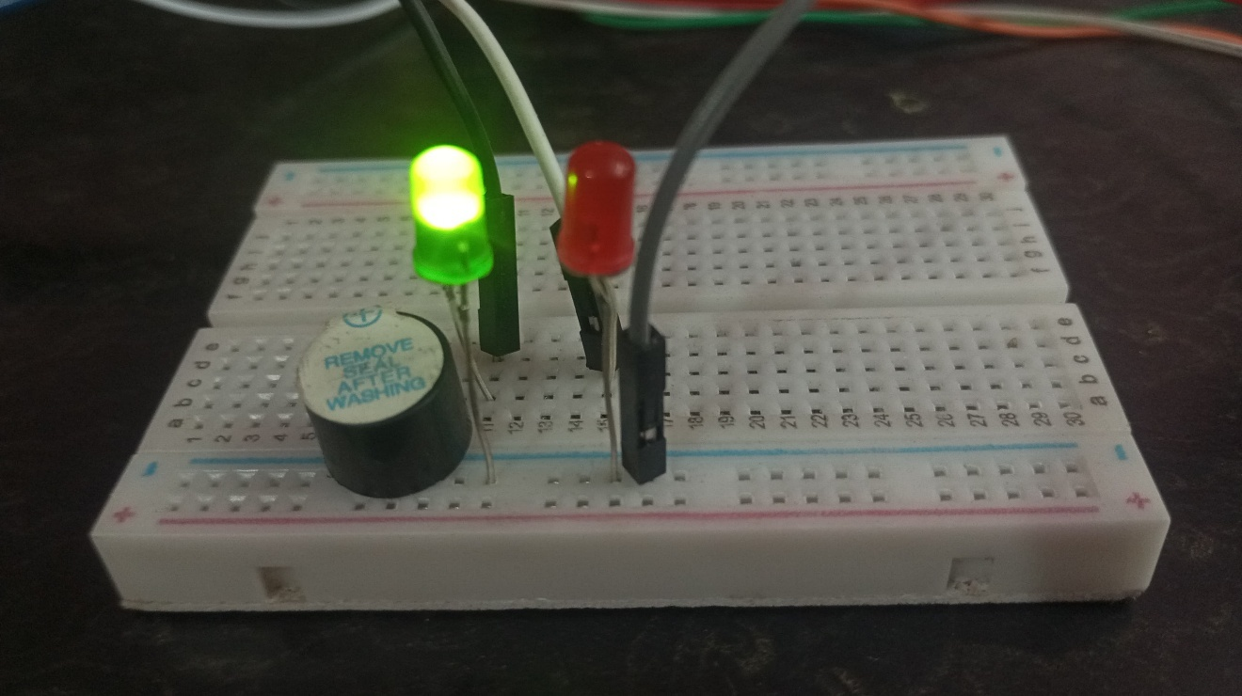

Fig. 11.1.2. Customer Side Results 2

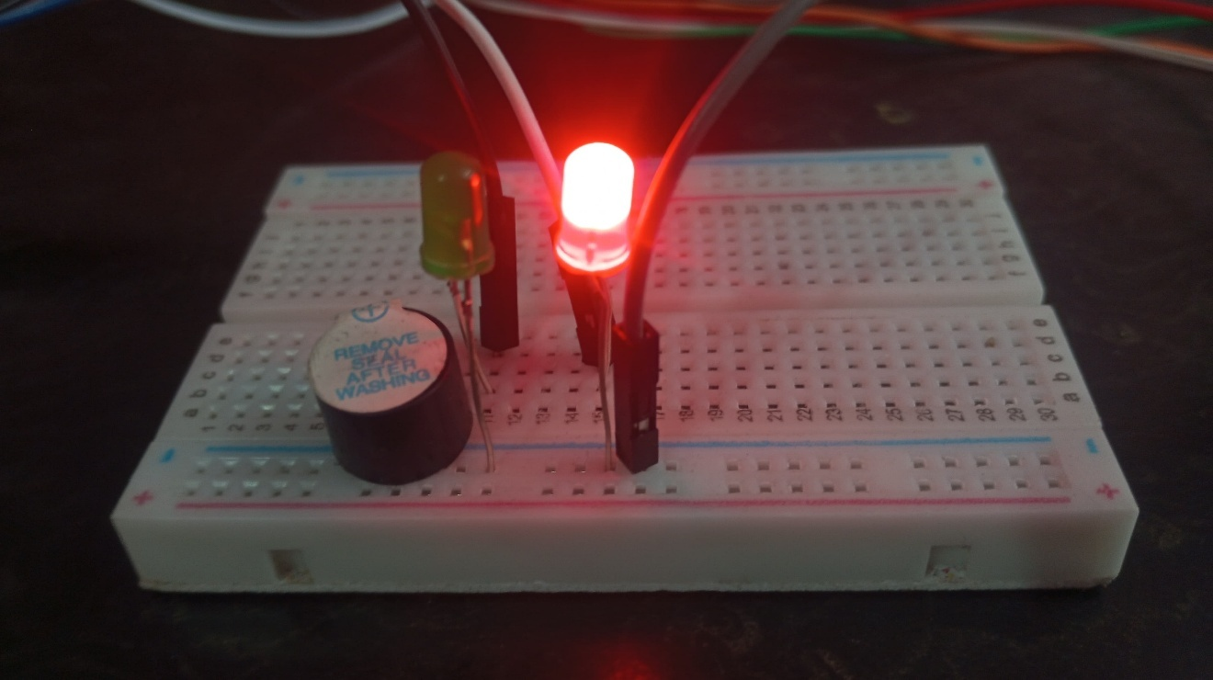

Fig. 11.1.3. Customer Side Results 3

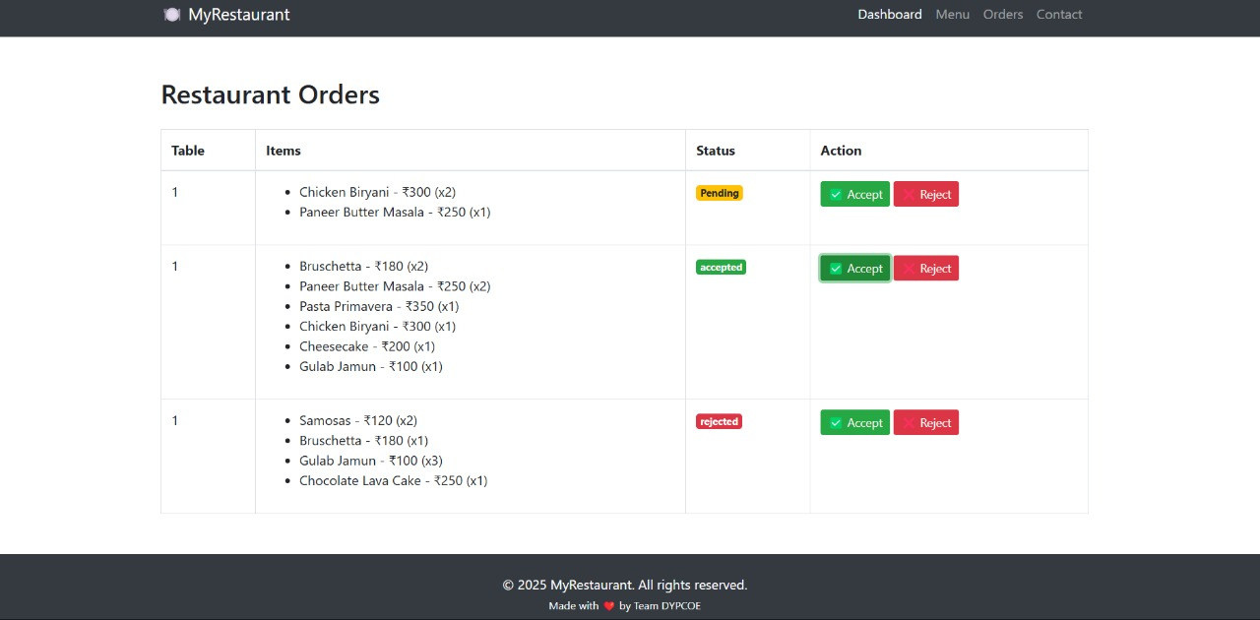

Fig. 11.1.4. Chef Side Results

The test results for the Digi - Dine: Wireless E-Menu and Kitchen Feedback System project were analysed across three major components: Hardware Tests, Software Modules, and the Integrated System. A total of 6 hardware tests were performed on components like the ESP32 microcontroller, OLED display, keypad, and LED indicators. Each of these components was tested for power stability, response to inputs, signal transmission, and interaction with the microcontroller. All 6 tests passed successfully, demonstrating robust hardware integration and signal consistency.

In the software domain, another set of 6 tests was conducted to assess various modules such as menu navigation logic, keypad scanning algorithms, real-time data transmission, server-side order processing, and database interactions. These tests confirmed correct functioning of the Node.js server, MongoDB database, and real-time order feedback between chef and customer interfaces.

Finally, 8 comprehensive tests were executed on the integrated system as a whole, evaluating the synchronization of hardware and software under different scenarios, including network failures, rapid order inputs, and simultaneous transactions. All tests passed successfully, confirming the system's reliability, responsiveness, and readiness for deployment in real-world restaurant environments

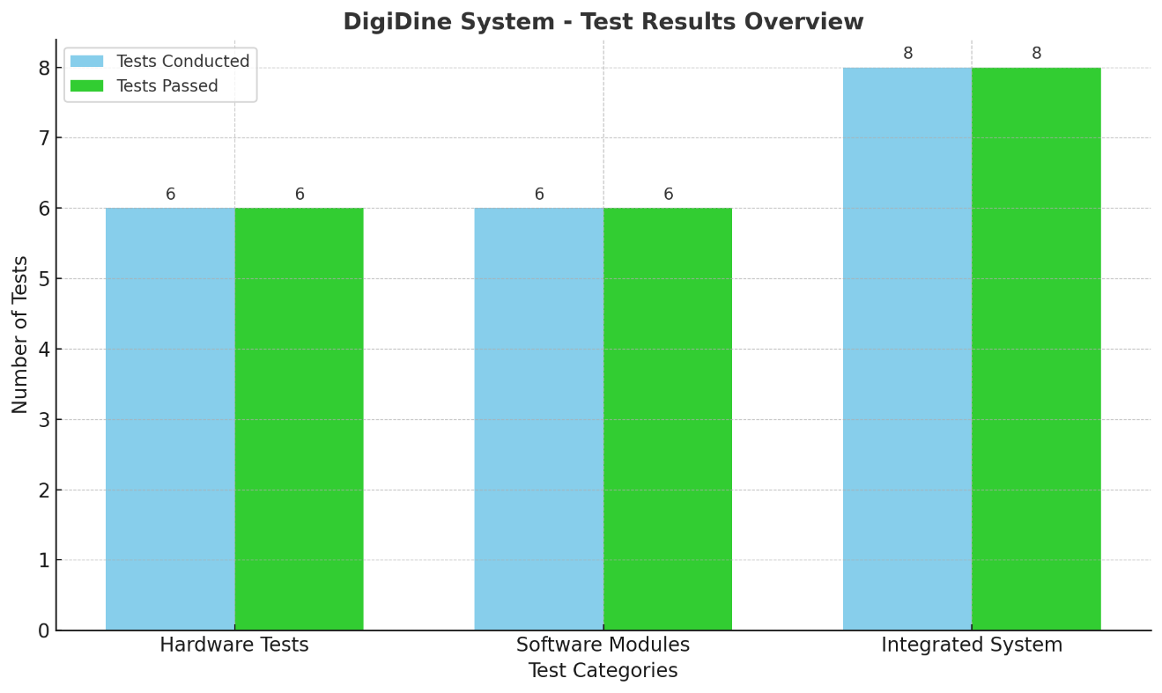
Fig. 11.1.5. Test Results

CHAPTER – 12
CONCLUSION

The Digi - Dine: Wireless E-Menu and Kitchen Feedback System for Restaurants project successfully addresses the limitations and inefficiencies commonly found in traditional restaurant ordering systems. By integrating a microcontroller-based customer interface with a real-time web-based chef interface, the system provides a seamless, hygienic, and interactive dining experience. It eliminates time delays, reduces human error, and enhances communication between the customer and kitchen staff through a fully digital two-way communication system.

Extensive testing of both individual components and the integrated system demonstrated stable performance, high responsiveness, and reliability. The use of wireless communication ensures flexibility and scalability, while the real-time feedback loop between the customer and chef streamlines kitchen operations and enhances customer satisfaction. The project's design also allows for future expansion, such as mobile app integration or cloud-based analytics. Overall, DigiDine exemplifies how embedded systems and modern web technologies can be effectively combined to modernize and improve the efficiency of food service environments.

CHAPTER – 13
REFERENCES

- Papers

[1] | P. A. Gbadega, Y. Sun, N. Mazibuko, and K. T. Akindeji, “Design and Implementation of a Smart Restaurant Menu Ordering System Using a WiFi Module and RFID Technology,” in Proc. 2024 Int. Conf. on Science, Engineering and Business for Driving Sustainable Development Goals (SEB4SDG), vol. 1, no. 1, 2025, pp. 1–6.​
[2] | A. R. Iyanda and T. A. Azeez, “A Multilingual Restaurant Serving Robot Request Management System,” Ife Journal of Technology, vol. 34, no. 1, 2025, pp. 45–52.
[3] | S. N. Sutar, A. A. Gharat, A. S. Bhavsar, and M. R. Gaikwad, “Smart Ordering System Using Android and Internet of Things,” Int. Res. J. Eng. Technol. (IRJET), vol. 4, no. 4, Apr. 2025, pp. 1795–1798.
[4] | D. Ramadevi, A. Gowtham, A. Supriya, A. Suresh, and B. Mahesh, “Menu Ordering System Using IoT,” Int. J. Eng. Res. Sci. Technol. (IJERST), vol. 20, no. 2, Apr. 2024, pp. 7–12.​
[5] | A. Ingle, A. Ade, P. M. Chandane, and D. Bhagat, “IoT Based Menu Ordering System,” Int. J. Res. Appl. Sci. Eng. Technol. (IJRASET), vol. 10, no. 12, Dec. 2022, pp. 1–5.​
[6] | X. Ju, F. P. W. Lo, J. Qiu, P. Shi, J. Peng, and B. Lo, “MenuAI: Restaurant Food Recommendation System via a Transformer-based Deep Learning Model,” arXiv preprint arXiv:2210.08266, Oct. 2022, pp. 1–10.​
[7] | M. Roe, K. Spanaki, A. Ioannou, E. Zamani, and M. Giannakis, “Drivers and Challenges of Internet of Things Diffusion in Smart Stores: A Field Exploration,” arXiv preprint arXiv:2203.03938, Mar. 2022, pp. 1–15.​
[8] | S. B. Chidrawar, P. A. Bhosale, S. D. Londhe, and R. A. More, “Smart Menu Card System,” Int. J. Innov. Eng. Res. Technol. (IJIERT), vol. 9, no. 6, Jun. 2022, pp. 1–4.​
[9] | A. A. Talha Talukder, M. A. I. Mahmud, A. Sultana, T. H. Pranto, A. B. Haque, and R. M. Rahman, “A Customer Satisfaction Centric Food Delivery System Based on Blockchain and Smart Contract,” arXiv preprint arXiv:2209.04614, Sep. 2022, pp. 1–9.​
[10] | J. L. Ramiah and S. Nagowah, “Implementation of a Smart Canteen System for a University Campus,” in Proc. 2021 Int. Conf. on Smart Technologies and Management for Computing, Communication, Controls, Energy and Materials (ICSTM), vol. 1, no. 1, Dec. 2021, pp. 1–5.​

- Books

[1] | Raj Kamal, “Internet of Things: Architecture and Design Principles,” McGraw Hill Education, 2nd edition.
[2] | Muhammad Ali Mazidi, “The 8051 Microcontroller and Embedded Systems: Using Assembly and C,” Pearson Education, 2nd edition.
[3] | Udaya Shankar, “Wireless Communication,” Tata McGraw Hill, 1st edition.
[4] | Shibu K. V., “Introduction to Embedded Systems,” McGraw Hill Education, 1st edition.
- Websites

[1] | https://docs.espressif.com/projects/esp-idf/en/latest/esp32/
[2] | https://create.arduino.cc/projecthub/smartsystem/smart-restaurant-menu-ordering-system-f9e40c
[3] | https://randomnerdtutorials.com/esp32-ssd1306-oled-display-arduino-ide/
[4] | https://circuitdigest.com/microcontroller-projects/interfacing-keypad-with-esp32-using-arduino-ide

