**#Crowd Counting#**

This project contains various computer vision and AI related python scripts

This project detects and count the person in image file.

**Dataset name**: ShanghaiTech

**##Platform and Required Libraries are**

**Platform – vs code**

**Libraries are,**

1)Opencv

2)numpy

3)imutils

4)tensorflow

5)torch

**###Method used is**

MobileNetSSD CaffeModel

It requires 2 files

1)MobileNetSSD_deploy.caffemodel

<https://github.com/mailrocketsystems/AIComputerVision/blob/master/MobileNetSSD_deploy.caffemodel>

2)MobileNetSSD_deploy.prototxt

<https://github.com/mailrocketsystems/AIComputerVision/blob/master/MobileNetSSD_deploy.prototxt>

**####Result/Output:**

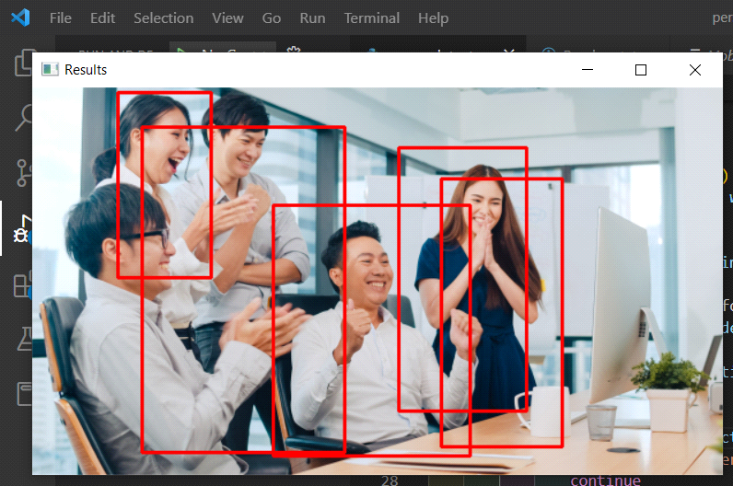

People count: 5