


Assessment Report
on
“AI/ML Prediction-Based”
submitted as partial fulfillment for the award of
BACHELOR OF TECHNOLOGY
DEGREE
SESSION 2025-26
in
CSE(AIML)
By
Name: Shreya
Roll Number: 202401100400179
Section: C

Under the supervision of
“Shivansh Prasad”

KIET Group of Institutions, Ghaziabad
May, 2025

Problem 1: Titanic Survival Prediction
1. Introduction
The Titanic Survival Prediction project aims to predict whether a passenger survived the Titanic disaster using machine learning classification techniques. The dataset contains passenger information such as age, gender, ticket fare, passenger class, and family details. Data preprocessing and Naive Bayes classification are used to build the prediction model.
2. Problem Statement
To develop a classification model that predicts passenger survival in the Titanic dataset using Naive Bayes classification and data preprocessing techniques.

3. Objectives
- Clean and preprocess the dataset
- Handle missing values
- Train a Naive Bayes classification model
- Predict passenger survival
- Visualize the results using graphs and confusion matrix

4. Methodology
- Data Collection: The Titanic dataset was downloaded from Kaggle and uploaded into Google Colab.
- Data Preprocessing:
- Missing values in Age and Fare columns were filled using median values
- Embarked missing values were filled using mode
- Unnecessary columns were removed
- Categorical data was converted into numerical form
- New features such as FamilySize and IsAlone were created

- Model Building:
  - Dataset was split into training and testing sets
  - Feature scaling was performed using StandardScaler
  - Gaussian Naive Bayes classifier was trained
- Model Evaluation:
  - Accuracy score was calculated
  - Classification report was generated
  - Confusion matrix heatmap was visualized

5. Code
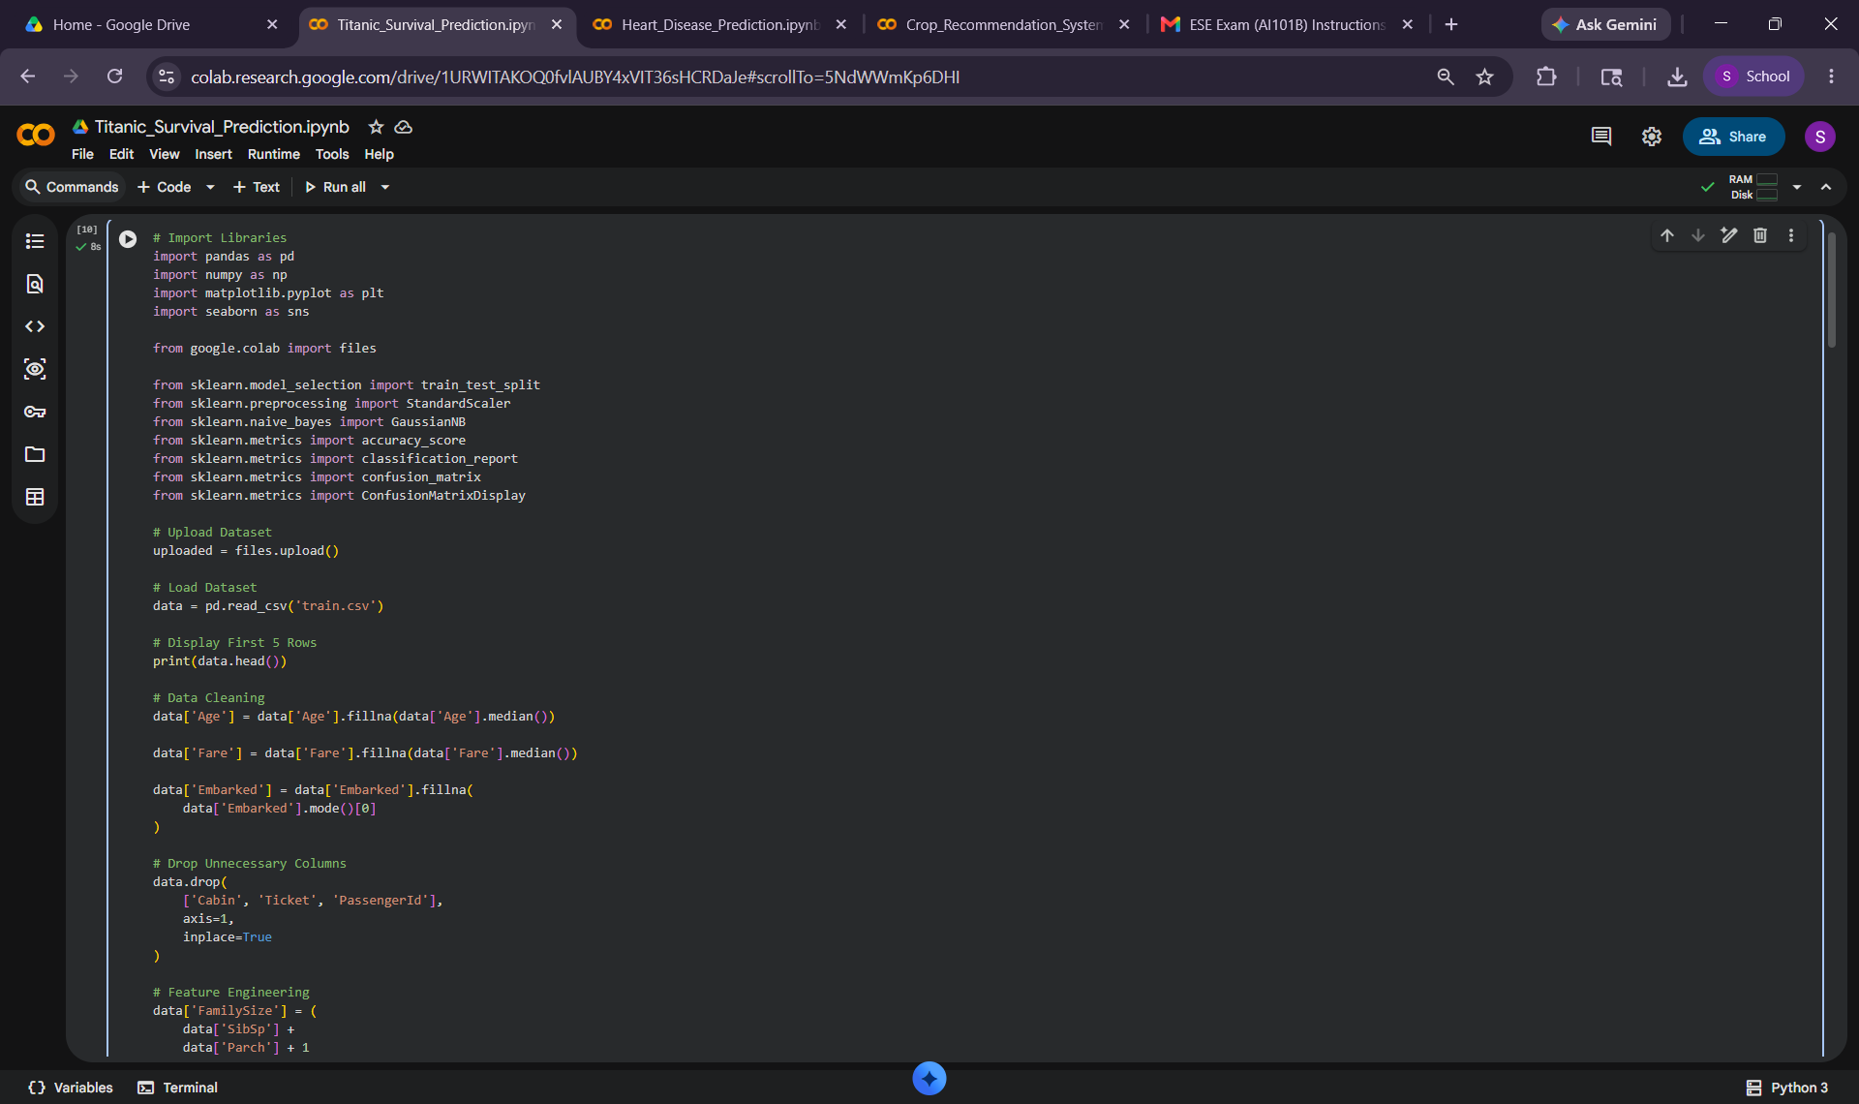
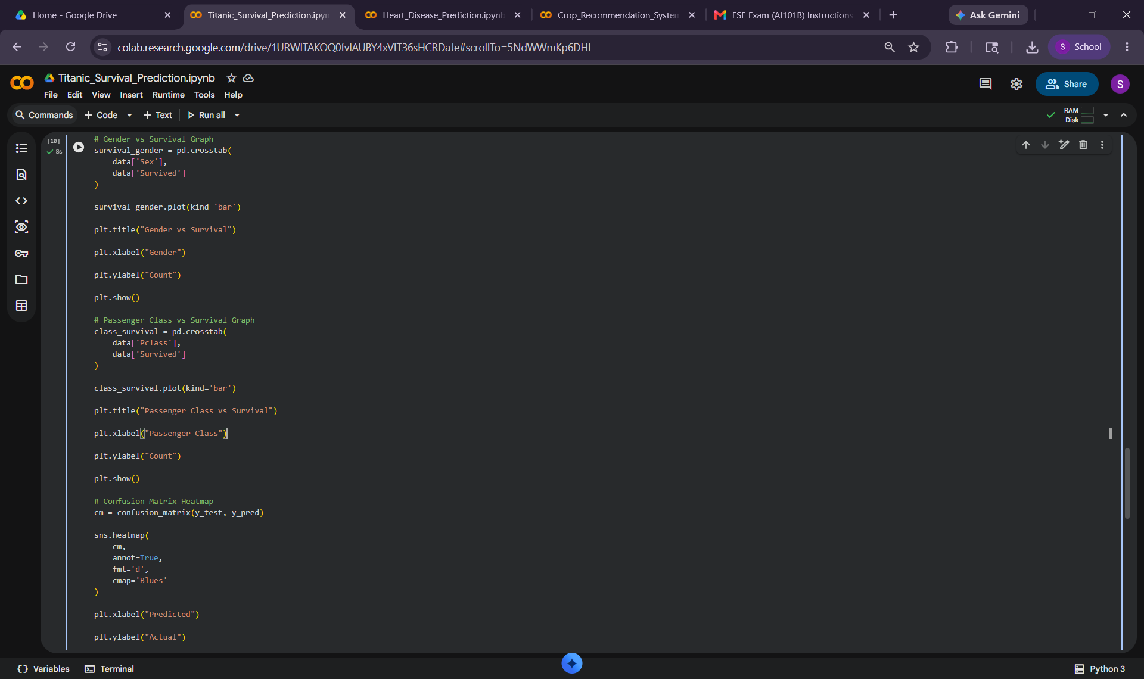

6. Model Implementation
Gaussian Naive Bayes algorithm was implemented for classification. The model was trained on the processed Titanic dataset and used to predict passenger survival on test data.
7. Evaluation Metrics
Evaluation Metrics
The following metrics were used:
- Accuracy Score
- Precision
- Recall
- F1 Score
- Confusion Matrix

8. Results and Analysis
The model achieved satisfactory accuracy in predicting passenger survival. Feature engineering and preprocessing improved prediction performance. Graphs and confusion matrix heatmap helped visualize the classification results effectively.
9. Conclusion
The Naive Bayes classification model successfully predicted passenger survival using the Titanic dataset. Data preprocessing and feature engineering improved model performance and helped achieve satisfactory accuracy.

10. References
- Titanic Dataset from Kaggle
- scikit-learn documentation
- pandas documentation
- matplotlib and seaborn libraries

11. Output/Results
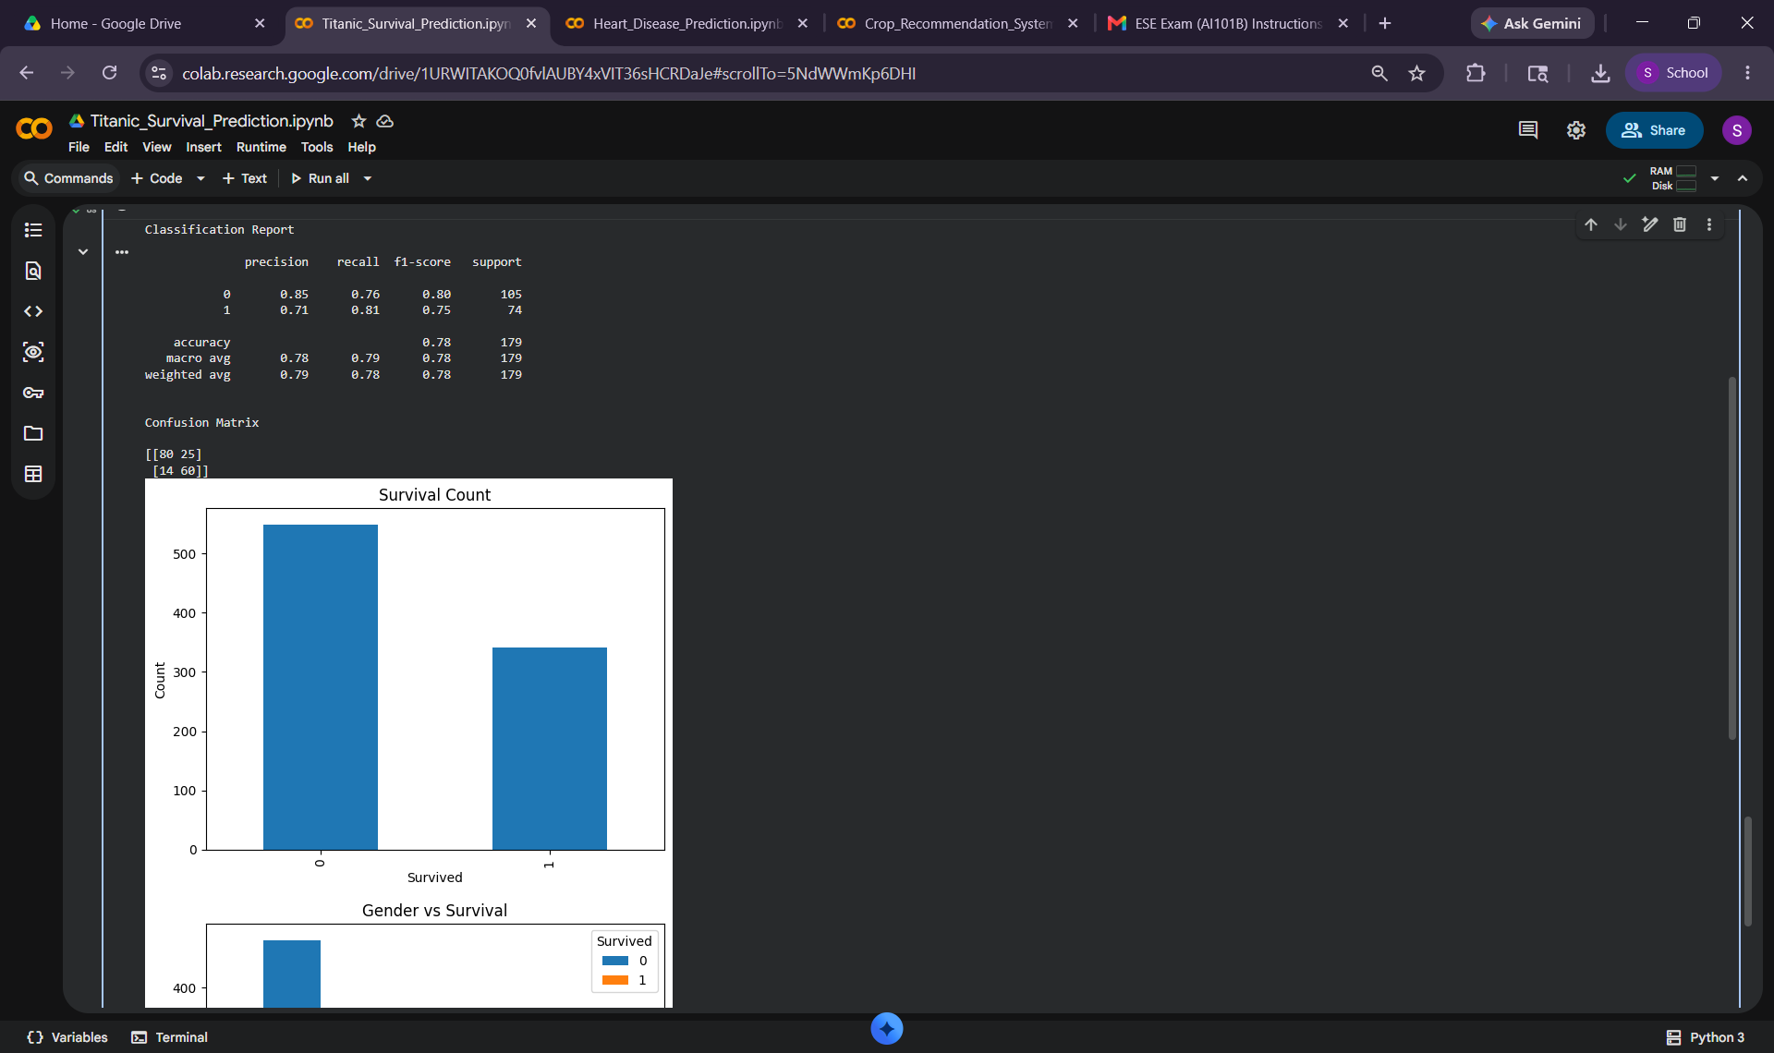

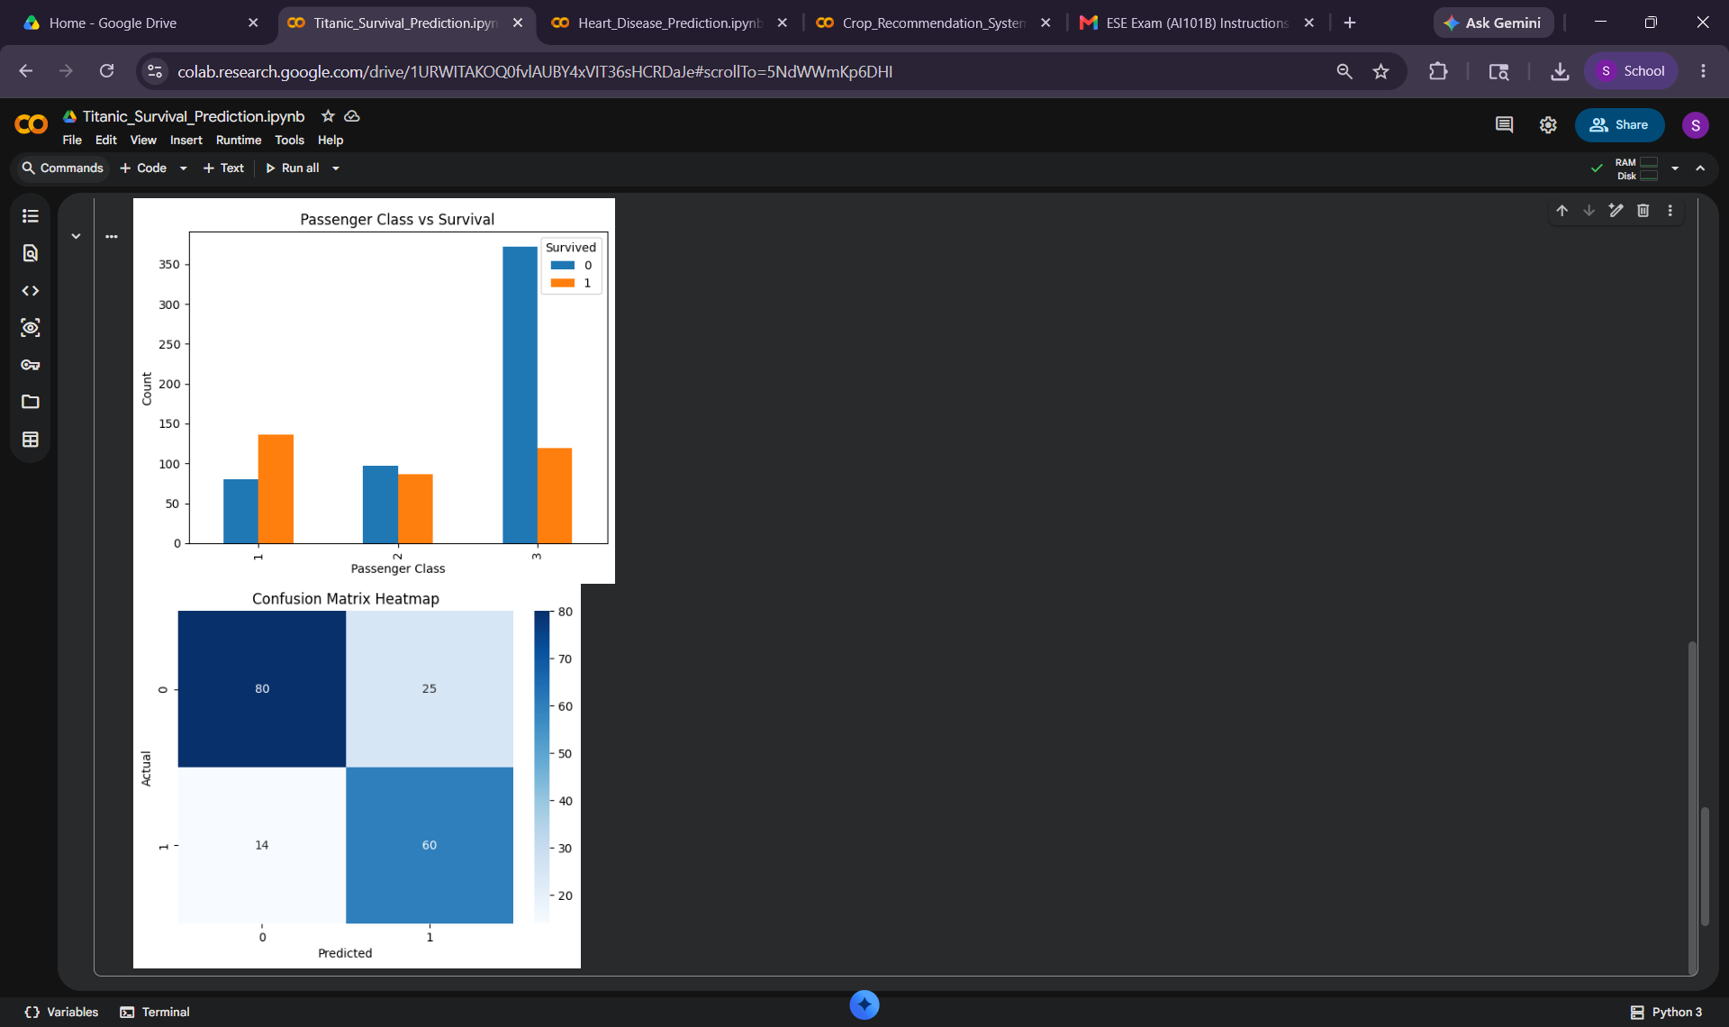

Problem 2: Heart Disease Prediction
1. Introduction
The Heart Disease Prediction project predicts the likelihood of heart disease based on medical parameters such as age, cholesterol level, chest pain type, blood pressure, and heart rate. Machine learning classification techniques were used to analyze the medical dataset and predict heart disease accurately.

2. Problem Statement
To develop a machine learning model that predicts heart disease using patient medical data and classification algorithms.
3. Objectives
- Preprocess medical dataset
- Handle categorical and numerical data
- Train a classification model
- Predict heart disease
- Evaluate model performance
- Visualize predictions and relationships using graphs

4. Methodology
- Data Collection:
The Heart Disease dataset was downloaded from Kaggle and uploaded into Google Colab.
- Data Preprocessing:
- Missing values were removed from the dataset
- Categorical values such as gender, chest pain type, slope, and thal were encoded into numerical values
- Feature scaling was applied using StandardScaler
- Input features and target variables were seperated
- Model Building:
  - Dataset was divided into training and testing sets
  - Random Forest classifier was selected for classification
  - Model was trained using training data
- Model Implementation:
Random Forest classifier was implemented because it provides high accuracy and handles medical datasets efficiently. Multiple decision trees were trained to improve prediction accuracy.
5. Evaluation Metrics
The following evaluation metrics were used:
- Accuracy Score
- Precision
- Recall
- F1 Score
- Confusion Matrix

6. Code
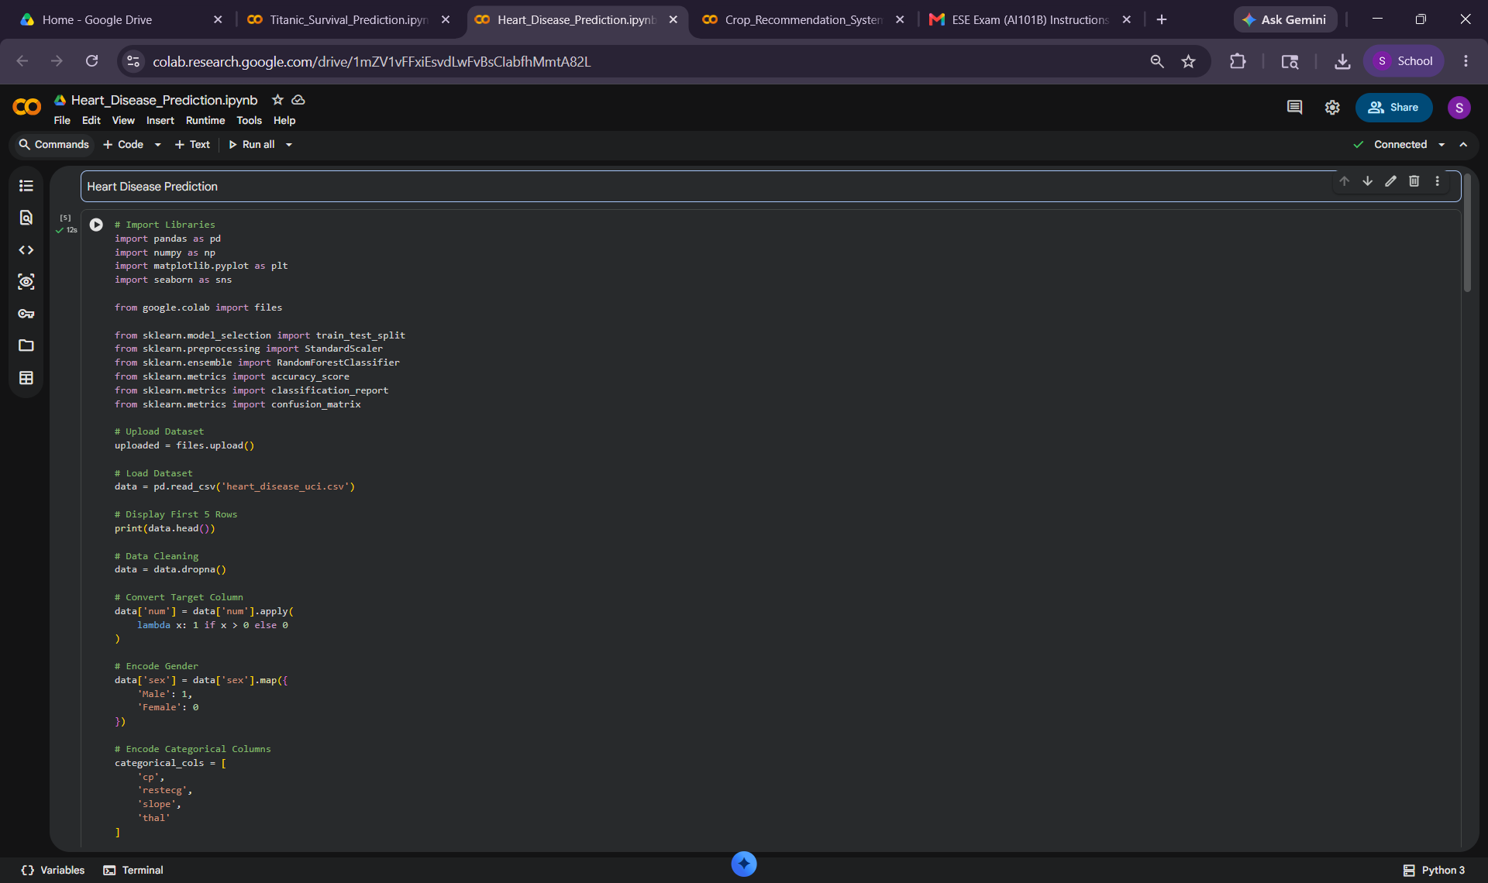
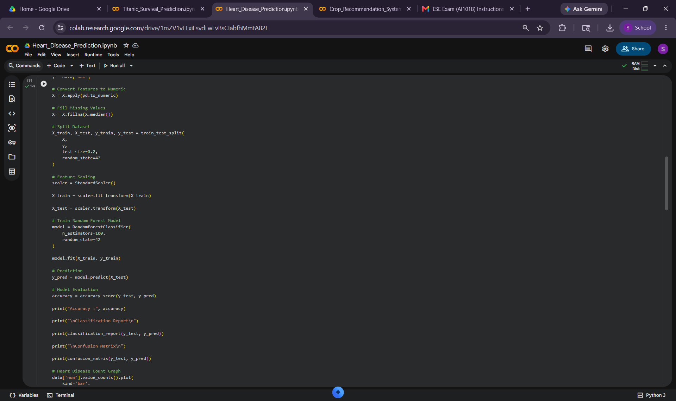

7. Results and Analysis
The Random Forest classifier achieved high accuracy in detecting heart disease. Graphs such as heart disease count, chest pain analysis, and confusion matrix heatmap helped analyze prediction performance and dataset patterns.
8. Conclusion
The Heart Disease Prediction system successfully predicted heart disease using machine learning classification techniques. The project demonstrates the practical application of machine learning in healthcare and disease diagnosis.
9. References
- Heart Disease Dataset from Kaggle
- scikit-learn documentation
- pandas documentation
- seaborn and matplotlib libraries
10. Output/Results
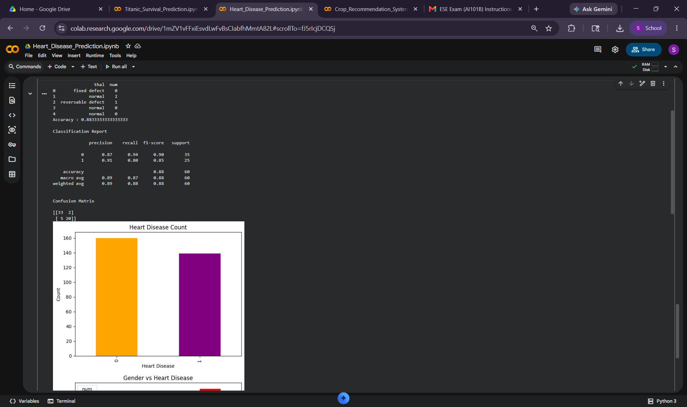

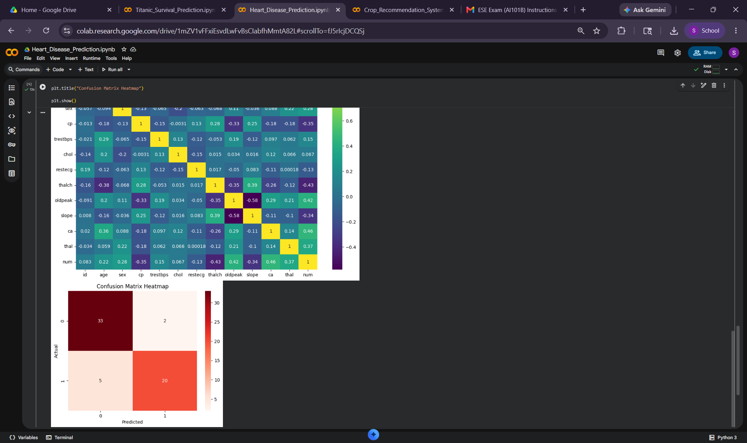

Problem 3: Crop Recommendation System
1. Introduction
The Crop Recommendation System predicts the most suitable crop based on soil nutrients and environmental conditions such as nitrogen, phosphorus, potassium, humidity, rainfall, and temperature. Machine learning classification techniques were used to recommend crops accurately.

2. Problem Statement
To design a machine learning recommendation system that predicts suitable crops based on soil and weather conditions.
3. Objectives
- Analyse agricultural dataset
- Preprocess soil and weather data
- Train a machine learning classification model
- Recommend suitable crops
- Visualize feature relationships and predictions
- Evaluate model performance

4. Methodology
- Data Collection:
The Crop Recommendation dataset was downloaded from Kaggle and uploaded into Google Colab.
- Data Preprocessing:
- Dataset was checked for missing values
- Features and target variables were separated
- Feature scaling was performed using StandardScaler
- Data was converted into machine learning compatible format

- Model Building:
  - Dataset was split into training and testing sets
  - Random Forest classifier was used for crop prediction
  - Model was trained using processed agricultural data
- Model Implementation:
Random Forest classification algorithm was implemented because it provides high prediction accuracy and handles agricultural datasets effectively. The trained model was used to recommend suitable crops based on environmental conditions.
5. Evaluation Metrics
The following metrics were used:
- Accuracy Score
- Precision
- Recall
- F1 Score
- Confusion Matrix

6. Code

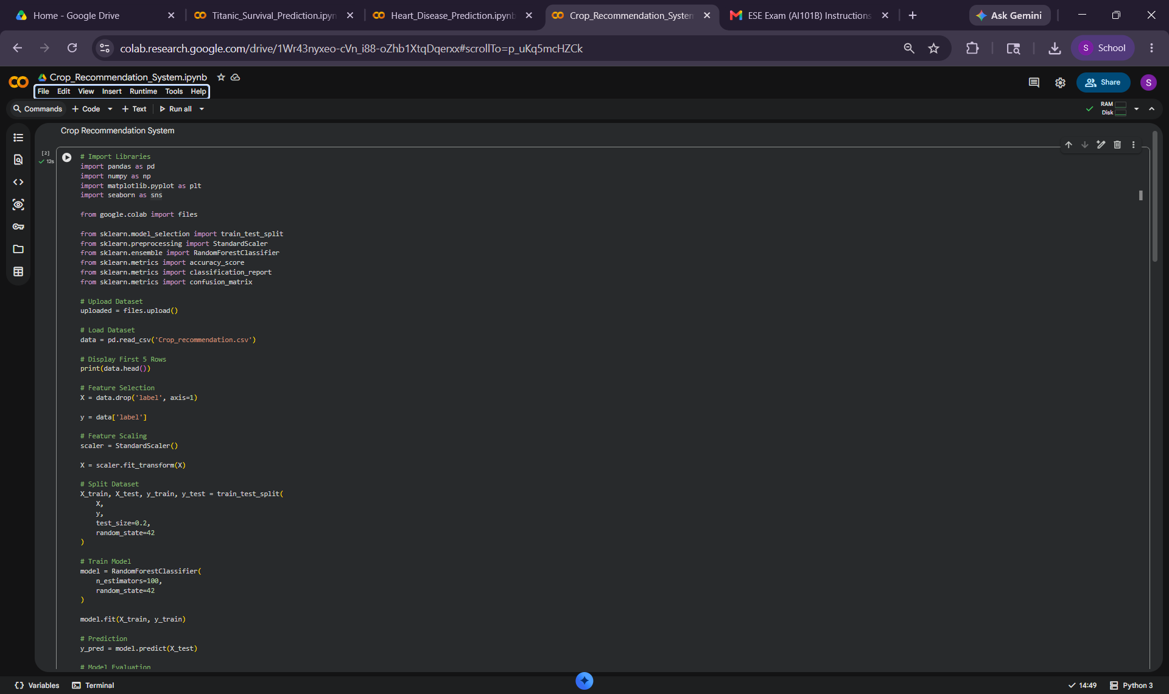
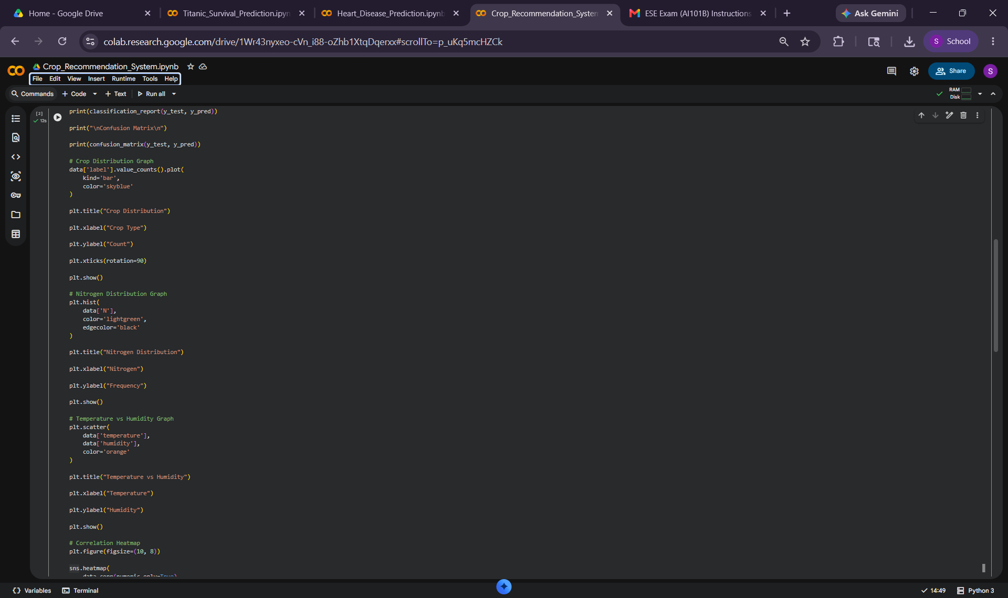

7. Results and Analysis
The Crop Recommendation model achieved very high prediction accuracy. Graphs such as crop distribution, nitrogen distribution, temperature vs humidity graph, and confusion matrix heatmap helped visualize dataset patterns and model predictions effectively.
8. Conclusion
The Crop Recommendation System successfully predicted suitable crops using machine learning classification techniques. The Random Forest classifier achieved excellent accuracy and demonstrated the importance of machine learning in smart agriculture systems.
9. References
- Crop Recommendation Dataset from Kaggle
- scikit-learn documentation
- pandas documentation
- matplotlib and seaborn libraries

10. Output/Results
