**Experiment No. 10**

**AIM:** To use selenium as a testing tool for one of the test case.

**THEORY:**

Selenium is a free (open source) automated testing suite for web applications across different browsers and platforms. It is quite similar to HP Quick Test Pro (QTP now UFT) only that Selenium focuses on automating web-based applications. Testing done using Selenium tool is usually referred as Selenium Testing.

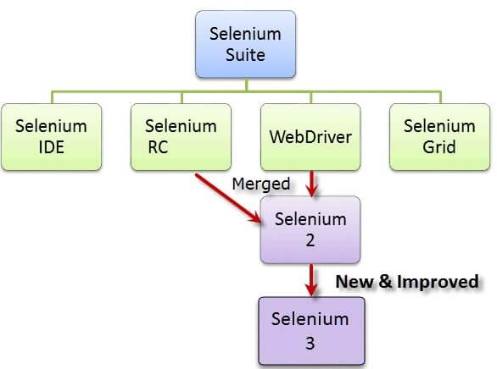

**CODE(Testing validation):**

package com.test.webdriver;

import static org.testng.AssertJUnit.assertEquals;

import org.openqa.selenium.By;

import org.openqa.selenium.WebDriver;

import org.openqa.selenium.firefox.FirefoxDriver;

import org.testng.annotations.AfterClass;

import org.testng.annotations.BeforeClass;

import org.testng.annotations.Test;

public class Driver {

private WebDriver driver;

 @BeforeClass

 public void Startup(){

  driver = new FirefoxDriver();

 }

 @Test (description="Google Login")

 public void GoogleLogin() throws Exception{

  driver.get("http://www.gmail.com");

  assertEquals("Sign in", driver.findElement(By.id("signIn")).getAttribute("value"));

  driver.findElement(By.id("Email")).sendKeys("*********");

  driver.findElement(By.id("Passwd")).sendKeys("**********");

  driver.findElement(By.id("signIn")).click();

  Thread.sleep(10000);

  driver.switchTo().frame("canvas_frame");

  driver.findElement(By.id("gbgs4dn")).click();

  driver.findElement(By.id("gb_71")).click();

  driver.switchTo().defaultContent();

assertEquals("Sign in to Gmail", driver.findElement(By.id("button")).getText());

 }

@AfterClass

 public void teardown(){

   driver.quit();

 }}

**OUTPUT:**

