**EXPERIMENT 3**

**AIM:** Estimate effort using function points and COCOMO.

**THEORY:**

**FUNCTION POINTS**

**1] Diagram**

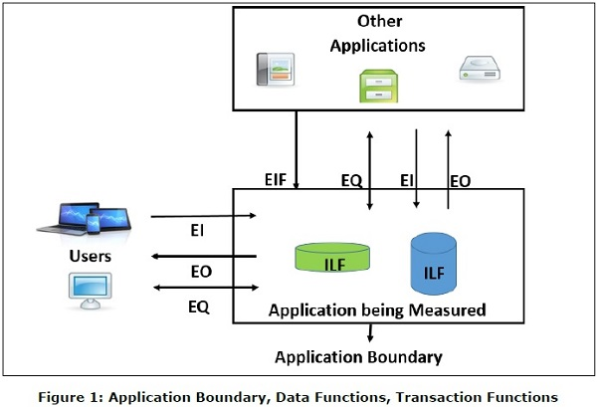

**2] Identify EI and EO**

|  |  |
| --- | --- |
| External Input(EIs) | 3 |
| External Output(Eos) | 4 |
| External Inquiries(EQs) | 2 |
| Internal Logical Files(ILFs) | 2 |
| External Interface Files(EIFs) | 2 |

**3] COUNT TOTAL:**

3

**Information**

**Domain Value**

**Count**

**simple average complex**

**Weighting factor**

External Inputs (

EIs

)

External Outputs (

EOs

)

External Inquiries (

EQs

)

Internal Logical Files (

ILFs

)

External Interface Files (

EIFs

)

4

2

2

2

3

4

6

4

5

7

3

4

6

7

10

15

5

7

10

=

=

=

=

=

9

16

6

14

10

Count total

55

**4]** **14 Questions with justification:**

1. Does the system require backup and recovery? (3)
2. Are specialized data communication required to transfer information to & from the application?(4)
3. Are these distributed processing functions?(4)
4. Is Performance Critical?(5)
5. Will the system run in an existing heavily utilized operational environment?(3)
6. Does the system require online data entry?(3)
7. Does the online data entry require input transaction to be built ever multiple screens?(3)
8. Are the ILFs updated online?(4)
9. Are the inputs, outputs and enquires complex?(1)
10. Is the internal processing complex?(2)
11. Is the code design to be reusable?(5)
12. Are conversion and installation included in the system?(3)
13. Is the system designed for multiple installations in different organisations?(2)
14. Is the application designed to facilitate change and for ease of use by the user?(3)

**Calculate Fi:**

Σ (Fi)= 45

**5]Calculate FP:**

FPestimated = count-total x [0.65 + 0.01 x Σ (Fi)]

FPestimated = 55 x [0.65 + 0.01 x 45]

**FPestimated = 60.5**

**6]Assume Productivity:**

FP = 60.5

Prod = 6.5 FP/pm

**7]Calculate effort:**

FP = 60.5

Prod = 6.5 FP/pm

Cost = $1230 / FP

Effort = FP/ Prod = 60.5/6.5 = 9.308pm

Total estimated cost = FP * Cost / FP = 60.5 * 1230= $74415

**COCOMO:**

|  |  |
| --- | --- |
| RELY | 1.39 |
| DATA | 1 |
| CPLX | 0.88 |
| RUSE | 1.14 |
| DOCV | 0.95 |
| TIME | 1.11 |
| STOR | 1.06 |
| PVOL | 0.87 |
| ACAP | 1 |
| PCAP | 0.87 |
| PCON | 1 |
| AEXP | 0.89 |
| PEXP | 1 |
| LTEX | 0.91 |
| TOOL | 1 |
| SITE | 0.91 |
| SCED | 1 |

|  |  |  |
| --- | --- | --- |
| Cost Driver |  |  |
| RCPX | RELY*DATA*CLPLX*DOCU | 1.16204 |
| RUSE | RUSE | 1.14 |
| PDIF | TIME*STOR*PVOL | 1.023 |
| PERS | ACAP*PCAP*PCON | 0.87 |
| PREX | AEXP*PEXP*LTEX | 0.8099 |
| FCIF | TOOL*SITE | 1.25 |
| SCED | SCED | 1 |

**TOTAL (EAF) =1.404**

KLOC=60.5*30=1815

EFFORT: a*KLOC*EAF

=2.45*1.815*1.404

=**6.243237 pm**