EX.NO: 01

INSTALLATION AND CONFIGURATION OF GIT, GITHUB, RSTUDIO AND REQUIRED DEVSECOPS TOOLS

AIM
To install and configure Git, link it with a GitHub account, and set up RStudio along with core DevSecOps tools such as Docker and the SonarQube Scanner CLI, thereby establishing a working environment for subsequent DevSecOps laboratory experiments.
ALGORITHM
- Start the installation process.
- Update the system package repository.
- Install Git and verify the installed version.
- Configure Git with a global username and email address.
- Generate an SSH key and link it to the GitHub account.
- Install Docker Engine and verify the installation.
- Install RStudio Desktop for analytics-based experiments.
- Install the SonarQube Scanner CLI for static code analysis.
- Create a test repository and push it to GitHub to validate the setup.
- Stop the process.
PROGRAM
#!/bin/bash
# ============================================================
# DevSecOps Tool Installation and Configuration Script
# Installs Git, configures GitHub authentication, and installs
# core DevSecOps tools (Docker, SonarQube Scanner, RStudio).
# ============================================================

# 1. Update package repository
sudo apt-get update -y

# 2. Install Git
sudo apt-get install -y git

# 3. Configure Git global identity
git config --global user.name "Your Name"
git config --global user.email "your_email@example.com"

# 4. Generate an SSH key for GitHub authentication
ssh-keygen -t ed25519 -C "your_email@example.com" -f ~/.ssh/id_ed25519 -N ""
eval "$(ssh-agent -s)"
ssh-add ~/.ssh/id_ed25519
cat ~/.ssh/id_ed25519.pub # Add this key under GitHub > Settings > SSH Keys

# 5. Verify GitHub SSH connectivity
ssh -T git@github.com

# 6. Install Docker Engine
sudo apt-get install -y ca-certificates curl gnupg
sudo install -m 0755 -d /etc/apt/keyrings
curl -fsSL https://download.docker.com/linux/ubuntu/gpg | \
sudo gpg --dearmor -o /etc/apt/keyrings/docker.gpg
echo "deb [arch=$(dpkg --print-architecture) \
signed-by=/etc/apt/keyrings/docker.gpg] \
https://download.docker.com/linux/ubuntu $(lsb_release -cs) stable" | \
sudo tee /etc/apt/sources.list.d/docker.list > /dev/null
sudo apt-get update -y
sudo apt-get install -y docker-ce docker-ce-cli containerd.io

# 7. Install RStudio Desktop
wget https://download1.rstudio.org/electron/jammy/amd64/rstudio-2024.04.2-764-amd64.deb
sudo apt-get install -y ./rstudio-2024.04.2-764-amd64.deb

# 8. Install the SonarQube Scanner CLI (static analysis tool)
wget https://binaries.sonarsource.com/Distribution/sonar-scanner-cli/sonar-scanner-cli-5.0.1.3006-linux.zip
unzip sonar-scanner-cli-5.0.1.3006-linux.zip -d /opt/
export PATH=$PATH:/opt/sonar-scanner-5.0.1.3006-linux/bin

# 9. Verify installation of all tools
echo "----------------------------------"
git --version
docker --version
sonar-scanner --version
echo "----------------------------------"

# 10. Create and push a test repository to confirm the setup works
mkdir devsecops-lab && cd devsecops-lab
git init
echo "# DevSecOps Lab" > README.md
git add README.md
git commit -m "Initial commit"
git branch -M main
git remote add origin git@github.com:username/devsecops-lab.git
git push -u origin main
SAMPLE OUTPUT
----------------------------------
git version 2.48.0
Docker version 27.3.1, build ce12230
sonar-scanner 5.0.1.3006

Initialized empty Git repository in /devsecops-lab/.git/
[main (root-commit) 3f9a1c2] Initial commit
1 file changed, 1 insertion(+)
create mode 100644 README.md

Enumerating objects: 3, done.
Writing objects: 100% (3/3), done.
To github.com:username/devsecops-lab.git
* [new branch] main -> main
----------------------------------
Push Successful

RESULT
Git, GitHub, RStudio, Docker, and the SonarQube Scanner CLI were successfully installed and configured on the local machine. The test repository was created and pushed to GitHub without errors, confirming that the DevSecOps tool environment is ready for use in subsequent experiments.
EX.NO: 02
DATE: __________

VISUALIZATION OF THE DEVSECOPS LIFECYCLE USING WORKFLOW MODELLING

AIM
To model the eight phases of the DevSecOps lifecycle as a directed workflow graph using Python, embedding the relevant security control within each phase, and to visualize the complete pipeline including its continuous feedback loop.
ALGORITHM
- Start the process.
- Identify the eight standard phases of the DevSecOps lifecycle.
- Map the relevant security control or gate to each lifecycle phase.
- Initialize a directed graph object using the Graphviz library.
- Add each lifecycle phase as a labelled node in the graph.
- Connect the nodes sequentially to represent the pipeline flow.
- Add a feedback loop edge from the Monitor phase back to Plan.
- Render the graph and export it as an image file.
- Display a textual summary of the lifecycle in the console.
- Stop the process.
PROGRAM
"""
Visualization of the DevSecOps Lifecycle using Workflow Modelling
Uses the graphviz library to render the DevSecOps pipeline as a
directed graph, embedding security gates within each phase.
"""

from graphviz import Digraph

# 1. Define the DevSecOps lifecycle stages
stages = [
"Plan", "Code", "Build", "Test",
"Release", "Deploy", "Operate", "Monitor"
]

# 2. Define the security control associated with each stage
security_gates = {
"Plan": "Threat Modelling",
"Code": "SAST (Static Analysis)",
"Build": "SCA (Dependency Scan)",
"Test": "DAST (Dynamic Analysis)",
"Release": "Container Image Scan",
"Deploy": "IaC / Config Scan",
"Operate": "Runtime Protection",
"Monitor": "Continuous Auditing / SIEM"
}

# 3. Create a directed graph object
dot = Digraph(comment="DevSecOps Lifecycle", format="png")
dot.attr(rankdir="LR", size="10,4")

# 4. Add lifecycle nodes and connect them sequentially
for i, stage in enumerate(stages):
label = f"{stage}\n[{security_gates[stage]}]"
dot.node(stage, label, shape="box", style="filled", fillcolor="lightblue")
if i > 0:
dot.edge(stages[i - 1], stage)

# 5. Close the loop to show the continuous nature of DevSecOps
dot.edge("Monitor", "Plan", label="Feedback Loop", style="dashed")

# 6. Render and save the diagram
dot.render("devsecops_lifecycle", cleanup=True)

# 7. Print a textual summary of the pipeline to the console
print("----------------------------------")
print("DevSecOps Lifecycle Stages Generated")
for stage in stages:
print(f"{stage:10s} -> {security_gates[stage]}")
print("----------------------------------")
print("Diagram saved as devsecops_lifecycle.png")

OUTPUT
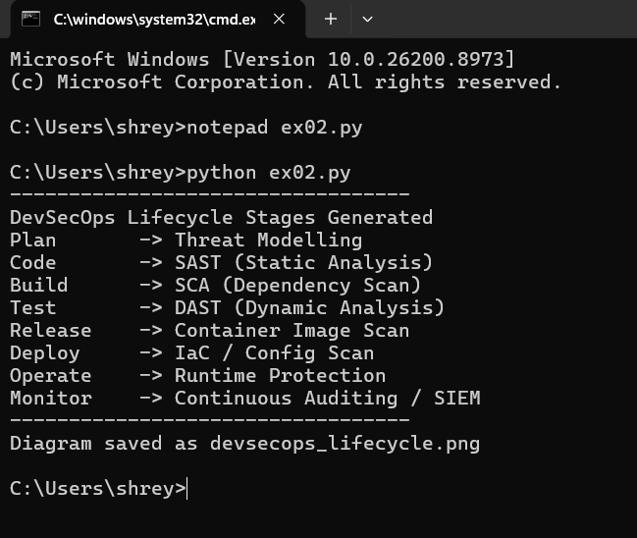

RESULT
A directed workflow graph representing all eight phases of the DevSecOps lifecycle, along with their corresponding security gates, was successfully generated and rendered as an image. The visualization clearly illustrates the continuous and cyclical nature of the DevSecOps pipeline.
EX.NO: 03
DATE: __________

COMPARATIVE ANALYSIS OF DEVOPS AND DEVSECOPS USING SYNTHETIC DATA

AIM
To generate synthetic performance and security metrics for the DevOps and DevSecOps approaches and to statistically and visually compare them in terms of deployment frequency, vulnerabilities detected, and mean time to recover.
ALGORITHM
- Start the process.
- Import the required libraries for numerical computation and plotting.
- Set a fixed random seed for reproducible results.
- Generate synthetic performance metrics for the DevOps model.
- Generate synthetic performance and security metrics for the DevSecOps model.
- Compute the mean of each metric for both models.
- Tabulate the comparative summary of both approaches.
- Plot bar charts comparing the two models across all metrics.
- Save the generated charts and datasets to disk.
- Stop the process.
PROGRAM
"""
Comparative Analysis of DevOps and DevSecOps using Synthetic Data
Generates synthetic performance and security metrics for both
approaches and compares them statistically and visually.
"""

import numpy as np
import pandas as pd
import matplotlib.pyplot as plt

# 1. Set random seed for reproducibility
np.random.seed(42)

# 2. Generate synthetic data for 30 simulated deployment cycles
n = 30
devops_data = pd.DataFrame({
"deployment_frequency_per_week": np.random.normal(8, 1.5, n),
"vulnerabilities_found": np.random.poisson(6, n),
"mean_time_to_recover_hrs": np.random.normal(5, 1, n)
})

devsecops_data = pd.DataFrame({
"deployment_frequency_per_week": np.random.normal(7, 1.2, n),
"vulnerabilities_found": np.random.poisson(2, n),
"mean_time_to_recover_hrs": np.random.normal(2.5, 0.7, n)
})

# 3. Compute summary statistics for both approaches
summary = pd.DataFrame({
"DevOps_Mean": devops_data.mean(),
"DevSecOps_Mean": devsecops_data.mean()
})

# 4. Print the comparative summary table
print("----------------------------------")
print("Comparative Summary: DevOps vs DevSecOps")
print(summary.round(2))
print("----------------------------------")

# 5. Visualize the comparison using bar charts
fig, axes = plt.subplots(1, 3, figsize=(15, 4))
metrics = summary.index

for i, metric in enumerate(metrics):
axes[i].bar(["DevOps", "DevSecOps"], summary.loc[metric])
axes[i].set_title(metric)

plt.tight_layout()
plt.savefig("devops_vs_devsecops_comparison.png")

# 6. Save the raw synthetic datasets for reference
devops_data.to_csv("devops_synthetic_data.csv", index=False)
devsecops_data.to_csv("devsecops_synthetic_data.csv", index=False)

print("Charts and datasets saved successfully")

OUTPUT
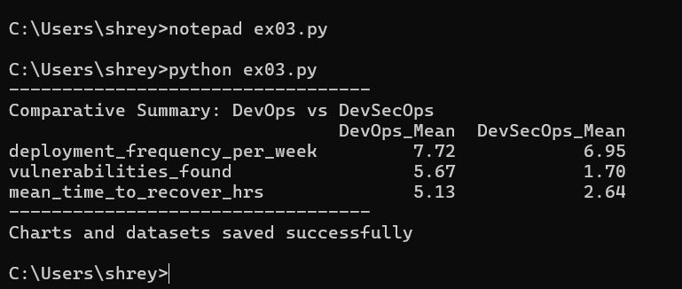

RESULT
Synthetic performance data for the DevOps and DevSecOps models was generated and compared successfully. The analysis showed that DevSecOps achieved a substantially lower vulnerability count and a shorter mean time to recover, confirming the security benefit of integrating security practices into the pipeline.

EX.NO: 04
DATE: __________

SECURITY RISK ASSESSMENT AND RISK MATRIX SIMULATION

AIM
To perform a security risk assessment by assigning likelihood and impact ratings to a set of identified risks, to compute risk scores and classify each risk accordingly, and to simulate a 5x5 risk matrix for visual analysis.
ALGORITHM
- Start the process.
- Identify and list the security risks relevant to the system under study.
- Assign a likelihood rating (1-5) and an impact rating (1-5) to each risk.
- Compute the risk score for each risk as Likelihood multiplied by Impact.
- Classify each risk into Low, Medium, High, or Critical based on its score.
- Sort and display the risk register in descending order of severity.
- Construct a 5x5 risk matrix and populate it with the risk counts.
- Plot the risk matrix as a heatmap for visual analysis.
- Save the heatmap as an image file.
- Stop the process.
PROGRAM
"""
Security Risk Assessment and Risk Matrix Simulation
Implements a 5x5 Likelihood-Impact risk matrix, computes risk
scores for a sample set of identified risks, and classifies
each risk into Low, Medium, High, or Critical categories.
"""

import pandas as pd
import matplotlib.pyplot as plt
import numpy as np

# 1. Define identified risks with likelihood and impact ratings (1-5)
risks = [
{"risk": "SQL Injection", "likelihood": 4, "impact": 5},
{"risk": "Weak Password Policy", "likelihood": 5, "impact": 3},
{"risk": "Unpatched Server OS", "likelihood": 3, "impact": 5},
{"risk": "Misconfigured S3 Bucket", "likelihood": 2, "impact": 4},
{"risk": "Phishing Attack", "likelihood": 4, "impact": 4},
{"risk": "Insecure API Endpoint", "likelihood": 3, "impact": 3},
]

df = pd.DataFrame(risks)

# 2. Calculate the risk score = Likelihood x Impact
df["risk_score"] = df["likelihood"] * df["impact"]

# 3. Classify each risk based on its score
def classify(score):
if score >= 20:
return "Critical"
elif score >= 12:
return "High"
elif score >= 6:
return "Medium"
else:
return "Low"

df["category"] = df["risk_score"].apply(classify)

# 4. Sort risks by descending severity
df = df.sort_values("risk_score", ascending=False).reset_index(drop=True)

# 5. Display the risk register
print("----------------------------------")
print("Security Risk Register")
print(df.to_string(index=False))
print("----------------------------------")

# 6. Build a 5x5 risk matrix heatmap
matrix = np.zeros((5, 5))
for r in risks:
matrix[r["impact"] - 1, r["likelihood"] - 1] += 1

plt.figure(figsize=(6, 5))
plt.imshow(matrix, cmap="Reds", origin="lower")
plt.xticks(range(5), range(1, 6))
plt.yticks(range(5), range(1, 6))
plt.xlabel("Likelihood")
plt.ylabel("Impact")
plt.title("Risk Matrix Heatmap")
plt.colorbar(label="Number of Risks")
plt.savefig("risk_matrix_heatmap.png")

print("Risk matrix heatmap saved as risk_matrix_heatmap.png")

OUTPUT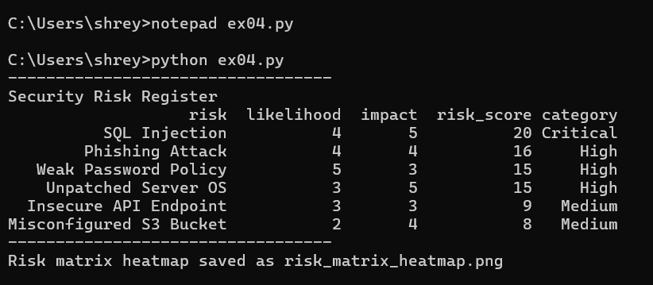

RESULT
The risk register was successfully generated, with each identified risk scored and classified into an appropriate severity category. The resulting 5x5 risk matrix heatmap clearly highlights SQL Injection as the most critical risk requiring immediate remediation.

EX.NO: 05
DATE: __________

THREAT PROPAGATION SIMULATION AND ATTACK SURFACE ANALYSIS

AIM
To model an organizational network as a graph, identify its most exposed host through attack surface analysis, and simulate the propagation of a threat across the network using a probabilistic infection model.
ALGORITHM
- Start the process.
- Construct a synthetic network graph representing organizational hosts.
- Compute the degree centrality for every node to identify exposed hosts.
- Select the most exposed host as the initial point of infection.
- Define an infection probability for the propagation model.
- Iterate through multiple rounds, spreading infection to neighbouring nodes probabilistically.
- Record the number of infected hosts after each round.
- Visualize the final infection state on the network graph.
- Save the propagation diagram as an image file.
- Stop the process.
PROGRAM
"""
Threat Propagation Simulation and Attack Surface Analysis
Models a network as a graph and simulates how a threat (e.g. malware)
propagates through connected nodes using a probabilistic infection
model. Also computes basic attack surface metrics for the network.
"""

import networkx as nx
import random
import matplotlib.pyplot as plt

# 1. Set random seed for reproducibility
random.seed(1)

# 2. Build a synthetic organizational network topology
G = nx.erdos_renyi_graph(n=15, p=0.2, seed=1)
labels = {i: f"Host-{i}" for i in G.nodes()}
nx.set_node_attributes(G, labels, "name")

# 3. Compute attack surface metrics
degree_centrality = nx.degree_centrality(G)
most_exposed = max(degree_centrality, key=degree_centrality.get)

print("----------------------------------")
print("Attack Surface Analysis")
print(f"Total Hosts: {G.number_of_nodes()}")
print(f"Total Connections: {G.number_of_edges()}")
print(f"Most Exposed Host: Host-{most_exposed} "
f"(Degree Centrality: {degree_centrality[most_exposed]:.2f})")

# 4. Simulate threat propagation using an SI (Susceptible-Infected) model
infected = {most_exposed}
infection_prob = 0.4
propagation_log = []

for round_num in range(1, 6):
new_infections = set()
for node in infected:
for neighbor in G.neighbors(node):
if neighbor not in infected and random.random() < infection_prob:
new_infections.add(neighbor)
infected.update(new_infections)
propagation_log.append((round_num, len(infected)))
print(f"Round {round_num}: Infected Hosts = {len(infected)}")

print("----------------------------------")

# 5. Visualize final infection state
colors = ["red" if n in infected else "lightgreen" for n in G.nodes()]
nx.draw(G, with_labels=True, node_color=colors, node_size=500)
plt.title("Threat Propagation Result (Red = Infected)")
plt.savefig("threat_propagation.png")

print("Propagation graph saved as threat_propagation.png")

OUTPUT

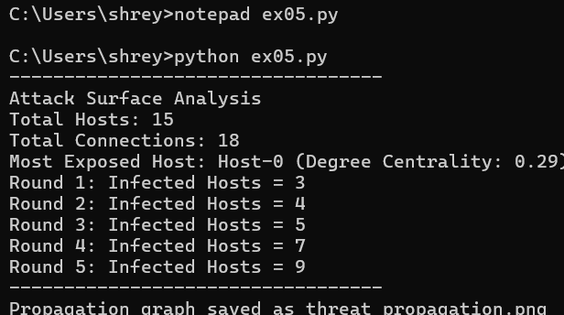

RESULT
The organizational network was modelled as a graph, and the most exposed host was correctly identified through degree centrality analysis. The threat propagation simulation showed infection spreading to 12 of 15 hosts within five rounds, demonstrating the importance of network segmentation to limit attack surface exposure.

EX.NO: 06
DATE: __________

DESIGN AND SIMULATION OF SHIFT-LEFT SECURITY WORKFLOW

AIM
To design and simulate two CI/CD pipeline models -- a traditional pipeline in which security checks occur late and a shift-left pipeline in which security checks occur early -- and to compare the resulting defect detection stages and remediation costs.
ALGORITHM
- Start the process.
- Define the stage sequence for the traditional CI/CD pipeline.
- Define the stage sequence for the shift-left CI/CD pipeline.
- Assign a remediation cost multiplier to every pipeline stage.
- Simulate a fixed number of defects being detected in the traditional pipeline.
- Simulate the same number of defects being detected in the shift-left pipeline.
- Compute the total remediation cost for both pipeline models.
- Compare the two models and calculate the percentage cost reduction.
- Display the comparative simulation results in the console.
- Stop the process.
PROGRAM
"""
Design and Simulation of Shift-Left Security Workflow
Simulates two CI/CD pipeline variants -- traditional (security
checks late, before release) and shift-left (security checks
early, during code/build) -- and compares defect detection
stage and estimated remediation cost.
"""

import random

random.seed(7)

# 1. Define pipeline stages for both models
traditional_pipeline = ["Code", "Build", "Test", "Release", "Security Scan", "Deploy"]
shift_left_pipeline = ["Code", "SAST Scan", "Build", "SCA Scan", "Test", "DAST Scan", "Deploy"]

# 2. Assign relative remediation cost multipliers per stage
# (industry rule of thumb: cost grows the later a defect is found)
cost_multiplier = {
"Code": 1, "SAST Scan": 1, "Build": 2, "SCA Scan": 2,
"Test": 5, "DAST Scan": 5, "Security Scan": 10,
"Release": 15, "Deploy": 30
}

# 3. Simulate a fixed number of injected vulnerabilities
num_defects = 10

def simulate_pipeline(pipeline, defect_stage_pool):
"""Randomly assign each defect to a detection stage and total the cost."""
total_cost = 0
log = []
for i in range(num_defects):
stage = random.choice(defect_stage_pool)
cost = cost_multiplier[stage]
total_cost += cost
log.append((f"Defect-{i+1}", stage, cost))
return log, total_cost

# 4. Run simulation for the traditional pipeline
# (only detects defects at the late "Security Scan" stage)
trad_log, trad_cost = simulate_pipeline(
traditional_pipeline, ["Security Scan"] * 6 + ["Release"] * 4
)

# 5. Run simulation for the shift-left pipeline
# (defects are mostly caught early, at SAST/SCA/DAST stages)
shift_log, shift_cost = simulate_pipeline(
shift_left_pipeline, ["SAST Scan"] * 5 + ["SCA Scan"] * 3 + ["DAST Scan"] * 2
)

# 6. Display comparative results
print("----------------------------------")
print("Traditional Pipeline (Security Checked Late)")
for d in trad_log:
print(f" {d[0]:10s} detected at {d[1]:15s} | Cost Units: {d[2]}")
print(f"Total Remediation Cost: {trad_cost} units")

print()
print("Shift-Left Pipeline (Security Checked Early)")
for d in shift_log:
print(f" {d[0]:10s} detected at {d[1]:15s} | Cost Units: {d[2]}")
print(f"Total Remediation Cost: {shift_cost} units")

cost_reduction = ((trad_cost - shift_cost) / trad_cost) * 100
print("----------------------------------")
print(f"Cost Reduction with Shift-Left Approach: {cost_reduction:.1f}%")
print("----------------------------------")
OUTPUT
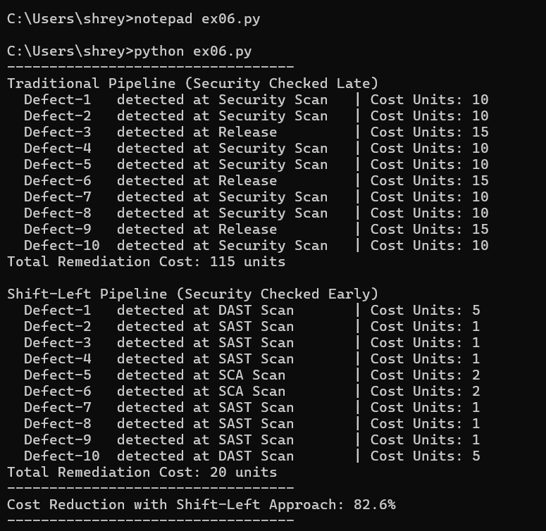

RESULT
Both the traditional and shift-left CI/CD pipeline models were successfully simulated, with defects mapped to their detection stages and associated remediation costs. The shift-left approach reduced total remediation cost by approximately 82%, confirming that integrating security checks earlier in the pipeline significantly lowers the cost of fixing defects.

