REPRESENTATION OF COVID STATUS AROUND THE WORLD USING MAPS

A Minor Project report submitted to the JAWAHARLAL NEHRU TECHNOLOGICAL UNIVERSITY HYDERABAD in partial fulfillment of the requirements for the award of the degree of

**BACHELOR OF TECHNOLOGY**

**IN**

**COMPUTER SCIENCE AND ENGINEERING**

## Submitted By

Miss. Chinoori Shreya Reddy (18071A0569)

Mr. Chinta Chakrapani (18071A0570)

Miss. Pujari Samhitha (18071A05A2)

Miss. Yalamareddy Vaishnavi (18071A05B6)

Mr. Chenimineni Vinay Datta (17071A0574)

Under the Guidance Of

**Mrs R.Vasavi**

**(Assistant Professor, Dept of CSE)**

# COMPUTER SCIENCE AND ENGINEERING DEPARTMENT

## VNR VIGNANA JYOTHI INSTITUTE OF ENGINEERING AND TECHNOLOGY

(An Autonomous Institute, NAAC Accredited With ‘A++’ Grade, NBA Accredited, Approved by AICTE, New Delhi, Affiliated to JNTUH)

2021.

**VALLURUPALLI NAGESWARA RAO VIGNANA JYOTHI INSTITUTE OF ENGINEERING and TECHNOLOGY**

## (An Autonomous Institute, NAAC Accredited With ‘A++’ Grade, NBA Accredited, Approved by AICTE, New Delhi, Affiliated to JNTUH)

Vignana Jyothi Nagar, Pragathi Nagar, Nizampet (S.O), Hyderabad – 500 090, TS, India

**DEPARTMENT OF COMPUTER SCIENCE AND ENGINEERING**



**CERTIFICATE**

This is to certify that the project report entitled “**REPRESENTATION OF COVID STATUS AROUND THE WORLD USING MAPS**” is a bonafide work done under our supervision and is being submitted by **Miss. Chinoori Shreya Reddy (18071A0569), Mr. Chinta Chakrapani (18071A0570), Miss. Pujari Samhitha (18071A05A2), Miss. Yalamareddy Vaishnavi (18071A05B6) , Mr. Chenimineni Vinay Datta (17071A0574)** in partial fulfilment for the award of the degree of **Bachelor of Technology** in Computer Science and Engineering, of the VNRVJIET, Hyderabad during the academic year 2020-2021. Certified further that to the best of our knowledge the work presented in this thesis has not been submitted to any other University or Institute for the award of any Degree or Diploma.

Mrs. R. Vasavi Dr .S.Nagini

Assistant Professor & Project guide Professor & HOD

Department of CSE Department Of CSE

VNR VJIET VNR VJIET

**VALLURUPALLI NAGESWARA RAO VIGNANA JYOTHI INSTITUTE OF ENGINEERING and TECHNOLOGY**

## (An Autonomous Institute, NAAC Accredited With ‘A++’ Grade, NBA Accredited, Approved by AICTE, New Delhi, Affiliated to JNTUH)

Vignana Jyothi Nagar, Pragathi Nagar, Nizampet (S.O), Hyderabad – 500 090, TS, India

**DEPARTMENT OF COMPUTER SCIENCE AND ENGINEERING**



**DECLARATION**

We declare that the major project work entitled “**REPRESENTATION OF COVID STATUS AROUND THE WORLD USING MAPS**” submitted in the department of Computer Science and Engineering, Vallurupalli Nageswara Rao Vignana Jyothi Institute of Engineering and Technology, Hyderabad, in partial fulfilment of the requirement for the award of the degree of **Bachelor of Technology** in **Computer Science and Engineering** is a bonafide record of our own work carried out under the supervision of **Mrs. R. Vasavi, Assistant Professor, Department of CSE, VNRVJIET.** Also, we declare that the matter embodied in this thesis has not been submitted by us in full or in any part thereof for the award of any degree/diploma of any other institution or university previously.

Place: Hyderabad

**Chinoori Chinta Pujari Yalamareddy Chenimenini**

**Shreya Reddy Chakrapani Samhitha Vaishnavi VinayDatta**

**(18071A0569) (18071A0570) (18071A05A2) (18071A05B6) (17071A0574)**

# ACKNOWLEDGEMENT

Firstly, we would like to express our immense gratitude towards our institution VNR Vignana Jyothi Institute of Engineering and Technology, which created a great platform to attain profound technical skills in the field of Computer Science, thereby fulfilling our most cherished goal.

We are very much thankful to our Principal**, Dr. Challa Dhanunjaya Naidu** and our Head of Department, **Dr.S.Nagini,** for extending their cooperation in doing this project in stipulated time.

We extend our heartfelt thanks to our guide**, Mrs. R. Vasavi** and the project coordinators**,** for their enthusiastic guidance throughout the course of our project.

Finally, our appreciable obligation also goes to all the staff members of the Computer Science & Engineering department and to our fellow classmates who directly or indirectly helped us.

Miss. Chinoori Shreya Reddy (18071A0569)

Mr. Chinta Chakrapani (18071A0570)

Miss. Pujari Samhitha (18071A05A2)

Miss. Yalamareddy Vaishnavi (18071A05B6)

Mr. Chenimineni Vinay Datta (17071A0574)

# ABSTRACT

COVID-19 outbreak was first reported in Wuhan, China and has spread to more than 50 countries. WHO declared COVID-19 as a Public Health Emergency of International Concern (PHEIC) on 30 January 2020. Naturally, a rising infectious disease involves fast spreading, endangering the health of many people, and thus requires immediate action to prevent the disease at the community level. In this project, we implement a dashboard for COVID 19 spread (Country wise details about cases , tests, vaccination etc. represented on map). This dashboard provides many insightful visualizations for the study of coronavirus spread. In this project, we work on a dataset and generate a dashboard using flask and folium. We use flask and folium python packages for making interactive dashboards. The dataset consists of corona spread data from different countries. This dataset also contains the latitude and longitude of corona affected areas. The countries with maximum corona cases are filtered and visualized. This helps people in easily understanding and analyzing the severity of covid 19 spread.

# Key Words:

CoronaVirus, Covid-19, Pandemic, Flask, Folium, Data Visualization

**Table Of Contents**

CHAPTER 1. INTRODUCTION 1

CHAPTER 2: LITERATURE SURVEY 4

CHAPTER 3: PROPOSED SYSTEM 6

CHAPTER 4: SYSTEM-ANALYSIS 8

4.1 SYSTEM REQUIREMENTS 8

4.1.1 FUNCTIONAL REQUIREMENTS: 8

4.1.2 NON-FUNCTIONAL REQUIREMENTS: 8

4.2 SYSTEM ARCHITECTURE 9

CHAPTER 5: SOFTWARE DESIGN 10

UML DIAGRAMS 10

5.1 USE CASE DIAGRAM 10

5.2 ACTIVITY DIAGRAM 11

CHAPTER 6: IMPLEMENTATION 12

FRAMEWORK: 12

6.1 GIT: 12

6.2 MODEL (DATABASE): 12

6.3 PYTHON: 13

6.4 FLASK: 14

6.5 FOLIUM: 14

6.6 VISUAL STUDIO CODE: 16

6.7 USER INTERFACE: 16

6.8 FRONT END: 18

CHAPTER 7: TESTING 21

7.1 TESTING PLAN 21

7.1.1 TEST DATA 21

7.1.2 UNIT TESTING 21

7.1.3 TEST REPORT 21

7.2 TESTING 21

CHAPTER 8: RESULT AND DISCUSSION 23

8.1: COVID DASHBOARD 23

8.2: TABLE 24

8.3: DETAILS OF SELECTED COUNTRY 24

CHAPTER 9: CONCLUSION AND FUTURE SCOPE 26

9.1 CONCLUSION: 26

9.2 FUTURE SCOPE: 26

CHAPTER 10: BIBLIOGRAPHY 27

References 27

# List Of Figures

**Fig 4.2:** System Architecture 9

**Fig 5.1:** Use Case Diagram 10

**Fig 5.2:** Activity Diagram 11

**Fig 6.1:** GIT 12

**Fig 6.2.1:** Importing Dataset 13

**Fig.6.2.2:** Dataset or CSV file 13

**Fig 6.4:** Importing flask and folium 14

**Fig 6.7.1:** Finding top countries 17

**Fig 6.7.2:** Making map 17

**Fig 6.7.3:** Making pairs 17

**Fig 6.7.4:** Rendering map and table 18

**Fig 6.7.5:** For circle and popup 18

**Fig 6.8.1:** base.html 19

**Fig 6.8.2**: styles.css 20

**Fig 6.8.3**: home.html 20

**Fig 7.2.1:** US Covid Details in Dataset 21

**Fig 7.2.2** : US covid details rendered on Dashboard 22

**Fig 8.1:** Covid Dashboard 23

**Fig 8.2:** Top 15 countries table 24

**Fig 8.3**: Report of United states 25

# CHAPTER 1. INTRODUCTION

Corona Virus which is commonly known as COVID-19 is an infectious disease that causes illness in the respiratory system in humans. The term Covid 19 is sort of an acronym, derived from “Novel Coronavirus Disease 2019”. Coronavirus (or COVID-19) was first identified in December 2019 in Wuhan city of China. In March 2020, the World Health Organization (WHO) declared the Corona Virus outbreak a pandemic. The epidemic of COVID-19 spread rapidly to more than 200 countries.

Corona Virus has affected the day to day lives of millions of people. COVID-19 often spreads by person-to-person transmission via respiratory droplets and close contact. COVID-19 enters your body through your mouth, nose or eyes (directly from the airborne droplets or from transfer of the virus from your hands to your face). The virus travels to the back of your nasal passages and mucous membrane in the back of your throat. It attaches to cells there, begins to multiply and moves into lung tissue. From there, the virus can spread to other body tissues. Common signs of infection include fever, coughing and breathing difficulties. In severe cases, it can cause pneumonia, multiple organ failure and death.

The incubation period of COVID-19 is thought to be between one and 14 days. It is contagious before symptoms appear, which is why so many people get infected. Infected patients can also be asymptomatic, meaning they do not display any symptoms despite having the virus in their systems.

Governments, health agencies, researchers and healthcare providers are all working together to develop policies and procedures to limit the spread of this virus both globally and from individual to individual.

Health professionals have long considered conventional mapping, and more recently geographic information systems, as critical tools in tracking and combating contagious diseases. The earliest map visualization was in 1694 on plague containment in Italy. The value of maps as a communication tool blossomed over the next 225 years in the service of understanding and tracking infectious diseases, such as yellow fever, cholera and the 1918 influenza pandemic. From the 1960s, when computerized geographic information systems were born, the possibilities for analyzing, visualizing, and detecting patterns of disease dramatically increased again.

The best way to prevent and slow down transmission is to be well informed about the disease and how the virus spreads. The speed with which the disease has spread throughout the world demands agile solutions to understand and estimate the disease progression.

Never in the history of pandemics has so much data been available to professional data scientists or the general public to track the progression of a disease. And as better ways to illustrate the COVID-19 data emerge, the charts and graphics we are seeing to describe it are themselves evolving with the shape and scale of the pandemic over time. This rapid proliferation of information and data depictions threatens to overwhelm the average observer.

Whether or not we should be plotting these measured observations, barring egregious issues with the underlying data, scientists are still compelled to plot them, hoping to reduce complexity, increase learning and weave some understandable narratives from them. As we do, we should know the rendering of the data that best tells the story, the depiction that provides the appropriate context and gives the best understanding of growth and mitigation and conveys the human responses of threat and hope.

So, as we move beyond the data’s fundamental validity, we see that what also matters is to depict the data appropriately so that the stories, meaning, insights and implications that emerge are within human ken, scale and understanding. This is especially needed during a time of existential threat.

Therefore, Interactive dashboards with several charts surfaced in different formats offer concise ways to express the pandemic's growth.

The map provides a real-time count of the number of Confirmed cases, New cases, Deaths, New Deaths, Tests, New Tests ,Positive Rate, Tests Per Case, Total Vaccinations, People Vaccinated , People Fully Vaccinated, Population, Median Age of the population ,people aged 65 and older, GDP Per Capita , Extreme Poverty of the respective country or region along with the last updated date.

Maps with good design and execution can build awareness and shape smarter decision-making from the global to the hyper-local level. These maps can provide insightful visualizations for the study of coronavirus spread.

The key objectives for the project were identified as:

* To provide insightful visualizations for the study of coronavirus spread.
* To implement an interactive dashboard for COVID 19 spread analysis.
* To filter and visualize the countries and the cities within countries with maximum corona cases.

# CHAPTER 2: LITERATURE SURVEY

Many studies focused on statistical models. Most of them focused on future predictions, patterns and did not give any visualization on the current situation and spread of the virus. In “A data analytics approach for COVID-19 spread and end prediction (with a case study in Iran)” ML algorithms were used such as logistic function using inflection points, created new rates such as weekly death rate, life rate and new approaches to mortality rate and recovery rate in Iran.

In “Analysis of COVID-19 spread in South Korea using the SIR model with time-dependent parameters and deep learning” researchers trained, and validated models based on the classic SIR (Susceptible-Infectious Removed) model to predict the future trend in different scenarios.

The traditional SEIR (Susceptible-Exposed-Infectious-Removed) model was employed to simulate the spread of the epidemic in “Regression analysis of Covid 19 using machine learning algorithms”.

Previous studies have focused on the macroscopic perspective of the COVID-19 epidemic using Baidu migration and confirmed diagnosis data at the national or provincial scale in “Analysis of COVID-19 spread in South Korea using the SIR model with time-dependent parameters and deep learning” and “Rajan Gupta, Saibal K. Pal, Gaurav Pandey, A Comprehensive Analysis of Covid 19 outbreak situation in India”.

In “Statistical Analysis of Covid-19 (SARS-COV-2) Patients Data of Karnataka, India”, Covid-19 patients’ data were analyzed to determine the relationship between different variables such as age, gender using SEIR Model and Statistical analysis.

Very little data was used and a huge part of research is based only on cases in Wuhan city and Karnataka.

In “Analyzing the Covid-19 Cases in Kerala: A Visual Exploratory Data Analysis Approach” an exploratory data analysis was conducted on the Covid-19 cases in Kerala by dividing the Covid-19 data from January 30, 2020, to May 31, 2020 into three phases.

Similar to “Statistical Analysis of Covid-19 (SARS-COV-2) Patients Data of Karnataka, India”, analysis is done on limited data and restricts the comparison only to Kerala and India.

In “Prediction and forecast for COVID-19 Outbreak in India based on Enhanced Epidemiological Models” SIRD was used, no. of deaths, the time dependence of Outbreak's Intensity in India to forecast maximum no. of confirmed active cases of COVID-19 present in a day and also predicted total number of deaths in India. Even in this, very little data and a huge part of research is based only on cases in India.

The correlation coefficients and multiple linear regression applied for prediction and autocorrelation and auto regression have been used to improve the accuracy in “Analysis and Predictions of Spread, Recovery, and Death Caused by COVID-19 in India”. Scope is only India and models may not be so accurate.

In “Topological Data analysis model for the spread of the corona virus”, Topological data analysis model was used for US data only. It's more complex for normal people to understand and infer information from the visualizations they provided. Main focus was on the evolution of cases from time to time but not on the current situation.

# CHAPTER 3: PROPOSED SYSTEM

As better ways to illustrate the COVID-19 data emerge, the charts and graphics we are seeing to describe it are themselves evolving with the shape and scale of the pandemic over time. So, when we move beyond the data’s fundamental validity, we see that what also matters is to depict the data appropriately so that the stories, meaning, insights and implications that emerge are within human ken, scale and understanding. This is especially needed during a time of existential threat.

We use visualization techniques to simplify these kinds of issues. Map visualization is used to analyze and display the geographically related data and present it in the form of maps. Data expression using maps is clearer and more intuitive. We can visually see the distribution or proportion of data in each region. It is convenient for everyone to mine deeper information and make better decisions. Maps make it easier and more effective to track the status and situation around the world and deal with geospatial data.

We use flask and folium python packages for making interactive dashboards. Flask is a web server gateway interface application in python. This is used for developing web apps. Using Flask, we can build applications that can scale up to complex applications. Folium is a python API for visualizing data. It is a good API to include map related visualizations.

We use a dataset containing covid related information about different countries around the world. The dataset provides a [real-time count](https://www.arcgis.com/apps/opsdashboard/index.html#/bda7594740fd40299423467b48e9ecf6) of the number of Confirmed cases, New cases, Deaths, New Deaths, Tests ,New Tests ,Positive Rate, Tests Per Case, Total Vaccinations, People Vaccinated , People Fully Vaccinated, Population, Median Age of the population ,people aged 65 and older, GDP Per Capita , Extreme Poverty of the respective country or region along with the last updated date. The dataset also contains the latitude and longitude of corona affected areas. The countries with maximum corona cases are filtered and visualized.

As different countries have impacted in different ways, there can be outliers as well and some may have a large number of cases and some less, so we normalize the data and scale the data to a range, perform data preprocessing to remove noisy data and check for missing data as well.

After doing all the required preprocessing, we load the data to the website. This imported data is used to collect the top n regions having the largest corona cases to display them as a table. We make a map using the folium package and write a function to make circles on active corona cases regions. To indicate the regions having higher intensity of covid, a circle having higher radius is used and others relatively. We can just click anywhere on the red circle corresponding to a particular region and that pops up the data highlighting all the important data regarding the virus spread in that place. These circles give us a comparative view of covid intensity across the world.

# CHAPTER 4: SYSTEM-ANALYSIS

## SYSTEM REQUIREMENTS

A condition or capability needed by a user to solve a problem or achieve an objective. The requirements are the descriptions of the system services and constraints.

## Functional Requirements:

Functional requirements are the requirements in which it is required to operate a system. These requirements are necessary to assemble a system which will be required to attain the objectives.

**Some of the important functional requirements are:**

Sending the list of country wise covid related details directly to the database on a regular basis.

Selecting the country by the user in order to see a detailed view of covid data corresponding to that country.

## Non-Functional Requirements:

Non-functional Requirements are characteristics or attributes of the system that can judge its operation. (or) Non-functional Specifications are the needs based on the specific criteria to evaluate the operation of the system. These requirements are collected and analyzed based on the client needs and exceptions, security and working etc.

* **Accuracy and Precision:** The system should perform its process in accuracy and Precision to avoid problems.
* **Modifiability:** The system should be easy to modify, any wrong should be correct.
* **Security:** The system should be secure and saving details of all countries.
* **Usability:** The system should be easy to deal with and simple to understand.
* **Maintainability:** The maintenance group should be able to fix any problem occur suddenly.
* **Speed and Responsiveness:** Execution of operations should be fast.

**Some of the important Non-functional requirements are:**

* The first and most important thing is that the admin needs to find an easy way of capturing the required covid data.
* Each request should be processed within a few seconds.
* The website must be fast, reliable, efficient.
* Good user experience.

## SYSTEM ARCHITECTURE

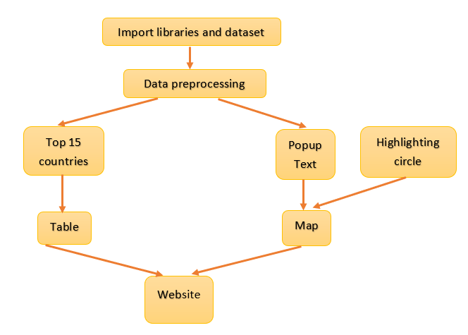

## Fig 4.2: System Architecture

# CHAPTER 5: SOFTWARE DESIGN

## UML Diagrams

A UML diagram is a diagram based on the UML (Unified Modeling Language) with the purpose of visually representing a system along with its main actors, roles, actions, artifacts, or classes, to better understand, alter, maintain, or document information about the system.

There are several types of UML diagrams and each one of them serves a different purpose regardless of whether it is being designed before the implementation or after (as part of documentation).

## 5.1 USE CASE DIAGRAM

A use case diagram is a dynamic or behavior diagram in [UML](https://www.smartdraw.com/uml-diagram/). Use case diagrams model the functionality of a system using actors and use cases. Use cases are a set of actions, services, and functions that the system needs to perform. In this context, a "system" is something being developed or operated, such as a web site. The "actors" are people or entities operating under defined roles within the system.

The following represents the use case diagram of the proposed system:

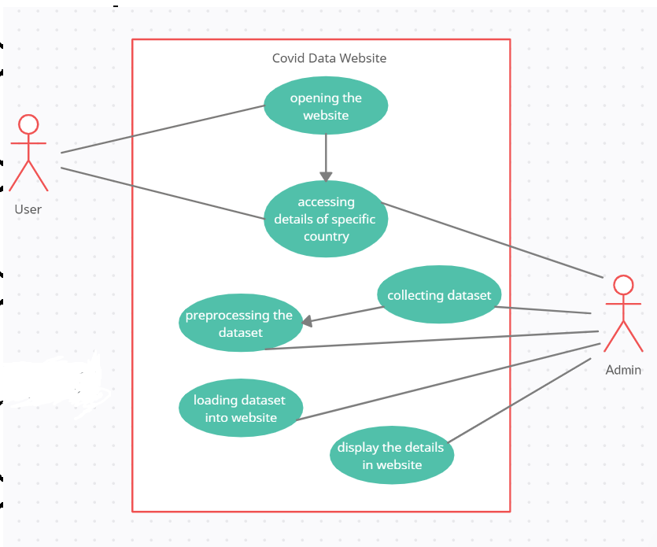

# Fig 5.1: Use Case Diagram

## Activity Diagram

## Fig 5.2: Activity Diagram

Activity diagram is another important diagram in UML to describe the dynamic aspects of the system. Activity diagram is basically a flowchart to represent the flow from one activity to another activity. The activity can be described as an operation of the system. The control flow is drawn from one operation to another. This flow can be sequential, branched, or concurrent. Activity diagrams deal with all type of flow control by using different elements such as fork, join, etc.

# CHAPTER 6: IMPLEMENTATION

## FRAMEWORK:

Frameworks are specific software libraries that serve as a filing system in a standard format to store code and procedures. We used Flask to develop our website.

## GIT:

Git is software for tracking changes in any set of files, usually used for coordinating work among programmers collaboratively developing source code during software development. Its goals include speed, data integrity, and support for distributed, non-linear workflows.



## Fig 6.1: GIT

We used git software to make checkpoints and keep track of version control for our website.

## MODEL (DATABASE):

We used a csv file to store our data. It contains different attributes like real-time count of the number of Confirmed cases, New cases, Deaths, New Deaths, Tests, New Tests, Positive Rate, Tests Per Case, Total Vaccinations, People Vaccinated, People Fully Vaccinated, Population, Median Age of the population, people aged 65 and older, GDP Per Capita , Extreme Poverty of the respective country or region along with the last updated date.

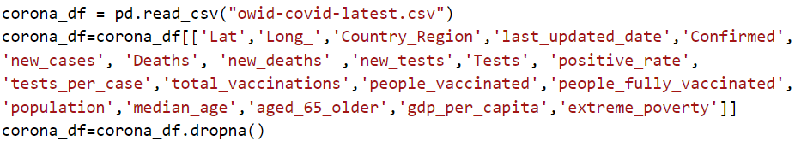

## Fig 6.2.1: Importing Dataset

## Fig 6.2.2: Dataset or CSV file

## PYTHON:

Python is an interpreted high-level general-purpose programming language. Its design philosophy emphasizes code readability with its use of significant indentation. The language constructs as well as its object-oriented approach aim to help programmers write clear, logical code for small and large-scale projects.

# 6.4 FLASK:

Flask is a micro [web framework](https://en.wikipedia.org/wiki/Web_framework) written in [Python](https://en.wikipedia.org/wiki/Python_(programming_language)). It is classified as a [microframework](https://en.wikipedia.org/wiki/Microframework) because it does not require particular tools or libraries. It has no [database](https://en.wikipedia.org/wiki/Database) abstraction layer, form validation, or any other components where pre-existing third-party libraries provide common functions. However, Flask supports extensions that can add application features as if they were implemented in Flask itself. Extensions exist for object-relational mappers, form validation, upload handling, various open authentication technologies and several common framework related tools.

Flask is an API of Python that allows us to build up web-applications. It was developed by Armin Ronacher. Flask’s framework is more explicit than Django’s framework and is also easier to learn because it has less base code to implement a simple web-Application. A Web-Application Framework or Web Framework is the collection of modules and libraries that helps the developer to write applications without writing the low-level codes such as protocols, thread management, etc. Flask is based on the WSGI (Web Server Gateway Interface) toolkit and Jinja2 template engine.

To install Flask:

pip install Flask

## Fig 6.4: Importing flask and folium

## 6.5 FOLIUM:

[Folium](http://folium.readthedocs.io/en/latest/) is built on the data wrangling strengths of the Python ecosystem and the mapping strengths of the Leaflet.js (JavaScript) library. Simply, manipulate your data in Python, then visualize it on a leaflet map via Folium.

Folium makes it easy to visualize data that’s been manipulated in Python on an interactive leaflet map. It enables both the binding of data to a map for choropleth visualizations as well as passing rich vector/raster/HTML visualizations as markers on the map.

The library has a number of built-in tilesets from OpenStreetMap, Mapbox, and Stamen, and supports custom tilesets with Mapbox or Cloudmade API keys. Folium supports both Image, Video, GeoJSON and TopoJSON overlays.

**USING FOLIUM WITH FLASK**

*""" flask_example.py*

*Required packages:*

*- flask*

*- folium*

*Usage:*

*Start the flask server by running:*

*$ python flask_example.py*

*And then head to http://127.0.0.1:5000/ in your browser to see the map displayed*

*"""*

**from** **flask** **import** Flask

**import** **folium**

app = Flask(__name__)

**@app**.route('/')

**def** index():

start_coords = (46.9540700, 142.7360300)

folium_map = folium.Map(location=start_coords, zoom_start=14)

**return** folium_map._repr_html_()

**if** __name__ == '__main__':

app.run(debug=**True**)

To install Folium:

pip install Folium

## 6.6 VISUAL STUDIO CODE:

Visual Studio Code is a streamlined code editor with support for development operations like debugging, task running, and version control. It aims to provide just the tools a developer needs for a quick code-build-debug cycle and leaves more complex workflows to fuller featured IDEs, such as IDE. Visual studio has features that are used for debugging and task execution. It is a code editor which gives developers tools which help them in rapid development of software with the help of Visual Studio IDE.

## 6.7 USER INTERFACE:

Providing a best possible graphic user interface which cannot just give us the top 15 countries' statistics but also let us know about the status of each country or region.

A website is developed using flask and folium where users can see the required details of covid .

Users can get the covid data by the following two means:

The details of the covid in each country can be accessible by the user.

* The user can get the abstract view about the top 15(which can be configured) countries in the left side of the dashboard, i.e., only about the total cases in each country.
* If the user wants to see a more detailed view then they can hover over the red circle corresponding to that region on the map. Then they can see a popup box containing details like real-time count of the number of Confirmed cases, New cases, Deaths, New Deaths, Tests ,New Tests ,Positive Rate, Tests Per Case, Total Vaccinations, People Vaccinated , People Fully Vaccinated, Population, Median Age of the population ,people aged 65 and older, GDP Per Capita , Extreme Poverty of the respective country or region along with the last updated date.
* Intensity of covid in each country can be determined by the radius of the red circle corresponding to that country.

**Finding top countries:**

## Fig 6.7.1: Finding top countries

**Making a map:**

## Fig 6.7.2: Making map

**Pairs (country, confirmed cases):**

## Fig 6.7.3: Making pairs

**Rendering map and table:**

## Fig 6.7.4: Rendering map and table

**For Circle and popup:**

## Fig 6.7.5: For circle and popup

## FRONT END:

For the front-end template, we used Flask and Folium.

We used html files to give formatting and css to style the content.

A world map is displayed on the site with red circles on each country using folium. Size of the red circle indicates the intensity of spread of the virus in that country. One can visualize other details such as confirmed cases, deaths, number of vaccinations etc. by clicking on the red circle.

A table of top 15 countries with more number of covid cases as well.

**Base.html**

## Fig 6.8.1: base.html

**style.css**

## Fig 6.8.2: styles.css

**Home.html**

## Fig 6.8.3: home.html

## CHAPTER 7: TESTING

## 7.1 TESTING PLAN

Testing process starts with a test plan. This plan identifies all the testing related activities that must be performed and specifies the schedules, allocates the resources, and specified guidelines for testing. During the testing of the unit the specified test cases are executed and the actual result compared with expected output. The final output of the testing phase is the test report and the error report.

## 7.1.1 Test Data

Testing process begins with a test design. This arrangement recognizes all the testing related exercises that must be performed like the timetables, assigning the assets, and determining rules for testing. This testing of the unit of the predetermined experiments is executed and the genuine outcome is expected. The last part of the testing stage is the test report.

## 7.1.2 Unit testing

Every individual module has been tried against the necessity with some test information.

## Test Report

The module is working appropriately given the client must hover over the red circle of the required country. All information section frames have been tested with indicated test cases and all information passage shapes are working properly.

## 7.2 TESTING

## Fig 7.2.1: US Covid Details in Dataset

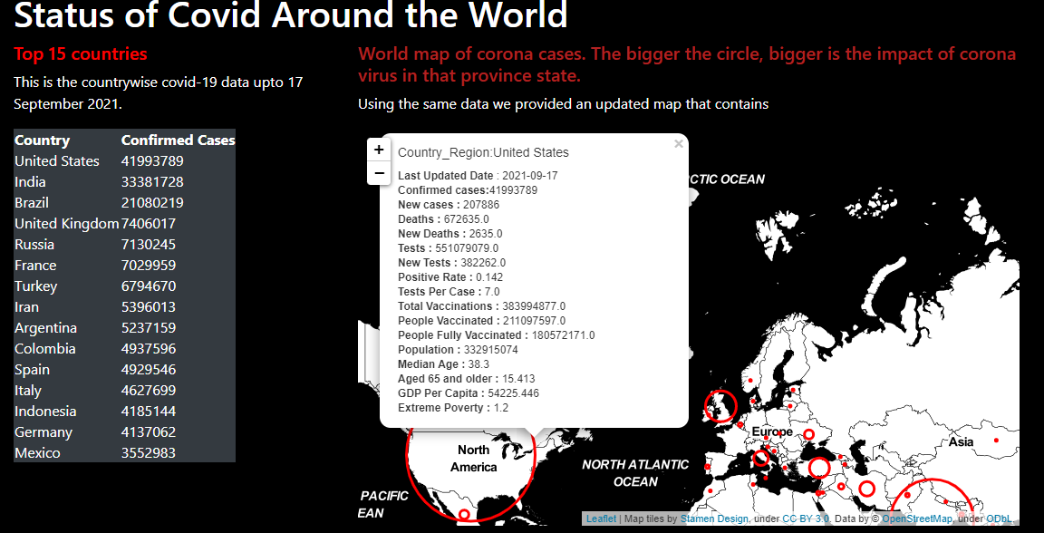

## Fig 7.2.2 : US covid details rendered on Dashboard

As we can see the covid details corresponding to covid are rendered exactly the same on the dashboard as seen in the database.

# CHAPTER 8: RESULT AND DISCUSSION

# 

# 8.1: COVID DASHBOARD

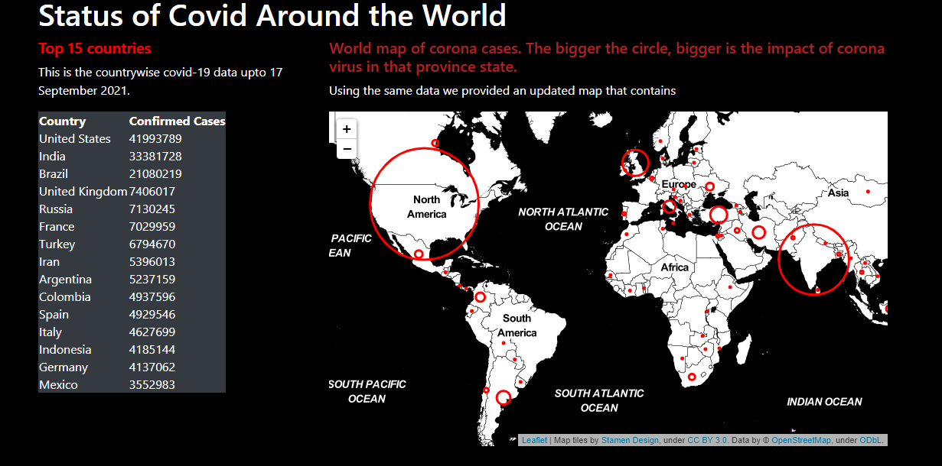COVID-19 Dashboard allows understanding COVID-19 behavior and evolution from different perspectives. Based on those perspectives, it is possible to assess not only the actual number of cases and deaths worldwide and by country, but also the most impacted countries by observing the number of cases and deaths per million people and mortality rate. COVID-19 Dashboard offers a projection of current cases and deaths, which is an important tool to estimate the disease’s evolution. Based on these projections, health organizations around the world might take action in order to minimize the impact, as well as estimate the date when the COVID-19 might stop impacting various countries.COVID-19 Dashboard allows understanding COVID-19 behavior and evolution from different perspectives. Based on those perspectives, it is possible to assess not only the actual number of cases and deaths worldwide and by country, but also the most impacted countries by observing the number of cases and deaths per million people and mortality rate. COVID-19 Dashboard offers a projection of current cases and deaths, which is an important tool to estimate the disease’s evolution.

## Fig 8.1: Covid Dashboard

Based on these projections, health organizations around the world might take action in order to minimize the imp act, as well as estimate the date when the COVID-19 might stop impacting various countries.

## 8.2: TABLE

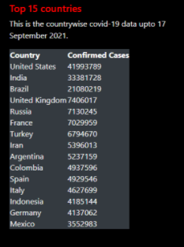A table is displayed on the website which shows the confirmed cases of the top 15 countries in the world. This table gets updated as and when the data is updated so as to keep track of the most affected areas at that particular time.

## Fig 8.2: Top 15 countries table

## 8.3: DETAILS OF SELECTED COUNTRY

As mentioned above, the number of cases, deaths, and mortality rates are deployed using geographic charts. [Figure](https://f1000research.com/articles/9-570#f2) 8.1 presents a geographic chart with the number of confirmed cases, deaths, population, people vaccinated etc. by country, where larger circles implies a large number of confirmed cases and smaller circles implies less number of confirmed cases. On the date that this chart was obtained from COVID-19 Dashboard, the United States had the largest number of cases worldwide followed by India, Brazil, United Kingdom, and Russia.

## Fig 8.3: Report of United States

COVID-19 Dashboard displays information of all the countries considered and from which data is collected and updated as follows:

* Number of confirmed cases, new cases
* Number of deaths, new deaths by country
* Positive rate, tests per case
* Vaccinations, Total vaccinations
* Population, Per capita GDP, median age of people and extreme poverty

COVID-19 Dashboard allows understanding COVID-19 behavior and evolution from different perspectives. Based on those perspectives, it is possible to assess the actual number of cases and deaths by country. Based on these projections, health organizations around the world might take action and people around the world will be able to know and understand the impact of spread with the updated details.

# CHAPTER 9: CONCLUSION AND FUTURE SCOPE

## CONCLUSION:

This project aims to give a detailed analysis on how Covid-19 has impacted the world. These visualizations shows current status on a large scale, can also be downscaled with the emergence of precise datasets on hand to go over current status at a local level. The infographic is easily understandable for people to make better and more informed decisions during this crisis. The derived insights can also be used for further analysis.

## FUTURE SCOPE:

The Covid Dashboard is a static webpage which is used to display the severity of Covid over the countries based on a recent Dataset. With the help of live dataset, the project can be made as a dynamic webpage. With the huge growth in technology and human nature the world is unpredictable, so this project can be used to keep track of other pandemic outbreaks in the future. This project can be extended from countries to states to cities to villages. Based on the information, datasets we have, this model can be used to forecast or predict cases by adding predictive models.

# CHAPTER 10: BIBLIOGRAPHY

## References

* [1] Arman Behnam ,Roohollah Jahanmahin, A data analytics approach for COVID-19 spread and end prediction (with a case study in Iran), 2021
* [2] Hyeontae Jo,Hwijae Son,Hyung JuHwang, Se Young Jung Analysis of COVID-19 spread in South Korea using the SIR model with time-dependent parameters and deep learning (April 2020)
* [3] Ekta Gambhir,Ritika Jain,Alankrit Gupta,Uma Tomer Regression analysis of Covid 19 using machine learning algorithms(SEP 2020)
* [4] Rajan Gupta,Saibal K. Pal,,Gaurav Pandey, A Comprehensive Analysis of Covid 19 outbreak situation in India(April 2020)
* [5]Ravi Sharma ,Nonita Sharma, Statistical Analysis of Covid-19 (SARS-COV-2) Patients Data of Karnataka, India (SEP ,2020)
* [6] Jayesh S,Shilpa Sreedharan , Analysing the Covid-19 Cases in Kerala: a Visual Exploratory Data Analysis Approach(Aug,2020)
* [7] [Siddharth Singh](https://ieeexplore.ieee.org/author/37088491274), [Piyush Raj](https://ieeexplore.ieee.org/author/37088493242);,[Raman Kumar](https://ieeexplore.ieee.org/author/37088491467), [Rishu Chaujar](https://ieeexplore.ieee.org/author/37542982400),Prediction and forecast for COVID-19 Outbreak in India based on Enhanced Epidemiological Models(2020)
* [8] Rajani Kumari, Sandeep Kumar, Ramesh Chandra Poonia, Vijander Singh, Linesh Raja, Vaibhav Bhatnagar,Pankaj Agarwal, Analysis and Predictions of Spread, Recovery, and Death Caused by COVID-19 in India(2021)
* [9]Abdallah M.Samy, Faculty of Sci ence, Ain Shams University, Egypt,A statistical analysis of novel coronavirus(COVID-19) in Italy and Spain(2021)
* [10]Gabriele Oliva, University Campus Bio-Medico of Rome, ITALY ,Topological Data analysis model for the spread of the corna virus ,(2021)