***Abstract --*** COVID-19 outbreak was first reported in Wuhan, China and has spread to more than 50 countries. WHO declared COVID-19 as a Public Health Emergency of International Concern (PHEIC) on 30 January 2020. Naturally, a rising infectious disease involves fast spreading, endangering the health of a large number of people, and thus requires immediate action to prevent the disease at the community level. In this project, we implement a dashboard for COVID 19 spread(Country wise details about cases , tests, vaccination etc. represented on map). This dashboard provides many insightful visualizations for the study of coronavirus spread. In this project, we work on a dataset and generate a dashboard using flask and folium. We use flask and folium python packages for making interactive dashboards. The dataset consists of corona spread data from different countries. This dataset also contains the latitude and longitude of corona affected areas. We filter and visualize the countries with maximum corona cases. This helps people in easily understanding and analyzing the severity of covid 19 spread.

***Keywords –***

*CoronaVirus, Covid-19, Pandemic, Flask, Folium , Data Visualization.*

1. **INTRODUCTION**

Corona Virus which is commonly known as COVID-19 is an infectious disease that causes illness in the respiratory system in humans. The term Covid 19 is sort of an acronym, derived from “Novel CoronaVirus Disease 2019”. Coronavirus (or COVID-19) was first identified in December 2019 in Wuhan city of China. In March 2020, the World Health Organization (WHO) declared the Corona Virus outbreak a pandemic. The epidemic of COVID-19 spread rapidly to more than 200 countries.

Corona Virus has affected the day to day lives of millions of people. COVID-19 often spreads by person-to-person transmission via respiratory droplets and close contact. COVID-19 enters your body through your mouth, nose or eyes (directly from the airborne droplets or from transfer of the virus from your hands to your face). The virus travels to the back of your nasal passages and mucous membrane in the back of your throat. It attaches to cells there, begins to multiply and moves into lung tissue. From there, the virus can spread to other body tissues. Common signs of infection include fever, coughing and breathing difficulties. In severe cases, it can cause pneumonia, multiple organ failure and death.

The incubation period of COVID-19 is thought to be between one and 14 days. It is contagious before symptoms appear, which is why so many people get infected. Infected patients can also be asymptomatic, meaning they do not display any symptoms despite having the virus in their systems.

Governments, health agencies, researchers and healthcare providers are all working together to develop policies and procedures to limit the spread of this virus both globally and from individual to individual.

Health professionals have long considered conventional mapping, and more recently geographic information systems, as critical tools in tracking and combating contagious diseases. The earliest map visualization was in 1694 on plague containment in Italy. The value of maps as a communication tool blossomed over the next 225 years in the service of understanding and tracking infectious diseases, such as yellow fever, cholera and the 1918 influenza pandemic. From the 1960s, when computerized geographic information systems were born, the possibilities for analyzing, visualizing, and detecting patterns of disease dramatically increased again.

The best way to prevent and slow down transmission is to be well informed about the disease and how the virus spreads. The speed with which the disease has spread throughout the world demands agile solutions to understand and estimate the disease progression.

Never in the history of pandemics has so much data been available to professional data scientists or the general public to track the progression of a disease. And as better ways to illustrate the COVID-19 data emerge, the charts and graphics we are seeing to describe it are themselves evolving with the shape and scale of the pandemic over time. This rapid proliferation of information and data depictions threatens to overwhelm the average observer.

Whether or not we should be plotting these measured observations, barring egregious issues with the underlying data, scientists are still compelled to plot them, hoping to reduce complexity, increase learning and weave some understandable narratives from them. When we do, we should know the rendering of the data that best tells the story, the depiction that provides the appropriate context and gives the best understanding of growth and mitigation and conveys the human responses of threat and hope.

So, as we move beyond the data’s fundamental validity, we see that what also matters is to depict the data appropriately so that the stories, meaning, insights and implications that emerge are within human ken, scale and understanding. This is especially needed during a time of existential threat.

Therefore, Interactive dashboards with several charts surfaced in different formats offer concise ways to express the pandemic's growth.

The map provides a real-time count of the number of Confirmed cases, New cases, Deaths, New Deaths, Tests, New Tests, Positive Rate, Tests Per Case, Total Vaccinations, People Vaccinated, People Fully Vaccinated, Population, Median Age of the population, people aged 65 and older, GDP Per Capita, Extreme Poverty of the respective country or region along with the last updated date.

Maps with good design and execution can build awareness and shape smarter decision-making from the global to the hyper-local level. These maps can provide insightful visualizations for the study of coronavirus spread.

The key objectives for the project were identified as:

* To provide insightful visualizations for the study of coronavirus spread.
* To implement an interactive dashboard for COVID 19 spread analysis.
* To filter and visualize the countries and the cities within countries with maximum corona cases.

1. **RELATED WORK**

Many studies focused on statistical models. They focused more on future predictions, patterns and did not give any visualization on the current situation and spread of the virus. In [1] they used ML algorithms such as logistic function using inflection points, created new rates such as weekly death rate, life rate and new approaches to mortality rate and recovery rate in Iran.

In [2] researchers trained, and validated models based on the classic SIR (Susceptible-Infectious Removed) model to predict the future trend in different scenarios.

They employed the traditional SEIR (Susceptible-Exposed-Infectious-Removed) model to simulate the spread of the epidemic in [3].

Previous studies have focused on the macroscopic perspective of the COVID-19 epidemic using Baidu migration and confirmed diagnosis data at the national or provincial scale in [2] and [4].

In [5], Covid-19 patients’ data were analyzed to determine the relationship between different variables such as age , gender using SEIR Model and Statistical analysis.

They used very little data and a huge part of research is based only on cases in Wuhan city and Karnataka.

In [6] an exploratory data analysis was conducted on the Covid-19 cases in Kerala by dividing the Covid-19 data from January 30, 2020, to May 31, 2020 into three phases.

Similar to [5], analysis is done on limited data and restricts the comparison only to Kerala and India.

In [7] they used SIRD, no. of deaths, the time dependence of Outbreak's Intensity in India to forecast maximum no. of confirmed active cases of COVID-19 present in a day and also predicted total number of deaths in India. They also considered very little data and a huge part of research is based only on cases in India.

The correlation coefficients and multiple linear regression applied for prediction and autocorrelation and auto regression have been used to improve the accuracy in [8].Scope is only India and models may not be so accurate.

In [10] , They used the topological data analysis model for US data only. It's more complex for normal people to understand and infer information from the visualizations they provided. They focused on the evolution of cases from time to time but not on the current situation.

1. **PROPOSED WORK**

As better ways to illustrate the COVID-19 data emerge, the charts and graphics we are seeing to describe it are themselves evolving with the shape and scale of the pandemic over time. So, when we move beyond the data’s fundamental validity, we see that what also matters is to depict the data appropriately so that the stories, meaning, insights and implications that emerge are within human ken, scale and understanding. This is especially needed during a time of existential threat.

We use visualization techniques to simplify these kinds of issues. Map visualization is used to analyze and display the geographically related data and present it in the form of maps. This kind of data expression is clearer and more intuitive. We can visually see the distribution or proportion of data in each region. It is convenient for everyone to mine deeper information and make better decisions. They make it easier and more effective to track the status and situation around the world and deal with geospatial data.

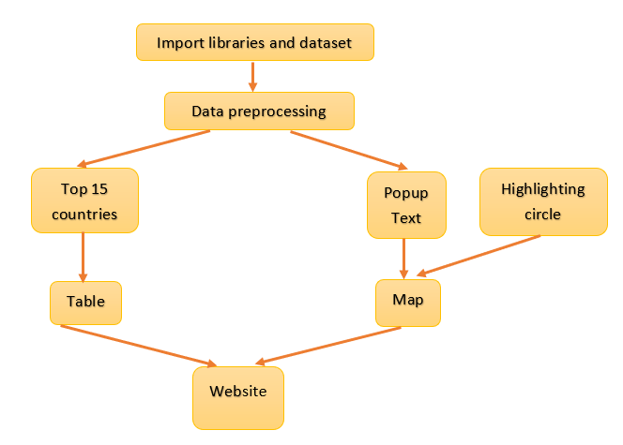

***Fig 1: System Architecture***

We use flask and folium python packages for making interactive dashboards. Flask is a web server gateway interface application in python. This is used for developing web apps. Using Flask, we can build applications that can scale up to complex applications. Folium is a python API for visualizing data. It is a good API to include map related visualizations.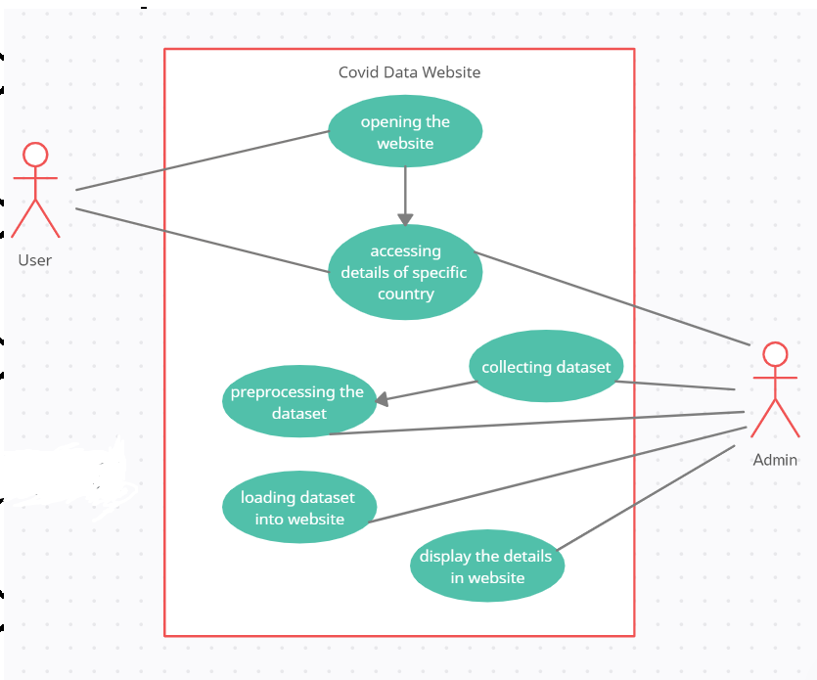

***Fig 2: Use case Diagram***

We use a dataset containing covid related information about different countries around the world. The dataset provides a [real-time count](https://www.arcgis.com/apps/opsdashboard/index.html#/bda7594740fd40299423467b48e9ecf6) of the number of Confirmed cases, New cases, Deaths, New Deaths, Tests, New Tests, Positive Rate, Tests Per Case, Total Vaccinations, People Vaccinated, People Fully Vaccinated, Population, Median Age of the population ,people aged 65 and older, GDP Per Capita , Extreme Poverty of the respective country or region along with the last updated date. The dataset also contains the latitude and longitude of corona affected areas. We filter and visualize the countries and the cities within countries with maximum corona cases.

As different countries have impacted in different ways, there can be outliers as well and some may have a large number of cases and some less, so we normalize the data and scale the data to a range ,perform data preprocessing to remove noisy data and check for missing data as well. 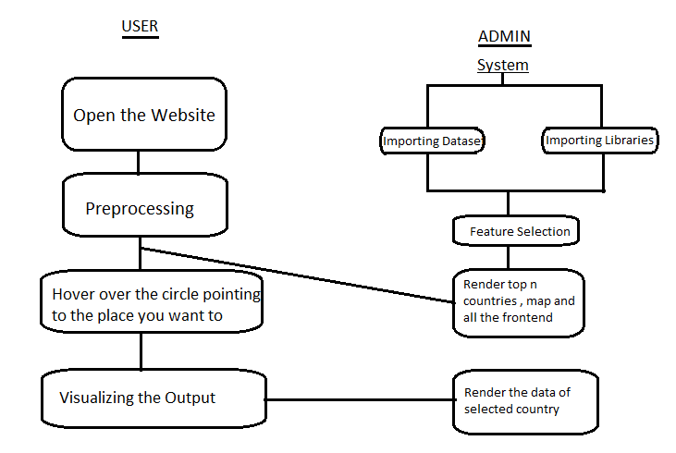

***Fig 3 : Activity Diagram***

After doing all the required preprocessing , we load the data to the website. This imported data is used to collect the top n regions having the largest corona cases to display them as a table . We make a map using the folium package and write a function to make circles on active corona cases regions. To indicate the regions having higher intensity of covid ,a circle having higher radius is used and others relatively. We can just click anywhere on the red circle corresponding to a particular region and that pops up the data highlighting all the important data regarding the virus spread in that place. These circles give us a comparative view of covid intensity across the world.

1. **RESULTS AND DISCUSSIONS**

COVID-19 Dashboard allows understanding COVID-19 behavior and evolution from different perspectives. Based on those perspectives, it is possible to assess not only the actual number of cases and deaths worldwide and by country, but also the most impacted countries by observing the number of cases and deaths per million people and mortality rate. COVID-19 Dashboard offers a projection of future cases and deaths, which is an important tool to estimate the disease’s evolution. Based on these projections, health organizations around the world might take action in order to minimize the impact, as well as estimate the date when the COVID-19 might stop impacting various countries.

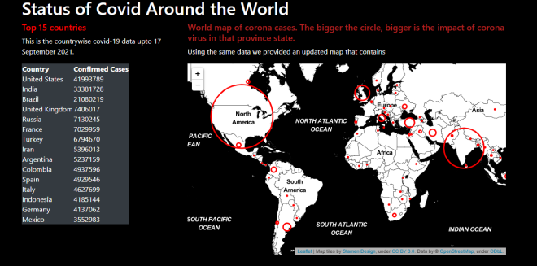

***Fig 4: Dashboard of the world map***

As mentioned above, the number of cases, deaths, and mortality rates are deployed using geographic charts. [Figure](https://f1000research.com/articles/9-570#f2) 4 presents a geographic chart with the number of deaths by country, where larger circles implies a large number of deaths and smaller circles implies a low number of deaths. On the date that this chart was obtained from COVID-19 Dashboard, the United States had the largest number of deaths worldwide followed by India, Brazil, United Kingdom, and Russia.

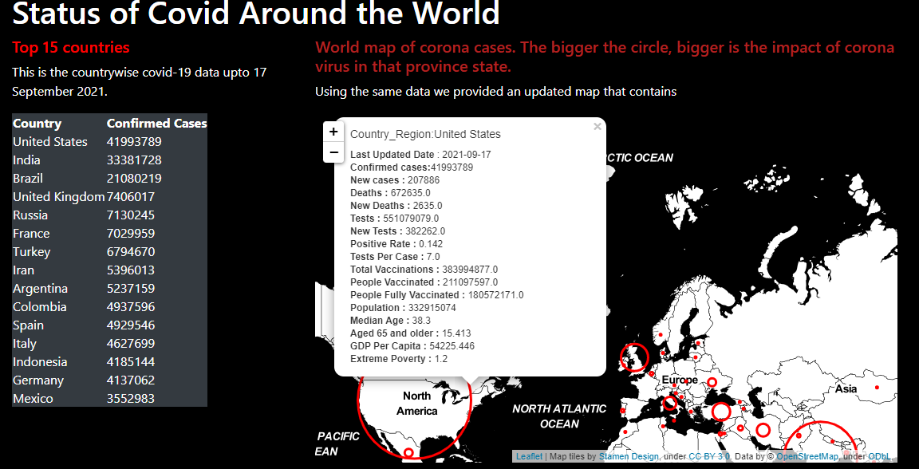

***Fig 5: Report of United States***

*COVID-19 Dashboard* is able to process the data provided by the WHO related to COVID-19 rates and World Population Review related to the current world population. This system deploys up-to-date information as follows:

* *Cases and deaths by country.*
* *Cases and deaths by country per million people.*
* *Mortality rate and poverty rate by country.*
* *Cases and deaths by date worldwide and by selected country.*
* *Number of completed vaccinations.*

COVID-19 Dashboard allows understanding COVID-19 behavior and evolution from different perspectives. Based on those perspectives, it is possible to assess not only the actual number of cases and deaths worldwide and by country, but also the most impacted countries by observing the number of cases and deaths per million people and mortality rate. COVID-19 Dashboard offers a projection of future cases and deaths, which is an important tool to estimate the disease’s evolution. Based on these projections, health organizations around the world might take action in order to minimize the impact, as well as estimate the date when the COVID-19 might stop impacting various countries.

1. **FUTURE SCOPE**

* The Covid Dashboard is a static webpage which is used to display the severity of Covid over the countries based on a recent Dataset.
* With the help of live dataset, the project can be made as a dynamic webpage.
* With the huge growth in technology and human nature the world is unpredictable, so this project can be used to keep track of other pandemic outbreaks in the future.
* This project can be extended from countries to states to cities to villages.
* Based on the information, datasets we have, this model can be used to forecast or predict cases by adding predictive models.

1. **REFERENCES**

[1] Arman Behnam, Roohollah Jahanmahin, A data analytics approach for COVID-19 spread and end prediction (with a case study in Iran), 2021

[2] Hyeontae Jo,Hwijae Son,Hyung JuHwang, Se Young Jung Analysis of COVID-19 spread in South Korea using the SIR model with time-dependent parameters and deep learning (April 2020)

[3] Ekta Gambhir,Ritika Jain,Alankrit Gupta,Uma Tomer Regression analysis of Covid 19 using machine learning algorithms (SEP 2020)

[4] Rajan Gupta,Saibal K. Pal, Gaurav Pandey, A Comprehensive Analysis of Covid 19 outbreak situation in India (April 2020)

[5] Ravi Sharma ,Nonita Sharma, Statistical Analysis of Covid-19 (SARS-COV-2) Patients Data of Karnataka, India (SEP, 2020)

[6] Jayesh S,Shilpa Sreedharan, Analysing the Covid-19 Cases in Kerala: a Visual Exploratory Data Analysis Approach (Aug, 2020)

[7] [Siddharth Singh](https://ieeexplore.ieee.org/author/37088491274), [Piyush Raj](https://ieeexplore.ieee.org/author/37088493242);,[Raman Kumar](https://ieeexplore.ieee.org/author/37088491467), [Rishu Chaujar](https://ieeexplore.ieee.org/author/37542982400),Prediction and forecast for COVID-19 Outbreak in India based on Enhanced Epidemiological Models (2020)

[8] Rajani Kumari, Sandeep Kumar, Ramesh Chandra Poonia, Vijander Singh, Linesh Raja, Vaibhav Bhatnagar, Pankaj Agarwal, Analysis and Predictions of Spread, Recovery, and Death Caused by COVID-19 in India(2021)

[9] Abdallah M.Samy, Faculty of Science, Ain Shams University, Egypt, A statistical analysis of novel coronavirus (COVID-19) in Italy and Spain (2021)

[10] Gabriele Oliva, University Campus Bio-Medico of Rome, ITALY, Topological Data analysis model for the spread of the corna virus, (2021)