TITLE OF THE PROJECT
“MEDICAL SHOP MANAGEMENT SYSTEM”

INTRODUCTION
Medical Shop Management System is being developed with the help of two advanced programming language “JAVA” and “ORACLE”.
The Java is being used as Front-end and Oracle as the Backend.
This is to automate the manual processing of the store. This will reduce the time & tedious work in recording, processing and managing data manually.
I have tried my best to make the complicated process of “Medical Shop Management System” as simple as possible using Structured and modular techniques. I have designed the software in such a way that user may not have any difficulty in using this package and further expansion is possible without many efforts. Even though I can’t claim that this work to be entirely exhaustive, the main purpose of my exercise is perform each medical store activities in computerized way rather than manually which is time consuming.
In this project I am basically focus on the information which is given below: -
- Customer detail
- Supplier_detail
- Customer_invoice
- Sale_detail
- Purchase_detail
- Supplier_order etc.
OBJECTIVES OF THE PROJECT
- Making a user friendly system involving fewer buttons.
- Bunching of scattered information into fewer tables.
- Providing necessary validation checks for data accuracy.
- Facilitating quick and easy updation of data.
- Making fast and effortless retrieval of data.
- Providing the much needed flexibility in the system.
- Providing adequate security.
- Making a simple system for ease of understanding operation.
- Keeping the necessary storage of data for reference.
- Utilizing existing personnel to their best involving minimum man – hours and maximum output.
- Better security: Safeguarding sensitive and important by making it accessible only to authorized persons. There are three level securities: -one is data level, second is user level and third is administrator level.
- Enhanced communication: -The front-end of the project is Java and designed in interactive graphical interface using windows type interface.
Medical Shop purchases, sales and stores the medicine. There is need to store the information of the medicine like manufacturing date, purchase rate, sales rate, expiry date and discount on the medicine including information of the accounts, information of the Supplier details, medicine details, information of the retailer, etc. The modules of the project will be Product details, Customer Details, supplier details, purchase details, sales detail, Bill details etc.

PROJECT CATEGORY
FRONT-END: Java
JAVA is pure object oriented programming language, which has derived C syntax and C++ object oriented programming features. Is compiled and interpreted language and is platform independent and can do graphics, networking, multithreading. Java was conceived by James Gosling, at Sun Microsystems Inc., in 1991. It took 18 months to develop the first working version. This language was initially called “Oak”, but was renamed “Java” in 1995. The primary motivation of Java was the need for a platform independent language that could be used to create software to be embedded in various consumer electronic devices, such as microwave ovens and remote controls.
Java have a following list of buzzwords:-
Java provides many features which are also known as Java buzzwords. These are:
- Simple
- Secure
- Portable
- Object-oriented
- Robust
- Multithreading
- Architecture-neutral
- Interpreted
- High Performance
- Distributed
- Dynamic
BASIC DATABASE CONCEPTS
A database is a collection of related information stored so that it is available to many users for different purposes. It consists the collection of interrelated data and a set of programs to access those data. It is a coherent collection of data with some inherent meaning, design, built and populated with data for a specific purpose.
About Oracle 10g (Back-end)
Oracle 10g is an RDBMS package developed by Oracle Corporation. This RDBMS package can manage any type of data in a well designed manner. Oracle is structured query language (SQL), is the set of commands that all program and users must use to access data within the Oracle Database. Application program and Oracle tools often allow users to access the data base without directly using SQL, but, these application in turn must use SQL when Executing the users request.
TOOLS/ENVIRONMENT USED
Software Requirement
- OPERATING SYSTEM – WINDOWS 2007/10 (64-bit)
- FRONT END TOOLS—JAVA (SWING) 1.6
- BACK END TOOLS—ORACLE 10g
Hardware Requirement
- Intel Corei3
- 4 GB RAM
- 500 GB HARD DISK

SYSTEM ANALYSIS
IDENTIFICATION OF NEED :-
In this MEDICAL SHOP did each and every work manually. By doing the work manually, there were always great chances of errors and dissatisfactions among management also. The manual work is tedious and time consuming. It also get pressurize the employees regarding their efficiency. Therefore there was always need for a kind of software which can fulfill all the above requirement with accuracy in a minimum amount of time and sorting all relevant problems using less afford.
The analyst meets the branch heads and with the users, the user that is starting point in the computer based system. To begin the analyst assists the staffs defining the goal of the system. An analyst maker sure to distinguish between students needs and user wants. Once the goal are identified the analyst moves in to evaluation of supplementary information gathered here is specified in a system concept document. In Medical Shop Management System employees did each and every work manually. By doing the work manually, there were always great chances of errors and dissatisfactions among management also. The manual work is tedious and time consuming. It also get pressurize the employees regarding their efficiency. Therefore there was always need for a kind of software which can fulfill all the above requirement with accuracy in a minimum amount of time and sorting all relevant problems using less afford. So, before developing software, I have to go through the whole working process on the website. Collecting all information from the employees and management, I started my work on the project with collecting all information and preparing an initial documents and again conducting an interviews with the employees and management.
Preliminary Investigation
The first step in the system development life cycle is the preliminary investigation to determine the feasibility of the System. The purpose of the preliminary investigation is to evaluate project requests. It is neither a design study nor does it includes the collection of details top describe the business system in all respect. Rather, it is collecting of information that helps committee members to evaluate the merits of the project request and make an informed judgment about the feasibility of the proposed project.
Here for the “Medical Shop Management System”, I have worked on the preliminary investigation that accomplished the following objectives:
- Clarify and understand the project request.
- Determine the size of the project.
- Assess costs and benefits of alternative approaches.
Feasibility Study:
An important outcome of the preliminary investigation phase is that the package required is feasible and meets the efficiency criterion, the workability standard; also it meets the user’s needs. The various types of feasibility are-
Technical Feasibility:
This evaluation determines Whether the technology needed for the proposed system is available. How this technology integrated within the organization.
Economic Feasibility:
This evaluation looks at the financial aspect of the project. To carry out an economical study it is necessary to place actual money values against any activities needed to implement the proposed system. It is also necessary to place money values against any benefits that will come from a new system. Such calculations are often described as cost benefit analysis. The proposed software is economically feasible, as no big investment is required.
Operational Feasibility:
Operational feasibility covers two aspects. The operational feasibility determines how acceptable the software is within the organization. The evaluation must then determine the general attitude and skills whether such restructuring of the jobs will be acceptable to the users.
Design: -
Software design is actually a multi step process that focuses on four distinct attributes of a program data structure, software architecture, interface representations, and procedural (algorithmic) detail. The design process translates requirements into a
Code Generation: -
The design must be translated into a machine-readable form. The code generation step performs this task. If design is performed in a detailed manner, code generation can be accomplished mechanistically.
Testing: -
Once code has been generated, program testing begins. The testing process focuses on the logical internals of the software, ensuring that all statements have been tested and on the functional externals, that is, conducting tests to uncover errors and ensure that defined input will product actual results that agree with required results.
Requirement & Analysis Specification
Design &
Specification
Coding
Module Testing
Testing
System Testing
Delivery
Maintenance

Figure : Waterfall Model of Software Life Cycle

SOFTWARE REQUIREMENT SPECIFICATION(SRS)
The software requirement specification is the output of a structure system analysis. System analysis use it as a reference for the system development group, who need detailed system specification to build the srs.
Requirement Definition and description

System model description
Software requirement specification

The SRS template under reference helps to specify function, interface, performance, controls and constraints. SRS review is an activity begin after major work on SRS is done and documented. This process helps to verify and validate the need and correctness of the requirement and its specification.
The major characteristics of SRS are mainly completeness, correctness, traceability, testability and whether it is unambiguous and consistent. It is advisable spend time and money and effort in activities like protyping, experimenting, reviewing and checking sensitive aspects of tools and technology. The major effort focus should be on feasibility, economic feasibility to reduce business risk, technical feasibility for achieving high degree of customer specification.

REQUIREMENT ANALYSIS
This section lists the functional requirements in ranked order. Functional requirements describe the possible effects of a software system, in other words, what the system must accomplish. Other kinds of requirements (such as interface requirements, performance requirements, or reliability requirements) describe how the system accomplishes its functional requirements.
Functional Requirement
In software engineering, a functional requirement defines a function of a software system or its component. A function is described as a set of inputs, the behavior, and outputs. Functional requirements may be calculations, technical details, data manipulation and processing and other specific functionality that define what a system is supposed to accomplish.
FR1: Product Details
FR2: Customer Details
FR3: Purchase & Sales Details
FR4: Supplier & Suplier Order Details
FR5: Bill Details
Non-functional Requirement
PERFORMANCE REQUIREMENTS
USER FRIENDLY:
The system should be user friendly so that it can easily be understand by the user without any difficulty.
EASE OF MAINTENANCE:
The system should be easy to maintain and use.
The SRS of customer detail:-
Start

Enter customer detail data
Open customer detail entry form

Update customer detail db
Check for duplicate record

Save customer detail data

The SRS of customer order and sales detail:-
Start

Enter customer order data
Open customer order entry form

Open customer detail entry form
Validate customer record

Check stock

sales detail:-
Start
Enter ales detail data
Open Sales detail entry form

Open supplier detail entry form
Customer order

Check for product code

Update customer invoice
Customer delivery
Update stock

CLASS DIAGRAM
customer_details
c_id: String
name: String
fname:String
occ:String
address: string
city: String
dob: date
Save()
Update()
Login

User_Name: String
Password: String

Supplier Details

s_id: String
name: String
Address:String
city: String
state: string
email: string
Save()
Search()
product_details
pcode: String
name: String
mrp:int
total:int

save()
search()

sale_details

s_no: String
cid: string
qty:int
rate:int
total: int
save()
update()
Purchase details
p_id: String
name: String
cprice:int
qty:int
total: int

purchase()
Update()
invoice
inv_no: String
c_id: String
name:string
qty:int
rate: int
gtotal: int
cal_bill()
Search()

data flow diagram

MEDICAL SHOP MANAGEMENT SYSTEM

REPORTS
ADMIN
Login
Print

DATABASE

FIG:-‘0’ LEVEL DFD

1 LEVEL DFD
1.0

Product Module
Product details
Admin
enter store

ADMIN
2.0
Customer details,
Supplier
Customer
Enter details
Supplier

3.0
Supplier Order
Supplier Order

enter

Purchase

4.0
Purchase & Sale Details

Sale Details
Transaction

Consumer Invoice
5.0
Customer Invoice
Report

Report

2nd LEVEL DFD
1.0
Product Module
Consumer
Product details
Admin
enter store
1.0.1
Update
Consumer Module
Consumer
1.0.2
Delete
Consumer Module
Consumer

ADMIN
2.0
Customer & supplier
Customer
Enter details
2.0.1
Update customer
Connection
Consumer

3.0
Supplier order

Suppl. order

3.0.1
update

4.0
Purchase & Sale

enter
4.0.1
Calculate Invoice
Consumer

5.0
Report
Report
Bill Report

Product Report

ER DIAGRAM

Inv_date
inv_id
Supl_id
Total
M
Invoice
has
supplier
Cust_id
1
Address
has
1
Name
Customer
M
Pwd
User_id
N
Phone
P_id
Cust_name
Admin_login
Name
Purchase
sale
1 1
Purchase
M
prod_id
P_Type
P_Name
Product
sale_no
Invoice
P_code
Sale_dtl
order
M
Total

Generate
Sup_order

Prod_name
S_order_no

Project Planning:-
The project planning objective is achieved through a process of information discovery that leads to reasonable estimates. Before the project can begin, the manager and software team must estimate the work to be done. A manager must decide what objectives are to be achieved, what resource are required to achieve the objectives how and when resource are to be achieved and how the goals are to be achieved.
Thus, project planning for any company has the following four main steps: -
1. Organising the resources available for the project.
2. Scheduling the events of the project.
3. Evaluating the progress.
4. Establishing standards for the project.
An effective manager is essential for successful project planning. The techniques of project planning are not a substitute for good management, but merely a tool to be used by managers to achieve better results. Only effective management can complete the project on time, within budget, and with satisfactory results.
Project Scheduling:-
Software project scheduling is an activities that distributes estimated efforts across the planned project duration by allocating the effort to specific software engineering tasks. Scheduling of a project can be correlated to prioritizing various tasks with respect to their cost, time and duration.

GANTT CHART

Days  Phase | 20Days | 15 Days | 15 Days | 20 Days | 10 Days | 10 Days
System Requirement Specification
System Analysis
Designing
Coding
Co
Testing

Implementation

PERT CHART
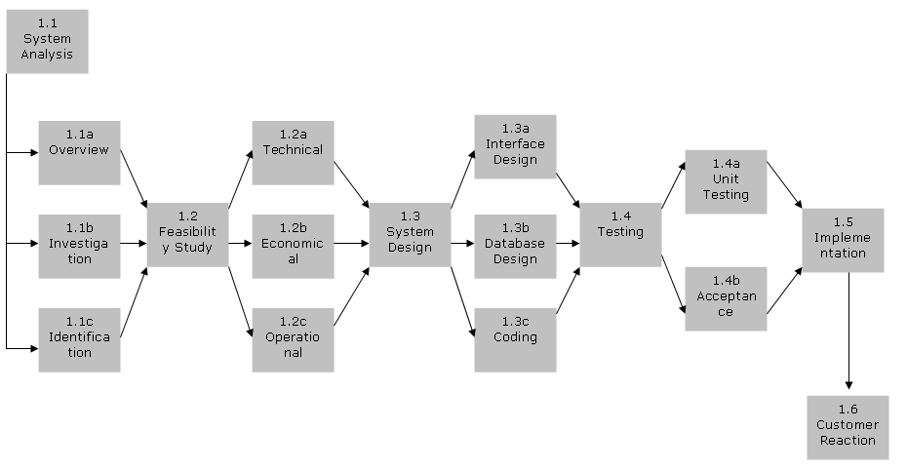

MODULES
After going through the detail analysis of Medical Shop, I found that it has very complex architecture. Therefore for better management and simplicity in development, I develop the module of this project and decomposed this module into three sub-modules which are as:-
- Master Module.
- Transaction Module.
- Invoice Module.
Master module: -
This module is most important module of this MEDICAL SHOP. This module is responsible for
- Customer Detail
- Product Detail
- Supplier Detail
This module having the detail information like as
- Customer detail
- Product detail
- Supplier detail
- Generate the report of the day-to-day transaction and profit & loss report.

Transaction Module
This module having the details of stock and responsible for
- Purchase details.
- Supplier order
- Sale details
This module having information like as
- Detail information of purchase details of the product.
- Detail information with the expiry date and MRP with purchase rate.
- Detail of the stock particular product wise.
- Generate the report of the supplier product status.
- Generate the report of the stock.
Invoice module: -
This management module is responsible for all type of invoice
- Customer Invoice details of the customer.
Report Module
In this sub-module all type of report can be automatically generated according to your query related to masters that is-
- Customer report according to their area and visiting status.
- Supplier report according to their area and product status.
- Generate the report related to invoice.

DATABASE DESIGN
1. Login:-
Field | Data Type | Width | Attribute
Name | Varchar2 | 6 | Not null
Password | Varchar2 | 20 | Not null
2.Product Detail: -
Field | Type | Width | Attribute
Product_code | Varchar2 | 10 | Primary Key
Product_Name | Varchar2 | 20 | Not null
Mfg_date | Date |  | Not null
Exp_date | Date |  | Not null
Prod_type | Varchar2 | 10 | Not null
Comp_name | Varchar2 | 20 | Not null
Mrp | Number | 8,2 | Not null
Tax | Number | 8,2 | Not null
Total_price | Number | 8,2 | Not null
3.Customer_detail: -
Field | Data Type | Width | Attribute
Customer_id | Varchar2 | 6 | Primary key
Name | Varchar2 | 20 | Not null
Address | Varchar2 | 50 | Not null
District | Varchar2 | 15 | Not null
State | Varchar2 | 15 | Not null
Pin_code | Number | 6 | Not null
Mob_no. | Varchar2 | 15 | Not null
Email_id | Varchar2 | 50 | Not null

4.Supplier_detail: -
Field | Data Type | Width | Attribute
Supplier_id | Varchar2 | 6 | Primary key
Name | Varchar2 | 20 | Not null
Address | Varchar2 | 50 | Not null
City | Varchar2 | 50 | Not null
District | Varchar2 | 15 | Not null
State | Varchar2 | 15 | Not null
Pin_code | Number | 6 | Not null
Mob_no. | Varchar2 | 15 | Not null
Email_id | Varchar2 | 50 | Not null
5.Purchase_detail: -
Field | Data Type | Width | Attribute
P_no. | Varchar2 | 6 | Primary key
Supplier_id | Varchar2 | 6 | Foreign key
Product_code | Varchar2 | 6 | Foreign key
Product_name | Varchar2 | 20 | Not null
Product_type | Varchar2 | 10 | Not null
Content | Varchar2 | 10 | Not null
Quantity | Number | 8 | Not null
Rate | Number | 8,2 | Not null
Total_price | Number | 8,2 | Not null
TAX | Number | 8,2 | Not null
Discount | Number | 8,2 | Not null
Grand_total | Number | 8,2 | Not null
Purchase_Date | Date |  | Not null

6. Sales_detail: -
Field | Data Type | Width | Attribute
S_no. | Varchar2 | 6 | Primary key
Customer_id | Varchar2 | 6 | Not null
Product_code | Varchar2 | 6 | Foreign key
Product_name | Varchar2 | 20 | Not null
Product_type | Varchar2 | 10 | Not null
Content | Varchar2 | 10 | Not null
Quantity | Number | 8 | Not null
Rate | Number | 8,2 | Not null
Total_price | Number | 8,2 | Not null
TAX | Number | 8,2 | Not null
Discount | Number | 8,2 | Not null
Grand_total | Number | 8,2 | Not null
Sale_Date | Date |  | Not null
7. Customer_invoice: -
Field | Data Type | Width | Attribute
C_invoice_no. | Varchar2 | 6 | Primary key
C_delivery_no. | Varchar2 | 6 | Not null
Customer_id | Varchar2 | 6 | Foreign key
Product_code | Varchar2 | 6 | Foreign key
Product_name | Varchar2 | 20 | Not null
Product_type | Varchar2 | 10 | Not null
Content | Varchar2 | 10 | Not null
Quantity | Number | 8 | Not null
Rate | Number | 8,2 | Not null
Grand_total | Number | 8,2 | Not null
Paid_amount | Number | 8,2 | Not null
Rest_amount | Number | 8,2 | Not null
Inv_Date | Date |  | Not null
8.Supplier_order: -
Field | Type | Width | Attribute
Supplier_id | Varchar2 | 6 | Foreign key
s_order_no | Varchar2 | 6 | Not null
s_delivery_no. | Varchar2 | 6 | Not null
Product_name | Varchar2 | 20 | Not null
Product_type | Varchar2 | 10 | Not null
Quantity | Number | 8 | Not null
Quantity dues | Number | 8 | Not null
Rate | Number | 8,2 | Not null
sDate | Date |  | Not null

USER DESIGN
Home Page
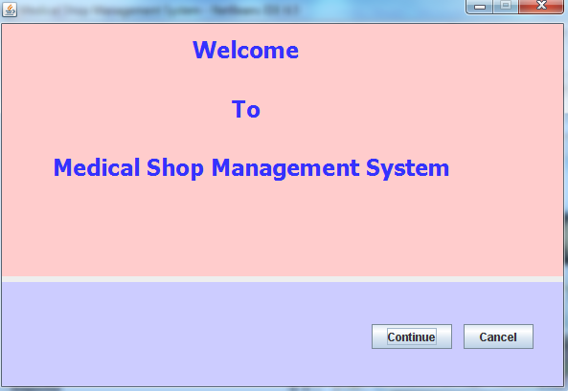
Login Page
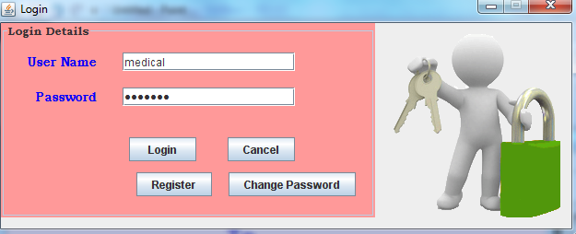

Create New User
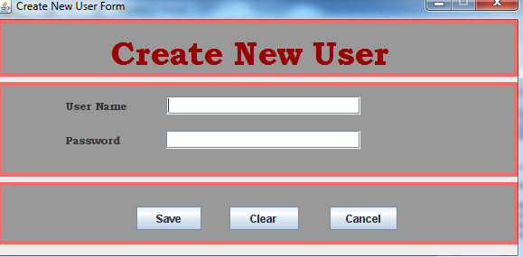
Change Password
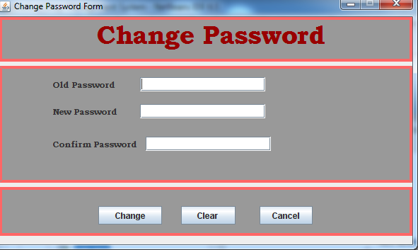

Menu Page
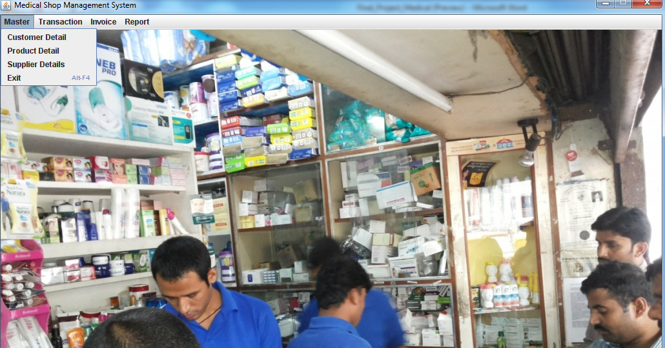
Customer Details
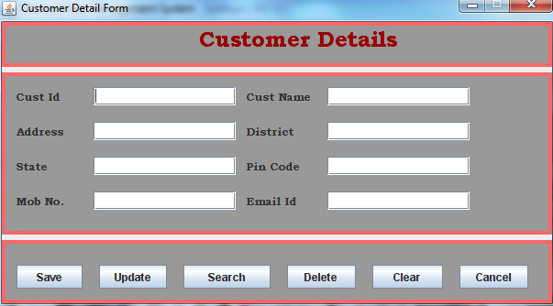

Product Details
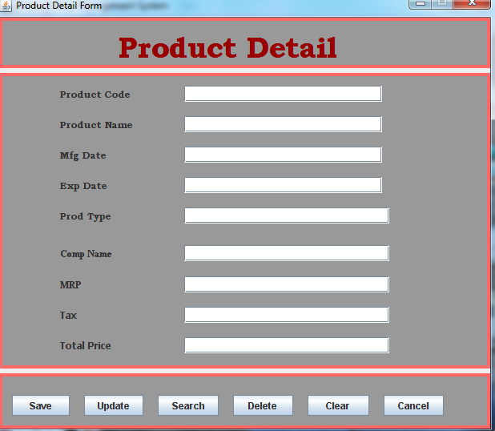
Supplier Detail
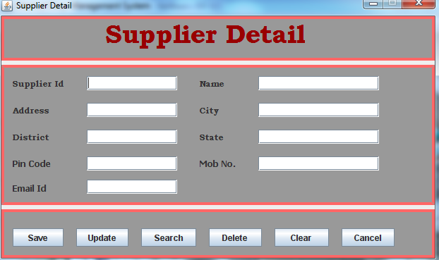

Purchase Details
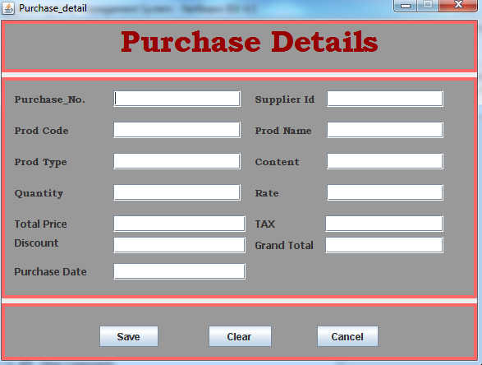
Sale Details
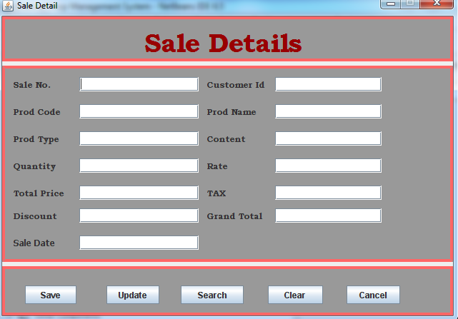

Customer Invoice
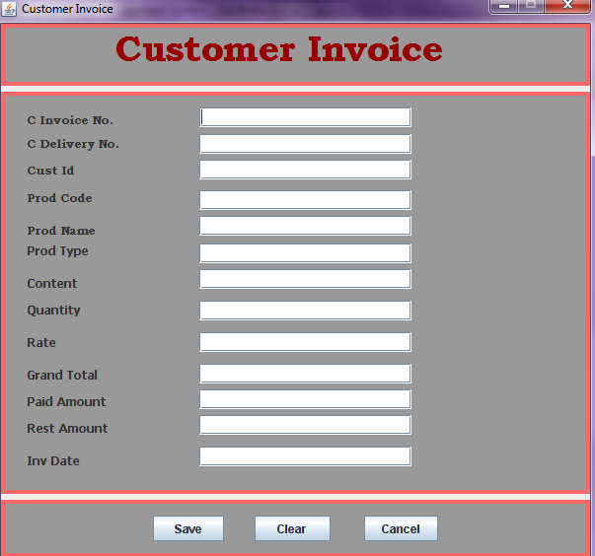

Supplier Order

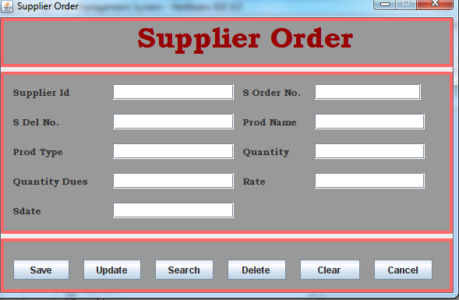

PROGRAM CODE

Connection Coding
package connection;
import java.sql.*;
import javax.swing.JOptionPane;
public class connect {
static Connection con=null;
public static Connection conn()
{
try
{
Class.forName("oracle.jdbc.driver.OracleDriver"); con=DriverManager.getConnection("jdbc:oracle:thin:@localhost:1521:xe","medical","medical");
System.out.println("Connection Created...... ");
}
catch(Exception e){
e.printStackTrace();
System.out.println("connnection not created");
JOptionPane.showMessageDialog(null, "Sorry!, Please check the Connection and Database");

}
return con;
}

}

Home Page

package msms;
public class home extends javax.swing.JFrame {
/** Creates new form home */
public home() {
initComponents();
}
private void initComponents() {
jPanel1 = new javax.swing.JPanel();
jLabel1 = new javax.swing.JLabel();
jLabel2 = new javax.swing.JLabel();
btncontinue = new javax.swing.JButton();
btncancel = new javax.swing.JButton();
jLabel4 = new javax.swing.JLabel();
setDefaultCloseOperation(javax.swing.WindowConstants.EXIT_ON_CLOSE);
setTitle("Home");
setResizable(false);
jPanel1.setBackground(new java.awt.Color(153, 153, 153));
jLabel1.setFont(new java.awt.Font("Bookman Old Style", 1, 36));
jLabel1.setText("Welcome");
jLabel2.setFont(new java.awt.Font("Bookman Old Style", 1, 24));
jLabel2.setForeground(new java.awt.Color(255, 204, 102));
jLabel2.setText("To");
jLabel3.setFont(new java.awt.Font("Bookman Old Style", 1, 24));
jLabel3.setForeground(new java.awt.Color(153, 51, 0));
jLabel3.setText("MEDICAL SHOP Management System");
btncontinue.setText("Continue");
btncontinue.addActionListener(new java.awt.event.ActionListener() {
public void actionPerformed(java.awt.event.ActionEvent evt) {
btncontinueActionPerformed(evt);
}
});
btncancel.setText("Cancel");
btncancel.addActionListener(new java.awt.event.ActionListener() {
public void actionPerformed(java.awt.event.ActionEvent evt) {
btncancelActionPerformed(evt);
}
});
jLabel4.setFont(new java.awt.Font("Tahoma", 1, 18));
jLabel4.setForeground(new java.awt.Color(51, 51, 51));
private void btncontinueActionPerformed(java.awt.event.ActionEvent evt) {
// coding for continue
login lg=new login();
dispose();
lg.show();
}
private void btncancelActionPerformed(java.awt.event.ActionEvent evt) {
// coding for cancel
dispose();
}
public static void main(String args[]) {
java.awt.EventQueue.invokeLater(new Runnable() {
public void run() {
new home().setVisible(true);
}
});
}
// Variables declaration - do not modify
private javax.swing.JButton btncancel;
private javax.swing.JButton btncontinue;
private javax.swing.JLabel jLabel1;
private javax.swing.JLabel jLabel2;
private javax.swing.JLabel jLabel3;
private javax.swing.JLabel jLabel4;
}

Login Page

package msms;
import java.sql.*;
import javax.swing.JOptionPane;
public class login extends javax.swing.JFrame {
Connection con=null;
String userid=null;
String pwd=null;
PreparedStatement ps=null;
ResultSet rs=null;
/** Creates new form login */
public login() {
initComponents();
}
@SuppressWarnings("unchecked")
// <editor-fold defaultstate="collapsed" desc="Generated Code">
private void initComponents() {
jPanel1 = new javax.swing.JPanel();
jLabel1 = new javax.swing.JLabel();
jLabel2 = new javax.swing.JLabel();
txtu_id = new javax.swing.JTextField();
txtpwd = new javax.swing.JPasswordField();
btnlogin = new javax.swing.JButton();
btncancel = new javax.swing.JButton();
setDefaultCloseOperation(javax.swing.WindowConstants.EXIT_ON_CLOSE);
setTitle("Login");
setResizable(false);
jPanel1.setBackground(new java.awt.Color(255, 153, 153));
jPanel1.setBorder(javax.swing.BorderFactory.createTitledBorder(null, "Login Details", javax.swing.border.TitledBorder.DEFAULT_JUSTIFICATION, javax.swing.border.TitledBorder.DEFAULT_POSITION, new java.awt.Font("Bookman Old Style", 1, 12))); // NOI18N
jLabel1.setFont(new java.awt.Font("Bookman Old Style", 1, 14));
jLabel1.setForeground(new java.awt.Color(0, 0, 255));
jLabel1.setText("User Name");
jLabel2.setFont(new java.awt.Font("Bookman Old Style", 1, 14));
jLabel2.setForeground(new java.awt.Color(0, 0, 255));
jLabel2.setText("Password");
btnlogin.setText("Login");
btnlogin.addActionListener(new java.awt.event.ActionListener() {
public void actionPerformed(java.awt.event.ActionEvent evt) {
btnloginActionPerformed(evt);
}
});
btncancel.setText("Cancel");
btncancel.addActionListener(new java.awt.event.ActionListener() {
public void actionPerformed(java.awt.event.ActionEvent evt) {
btncancelActionPerformed(evt);
}
});
private void btnloginActionPerformed(java.awt.event.ActionEvent evt) {
// Coding for login
userid=txtu_id.getText();
pwd=txtpwd.getText();
if(userid.equals("medical") && pwd.equals("medical"))
{
menu m=new menu();
dispose();
m.show();
}
else
{
JOptionPane.showMessageDialog(null,"invalid user name and password");
}
}
private void btncancelActionPerformed(java.awt.event.ActionEvent evt) {
// Coding for cancel
dispose();
}
public static void main(String args[]) {
java.awt.EventQueue.invokeLater(new Runnable() {
public void run() {
new login().setVisible(true);
}
});
}
// Variables declaration - do not modify
private javax.swing.JButton btncancel;
private javax.swing.JButton btnlogin;
private javax.swing.JLabel jLabel1;
private javax.swing.JLabel jLabel2;
private javax.swing.JPanel jPanel1;
private javax.swing.JPasswordField txtpwd;
private javax.swing.JTextField txtu_id;
// End of variables declaration
}

Create New user

package msms;
import java.sql.*;
import javax.swing.JOptionPane;
public class Create_new_user extends javax.swing.JFrame {
Connection con=null;
PreparedStatement ps=null;
ResultSet rs=null;
String uid=null;
String pwd=null;

/** Creates new form new_user */
public Create_new_user() {
initComponents();
}

// <editor-fold defaultstate="collapsed" desc="Generated Code">
private void initComponents() {

jPanel1 = new javax.swing.JPanel();
jLabel1 = new javax.swing.JLabel();
jPanel2 = new javax.swing.JPanel();
jLabel2 = new javax.swing.JLabel();
jLabel3 = new javax.swing.JLabel();
txtuname = new javax.swing.JTextField();
txtpwd = new javax.swing.JPasswordField();
jPanel3 = new javax.swing.JPanel();
btnsave = new javax.swing.JButton();
btnclear = new javax.swing.JButton();
btncancel = new javax.swing.JButton();

setDefaultCloseOperation(javax.swing.WindowConstants.EXIT_ON_CLOSE);
setTitle("Create New User Form");
setResizable(false);

jPanel1.setBackground(new java.awt.Color(153, 153, 153));
jPanel1.setBorder(javax.swing.BorderFactory.createLineBorder(new java.awt.Color(255, 102, 102), 4));

jLabel1.setFont(new java.awt.Font("Bookman Old Style", 1, 36));
jLabel1.setForeground(new java.awt.Color(153, 0, 0));
jLabel1.setText("Create New User");

javax.swing.GroupLayout jPanel1Layout = new javax.swing.GroupLayout(jPanel1);
jPanel1.setLayout(jPanel1Layout);
jPanel1Layout.setHorizontalGroup(

jPanel3.setBackground(new java.awt.Color(153, 153, 153));
jPanel3.setBorder(javax.swing.BorderFactory.createLineBorder(new java.awt.Color(255, 102, 102), 4));

btnsave.setText("Save");
btnsave.addActionListener(new java.awt.event.ActionListener() {
public void actionPerformed(java.awt.event.ActionEvent evt) {
btnsaveActionPerformed(evt);
}
});

btnclear.setText("Clear");
btnclear.addActionListener(new java.awt.event.ActionListener() {
public void actionPerformed(java.awt.event.ActionEvent evt) {
btnclearActionPerformed(evt);
}
});

btncancel.setText("Cancel");
btncancel.addActionListener(new java.awt.event.ActionListener() {
public void actionPerformed(java.awt.event.ActionEvent evt) {
btncancelActionPerformed(evt);
}
});

private void btnsaveActionPerformed(java.awt.event.ActionEvent evt) {
// coding for save
uid= txtuname.getText();
pwd= txtpwd.getText();
if (!uid.equals("")) {
try {
con=connection.connect.conn();
ps = con.prepareStatement("insert into login values(?,?)");
ps.setString(1, uid);
ps.setString(2, pwd);
ps.executeUpdate();
JOptionPane.showMessageDialog(null, "Data has been inserted successfully ");
clear();
} catch (Exception e) {
e.printStackTrace();
}
} else {
JOptionPane.showMessageDialog(null, "Data has not been inserted!!");
}
}

private void btnclearActionPerformed(java.awt.event.ActionEvent evt) {
// coding for clear
clear();
}

private void btncancelActionPerformed(java.awt.event.ActionEvent evt) {
// coding for cancel
dispose();
}
public void clear()
{
txtuname.setText("");
txtpwd.setText("");

}
/**
* @param args the command line arguments
*/
public static void main(String args[]) {
java.awt.EventQueue.invokeLater(new Runnable() {
public void run() {
new Create_new_user().setVisible(true);
}
});
}

// Variables declaration - do not modify
private javax.swing.JButton btncancel;
private javax.swing.JButton btnclear;
private javax.swing.JButton btnsave;
private javax.swing.JLabel jLabel1;
private javax.swing.JLabel jLabel2;
private javax.swing.JLabel jLabel3;
private javax.swing.JPanel jPanel1;
private javax.swing.JPanel jPanel2;
private javax.swing.JPanel jPanel3;
private javax.swing.JPasswordField txtpwd;
private javax.swing.JTextField txtuname;
// End of variables declaration

}

Change Password

package msms;
import java.sql.*;
import javax.swing.JOptionPane;

public class change_password extends javax.swing.JFrame {
Connection con=null;
PreparedStatement ps=null;
ResultSet rs=null;
String old_pwd=null;
String new_pwd=null;
String confirm_pwd=null;
String uid=null;
String ckpwd=null;
String uid1=null;
int mm3=0;
int mm2=0;
/** Creates new form product_detail */
public change_password() {
initComponents();
}

// <editor-fold defaultstate="collapsed" desc="Generated Code">
private void initComponents() {
jPanel1 = new javax.swing.JPanel();
jLabel1 = new javax.swing.JLabel();
jPanel2 = new javax.swing.JPanel();
jLabel2 = new javax.swing.JLabel();
jLabel3 = new javax.swing.JLabel();
jLabel5 = new javax.swing.JLabel();
txtoldp = new javax.swing.JTextField();
txtnewp = new javax.swing.JTextField();
txtconp = new javax.swing.JTextField();
jPanel3 = new javax.swing.JPanel();
btnsave = new javax.swing.JButton();
btnclear = new javax.swing.JButton();
btncancel = new javax.swing.JButton();
setDefaultCloseOperation(javax.swing.WindowConstants.EXIT_ON_CLOSE);
setTitle("Change Password Form");
setResizable(false);
btnsave.setText("Change");
btnsave.addActionListener(new java.awt.event.ActionListener() {
public void actionPerformed(java.awt.event.ActionEvent evt) {
btnsaveActionPerformed(evt);
}
});

btnclear.setText("Clear");
btnclear.addActionListener(new java.awt.event.ActionListener() {
public void actionPerformed(java.awt.event.ActionEvent evt) {
btnclearActionPerformed(evt);
}
});

btncancel.setText("Cancel");
btncancel.addActionListener(new java.awt.event.ActionListener() {
public void actionPerformed(java.awt.event.ActionEvent evt) {
btncancelActionPerformed(evt);
}
});

private void btnsaveActionPerformed(java.awt.event.ActionEvent evt) {
// Coding for change passowrd
old_pwd=txtoldp.getText();
new_pwd=txtnewp.getText();
confirm_pwd=txtconp.getText();
uid1=JOptionPane.showInputDialog("enter username");
mm2=new_pwd.compareTo(confirm_pwd);
if(mm2==0)
{

try
{
con=connection.connect.conn();
ps=con.prepareStatement("select * from login where u_id='"+uid1+"'");
rs=ps.executeQuery();
while(rs.next())
{
uid=(rs.getString(1));
ckpwd=(rs.getString(2));
mm3=ckpwd.compareTo(old_pwd);

if(mm3==0)
{
ps=con.prepareStatement("update login set u_id=?,pwd=? where u_id='"+uid1+"'");
ps.setString(1,uid);
ps.setString(2,confirm_pwd);
ps.executeUpdate();
JOptionPane.showMessageDialog(null,"password has been changed");
}
else
{
JOptionPane.showMessageDialog(null,"password was not changed");
}
}
}

catch(Exception e)
{
}
}
}

private void btnclearActionPerformed(java.awt.event.ActionEvent evt) {
// Coding for clear
clear();
}

private void btncancelActionPerformed(java.awt.event.ActionEvent evt) {
// Coding for cancel
dispose();
}
public void clear()
{
txtoldp.setText("");
txtnewp.setText("");
txtconp.setText("");

}
public static void main(String args[]) {
java.awt.EventQueue.invokeLater(new Runnable() {
public void run() {
new change_password().setVisible(true);
}
});
}
// Variables declaration - do not modify
private javax.swing.JButton btncancel;
private javax.swing.JButton btnclear;
private javax.swing.JButton btnsave;
private javax.swing.JLabel jLabel1;
private javax.swing.JLabel jLabel2;
private javax.swing.JLabel jLabel3;
private javax.swing.JLabel jLabel5;
private javax.swing.JPanel jPanel1;
private javax.swing.JPanel jPanel2;
private javax.swing.JPanel jPanel3;
private javax.swing.JTextField txtconp;
private javax.swing.JTextField txtnewp;
private javax.swing.JTextField txtoldp;
// End of variables declaration
}

Menu Page

package msms;
public class menu extends javax.swing.JFrame {
/** Creates new form menu */
public menu() {
initComponents();
}
private void initComponents() {
jMenuBar2 = new javax.swing.JMenuBar();
jMenu4 = new javax.swing.JMenu();
jMenu5 = new javax.swing.JMenu();
jLabel1 = new javax.swing.JLabel();
jLabel2 = new javax.swing.JLabel();
jMenuBar1 = new javax.swing.JMenuBar();
jMenu1 = new javax.swing.JMenu();
jMenuItem1 = new javax.swing.JMenuItem();
jMenuItem2 = new javax.swing.JMenuItem();
jMenuItem3 = new javax.swing.JMenuItem();
jMenuItem11 = new javax.swing.JMenuItem();
jMenu2 = new javax.swing.JMenu();
jMenuItem5 = new javax.swing.JMenuItem();
jMenuItem6 = new javax.swing.JMenuItem();
jMenuItem4 = new javax.swing.JMenuItem();
jMenu3 = new javax.swing.JMenu();
jMenuItem9 = new javax.swing.JMenuItem();
jMenu6 = new javax.swing.JMenu();
jMenuItem7 = new javax.swing.JMenuItem();
jMenuItem8 = new javax.swing.JMenuItem();
jMenu4.setText("File");
jMenuBar2.add(jMenu4);
jMenu5.setText("Edit");
jMenuBar2.add(jMenu5);
setDefaultCloseOperation(javax.swing.WindowConstants.EXIT_ON_CLOSE);
setTitle("MEDICAL SHOP Management System");
setResizable(false);
jLabel2.setFont(new java.awt.Font("Tahoma", 1, 14));
jLabel2.setText("Developed By : ");
jMenu1.setText("Master");
jMenuItem1.setText("Customer Detail");
jMenuItem1.addActionListener(new java.awt.event.ActionListener() {
public void actionPerformed(java.awt.event.ActionEvent evt) {
jMenuItem1ActionPerformed(evt);
}
});
jMenu1.add(jMenuItem1);
jMenuItem2.setText("Product Detail");
jMenuItem2.addActionListener(new java.awt.event.ActionListener() {
public void actionPerformed(java.awt.event.ActionEvent evt) {
jMenuItem2ActionPerformed(evt);
}
});
jMenu1.add(jMenuItem2);
jMenuItem3.setText("Supplier Details");
jMenuItem3.addActionListener(new java.awt.event.ActionListener() {
public void actionPerformed(java.awt.event.ActionEvent evt) {
jMenuItem3ActionPerformed(evt);
}
});
jMenu1.add(jMenuItem3);
jMenuItem11.setAccelerator(javax.swing.KeyStroke.getKeyStroke(java.awt.event.KeyEvent.VK_F4, java.awt.event.InputEvent.ALT_MASK));
jMenuItem11.setText("Exit");
jMenuItem11.addActionListener(new java.awt.event.ActionListener() {
public void actionPerformed(java.awt.event.ActionEvent evt) {
jMenuItem11ActionPerformed(evt);
}
});
jMenu1.add(jMenuItem11);
jMenuBar1.add(jMenu1);
jMenu2.setText("Transaction");
jMenuItem5.setText("Purchase Details");
jMenuItem5.addActionListener(new java.awt.event.ActionListener() {
public void actionPerformed(java.awt.event.ActionEvent evt) {
jMenuItem5ActionPerformed(evt);
}
});
jMenu2.add(jMenuItem5);

jMenuItem6.setText("Sale Details");
jMenuItem6.addActionListener(new java.awt.event.ActionListener() {
public void actionPerformed(java.awt.event.ActionEvent evt) {
jMenuItem6ActionPerformed(evt);
}
});
jMenu2.add(jMenuItem6);
jMenuItem4.setText("Supplier Order");
jMenuItem4.addActionListener(new java.awt.event.ActionListener() {
public void actionPerformed(java.awt.event.ActionEvent evt) {
jMenuItem4ActionPerformed(evt);
}
});
jMenu2.add(jMenuItem4);

jMenuBar1.add(jMenu2);
jMenu3.setText("Invoice");
jMenuItem9.setText("Customer Invoice");
jMenuItem9.addActionListener(new java.awt.event.ActionListener() {
public void actionPerformed(java.awt.event.ActionEvent evt) {
jMenuItem9ActionPerformed(evt);
}
});
jMenu3.add(jMenuItem9);
jMenuBar1.add(jMenu3);
jMenu6.setText("Report");
jMenuItem7.setText("Product Report");
jMenuItem7.addActionListener(new java.awt.event.ActionListener() {
public void actionPerformed(java.awt.event.ActionEvent evt) {
jMenuItem7ActionPerformed(evt);
}
});
jMenu6.add(jMenuItem7);
jMenuItem8.setText("Customer Invoice Report");
jMenuItem8.addActionListener(new java.awt.event.ActionListener() {
public void actionPerformed(java.awt.event.ActionEvent evt) {
jMenuItem8ActionPerformed(evt);
}
});
jMenu6.add(jMenuItem8);

jMenuBar1.add(jMenu6);
setJMenuBar(jMenuBar1);
private void jMenuItem1ActionPerformed(java.awt.event.ActionEvent evt) {
// TODO add your handling code here:
Customer_detail cmd=new Customer_detail();
cmd.show();
}
private void jMenuItem2ActionPerformed(java.awt.event.ActionEvent evt) {
// TODO add your handling code here:
Product_detail prod=new Product_detail();
prod.show();
}
private void jMenuItem3ActionPerformed(java.awt.event.ActionEvent evt) {
// TODO add your handling code here:
Supplier_detail sup=new Supplier_detail();
sup.show();
}
private void jMenuItem5ActionPerformed(java.awt.event.ActionEvent evt) {
// TODO add your handling code here:
Purchase_detail pur=new Purchase_detail();
pur.show();
}
private void jMenuItem6ActionPerformed(java.awt.event.ActionEvent evt) {
// TODO add your handling code here:
Sale_detail sal=new Sale_detail();
sal.show();
}
private void jMenuItem9ActionPerformed(java.awt.event.ActionEvent evt) {
// TODO add your handling code here:
Customer_invoice custinv=new Customer_invoice();
custinv.show();
}
private void jMenuItem11ActionPerformed(java.awt.event.ActionEvent evt) {
// TODO add your handling code here:
dispose();
}
private void jMenuItem7ActionPerformed(java.awt.event.ActionEvent evt) {
Product_Report prdrpt=new Product_Report();
prdrpt.show();
}
private void jMenuItem8ActionPerformed(java.awt.event.ActionEvent evt) {
Customer_Invoice_Report custinvrpt=new Customer_Invoice_Report();
custinvrpt.show();
}
private void jMenuItem4ActionPerformed(java.awt.event.ActionEvent evt) {
// TODO add your handling code here:
Supplier_order supord=new Supplier_order();
supord.show();
}
public static void main(String args[]) {
java.awt.EventQueue.invokeLater(new Runnable() {
public void run() {
new menu().setVisible(true);
} });
}
// Variables declaration - do not modify
private javax.swing.JLabel jLabel1;
private javax.swing.JLabel jLabel2;
private javax.swing.JMenu jMenu1;
private javax.swing.JMenu jMenu2;
private javax.swing.JMenu jMenu3;
private javax.swing.JMenu jMenu4;
private javax.swing.JMenu jMenu5;
private javax.swing.JMenu jMenu6;
private javax.swing.JMenuBar jMenuBar1;
private javax.swing.JMenuBar jMenuBar2;
private javax.swing.JMenuItem jMenuItem1;
private javax.swing.JMenuItem jMenuItem11;
private javax.swing.JMenuItem jMenuItem2;
private javax.swing.JMenuItem jMenuItem3;
private javax.swing.JMenuItem jMenuItem4;
private javax.swing.JMenuItem jMenuItem5;
private javax.swing.JMenuItem jMenuItem6;
private javax.swing.JMenuItem jMenuItem7;
private javax.swing.JMenuItem jMenuItem8;
private javax.swing.JMenuItem jMenuItem9;
// End of variables declaration
}

Customer Detail

package msms;
import java.sql.*;
import javax.swing.JOptionPane;
public class Customer_detail extends javax.swing.JFrame {
Connection con=null;
PreparedStatement ps=null;
ResultSet rs=null;
String cid=null;
String cname=null;
String addr=null;
String dist=null;
String state=null;
String pcode=null;
String phone=null;
String email=null;
/** Creates new form Customer_detail */
public Customer_detail() {
initComponents();
}

@SuppressWarnings("unchecked")
// <editor-fold defaultstate="collapsed" desc="Generated Code">
private void initComponents() {

jPanel1 = new javax.swing.JPanel();
jLabel1 = new javax.swing.JLabel();
jPanel2 = new javax.swing.JPanel();
jLabel2 = new javax.swing.JLabel();
jLabel3 = new javax.swing.JLabel();
jLabel4 = new javax.swing.JLabel();
jLabel5 = new javax.swing.JLabel();
txtcid = new javax.swing.JTextField();
txtaddr = new javax.swing.JTextField();
txtstate = new javax.swing.JTextField();
txtph = new javax.swing.JTextField();
jLabel7 = new javax.swing.JLabel();
jLabel8 = new javax.swing.JLabel();
jLabel9 = new javax.swing.JLabel();
jLabel10 = new javax.swing.JLabel();
txtcname = new javax.swing.JTextField();
txtdist = new javax.swing.JTextField();
txtpcode = new javax.swing.JTextField();
txtemail = new javax.swing.JTextField();
jPanel3 = new javax.swing.JPanel();
btnsave = new javax.swing.JButton();
btnupdate = new javax.swing.JButton();
btnsearch = new javax.swing.JButton();
btndelete = new javax.swing.JButton();
btnclear = new javax.swing.JButton();
btncancel = new javax.swing.JButton();
setDefaultCloseOperation(javax.swing.WindowConstants.EXIT_ON_CLOSE);
setTitle("Customer Detail Form");
setResizable(false);
jPanel1.setBackground(new java.awt.Color(153, 153, 153));

jPanel2.setBackground(new java.awt.Color(153, 153, 153));
jPanel2.setBorder(new javax.swing.border.LineBorder(new java.awt.Color(255, 102, 102), 4, true));

jLabel2.setFont(new java.awt.Font("Bookman Old Style", 1, 12));
jLabel2.setText("Cust Id");

jLabel3.setFont(new java.awt.Font("Bookman Old Style", 1, 12));
jLabel3.setText("Address");

jLabel4.setFont(new java.awt.Font("Bookman Old Style", 1, 12));
jLabel4.setText("State");

jLabel5.setFont(new java.awt.Font("Bookman Old Style", 1, 12));
jLabel5.setText("Phone No.");

jLabel7.setFont(new java.awt.Font("Bookman Old Style", 1, 12));
jLabel7.setText("Cust Name");

jLabel8.setFont(new java.awt.Font("Bookman Old Style", 1, 12));
jLabel8.setText("District");

jLabel9.setFont(new java.awt.Font("Bookman Old Style", 1, 12));
jLabel9.setText("Pin Code");

jLabel10.setFont(new java.awt.Font("Bookman Old Style", 1, 12));
jLabel10.setText("Email Id");

jPanel3.setBackground(new java.awt.Color(153, 153, 153));
jPanel3.setBorder(javax.swing.BorderFactory.createLineBorder(new java.awt.Color(255, 102, 102), 4));

btnsave.setText("Save");
btnsave.addActionListener(new java.awt.event.ActionListener() {
public void actionPerformed(java.awt.event.ActionEvent evt) {
btnsaveActionPerformed(evt);
}
});

btnupdate.setText("Update");
btnupdate.addActionListener(new java.awt.event.ActionListener() {
public void actionPerformed(java.awt.event.ActionEvent evt) {
btnupdateActionPerformed(evt);
}
});

btnsearch.setText("Search");
btnsearch.addActionListener(new java.awt.event.ActionListener() {
public void actionPerformed(java.awt.event.ActionEvent evt) {
btnsearchActionPerformed(evt);
}
});

btndelete.setText("Delete");
btndelete.addActionListener(new java.awt.event.ActionListener() {
public void actionPerformed(java.awt.event.ActionEvent evt) {
btndeleteActionPerformed(evt);
}
});
btnclear.setText("Clear");
btnclear.addActionListener(new java.awt.event.ActionListener() {
public void actionPerformed(java.awt.event.ActionEvent evt) {
btnclearActionPerformed(evt);
}
});

btncancel.setText("Cancel");
btncancel.addActionListener(new java.awt.event.ActionListener() {
public void actionPerformed(java.awt.event.ActionEvent evt) {
btncancelActionPerformed(evt);
}
});
private void btnsaveActionPerformed(java.awt.event.ActionEvent evt) {
// coding for save
cid= txtcid.getText();
cname= txtcname.getText();
addr= txtaddr.getText();
dist=txtdist.getText();
state=txtstate.getText();
pcode=txtpcode.getText();
phone=txtph.getText();
email=txtemail.getText();
if (!cid.equals("")) {
try {
con=connection.connect.conn();
ps = con.prepareStatement("insert into customer_detail values(?,?,?,?,?,?,?,?)");
ps.setString(1, cid);
ps.setString(2, cname);
ps.setString(3, addr);
ps.setString(4, dist);
ps.setString(5, state);
ps.setString(6, pcode);
ps.setString(7, phone);
ps.setString(8,email);
ps.executeUpdate();
JOptionPane.showMessageDialog(null, "Data has been inserted successfully ");
clear();
} catch (Exception e) {
e.printStackTrace();
}
} else {
JOptionPane.showMessageDialog(null, "Data has not been inserted!!");
}
}
private void btnupdateActionPerformed(java.awt.event.ActionEvent evt) {
// Coding for update
cid= txtcid.getText();
cname= txtcname.getText();
addr= txtaddr.getText();
dist=txtdist.getText();
state=txtstate.getText();
pcode=txtpcode.getText();
phone=txtph.getText();
email=txtemail.getText();
if (!cid.equals("")) {
try {
con=connection.connect.conn();
ps = con.prepareStatement("update customer_detail set cid=?,cname=?,addr=?,dist=?,state=?,pcode=?,phone=?,email=? where cid=?");
ps.setString(1, cid);
ps.setString(2, cname);
ps.setString(3, addr);
ps.setString(4, dist);
ps.setString(5, state);
ps.setString(6, pcode);
ps.setString(7, phone);
ps.setString(8,email);
ps.setString(9,cid);
ps.executeUpdate();
JOptionPane.showMessageDialog(null, "Data has been updated successfully ");
clear();
} catch (Exception e) {
e.printStackTrace();
}
} else {
JOptionPane.showMessageDialog(null, "please enter the cust id!!");
}
}

private void btnsearchActionPerformed(java.awt.event.ActionEvent evt) {
// Coding for search
cid= txtcid.getText();
if (!cid.equals("")) {
try {
con = connection.connect.conn();
ps = con.prepareStatement("select * from customer_detail where cid=?");
ps.setString(1, cid);
rs = ps.executeQuery();

while (rs.next()) {
txtcid.setText(rs.getString(1).trim());
txtcname.setText(rs.getString(2).trim());
txtaddr.setText(rs.getString(3).trim());
txtdist.setText(rs.getString(4).trim());
txtstate.setText(rs.getString(5).trim());
txtpcode.setText(rs.getString(6).trim());
txtph.setText(rs.getString(7).trim());
txtemail.setText(rs.getString(8).trim());
}
} catch (Exception e) {
e.printStackTrace();
}

} else {
JOptionPane.showMessageDialog(null, "Please Enter the customer Id!!");
}
}

private void btndeleteActionPerformed(java.awt.event.ActionEvent evt) {
// coding for delete
cid = txtcid.getText().trim();
if (!cid.equals("")) {
try {
con = connection.connect.conn();
int ok = 0;
if (ok == 0) {
ps = con.prepareStatement("delete customer_detail where cid=?");
ps.setString(1, cid);
int aa = ps.executeUpdate();
if (aa > 0) {
JOptionPane.showConfirmDialog(null, "Do you want to delete the Record?");
JOptionPane.showMessageDialog(null, "Data has been Deleted Successfully ");
} else {
JOptionPane.showMessageDialog(null, "Sorry!! ,Data Not Found!! ");
}
clear();
} else {
}

} catch (Exception e) {
e.printStackTrace();
JOptionPane.showMessageDialog(null, "Data not deleted ");
}
} else {
JOptionPane.showMessageDialog(null, "Plaese Enter the cust Id for Delete Record!!");

}
}
private void btnclearActionPerformed(java.awt.event.ActionEvent evt) {
// coding for clear
clear();
}
private void btncancelActionPerformed(java.awt.event.ActionEvent evt) {
// coding for cancel
dispose();
}
public void clear()
{
txtcid.setText("");
txtcname.setText("");
txtaddr.setText("");
txtdist.setText("");
txtstate.setText("");
txtpcode.setText("");
txtph.setText("");
txtemail.setText("");
}

public static void main(String args[]) {
java.awt.EventQueue.invokeLater(new Runnable() {
public void run() {
new Customer_detail().setVisible(true);
}
});
}
// Variables declaration - do not modify
private javax.swing.JButton btncancel;
private javax.swing.JButton btnclear;
private javax.swing.JButton btndelete;
private javax.swing.JButton btnsave;
private javax.swing.JButton btnsearch;
private javax.swing.JButton btnupdate;
private javax.swing.JLabel jLabel1;
private javax.swing.JLabel jLabel10;
private javax.swing.JLabel jLabel2;
private javax.swing.JLabel jLabel3;
private javax.swing.JLabel jLabel4;
private javax.swing.JLabel jLabel5;
private javax.swing.JLabel jLabel7;
private javax.swing.JLabel jLabel8;
private javax.swing.JLabel jLabel9;
private javax.swing.JPanel jPanel1;
private javax.swing.JPanel jPanel2;
private javax.swing.JPanel jPanel3;
private javax.swing.JTextField txtaddr;
private javax.swing.JTextField txtcid;
private javax.swing.JTextField txtcname;
private javax.swing.JTextField txtdist;
private javax.swing.JTextField txtemail;
private javax.swing.JTextField txtpcode;
private javax.swing.JTextField txtph;
private javax.swing.JTextField txtstate;
// End of variables declaration
}
Product Details

package msms;
import java.sql.*;
import javax.swing.JOptionPane;
public class Product_detail extends javax.swing.JFrame {
Connection con=null;
PreparedStatement ps=null;
ResultSet rs=null;
String pcode=null;
String pname=null;
String mfgdate=null;
String expdate=null;
String ptype=null;
String compname=null;
String mrp=null;
String tax=null;
String tprice=null;
/** Creates new form Product_detail */
public Product_detail() {
initComponents();
}
@SuppressWarnings("unchecked")
// <editor-fold defaultstate="collapsed" desc="Generated Code">
private void initComponents() {

jPanel1 = new javax.swing.JPanel();
jLabel1 = new javax.swing.JLabel();
jPanel2 = new javax.swing.JPanel();
jLabel2 = new javax.swing.JLabel();
jLabel3 = new javax.swing.JLabel();
jLabel4 = new javax.swing.JLabel();
jLabel5 = new javax.swing.JLabel();
txtpcode = new javax.swing.JTextField();
txtpname = new javax.swing.JTextField();
txtmfgdate = new javax.swing.JTextField();
txtexpdate = new javax.swing.JTextField();
jLabel6 = new javax.swing.JLabel();
txtptype = new javax.swing.JTextField();
jLabel7 = new javax.swing.JLabel();
jLabel8 = new javax.swing.JLabel();
jLabel9 = new javax.swing.JLabel();
jLabel10 = new javax.swing.JLabel();
txtcompname = new javax.swing.JTextField();
txtmrp = new javax.swing.JTextField();
txttax = new javax.swing.JTextField();
txttprice = new javax.swing.JTextField();
jPanel3 = new javax.swing.JPanel();
btnsave = new javax.swing.JButton();
btnupdate = new javax.swing.JButton();
btnsearch = new javax.swing.JButton();
btndelete = new javax.swing.JButton();
btnclear = new javax.swing.JButton();
btncancel = new javax.swing.JButton();
setDefaultCloseOperation(javax.swing.WindowConstants.EXIT_ON_CLOSE);
setTitle("Product Detail Form");
setResizable(false);

jPanel1.setBackground(new java.awt.Color(153, 153, 153));
jPanel1.setBorder(javax.swing.BorderFactory.createLineBorder(new java.awt.Color(255, 102, 102), 4));

jLabel1.setFont(new java.awt.Font("Bookman Old Style", 1, 36));
jLabel1.setForeground(new java.awt.Color(153, 0, 0));
jLabel1.setText("Product Detail");

javax.swing.GroupLayout jPanel1Layout = new javax.swing.GroupLayout(jPanel1);
jPanel1.setLayout(jPanel1Layout);
jPanel1Layout.setHorizontalGroup(
jPanel1Layout.createParallelGroup(javax.swing.GroupLayout.Alignment.LEADING)
.addGroup(jPanel1Layout.createSequentialGroup()
.addGap(145, 145, 145)
.addComponent(jLabel1)
.addContainerGap(179, Short.MAX_VALUE))
);
jPanel1Layout.setVerticalGroup(
jPanel1Layout.createParallelGroup(javax.swing.GroupLayout.Alignment.LEADING)
.addGroup(javax.swing.GroupLayout.Alignment.TRAILING, jPanel1Layout.createSequentialGroup()
.addContainerGap(javax.swing.GroupLayout.DEFAULT_SIZE, Short.MAX_VALUE)
.addComponent(jLabel1))
);

jPanel2.setBackground(new java.awt.Color(153, 153, 153));
jPanel2.setBorder(new javax.swing.border.LineBorder(new java.awt.Color(255, 102, 102), 4, true));

jLabel2.setFont(new java.awt.Font("Bookman Old Style", 1, 12));
jLabel2.setText("Product Code");

jLabel3.setFont(new java.awt.Font("Bookman Old Style", 1, 12));
jLabel3.setText("Product Name");

jLabel4.setFont(new java.awt.Font("Bookman Old Style", 1, 12));
jLabel4.setText("Mfg Date");

jLabel5.setFont(new java.awt.Font("Bookman Old Style", 1, 12));
jLabel5.setText("Exp Date");

jLabel6.setFont(new java.awt.Font("Bookman Old Style", 1, 12));
jLabel6.setText("Prod Type");

jLabel7.setFont(new java.awt.Font("Times New Roman", 1, 12)); // NOI18N
jLabel7.setText("Comp Name");

jLabel8.setFont(new java.awt.Font("Times New Roman", 1, 12)); // NOI18N
jLabel8.setText("MRP");

jLabel9.setFont(new java.awt.Font("Tahoma", 1, 12)); // NOI18N
jLabel9.setText("Tax");

jLabel10.setFont(new java.awt.Font("Tahoma", 1, 12)); // NOI18N
jLabel10.setText("Total Price");
btnsave.setText("Save");
btnsave.addActionListener(new java.awt.event.ActionListener() {
public void actionPerformed(java.awt.event.ActionEvent evt) {
btnsaveActionPerformed(evt);
}
});

btnupdate.setText("Update");
btnupdate.addActionListener(new java.awt.event.ActionListener() {
public void actionPerformed(java.awt.event.ActionEvent evt) {
btnupdateActionPerformed(evt);
}
});

btnsearch.setText("Search");
btnsearch.addActionListener(new java.awt.event.ActionListener() {
public void actionPerformed(java.awt.event.ActionEvent evt) {
btnsearchActionPerformed(evt);
}
});

btndelete.setText("Delete");
btndelete.addActionListener(new java.awt.event.ActionListener() {
public void actionPerformed(java.awt.event.ActionEvent evt) {
btndeleteActionPerformed(evt);
}
});

btnclear.setText("Clear");
btnclear.addActionListener(new java.awt.event.ActionListener() {
public void actionPerformed(java.awt.event.ActionEvent evt) {
btnclearActionPerformed(evt);
}
});

btncancel.setText("Cancel");
btncancel.addActionListener(new java.awt.event.ActionListener() {
public void actionPerformed(java.awt.event.ActionEvent evt) {
btncancelActionPerformed(evt);
}
});
.addGroup(jPanel3Layout.createParallelGroup(javax.swing.GroupLayout.Alignment.BASELINE)
.addComponent(btncancel)
.addComponent(btnclear)
.addComponent(btndelete)
.addComponent(btnsearch)
.addComponent(btnupdate)
.addComponent(btnsave))
.addContainerGap())
);
private void btnsaveActionPerformed(java.awt.event.ActionEvent evt) {
// Coding for save
pcode= txtpcode.getText();
pname= txtpname.getText();
mfgdate= txtmfgdate.getText();
expdate=txtexpdate.getText();
ptype=txtptype.getText();
compname=txtcompname.getText();
mrp=txtmrp.getText();
tax=txttax.getText();
tprice=txttprice.getText();
if (!pcode.equals("")) {
try {
con=connection.connect.conn();
ps = con.prepareStatement("insert into product_detail values(?,?,?,?,?,?,?,?,?)");
ps.setString(1, pcode);
ps.setString(2, pname);
ps.setString(3, mfgdate);
ps.setString(4, expdate);
ps.setString(5, ptype);
ps.setString(6,compname);
ps.setString(7,mrp);
ps.setString(8,tax);
ps.setString(9,tprice);
ps.executeUpdate();
JOptionPane.showMessageDialog(null, "Data has been inserted successfully ");
clear();
} catch (Exception e) {
e.printStackTrace();
}
} else {
JOptionPane.showMessageDialog(null, "Data has not been inserted!!");
}
}

private void btnupdateActionPerformed(java.awt.event.ActionEvent evt) {
// Coding for update
pcode= txtpcode.getText();
pname= txtpname.getText();
mfgdate= txtmfgdate.getText();
expdate=txtexpdate.getText();
ptype=txtptype.getText();
compname=txtcompname.getText();
mrp=txtmrp.getText();
tax=txttax.getText();
tprice=txttprice.getText();
if (!pcode.equals("")) {
try {
con=connection.connect.conn();
ps = con.prepareStatement("update product_detail set pcode=?,pname=?,mfgdate=?,expdate=?,ptype=?,compname=?,mrp=?,tax=?,tprice=? where pcode=?");
ps.setString(1, pcode);
ps.setString(2, pname);
ps.setString(3, mfgdate);
ps.setString(4, expdate);
ps.setString(5, ptype);
ps.setString(6, compname);
ps.setString(7,mrp);
ps.setString(8,tax);
ps.setString(9,tprice);
ps.executeUpdate();
JOptionPane.showMessageDialog(null, "Data has been updated successfully ");
clear();
} catch (Exception e) {
e.printStackTrace();
}
} else {
JOptionPane.showMessageDialog(null, "please enter the prod code!!");
}
}

private void btnsearchActionPerformed(java.awt.event.ActionEvent evt) {
// Coding for search
pcode= txtpcode.getText();
if (!pcode.equals("")) {
try {
con = connection.connect.conn();
ps = con.prepareStatement("select * from product_detail where pcode=?");
ps.setString(1,pcode);
rs = ps.executeQuery();

while (rs.next()) {
txtpcode.setText(rs.getString(1).trim());
txtpname.setText(rs.getString(2).trim());
txtmfgdate.setText(rs.getString(3).trim());
txtexpdate.setText(rs.getString(4).trim());
txtptype.setText(rs.getString(5).trim());
txtcompname.setText(rs.getString(6).trim());
txtmrp.setText(rs.getString(7).trim());
txttax.setText(rs.getString(8).trim());
txttprice.setText(rs.getString(9).trim());
}

} catch (Exception e) {
e.printStackTrace();
}

} else {
JOptionPane.showMessageDialog(null, "Please Enter the product Code!!");
}
}

private void btndeleteActionPerformed(java.awt.event.ActionEvent evt) {
// Coding for delete
pcode = txtpcode.getText().trim();
if (!pcode.equals("")) {
try {
con = connection.connect.conn();
int ok = 0;
if (ok == 0) {
ps = con.prepareStatement("delete product_detail where pid=?");
ps.setString(1, pcode);
int aa = ps.executeUpdate();
if (aa > 0) {
JOptionPane.showConfirmDialog(null, "Do you want to delete the Record?");
JOptionPane.showMessageDialog(null, "Data has been Deleted Successfully ");
} else {
JOptionPane.showMessageDialog(null, "Sorry!! ,Data Not Found!! ");
}
clear();
} else {
}

} catch (Exception e) {
e.printStackTrace();
JOptionPane.showMessageDialog(null, "Data not deleted ");
}
} else {
JOptionPane.showMessageDialog(null, "Plaese Enter the prod Id for Delete Record!!");

}
}

private void btncancelActionPerformed(java.awt.event.ActionEvent evt) {
// Coding for cancel
dispose();
}

private void btnclearActionPerformed(java.awt.event.ActionEvent evt) {
// Coding for clear
clear();
}
private void txttpriceActionPerformed(java.awt.event.ActionEvent evt) {
// Calculate total
mrp=txtmrp.getText();
tax=txttax.getText();
int mr=Integer.parseInt(mrp);
int tx=Integer.parseInt(tax);
int t=(mr+tx);
tprice=String.valueOf(t);
JOptionPane.showMessageDialog(null,"total="+tprice);
txttprice.setText(tprice);
}
public void clear()
{
txtpcode.setText("");
txtpname.setText("");
txtmfgdate.setText("");
txtexpdate.setText("");
txtptype.setText("");
txtcompname.setText("");
txtmrp.setText("");
txttax.setText("");
txttprice.setText("");

}
public static void main(String args[]) {
java.awt.EventQueue.invokeLater(new Runnable() {
public void run() {
new Product_detail().setVisible(true);
}
});
}
// Variables declaration - do not modify
private javax.swing.JButton btncancel;
private javax.swing.JButton btnclear;
private javax.swing.JButton btndelete;
private javax.swing.JButton btnsave;
private javax.swing.JButton btnsearch;
private javax.swing.JButton btnupdate;
private javax.swing.JLabel jLabel1;
private javax.swing.JLabel jLabel10;
private javax.swing.JLabel jLabel2;
private javax.swing.JLabel jLabel3;
private javax.swing.JLabel jLabel4;
private javax.swing.JLabel jLabel5;
private javax.swing.JLabel jLabel6;
private javax.swing.JLabel jLabel7;
private javax.swing.JLabel jLabel8;
private javax.swing.JLabel jLabel9;
private javax.swing.JPanel jPanel1;
private javax.swing.JTextField txtcompname;
private javax.swing.JTextField txtexpdate;
private javax.swing.JTextField txtmfgdate;
private javax.swing.JTextField txtmrp;
private javax.swing.JTextField txtpcode;
private javax.swing.JTextField txtpname;
private javax.swing.JTextField txtptype;
private javax.swing.JTextField txttax;
private javax.swing.JTextField txttprice;
// End of variables declaration
}

Supplier Detail

package msms;
import java.sql.*;
import javax.swing.JOptionPane;
public class Supplier_detail extends javax.swing.JFrame {
Connection con=null;
PreparedStatement ps=null;
ResultSet rs=null;
String sid=null;
String name=null;
String addr1=null;
String addr2=null;
String dist=null;
String state=null;
String pcode=null;
String phone=null;
String email=null;

/** Creates new form Supplier_detail */
public Supplier_detail() {
initComponents();
}
@SuppressWarnings("unchecked")
// <editor-fold defaultstate="collapsed" desc="Generated Code">
private void initComponents() {
jPanel1 = new javax.swing.JPanel();
jLabel1 = new javax.swing.JLabel();
jPanel2 = new javax.swing.JPanel();
jLabel2 = new javax.swing.JLabel();
jLabel3 = new javax.swing.JLabel();
jLabel4 = new javax.swing.JLabel();
txtsid = new javax.swing.JTextField();
txtaddr1 = new javax.swing.JTextField();
txtdist = new javax.swing.JTextField();
jLabel7 = new javax.swing.JLabel();
jLabel8 = new javax.swing.JLabel();
jLabel9 = new javax.swing.JLabel();
txtname = new javax.swing.JTextField();
txtladdr2 = new javax.swing.JTextField();
txtstate = new javax.swing.JTextField();
jLabel5 = new javax.swing.JLabel();
jLabel6 = new javax.swing.JLabel();
jLabel10 = new javax.swing.JLabel();
txtpcode = new javax.swing.JTextField();
txtphone = new javax.swing.JTextField();
txtemail = new javax.swing.JTextField();
jPanel3 = new javax.swing.JPanel();
btnsave = new javax.swing.JButton();
btnupdate = new javax.swing.JButton();
btnsearch = new javax.swing.JButton();
btndelete = new javax.swing.JButton();
btnclear = new javax.swing.JButton();
btncancel = new javax.swing.JButton();
setDefaultCloseOperation(javax.swing.WindowConstants.EXIT_ON_CLOSE);
setTitle("Supplier Detail");
setResizable(false);
jPanel1.setBackground(new java.awt.Color(153, 153, 153));
jPanel1.setBorder(javax.swing.BorderFactory.createLineBorder(new java.awt.Color(255, 102, 102), 4));

jLabel1.setFont(new java.awt.Font("Bookman Old Style", 1, 36));
jLabel1.setForeground(new java.awt.Color(153, 0, 0));
jLabel1.setText("Supplier Detail");
jPanel2.setBackground(new java.awt.Color(153, 153, 153));
jPanel2.setBorder(new javax.swing.border.LineBorder(new java.awt.Color(255, 102, 102), 4, true));
jLabel2.setFont(new java.awt.Font("Bookman Old Style", 1, 12));
jLabel2.setText("Supplier Id");
jLabel3.setFont(new java.awt.Font("Bookman Old Style", 1, 12));
jLabel3.setText("Address1");
jLabel4.setFont(new java.awt.Font("Bookman Old Style", 1, 12));
jLabel4.setText("District");
jLabel7.setFont(new java.awt.Font("Bookman Old Style", 1, 12));
jLabel7.setText("Name");

jLabel8.setFont(new java.awt.Font("Bookman Old Style", 1, 12));
jLabel8.setText("Address2");

jLabel9.setFont(new java.awt.Font("Bookman Old Style", 1, 12));
jLabel9.setText("State");

jLabel5.setFont(new java.awt.Font("Tahoma", 1, 12)); // NOI18N
jLabel5.setText("Pin Code");

jLabel6.setFont(new java.awt.Font("Tahoma", 1, 12)); // NOI18N
jLabel6.setText("Phone No.");

jLabel10.setFont(new java.awt.Font("Tahoma", 1, 12)); // NOI18N
jLabel10.setText("Email Id");
jPanel3.setBackground(new java.awt.Color(153, 153, 153));
jPanel3.setBorder(javax.swing.BorderFactory.createLineBorder(new java.awt.Color(255, 102, 102), 4));
btnsave.setText("Save");
btnsave.addActionListener(new java.awt.event.ActionListener() {
public void actionPerformed(java.awt.event.ActionEvent evt) {
btnsaveActionPerformed(evt);
}
});

btnupdate.setText("Update");
btnupdate.addActionListener(new java.awt.event.ActionListener() {
public void actionPerformed(java.awt.event.ActionEvent evt) {
btnupdateActionPerformed(evt);
}
});

btnsearch.setText("Search");
btnsearch.addActionListener(new java.awt.event.ActionListener() {
public void actionPerformed(java.awt.event.ActionEvent evt) {
btnsearchActionPerformed(evt);
}
});

btndelete.setText("Delete");
btndelete.addActionListener(new java.awt.event.ActionListener() {
public void actionPerformed(java.awt.event.ActionEvent evt) {
btndeleteActionPerformed(evt);
}
});

btnclear.setText("Clear");
btnclear.addActionListener(new java.awt.event.ActionListener() {
public void actionPerformed(java.awt.event.ActionEvent evt) {
btnclearActionPerformed(evt);
}
});

btncancel.setText("Cancel");
btncancel.addActionListener(new java.awt.event.ActionListener() {
public void actionPerformed(java.awt.event.ActionEvent evt) {
btncancelActionPerformed(evt);
}
});
.addGroup(jPanel3Layout.createParallelGroup(javax.swing.GroupLayout.Alignment.BASELINE)
.addComponent(btncancel)
.addComponent(btnclear)
.addComponent(btndelete)
.addComponent(btnsearch)
.addComponent(btnupdate)
.addComponent(btnsave))
.addContainerGap())
);
private void btnsaveActionPerformed(java.awt.event.ActionEvent evt) {
// Coding for save
sid= txtsid.getText();
name= txtname.getText();
addr1= txtaddr1.getText();
addr2=txtladdr2.getText();
dist=txtdist.getText();
state=txtstate.getText();
pcode=txtpcode.getText();
phone=txtphone.getText();
email=txtemail.getText();
if (!sid.equals("")) {
try {
con=connection.connect.conn();
ps = con.prepareStatement("insert into supplier_detail values(?,?,?,?,?,?,?,?,?)");
ps.setString(1, sid);
ps.setString(2, name);
ps.setString(3, addr1);
ps.setString(4, addr2);
ps.setString(5, dist);
ps.setString(6, state);
ps.setString(7,pcode);
ps.setString(8,phone);
ps.setString(9,email);
ps.executeUpdate();
JOptionPane.showMessageDialog(null, "Data has been inserted successfully ");
clear();
} catch (Exception e) {
e.printStackTrace();
}
} else {
JOptionPane.showMessageDialog(null, "Data has not been inserted!!");
}
}

private void btnupdateActionPerformed(java.awt.event.ActionEvent evt) {
// Coding for update
sid= txtsid.getText();
name= txtname.getText();
addr1= txtaddr1.getText();
addr2=txtladdr2.getText();
dist=txtdist.getText();
state=txtstate.getText();
pcode=txtpcode.getText();
phone=txtphone.getText();
email=txtemail.getText();
if (!sid.equals("")) {
try {
con=connection.connect.conn();
ps = con.prepareStatement("update supplier_detail set sid=?,name=?,addr1=?,addr2=?,dist=?,state=?,pcode=?,phone=?,email=? where sid=?");
ps.setString(1, sid);
ps.setString(2, name);
ps.setString(3, addr1);
ps.setString(4, addr2);
ps.setString(5, dist);
ps.setString(6, state);
ps.setString(7, pcode);
ps.setString(8, phone);
ps.setString(9, email);
ps.executeUpdate();
JOptionPane.showMessageDialog(null, "Data has been updated successfully ");
clear();
} catch (Exception e) {
e.printStackTrace();
}
} else {
JOptionPane.showMessageDialog(null, "please enter the supplier id!!");
}
}
private void btnsearchActionPerformed(java.awt.event.ActionEvent evt) {
// coding for search
sid= txtsid.getText();
if (!sid.equals("")) {
try {
con = connection.connect.conn();
ps = con.prepareStatement("select * from supplier_detail where sid=?");
ps.setString(1,sid);
rs = ps.executeQuery();

while (rs.next()) {
txtsid.setText(rs.getString(1).trim());
txtname.setText(rs.getString(2).trim());
txtaddr1.setText(rs.getString(3).trim());
txtladdr2.setText(rs.getString(4).trim());
txtdist.setText(rs.getString(5).trim());
txtstate.setText(rs.getString(6).trim());
txtpcode.setText(rs.getString(7).trim());
txtphone.setText(rs.getString(8).trim());
txtemail.setText(rs.getString(9).trim());
}
} catch (Exception e) {
e.printStackTrace();
}

} else {
JOptionPane.showMessageDialog(null, "Please Enter the supplier Id!!");
}
}
private void btndeleteActionPerformed(java.awt.event.ActionEvent evt) {
// coding for delete
sid = txtsid.getText().trim();
if (!sid.equals("")) {
try {
con = connection.connect.conn();
int ok = 0;
if (ok == 0) {
ps = con.prepareStatement("delete supplier_detail where sid=?");
ps.setString(1,sid);
int aa = ps.executeUpdate();
if (aa > 0) {
JOptionPane.showConfirmDialog(null, "Do you want to delete the Record?");
JOptionPane.showMessageDialog(null, "Data has been Deleted Successfully ");
} else {
JOptionPane.showMessageDialog(null, "Sorry!! ,Data Not Found!! ");
}
clear();
} else {
}

} catch (Exception e) {
e.printStackTrace();
JOptionPane.showMessageDialog(null, "Data not deleted ");
}
} else {
JOptionPane.showMessageDialog(null, "Plaese Enter the Supplier id for Delete Record!!");

}
}

private void btnclearActionPerformed(java.awt.event.ActionEvent evt) {
// coding for clear
clear();
}

private void btncancelActionPerformed(java.awt.event.ActionEvent evt) {
// Coding for cancel
dispose();
}
public void clear()
{
txtsid.setText("");
txtname.setText("");
txtaddr1.setText("");
txtladdr2.setText("");
txtdist.setText("");
txtstate.setText("");
txtpcode.setText("");
txtphone.setText("");
txtemail.setText("");
}
public static void main(String args[]) {
java.awt.EventQueue.invokeLater(new Runnable() {
public void run() {
new Supplier_detail().setVisible(true);
}
});
}
// Variables declaration - do not modify
private javax.swing.JButton btncancel;
private javax.swing.JButton btnclear;
private javax.swing.JButton btndelete;
private javax.swing.JButton btnsave;
private javax.swing.JButton btnsearch;
private javax.swing.JButton btnupdate;
private javax.swing.JLabel jLabel1;
private javax.swing.JLabel jLabel10;
private javax.swing.JLabel jLabel2;
private javax.swing.JLabel jLabel3;
private javax.swing.JLabel jLabel4;
private javax.swing.JLabel jLabel5;
private javax.swing.JLabel jLabel6;
private javax.swing.JLabel jLabel7;
private javax.swing.JLabel jLabel8;
private javax.swing.JLabel jLabel9;
private javax.swing.JPanel jPanel1;
private javax.swing.JPanel jPanel2;
private javax.swing.JPanel jPanel3;
private javax.swing.JTextField txtaddr1;
private javax.swing.JTextField txtdist;
private javax.swing.JTextField txtemail;
private javax.swing.JTextField txtladdr2;
private javax.swing.JTextField txtname;
private javax.swing.JTextField txtpcode;
private javax.swing.JTextField txtphone;
private javax.swing.JTextField txtsid;
private javax.swing.JTextField txtstate;
// End of variables declaration
}

Purchase Details

package msms;
import java.sql.*;
import javax.swing.JOptionPane;

public class Purchase_detail extends javax.swing.JFrame {
Connection con=null;
PreparedStatement ps=null;
ResultSet rs=null;
String pno=null;
String sid=null;
String pcode=null;
String pname=null;
String ptype=null;
String cont=null;
String quan=null;
String rate=null;
String tprice=null;
String disc=null;
String vat=null;
String gtotal=null;
String pdate=null;
/** Creates new form purchase_detail */
public Purchase_detail() {
initComponents();
}

@SuppressWarnings("unchecked")
// <editor-fold defaultstate="collapsed" desc="Generated Code">
private void initComponents() {

jPanel1 = new javax.swing.JPanel();
jLabel1 = new javax.swing.JLabel();
jPanel3 = new javax.swing.JPanel();
btnsave = new javax.swing.JButton();
btnclear = new javax.swing.JButton();
btncancel = new javax.swing.JButton();
jPanel2 = new javax.swing.JPanel();
jLabel2 = new javax.swing.JLabel();
jLabel3 = new javax.swing.JLabel();
jLabel4 = new javax.swing.JLabel();
jLabel5 = new javax.swing.JLabel();
txtpno = new javax.swing.JTextField();
txtpcode = new javax.swing.JTextField();
txtptype = new javax.swing.JTextField();
txtquan = new javax.swing.JTextField();
jLabel7 = new javax.swing.JLabel();
jLabel8 = new javax.swing.JLabel();
jLabel9 = new javax.swing.JLabel();
jLabel10 = new javax.swing.JLabel();
txtsid = new javax.swing.JTextField();
txtpname = new javax.swing.JTextField();
txtcon = new javax.swing.JTextField();
txtrate = new javax.swing.JTextField();
jLabel6 = new javax.swing.JLabel();
jLabel11 = new javax.swing.JLabel();
jLabel12 = new javax.swing.JLabel();
txttprice = new javax.swing.JTextField();
txtvat = new javax.swing.JTextField();
txtdisc = new javax.swing.JTextField();
jLabel13 = new javax.swing.JLabel();
jLabel14 = new javax.swing.JLabel();
txtgtotal = new javax.swing.JTextField();
txtpdate = new javax.swing.JTextField();

setDefaultCloseOperation(javax.swing.WindowConstants.EXIT_ON_CLOSE);
setTitle("Purchase_detail");
setResizable(false);

jPanel1.setBackground(new java.awt.Color(153, 153, 153));
jPanel1.setBorder(javax.swing.BorderFactory.createLineBorder(new java.awt.Color(255, 102, 102), 4));

jLabel1.setFont(new java.awt.Font("Bookman Old Style", 1, 36));
jLabel1.setForeground(new java.awt.Color(153, 0, 0));
jLabel1.setText("Purchase Details");

javax.swing.GroupLayout jPanel1Layout = new javax.swing.GroupLayout(jPanel1);
jPanel1.setLayout(jPanel1Layout);
jPanel1Layout.setHorizontalGroup(
jPanel1Layout.createParallelGroup(javax.swing.GroupLayout.Alignment.LEADING)
.addGroup(javax.swing.GroupLayout.Alignment.TRAILING, jPanel1Layout.createSequentialGroup()
.addContainerGap(123, Short.MAX_VALUE)
.addComponent(jLabel1)
.addGap(116, 116, 116))
);
jPanel1Layout.setVerticalGroup(
jPanel1Layout.createParallelGroup(javax.swing.GroupLayout.Alignment.LEADING)
.addGroup(jPanel1Layout.createSequentialGroup()
.addComponent(jLabel1)
.addContainerGap(javax.swing.GroupLayout.DEFAULT_SIZE, Short.MAX_VALUE))
);

jPanel3.setBackground(new java.awt.Color(153, 153, 153));
jPanel3.setBorder(javax.swing.BorderFactory.createLineBorder(new java.awt.Color(255, 102, 102), 4));

btnsave.setText("Save");
btnsave.addActionListener(new java.awt.event.ActionListener() {
public void actionPerformed(java.awt.event.ActionEvent evt) {
btnsaveActionPerformed(evt);
}
});

btnclear.setText("Clear");
btnclear.addActionListener(new java.awt.event.ActionListener() {
public void actionPerformed(java.awt.event.ActionEvent evt) {
btnclearActionPerformed(evt);
}
});

btncancel.setText("Cancel");
btncancel.addActionListener(new java.awt.event.ActionListener() {
public void actionPerformed(java.awt.event.ActionEvent evt) {
btncancelActionPerformed(evt);
}
});

javax.swing.GroupLayout jPanel3Layout = new javax.swing.GroupLayout(jPanel3);
jPanel3.setLayout(jPanel3Layout);
jPanel3Layout.setHorizontalGroup(
jPanel3Layout.createParallelGroup(javax.swing.GroupLayout.Alignment.LEADING)
.addGroup(jPanel3Layout.createSequentialGroup()
.addGap(115, 115, 115)
.addComponent(btnsave, javax.swing.GroupLayout.PREFERRED_SIZE, 72, javax.swing.GroupLayout.PREFERRED_SIZE)
.addGap(61, 61, 61)
.addComponent(btnclear, javax.swing.GroupLayout.PREFERRED_SIZE, 77, javax.swing.GroupLayout.PREFERRED_SIZE)
.addGap(55, 55, 55)
.addComponent(btncancel, javax.swing.GroupLayout.PREFERRED_SIZE, 75, javax.swing.GroupLayout.PREFERRED_SIZE)
.addContainerGap(98, Short.MAX_VALUE))
);
jPanel3Layout.setVerticalGroup(
jPanel3Layout.createParallelGroup(javax.swing.GroupLayout.Alignment.LEADING)
.addGroup(javax.swing.GroupLayout.Alignment.TRAILING, jPanel3Layout.createSequentialGroup()
.addContainerGap(23, Short.MAX_VALUE)
.addGroup(jPanel3Layout.createParallelGroup(javax.swing.GroupLayout.Alignment.BASELINE)
.addComponent(btnsave)
.addComponent(btncancel)
.addComponent(btnclear))
.addContainerGap())
);

jPanel2.setBackground(new java.awt.Color(153, 153, 153));
jPanel2.setBorder(new javax.swing.border.LineBorder(new java.awt.Color(255, 102, 102), 4, true));

jLabel2.setFont(new java.awt.Font("Bookman Old Style", 1, 12));
jLabel2.setText("Purchase_No.");

jLabel3.setFont(new java.awt.Font("Bookman Old Style", 1, 12));
jLabel3.setText("Prod Code");

jLabel4.setFont(new java.awt.Font("Bookman Old Style", 1, 12));
jLabel4.setText("Prod Type");

jLabel5.setFont(new java.awt.Font("Bookman Old Style", 1, 12));
jLabel5.setText("Quantity");

jLabel7.setFont(new java.awt.Font("Bookman Old Style", 1, 12));
jLabel7.setText("Supplier Id");

jLabel8.setFont(new java.awt.Font("Bookman Old Style", 1, 12));
jLabel8.setText("Prod Name");

jLabel9.setFont(new java.awt.Font("Bookman Old Style", 1, 12));
jLabel9.setText("Content");

jLabel10.setFont(new java.awt.Font("Bookman Old Style", 1, 12));
jLabel10.setText("Rate");

jLabel6.setFont(new java.awt.Font("Tahoma", 1, 12)); // NOI18N
jLabel6.setText("Total Price");

jLabel11.setFont(new java.awt.Font("Tahoma", 1, 12)); // NOI18N
jLabel11.setText("VAT");

jLabel12.setFont(new java.awt.Font("Tahoma", 1, 12)); // NOI18N
jLabel12.setText("Discount");

jLabel13.setFont(new java.awt.Font("Tahoma", 1, 12)); // NOI18N
jLabel13.setText("Grand Total");

jLabel14.setFont(new java.awt.Font("Tahoma", 1, 12)); // NOI18N
jLabel14.setText("Purchase Date");
private void btnsaveActionPerformed(java.awt.event.ActionEvent evt) {
// Coding for save
pno= txtpno.getText();
sid= txtsid.getText();
pcode= txtpcode.getText();
pname=txtpname.getText();
ptype=txtptype.getText();
cont=txtcon.getText();
quan=txtquan.getText();
rate=txtrate.getText();
tprice=txttprice.getText();
vat=txtvat.getText();
disc=txtdisc.getText();
gtotal=txtgtotal.getText();
pdate=txtpdate.getText();
if (!pno.equals("")) {
try {
con=connection.connect.conn();
ps = con.prepareStatement("insert into purchase_detail values(?,?,?,?,?,?,?,?,?,?,?,?,?)");
ps.setString(1,pno);
ps.setString(2,sid);
ps.setString(3,pcode);
ps.setString(4,pname);
ps.setString(5,ptype);
ps.setString(6,cont);
ps.setString(7,quan);
ps.setString(8,rate);
ps.setString(9,tprice);
ps.setString(10,vat);
ps.setString(11,disc);
ps.setString(12,gtotal);
ps.setString(13,pdate);
ps.executeUpdate();
JOptionPane.showMessageDialog(null, "Data has been inserted successfully ");
clear();
} catch (Exception e) {
e.printStackTrace();
}
} else {
JOptionPane.showMessageDialog(null, "Data has not been inserted!!");
}
}

private void btnclearActionPerformed(java.awt.event.ActionEvent evt) {
// Coding for clear
clear();

}

private void btncancelActionPerformed(java.awt.event.ActionEvent evt) {
// coding for cancel
dispose();
}
private void txtgtotalActionPerformed(java.awt.event.ActionEvent evt) {
//Calculate grand total
tprice=txttprice.getText();
vat=txtvat.getText();
disc=txtdisc.getText();
int tp=Integer.parseInt(tprice);
int vt=Integer.parseInt(vat);
int ds=Integer.parseInt(disc);
int gt=(tp+vt-ds);
gtotal=String.valueOf(gt);
JOptionPane.showMessageDialog(null,"grand total="+gtotal);
txtgtotal.setText(gtotal);
}

private void txttpriceActionPerformed(java.awt.event.ActionEvent evt) {
//Calculate total
quan=txtquan.getText();
rate=txtrate.getText();
int q=Integer.parseInt(quan);
int rt=Integer.parseInt(rate);
int tot=(q*rt);
tprice=String.valueOf(tot);
JOptionPane.showMessageDialog(null,"total="+tprice);
txttprice.setText(tprice);
}
public void clear()
{
txtpno.setText("");
txtsid.setText("");
txtpcode.setText("");
txtpname.setText("");
txtptype.setText("");
txtcon.setText("");
txtquan.setText("");
txtrate.setText("");
txttprice.setText("");
txtvat.setText("");
txtdisc.setText("");
txtgtotal.setText("");
txtpdate.setText("");
}

public static void main(String args[]) {
java.awt.EventQueue.invokeLater(new Runnable() {
public void run() {
new Purchase_detail().setVisible(true);
}
});
}

// Variables declaration - do not modify
private javax.swing.JButton btncancel;
private javax.swing.JButton btnclear;
private javax.swing.JButton btnsave;
private javax.swing.JLabel jLabel1;
private javax.swing.JLabel jLabel10;
private javax.swing.JLabel jLabel11;
private javax.swing.JLabel jLabel12;
private javax.swing.JLabel jLabel13;
private javax.swing.JLabel jLabel14;
private javax.swing.JLabel jLabel2;
private javax.swing.JLabel jLabel3;
private javax.swing.JLabel jLabel4;
private javax.swing.JLabel jLabel5;
private javax.swing.JLabel jLabel6;
private javax.swing.JLabel jLabel7;
private javax.swing.JLabel jLabel8;
private javax.swing.JLabel jLabel9;
private javax.swing.JTextField txtcon;
private javax.swing.JTextField txtdisc;
private javax.swing.JTextField txtgtotal;
private javax.swing.JTextField txtpcode;
private javax.swing.JTextField txtpdate;
private javax.swing.JTextField txtpname;
private javax.swing.JTextField txtrate;
private javax.swing.JTextField txtvat;
// End of variables declaration
}

Sale Detail

package msms;
import java.sql.*;
import javax.swing.JOptionPane;
public class Sale_detail extends javax.swing.JFrame {
Connection con=null;
PreparedStatement ps=null;
ResultSet rs=null;
String sno=null;
String cid=null;
String pcode=null;
String pname=null;
String ptype=null;
String cont=null;
String quan=null;
String rate=null;
String tprice=null;
String disc=null;
String vat=null;
String gtotal=null;
String sdate=null;
/** Creates new form Sale_detail */
public Sale_detail() {
initComponents();
}
@SuppressWarnings("unchecked")
// <editor-fold defaultstate="collapsed" desc="Generated Code">
private void initComponents() {

jPanel1 = new javax.swing.JPanel();
jLabel1 = new javax.swing.JLabel();
jPanel3 = new javax.swing.JPanel();
btnsave = new javax.swing.JButton();
btnupdate = new javax.swing.JButton();
btnsearch = new javax.swing.JButton();
btnclear = new javax.swing.JButton();
btncancel = new javax.swing.JButton();
jPanel2 = new javax.swing.JPanel();
jLabel2 = new javax.swing.JLabel();
jLabel3 = new javax.swing.JLabel();
jLabel4 = new javax.swing.JLabel();
jLabel5 = new javax.swing.JLabel();
txtsno = new javax.swing.JTextField();
txtpcode = new javax.swing.JTextField();
txtptype = new javax.swing.JTextField();
txtquan = new javax.swing.JTextField();
jLabel6 = new javax.swing.JLabel();
txttprice = new javax.swing.JTextField();
jLabel7 = new javax.swing.JLabel();
jLabel8 = new javax.swing.JLabel();
jLabel9 = new javax.swing.JLabel();
jLabel10 = new javax.swing.JLabel();
jLabel11 = new javax.swing.JLabel();
txtcid = new javax.swing.JTextField();
txtpname = new javax.swing.JTextField();
txtcont = new javax.swing.JTextField();
txtrate = new javax.swing.JTextField();
txtvat = new javax.swing.JTextField();
jLabel12 = new javax.swing.JLabel();
txtdisc = new javax.swing.JTextField();
jLabel13 = new javax.swing.JLabel();
txtgtotal = new javax.swing.JTextField();
jLabel14 = new javax.swing.JLabel();
txtsdate = new javax.swing.JTextField();

setDefaultCloseOperation(javax.swing.WindowConstants.EXIT_ON_CLOSE);
setTitle("Sale Detail");
setResizable(false);

jPanel1.setBackground(new java.awt.Color(153, 153, 153));
jPanel1.setBorder(javax.swing.BorderFactory.createLineBorder(new java.awt.Color(255, 102, 102), 4));

jLabel1.setFont(new java.awt.Font("Bookman Old Style", 1, 36));
jLabel1.setForeground(new java.awt.Color(153, 0, 0));
jLabel1.setText("Sale Details");

javax.swing.GroupLayout jPanel1Layout = new javax.swing.GroupLayout(jPanel1);
jPanel1.setLayout(jPanel1Layout);
jPanel1Layout.setHorizontalGroup(
jPanel1Layout.createParallelGroup(javax.swing.GroupLayout.Alignment.LEADING)
.addGroup(jPanel1Layout.createSequentialGroup()
.addGap(195, 195, 195)
.addComponent(jLabel1, javax.swing.GroupLayout.PREFERRED_SIZE, 229, javax.swing.GroupLayout.PREFERRED_SIZE)
.addContainerGap(189, Short.MAX_VALUE))
);
jPanel1Layout.setVerticalGroup(
jPanel1Layout.createParallelGroup(javax.swing.GroupLayout.Alignment.LEADING)
.addGroup(jPanel1Layout.createSequentialGroup()
.addContainerGap(javax.swing.GroupLayout.DEFAULT_SIZE, Short.MAX_VALUE)
.addComponent(jLabel1))
);

jPanel3.setBackground(new java.awt.Color(153, 153, 153));
jPanel3.setBorder(javax.swing.BorderFactory.createLineBorder(new java.awt.Color(255, 102, 102), 4));

btnsave.setText("Save");
btnsave.addActionListener(new java.awt.event.ActionListener() {
public void actionPerformed(java.awt.event.ActionEvent evt) {
btnsaveActionPerformed(evt);
}
});

btnupdate.setText("Update");
btnupdate.addActionListener(new java.awt.event.ActionListener() {
public void actionPerformed(java.awt.event.ActionEvent evt) {
btnupdateActionPerformed(evt);
}
});

btnsearch.setText("Search");
btnsearch.addActionListener(new java.awt.event.ActionListener() {
public void actionPerformed(java.awt.event.ActionEvent evt) {
btnsearchActionPerformed(evt);
}
});

btnclear.setText("Clear");
btnclear.addActionListener(new java.awt.event.ActionListener() {
public void actionPerformed(java.awt.event.ActionEvent evt) {
btnclearActionPerformed(evt);
}
});

btncancel.setText("Cancel");
btncancel.addActionListener(new java.awt.event.ActionListener() {
public void actionPerformed(java.awt.event.ActionEvent evt) {
btncancelActionPerformed(evt);
}
});
.addGroup(jPanel3Layout.createParallelGroup(javax.swing.GroupLayout.Alignment.BASELINE)
.addComponent(btnsave)
.addComponent(btnsearch)
.addComponent(btnupdate)
.addComponent(btncancel)
.addComponent(btnclear))
.addContainerGap())
);

jPanel2.setBackground(new java.awt.Color(153, 153, 153));
jPanel2.setBorder(new javax.swing.border.LineBorder(new java.awt.Color(255, 102, 102), 4, true));

jLabel2.setFont(new java.awt.Font("Bookman Old Style", 1, 12));
jLabel2.setText("Sale No.");

jLabel3.setFont(new java.awt.Font("Bookman Old Style", 1, 12));
jLabel3.setText("Prod Code");

jLabel4.setFont(new java.awt.Font("Bookman Old Style", 1, 12));
jLabel4.setText("Prod Type");

jLabel5.setFont(new java.awt.Font("Bookman Old Style", 1, 12));
jLabel5.setText("Quantity");

jLabel6.setFont(new java.awt.Font("Bookman Old Style", 1, 12));
jLabel6.setText("Total Price");

jLabel7.setFont(new java.awt.Font("Bookman Old Style", 1, 12));
jLabel7.setText("Customer Id");

jLabel8.setFont(new java.awt.Font("Bookman Old Style", 1, 12));
jLabel8.setText("Prod Name");

jLabel9.setFont(new java.awt.Font("Bookman Old Style", 1, 12));
jLabel9.setText("Content");

jLabel10.setFont(new java.awt.Font("Bookman Old Style", 1, 12));
jLabel10.setText("Rate");

jLabel11.setFont(new java.awt.Font("Bookman Old Style", 1, 12));
jLabel11.setText("VAT");

jLabel12.setFont(new java.awt.Font("Bookman Old Style", 1, 12));
jLabel12.setText("Discount");

jLabel13.setFont(new java.awt.Font("Bookman Old Style", 1, 12));
jLabel13.setText("Grand Total");

jLabel14.setFont(new java.awt.Font("Tahoma", 1, 12)); // NOI18N
jLabel14.setText("Sale Date");

javax.swing.GroupLayout jPanel2Layout = new javax.swing.GroupLayout(jPanel2);
jPanel2.setLayout(jPanel2Layout);
jPanel2Layout.setHorizontalGroup(
jPanel2Layout.createParallelGroup(javax.swing.GroupLayout.Alignment.LEADING)
.addGroup(jPanel2Layout.createSequentialGroup()
.addContainerGap()
.addGroup(jPanel2Layout.createParallelGroup(javax.swing.GroupLayout.Alignment.LEADING)
.addGroup(jPanel2Layout.createSequentialGroup()
.addGroup(jPanel2Layout.createParallelGroup(javax.swing.GroupLayout.Alignment.LEADING)
.addComponent(jLabel2)
.addComponent(jLabel3)
.addComponent(jLabel4)
.addComponent(jLabel5)
.addComponent(jLabel6)
.addComponent(jLabel12))
.addGap(21, 21, 21)
private void btnsaveActionPerformed(java.awt.event.ActionEvent evt) {
// Coding for save
sno= txtsno.getText();
cid= txtcid.getText();
pcode= txtpcode.getText();
pname=txtpname.getText();
ptype=txtptype.getText();
cont=txtcont.getText();
quan=txtquan.getText();
rate=txtrate.getText();
tprice=txttprice.getText();
vat=txtvat.getText();
disc=txtdisc.getText();
gtotal=txtgtotal.getText();
sdate=txtsdate.getText();
if (!sno.equals("")) {
try {
con=connection.connect.conn();
ps = con.prepareStatement("insert into sale_detail values(?,?,?,?,?,?,?,?,?,?,?,?,?)");
ps.setString(1,sno);
ps.setString(2,cid);
ps.setString(3,pcode);
ps.setString(4,pname);
ps.setString(5,ptype);
ps.setString(6,cont);
ps.setString(7,quan);
ps.setString(8,rate);
ps.setString(9,tprice);
ps.setString(10,vat);
ps.setString(11,disc);
ps.setString(12,gtotal);
ps.setString(13,sdate);
ps.executeUpdate();
JOptionPane.showMessageDialog(null, "Data has been inserted successfully ");
clear();
} catch (Exception e) {
e.printStackTrace();
}
} else {
JOptionPane.showMessageDialog(null, "Data has not been inserted!!");
}
}

private void btnupdateActionPerformed(java.awt.event.ActionEvent evt) {
// Coding for update
sno= txtsno.getText();
cid= txtcid.getText();
pcode= txtpcode.getText();
pname=txtpname.getText();
ptype=txtptype.getText();
cont=txtcont.getText();
quan=txtquan.getText();
rate=txtrate.getText();
tprice=txttprice.getText();
vat=txtvat.getText();
disc=txtdisc.getText();
gtotal=txtgtotal.getText();
sdate=txtsdate.getText();
if (!sno.equals("")) {
try {
con=connection.connect.conn();
ps = con.prepareStatement("update sale_detail set sno=?,cid=?,pcode=?,pname=?,ptype=?,cont=?,quan=?,rate=?,tprice=?,vat=?,disc=?,gtotal=?,sdate=? where sno=?");
ps.setString(1,sno);
ps.setString(2,cid);
ps.setString(3,pcode);
ps.setString(4,pname);
ps.setString(5,ptype);
ps.setString(6,cont);
ps.setString(7,quan);
ps.setString(8,rate);
ps.setString(9,tprice);
ps.setString(10,vat);
ps.setString(11,disc);
ps.setString(12,gtotal);
ps.setString(13,sdate);
ps.executeUpdate();
JOptionPane.showMessageDialog(null, "Data has been updated successfully ");
clear();
} catch (Exception e) {
e.printStackTrace();
}
} else {
JOptionPane.showMessageDialog(null, "please enter the sno!!");
}
}

private void btnsearchActionPerformed(java.awt.event.ActionEvent evt) {
// Coding for search
sno= txtsno.getText();
if (!sno.equals("")) {
try {
con = connection.connect.conn();
ps = con.prepareStatement("select * from sale_detail where sno=?");
ps.setString(1,sno);
rs = ps.executeQuery();

while (rs.next()) {
txtsno.setText(rs.getString(1).trim());
txtcid.setText(rs.getString(2).trim());
txtpcode.setText(rs.getString(3).trim());
txtpname.setText(rs.getString(4).trim());
txtptype.setText(rs.getString(5).trim());
txtcont.setText(rs.getString(6).trim());
txtquan.setText(rs.getString(7).trim());
txtrate.setText(rs.getString(8).trim());
txttprice.setText(rs.getString(9).trim());
txtvat.setText(rs.getString(10).trim());
txtdisc.setText(rs.getString(11).trim());
txtgtotal.setText(rs.getString(12).trim());
txtsdate.setText(rs.getString(12).trim());
}

} catch (Exception e) {
e.printStackTrace();
}

} else {
JOptionPane.showMessageDialog(null, "Please Enter the sno.!!");
}
}

private void btnclearActionPerformed(java.awt.event.ActionEvent evt) {
// TODO add your handling code here:
clear();
}

private void btncancelActionPerformed(java.awt.event.ActionEvent evt) {
// TODO add your handling code here:
dispose();
}
private void txttpriceActionPerformed(java.awt.event.ActionEvent evt) {
//Calculate total
quan=txtquan.getText();
rate=txtrate.getText();
int q=Integer.parseInt(quan);
int rt=Integer.parseInt(rate);
int tot=(q*rt);
tprice=String.valueOf(tot);
JOptionPane.showMessageDialog(null,"total="+tprice);
txttprice.setText(tprice);
}

private void txtgtotalActionPerformed(java.awt.event.ActionEvent evt) {
//Calculate grand total
tprice=txttprice.getText();
vat=txtvat.getText();
disc=txtdisc.getText();
int tp=Integer.parseInt(tprice);
int vt=Integer.parseInt(vat);
int ds=Integer.parseInt(disc);
int gt=(tp+vt-ds);
gtotal=String.valueOf(gt);
JOptionPane.showMessageDialog(null,"grand total="+gtotal);
txtgtotal.setText(gtotal);
}
public void clear()
{
txtsno.setText("");
txtcid.setText("");
txtpcode.setText("");
txtpname.setText("");
txtptype.setText("");
txtcont.setText("");
txtquan.setText("");
txtrate.setText("");
txttprice.setText("");
txtvat.setText("");
txtdisc.setText("");
txtgtotal.setText("");
}
public static void main(String args[]) {
java.awt.EventQueue.invokeLater(new Runnable() {
public void run() {
new Sale_detail().setVisible(true);
}
});
}

// Variables declaration - do not modify
private javax.swing.JButton btncancel;
private javax.swing.JButton btnclear;
private javax.swing.JButton btnsave;
private javax.swing.JButton btnsearch;
private javax.swing.JButton btnupdate;
private javax.swing.JLabel jLabel1;
private javax.swing.JLabel jLabel10;
private javax.swing.JLabel jLabel11;
private javax.swing.JLabel jLabel12;
private javax.swing.JLabel jLabel13;
private javax.swing.JLabel jLabel14;
private javax.swing.JLabel jLabel2;
private javax.swing.JLabel jLabel3;
private javax.swing.JLabel jLabel4;
private javax.swing.JLabel jLabel5;
private javax.swing.JLabel jLabel6;
private javax.swing.JLabel jLabel7;
private javax.swing.JLabel jLabel8;
private javax.swing.JLabel jLabel9;
private javax.swing.JPanel jPanel1;
private javax.swing.JPanel jPanel2;
private javax.swing.JPanel jPanel3;
private javax.swing.JTextField txtcid;
private javax.swing.JTextField txtcont;
private javax.swing.JTextField txtdisc;
private javax.swing.JTextField txtgtotal;
private javax.swing.JTextField txtpcode;
private javax.swing.JTextField txtpname;
private javax.swing.JTextField txtptype;
private javax.swing.JTextField txtquan;
private javax.swing.JTextField txtrate;
private javax.swing.JTextField txtsdate;
private javax.swing.JTextField txtsno;
private javax.swing.JTextField txtvat;
// End of variables declaration
}

Customer Invoice

package msms;
import java.sql.*;
import javax.swing.JOptionPane;
public class Customer_invoice extends javax.swing.JFrame {
Connection con=null;
PreparedStatement ps=null;
ResultSet rs=null;
String cinvno=null;
String cdelno=null;
String cid=null;
String pcode=null;
String pname=null;
String ptype=null;
String cont=null;
String quan=null;
String rate=null;
String gtotal=null;
String pamt=null;
String ramt=null;
String invdate=null;
/** Creates new form Customer_Invoice */
public Customer_invoice() {
initComponents();
}
@SuppressWarnings("unchecked")
// <editor-fold defaultstate="collapsed" desc="Generated Code">
private void initComponents() {

jPanel1 = new javax.swing.JPanel();
jLabel1 = new javax.swing.JLabel();
jPanel2 = new javax.swing.JPanel();
jLabel2 = new javax.swing.JLabel();
jLabel3 = new javax.swing.JLabel();
jLabel4 = new javax.swing.JLabel();
jLabel5 = new javax.swing.JLabel();
txtcdelno = new javax.swing.JTextField();
txtcid = new javax.swing.JTextField();
txtpcode = new javax.swing.JTextField();
txtpname = new javax.swing.JTextField();
jLabel6 = new javax.swing.JLabel();
txtcinvno = new javax.swing.JTextField();
jLabel7 = new javax.swing.JLabel();
jLabel8 = new javax.swing.JLabel();
jLabel9 = new javax.swing.JLabel();
jLabel10 = new javax.swing.JLabel();
jLabel11 = new javax.swing.JLabel();
jLabel12 = new javax.swing.JLabel();
jLabel13 = new javax.swing.JLabel();
jLabel14 = new javax.swing.JLabel();
txtptype = new javax.swing.JTextField();
txtcontent = new javax.swing.JTextField();
txtquan = new javax.swing.JTextField();
txtrate = new javax.swing.JTextField();
txtgtotal = new javax.swing.JTextField();
txtpamt = new javax.swing.JTextField();
txtramt = new javax.swing.JTextField();
txtinvdate = new javax.swing.JTextField();
jPanel3 = new javax.swing.JPanel();
btnsave = new javax.swing.JButton();
btnclear = new javax.swing.JButton();
btncancel = new javax.swing.JButton();
setDefaultCloseOperation(javax.swing.WindowConstants.EXIT_ON_CLOSE);
setTitle("Customer Invoice");
setResizable(false);

jPanel1.setBackground(new java.awt.Color(153, 153, 153));
jPanel1.setBorder(javax.swing.BorderFactory.createLineBorder(new java.awt.Color(255, 102, 102), 4));

jLabel1.setFont(new java.awt.Font("Bookman Old Style", 1, 36));
jLabel1.setForeground(new java.awt.Color(153, 0, 0));
jLabel1.setText("Customer Invoice");

javax.swing.GroupLayout jPanel1Layout = new javax.swing.GroupLayout(jPanel1);
jPanel1.setLayout(jPanel1Layout);
jPanel1Layout.setHorizontalGroup(
jPanel1Layout.createParallelGroup(javax.swing.GroupLayout.Alignment.LEADING)
.addGroup(jPanel1Layout.createSequentialGroup()
.addGap(112, 112, 112)
.addComponent(jLabel1)
.addContainerGap(124, Short.MAX_VALUE))
);
jPanel1Layout.setVerticalGroup(
jPanel1Layout.createParallelGroup(javax.swing.GroupLayout.Alignment.LEADING)
.addGroup(jPanel1Layout.createSequentialGroup()
.addComponent(jLabel1)
.addContainerGap(javax.swing.GroupLayout.DEFAULT_SIZE, Short.MAX_VALUE))
);

jPanel2.setBackground(new java.awt.Color(153, 153, 153));
jPanel2.setBorder(new javax.swing.border.LineBorder(new java.awt.Color(255, 102, 102), 4, true));

jLabel2.setFont(new java.awt.Font("Bookman Old Style", 1, 12));
jLabel2.setText("C Delivery No.");

jLabel3.setFont(new java.awt.Font("Bookman Old Style", 1, 12));
jLabel3.setText("Cust Id");

jLabel4.setFont(new java.awt.Font("Bookman Old Style", 1, 12));
jLabel4.setText("Prod Code");

jLabel5.setFont(new java.awt.Font("Bookman Old Style", 1, 12));
jLabel5.setText("Prod Name");

jLabel6.setFont(new java.awt.Font("Bookman Old Style", 1, 12));
jLabel6.setText("C Invoice No.");

jLabel7.setFont(new java.awt.Font("Tahoma", 1, 12)); // NOI18N
jLabel7.setText("Prod Type");

jLabel8.setFont(new java.awt.Font("Tahoma", 1, 12)); // NOI18N
jLabel8.setText("Content");

jLabel9.setFont(new java.awt.Font("Tahoma", 1, 12)); // NOI18N
jLabel9.setText("Quantity");
jLabel10.setFont(new java.awt.Font("Tahoma", 1, 12)); // NOI18N
jLabel10.setText("Rate");
jLabel11.setFont(new java.awt.Font("Tahoma", 1, 12)); // NOI18N
jLabel11.setText("Grand Total");
jLabel12.setFont(new java.awt.Font("Tahoma", 1, 12)); // NOI18N
jLabel12.setText("Paid Amount");
jLabel13.setFont(new java.awt.Font("Tahoma", 1, 12)); // NOI18N
jLabel13.setText("Rest Amount");
jLabel14.setFont(new java.awt.Font("Tahoma", 1, 12)); // NOI18N
jLabel14.setText("Inv Date");
jPanel3.setBackground(new java.awt.Color(153, 153, 153));
jPanel3.setBorder(javax.swing.BorderFactory.createLineBorder(new java.awt.Color(255, 102, 102), 4));
btnsave.setText("Save");
btnsave.addActionListener(new java.awt.event.ActionListener() {
public void actionPerformed(java.awt.event.ActionEvent evt) {
btnsaveActionPerformed(evt);
}
});
btnclear.setText("Clear");
btnclear.addActionListener(new java.awt.event.ActionListener() {
public void actionPerformed(java.awt.event.ActionEvent evt) {
btnclearActionPerformed(evt);
}
});
btncancel.setText("Cancel");
btncancel.addActionListener(new java.awt.event.ActionListener() {
public void actionPerformed(java.awt.event.ActionEvent evt) {
btncancelActionPerformed(evt);
}
});
private void btnsaveActionPerformed(java.awt.event.ActionEvent evt) {
// coding for save
cinvno=txtcinvno.getText();
cdelno= txtcdelno.getText();
cid= txtcid.getText();
pcode= txtpcode.getText();
pname=txtpname.getText();
ptype=txtptype.getText();
cont=txtcontent.getText();
quan=txtquan.getText();
rate=txtrate.getText();
gtotal=txtgtotal.getText();
pamt=txtpamt.getText();
ramt=txtramt.getText();
invdate=txtinvdate.getText();
if (!cinvno.equals("")) {
try {
con=connection.connect.conn();
ps = con.prepareStatement("insert into customer_invoice values(?,?,?,?,?,?,?,?,?,?,?,?,?)");
ps.setString(1,cinvno);
ps.setString(2,cdelno);
ps.setString(3,cid);
ps.setString(4,pcode);
ps.setString(5,pname);
ps.setString(6,ptype);
ps.setString(7,cont);
ps.setString(8,quan);
ps.setString(9,rate);
ps.setString(10,gtotal);
ps.setString(11,pamt);
ps.setString(12,ramt);
ps.setString(13,invdate);
ps.executeUpdate();
JOptionPane.showMessageDialog(null, "Data has been inserted successfully ");
clear();
} catch (Exception e) {
e.printStackTrace();
}
} else {
JOptionPane.showMessageDialog(null, "Data has not been inserted!!");
}
}
private void btnclearActionPerformed(java.awt.event.ActionEvent evt) {
// Coding for clear
clear();
}

private void btncancelActionPerformed(java.awt.event.ActionEvent evt) {
// Coding for cancel
dispose();
}
private void txtgtotalActionPerformed(java.awt.event.ActionEvent evt) {
// Calculate total
quan=txtquan.getText();
rate=txtrate.getText();
int qn=Integer.parseInt(quan);
int r=Integer.parseInt(rate);
int tot=(qn*r);
gtotal=String.valueOf(tot);
JOptionPane.showMessageDialog(null,"total="+gtotal);
txtgtotal.setText(gtotal);
}

private void txtramtActionPerformed(java.awt.event.ActionEvent evt) {
// Calculate total
gtotal=txtgtotal.getText();
pamt=txtpamt.getText();
int gt=Integer.parseInt(gtotal);
int pam=Integer.parseInt(pamt);
int ram=(gt-pam);
ramt=String.valueOf(ram);
JOptionPane.showMessageDialog(null,"total="+ramt);
txtramt.setText(ramt);
}
public void clear()
{
txtcinvno.setText("");
txtcdelno.setText("");
txtcid.setText("");
txtpcode.setText("");
txtpname.setText("");
txtptype.setText("");
txtcontent.setText("");
txtquan.setText("");
txtrate.setText("");
txtgtotal.setText("");
txtpamt.setText("");
txtramt.setText("");
txtinvdate.setText("");
}
public static void main(String args[]) {
java.awt.EventQueue.invokeLater(new Runnable() {
public void run() {
new Customer_invoice().setVisible(true);
}
});
}
// Variables declaration - do not modify
private javax.swing.JButton btncancel;
private javax.swing.JButton btnclear;
private javax.swing.JButton btnsave;
private javax.swing.JLabel jLabel1;
private javax.swing.JLabel jLabel10;
private javax.swing.JLabel jLabel11;
private javax.swing.JLabel jLabel12;
private javax.swing.JLabel jLabel13;
private javax.swing.JLabel jLabel14;
private javax.swing.JLabel jLabel2;
private javax.swing.JLabel jLabel3;
private javax.swing.JLabel jLabel4;
private javax.swing.JLabel jLabel5;
private javax.swing.JLabel jLabel6;
private javax.swing.JLabel jLabel7;
private javax.swing.JLabel jLabel8;
private javax.swing.JLabel jLabel9;
private javax.swing.JPanel jPanel1;
private javax.swing.JPanel jPanel2;
private javax.swing.JTextField txtcdelno;
private javax.swing.JTextField txtcid;
private javax.swing.JTextField txtcinvno;
private javax.swing.JTextField txtcontent;
private javax.swing.JTextField txtgtotal;
private javax.swing.JTextField txtinvdate;
private javax.swing.JTextField txtpamt;
private javax.swing.JTextField txtpcode;
private javax.swing.JTextField txtpname;
private javax.swing.JTextField txtptype;
private javax.swing.JTextField txtquan;
private javax.swing.JTextField txtramt;
private javax.swing.JTextField txtrate;
// End of variables declaration
}

Supplier Order

package msms;
import java.sql.*;
import javax.swing.JOptionPane;

public class Supplier_order extends javax.swing.JFrame {
Connection con=null;
PreparedStatement ps=null;
ResultSet rs=null;
String sid=null;
String sordno=null;
String sdelno=null;
String pname=null;
String ptype=null;
String quan=null;
String rquan=null;
String rate=null;
String sdate=null;

/** Creates new form supplier_order */
public Supplier_order() {
initComponents();
}

@SuppressWarnings("unchecked")
// <editor-fold defaultstate="collapsed" desc="Generated Code">
private void initComponents() {

jPanel1 = new javax.swing.JPanel();
jLabel1 = new javax.swing.JLabel();
jPanel2 = new javax.swing.JPanel();
jLabel2 = new javax.swing.JLabel();
jLabel3 = new javax.swing.JLabel();
jLabel4 = new javax.swing.JLabel();
jLabel5 = new javax.swing.JLabel();
txtsid = new javax.swing.JTextField();
txtsdelno = new javax.swing.JTextField();
txtptype = new javax.swing.JTextField();
txtrquan = new javax.swing.JTextField();
jLabel6 = new javax.swing.JLabel();
txtsdate = new javax.swing.JTextField();
jLabel7 = new javax.swing.JLabel();
jLabel8 = new javax.swing.JLabel();
jLabel9 = new javax.swing.JLabel();
jLabel10 = new javax.swing.JLabel();
txtsordno = new javax.swing.JTextField();
txtpname = new javax.swing.JTextField();
txtquan = new javax.swing.JTextField();
txtrate = new javax.swing.JTextField();
jPanel3 = new javax.swing.JPanel();
btnsave = new javax.swing.JButton();
btnupdate = new javax.swing.JButton();
btnsearch = new javax.swing.JButton();
btndelete = new javax.swing.JButton();
btnclear = new javax.swing.JButton();
btncancel = new javax.swing.JButton();

setDefaultCloseOperation(javax.swing.WindowConstants.EXIT_ON_CLOSE);
setTitle("Supplier Order");
setResizable(false);

jPanel1.setBackground(new java.awt.Color(153, 153, 153));
jPanel1.setBorder(javax.swing.BorderFactory.createLineBorder(new java.awt.Color(255, 102, 102), 4));

jLabel1.setFont(new java.awt.Font("Bookman Old Style", 1, 36));
jLabel1.setForeground(new java.awt.Color(153, 0, 0));
jLabel1.setText("Supplier Order");

javax.swing.GroupLayout jPanel1Layout = new javax.swing.GroupLayout(jPanel1);
jPanel1.setLayout(jPanel1Layout);
jPanel1Layout.setHorizontalGroup(
jPanel1Layout.createParallelGroup(javax.swing.GroupLayout.Alignment.LEADING)
.addGroup(javax.swing.GroupLayout.Alignment.TRAILING, jPanel1Layout.createSequentialGroup()
.addContainerGap(152, Short.MAX_VALUE)
.addComponent(jLabel1)
.addGap(123, 123, 123))
);
jPanel1Layout.setVerticalGroup(
jPanel1Layout.createParallelGroup(javax.swing.GroupLayout.Alignment.LEADING)
.addGroup(jPanel1Layout.createSequentialGroup()
.addComponent(jLabel1)
.addContainerGap(javax.swing.GroupLayout.DEFAULT_SIZE, Short.MAX_VALUE))
);

jPanel2.setBackground(new java.awt.Color(153, 153, 153));
jPanel2.setBorder(new javax.swing.border.LineBorder(new java.awt.Color(255, 102, 102), 4, true));

jLabel2.setFont(new java.awt.Font("Bookman Old Style", 1, 12));
jLabel2.setText("Supplier Id");

jLabel3.setFont(new java.awt.Font("Bookman Old Style", 1, 12));
jLabel3.setText("S Del No.");

jLabel4.setFont(new java.awt.Font("Bookman Old Style", 1, 12));
jLabel4.setText("Prod Type");

jLabel5.setFont(new java.awt.Font("Bookman Old Style", 1, 12));
jLabel5.setText("Rest Quantity");

jLabel6.setFont(new java.awt.Font("Bookman Old Style", 1, 12));
jLabel6.setText("Sdate");

jLabel7.setFont(new java.awt.Font("Bookman Old Style", 1, 12));
jLabel7.setText("S Order No.");

jLabel8.setFont(new java.awt.Font("Bookman Old Style", 1, 12));
jLabel8.setText("Prod Name");

jLabel9.setFont(new java.awt.Font("Bookman Old Style", 1, 12));
jLabel9.setText("Quantity");

jLabel10.setFont(new java.awt.Font("Bookman Old Style", 1, 12));
jLabel10.setText("Rate");

jPanel3.setBackground(new java.awt.Color(153, 153, 153));
jPanel3.setBorder(javax.swing.BorderFactory.createLineBorder(new java.awt.Color(255, 102, 102), 4));

btnsave.setText("Save");
btnsave.addActionListener(new java.awt.event.ActionListener() {
public void actionPerformed(java.awt.event.ActionEvent evt) {
btnsaveActionPerformed(evt);
}
});

btnupdate.setText("Update");
btnupdate.addActionListener(new java.awt.event.ActionListener() {
public void actionPerformed(java.awt.event.ActionEvent evt) {
btnupdateActionPerformed(evt);
}
});

btnsearch.setText("Search");
btnsearch.addActionListener(new java.awt.event.ActionListener() {
public void actionPerformed(java.awt.event.ActionEvent evt) {
btnsearchActionPerformed(evt);
}
});

btndelete.setText("Delete");
btndelete.addActionListener(new java.awt.event.ActionListener() {
public void actionPerformed(java.awt.event.ActionEvent evt) {
btndeleteActionPerformed(evt);
}
});

btnclear.setText("Clear");
btnclear.addActionListener(new java.awt.event.ActionListener() {
public void actionPerformed(java.awt.event.ActionEvent evt) {
btnclearActionPerformed(evt);
}
});

btncancel.setText("Cancel");
btncancel.addActionListener(new java.awt.event.ActionListener() {
public void actionPerformed(java.awt.event.ActionEvent evt) {
btncancelActionPerformed(evt);
}
});

private void btnsaveActionPerformed(java.awt.event.ActionEvent evt) {
// Coding for add
sid= txtsid.getText();
sordno= txtsordno.getText();
sdelno= txtsdelno.getText();
pname=txtpname.getText();
ptype=txtptype.getText();
quan=txtquan.getText();
rquan=txtrquan.getText();
rate=txtrate.getText();
sdate=txtsdate.getText();

if (!sid.equals("")) {
try {
con=connection.connect.conn();
ps = con.prepareStatement("insert into supplier_order values(?,?,?,?,?,?,?,?,?)");
ps.setString(1,sid);
ps.setString(2,sordno);
ps.setString(3,sdelno);
ps.setString(4,pname);
ps.setString(5,ptype);
ps.setString(6,quan);
ps.setString(7,rquan);
ps.setString(8,rate);
ps.setString(9,sdate);
ps.executeUpdate();
JOptionPane.showMessageDialog(null, "Data has been inserted successfully ");
clear();
} catch (Exception e) {
e.printStackTrace();
}
} else {
JOptionPane.showMessageDialog(null, "Data has not been inserted!!");
}
}

private void btnupdateActionPerformed(java.awt.event.ActionEvent evt) {
// Coding for update
sid= txtsid.getText();
sordno= txtsordno.getText();
sdelno= txtsdelno.getText();
pname=txtpname.getText();
ptype=txtptype.getText();
quan=txtquan.getText();
rquan=txtrquan.getText();
rate=txtrate.getText();
sdate=txtsdate.getText();
if (!sid.equals("")) {
try {
con=connection.connect.conn();
ps = con.prepareStatement("update supplier_order set sid=?,sordno=?,sdelno=?,pname=?,ptype=?,quan=?,rquan=?,rate=?,sdate=? where sid=?");
ps.setString(1,sid);
ps.setString(2,sordno);
ps.setString(3,sdelno);
ps.setString(4,pname);
ps.setString(5,ptype);
ps.setString(6,quan);
ps.setString(7,rquan);
ps.setString(8,rate);
ps.setString(9,sdate);
ps.executeUpdate();
JOptionPane.showMessageDialog(null, "Data has been updated successfully ");
clear();
} catch (Exception e) {
e.printStackTrace();
}
} else {
JOptionPane.showMessageDialog(null, "please enter the supplier id!!");
}
}

private void btnsearchActionPerformed(java.awt.event.ActionEvent evt) {
// coding for search
sid= txtsid.getText();
if (!sid.equals("")) {
try {
con = connection.connect.conn();
ps = con.prepareStatement("select * from supplier_order where sid=?");
ps.setString(1,sid);
rs = ps.executeQuery();

while (rs.next()) {
txtsid.setText(rs.getString(1).trim());
txtsordno.setText(rs.getString(2).trim());
txtsdelno.setText(rs.getString(3).trim());
txtpname.setText(rs.getString(4).trim());
txtptype.setText(rs.getString(5).trim());
txtquan.setText(rs.getString(6).trim());
txtrquan.setText(rs.getString(7).trim());
txtrate.setText(rs.getString(8).trim());
txtsdate.setText(rs.getString(9).trim());

}

} catch (Exception e) {
e.printStackTrace();
}

} else {
JOptionPane.showMessageDialog(null, "Please Enter the Supplier Id!!");
}
}

private void btndeleteActionPerformed(java.awt.event.ActionEvent evt) {
// coding for delete
sid = txtsid.getText().trim();
if (!sid.equals("")) {
try {
int aa = ps.executeUpdate();
if (aa > 0) {
JOptionPane.showConfirmDialog(null, "Do you want to delete the Record?");
JOptionPane.showMessageDialog(null, "Data has been Deleted Successfully ");
} else {
JOptionPane.showMessageDialog(null, "Sorry!! ,Data Not Found!! ");
}
clear();
} else {
}

} catch (Exception e) {
e.printStackTrace();
JOptionPane.showMessageDialog(null, "Data not deleted ");
}
} else {
JOptionPane.showMessageDialog(null, "Plaese Enter the supplier Id for Delete Record!!");

}
}

private void btnclearActionPerformed(java.awt.event.ActionEvent evt) {
// TODO add your handling code here:
clear();
}
private void btncancelActionPerformed(java.awt.event.ActionEvent evt) {
// coding for cancel
dispose();
}
public void clear()
{
txtsid.setText("");
txtsordno.setText("");
txtsdelno.setText("");
txtpname.setText("");
txtptype.setText("");
txtquan.setText("");
txtrquan.setText("");
txtrate.setText("");
txtsdate.setText("");

}
public static void main(String args[]) {
java.awt.EventQueue.invokeLater(new Runnable() {
public void run() {
new Supplier_order().setVisible(true);
}
});
}
// Variables declaration - do not modify
private javax.swing.JButton btncancel;
private javax.swing.JButton btnclear;
private javax.swing.JButton btndelete;
private javax.swing.JButton btnsave;
private javax.swing.JButton btnsearch;
private javax.swing.JButton btnupdate;
private javax.swing.JLabel jLabel1;
private javax.swing.JLabel jLabel10;
private javax.swing.JLabel jLabel2;
private javax.swing.JLabel jLabel3;
private javax.swing.JLabel jLabel4;
private javax.swing.JLabel jLabel5;
private javax.swing.JLabel jLabel6;
private javax.swing.JLabel jLabel7;
private javax.swing.JTextField txtpname;
private javax.swing.JTextField txtptype;
private javax.swing.JTextField txtquan;
private javax.swing.JTextField txtrate;
private javax.swing.JTextField txtrquan;
private javax.swing.JTextField txtsdate;
private javax.swing.JTextField txtsdelno;
private javax.swing.JTextField txtsid;
private javax.swing.JTextField txtsordno;
// End of variables declaration
}
REPORT
Report Coding
package msms;
import java.awt.*;
import java.awt.event.*;
import javax.swing.*;
import java.sql.*;
import java.awt.print.*;
public class Product_Report extends JFrame implements ActionListener
{
Container cp;
PrinterJob pj;
PageFormat pf;
PrintPanel canvas;

JPanel p,t;
JLabel lblpcode;
JComboBox cmbp_code;
JButton btnShow,btnShowAll,btnPrint,btnPgSetup,btnClose;
JTable table;
Connection cn;
ResultSet rs,rst;
ResultSetMetaData rsmd;
Statement st,stt;
int rc,cc,rc1,cc1;
Object[][] cells;
String rdt,wCOND="",columnNames[];
public void connect()
{
try{

Class.forName("oracle.jdbc.driver.OracleDriver"); con=DriverManager.getConnection("jdbc:oracle:thin:@localhost:1521:xe","medical","medical");
st=cn.createStatement(ResultSet.TYPE_SCROLL_INSENSITIVE,ResultSet.CONCUR_UPDATABLE);
rs=st.executeQuery("select * from product_detail");
}catch(Exception e) { }

}
public void grand_total()
{
try
{
String query1="Select sum(pcode) from product_detail where pcode=? group by pcode";
st = cn.createStatement(ResultSet.TYPE_SCROLL_INSENSITIVE,ResultSet.CONCUR_READ_ONLY);
rs = st.executeQuery(query1);
rc1 = 0;
while(rs.next())
rc1++;
rsmd=rs.getMetaData();
cc1=rsmd.getColumnCount();
}catch(Exception e) { }

}
public void openRecord()
{
try{
String query = "SELECT * FROM product_detail " + wCOND;
st = cn.createStatement(ResultSet.TYPE_SCROLL_INSENSITIVE,ResultSet.CONCUR_READ_ONLY);
rs = st.executeQuery(query);
rc = 0;
while(rs.next())
rc++;
rsmd=rs.getMetaData();
cc=rsmd.getColumnCount();
}catch(Exception e) { }
}
public void setemp_code()
{
String query = "SELECT pcode FROM product_detail " ;
try{
stt = cn.createStatement (ResultSet.TYPE_SCROLL_SENSITIVE,ResultSet.CONCUR_READ_ONLY);
rst = stt.executeQuery(query);
while(rst.next())
cmbp_code.addItem(rst.getString(1));
rst.close();
stt.close();
}catch(Exception e) { }
}
public void setData()
{
int i,j,k,l;
try
{
for(i=0;i<cc;i++)
columnNames[i]=rsmd.getColumnName(i+1);

i=0;
rs.first();
do{
for(j=0;j<cc;j++)
cells[i][j]=rs.getString(j+1);
i++;
}while(rs.next());

}catch (SQLException e){ }
}
public Product_Report()
{
setBounds(10,10,780,560);
setTitle("Product Report");

cp = getContentPane();
setDefaultCloseOperation(WindowConstants.HIDE_ON_CLOSE);
p=new JPanel();
p.setLayout(new GridLayout(0,7));
lblpcode = new JLabel("Product Code : ",SwingConstants.RIGHT);
cmbp_code = new JComboBox();
btnShow = new JButton("Show"); btnShow.setMnemonic('S');
btnShowAll = new JButton("Show All"); btnShow.setMnemonic('A');
btnPrint = new JButton("Print"); btnPrint.setMnemonic('P');
btnPgSetup = new JButton("Page setup");btnPgSetup.setMnemonic('G');
btnClose = new JButton("Close"); btnClose.setMnemonic('C');

cmbp_code.setEditable(false);
btnShow.setActionCommand("Show");
btnShowAll.setActionCommand("Show All");
btnPrint.setActionCommand("Print");
btnPgSetup.setActionCommand("Page Setup");
btnClose.setActionCommand("Close");

btnShow.addActionListener((ActionListener) this);
btnShowAll.addActionListener(this);
btnPrint.addActionListener(this);
btnPgSetup.addActionListener(this);
btnClose.addActionListener(this);

btnShow.setForeground(Color.BLUE);
btnShowAll.setForeground(Color.BLUE);
btnPrint.setForeground(Color.BLUE);
btnPgSetup.setForeground(Color.BLUE);
btnClose.setForeground(Color.BLUE);
lblpcode.setForeground(Color.BLUE);
cmbp_code.setForeground(Color.BLUE);

p.add(lblpcode);
p.add(cmbp_code);
p.add(btnShow);
p.add(btnShowAll);
p.add(btnPrint);
p.add(btnPgSetup);
p.add(btnClose);
cp.add(p,"North");
connect();
openRecord();
setemp_code();
t=new JPanel();
canvas = new PrintPanel();
cp.add(canvas, "Center");

}
public void actionPerformed(ActionEvent e)
{
String cmd = e.getActionCommand();
if(cmd.equals("Show"))
{
wCOND = " WHERE pcode='" + cmbp_code.getSelectedItem()+"'";
showGridData();
}
if(cmd.equals("Show All"))
{
wCOND = "";
showGridData();
}
if (cmd.equals("Print"))
{
pj = PrinterJob.getPrinterJob();
if (pf == null)
pf = pj.defaultPage();
pj.setPrintable(canvas, pf);
if (pj.printDialog())
{ try
{ pj.print();
}
catch (PrinterException exception)
{ JOptionPane.showMessageDialog(this, exception);
}
}
}

if(cmd.equals("Page Setup"))
{
pj = PrinterJob.getPrinterJob();
if (pf == null)
pf = pj.defaultPage();
pf = pj.pageDialog(pf);
}

if(cmd.equals("Close")){
if (cn != null) {
try{
cn.close();
}catch(Exception zx) {}
}
setVisible(false);
//System.exit(0);
}
}
void showGridData()
{
openRecord();
if(rc==0)
JOptionPane.showMessageDialog(null,"Data not Found.","Product Report",JOptionPane.INFORMATION_MESSAGE);
else
{
columnNames=new String[cc];
cells=new Object[rc][cc];
setData();
table = new JTable(cells, columnNames);
remove(t);
t=new JPanel();
t.setBorder(BorderFactory.createTitledBorder("Salary_report"));
t.setLayout(new BorderLayout());
t.add(new JScrollPane(table));
cp.add(t, "Center");
setVisible(true);
}
}
public static void main(String args[])
{
Product_Report dgr=new Product_Report();
dgr.show();
}
class PrintPanel extends JPanel implements Printable
{
@Override
public void paintComponent(Graphics g)
{ super.paintComponent(g);
}

public int print(Graphics g, PageFormat pf, int page) throws PrinterException
{
if (page >= 1) return Printable.NO_SUCH_PAGE;
Graphics2D g2 = (Graphics2D)g;
g2.setPaint(Color.black);
g2.translate(pf.getImageableX(), pf.getImageableY());
g2.draw(new java.awt.geom.Rectangle2D.Double(0, 0,
pf.getImageableWidth(), pf.getImageableHeight()));
int r=2;
try{
rdt="";
for(int i=0;i<cc;i++)
rdt+=rsmd.getColumnName(1)+ " ";
g.drawString(rdt,10,4);
rs.beforeFirst();
while(rs.next())
{
rdt="";
for(int i=0;i<cc;i++)
rdt+=rs.getString(i+1)+ " ";
g.drawString(rdt,10,(++r)*20);
}
}catch (SQLException e){ }
return Printable.PAGE_EXISTS;
}
public PrintPanel(){}
}
}

TESTING
Testing is a process of executing a program with the intent of finding an error.
A good test case is one that has high profitability of an as-yet-undiscovered error.
A successful test is one that uncovers an as-yet-undiscovered error.
Testing presents an interesting anomaly for the software engineers. If testing is conducted successfully it will uncover errors in the software. As a secondary benefit testing demonstrates that software Functions appear to be working according to specification. Data collected at the time of testing is a good indication of software reliability and some indication of software quality as whole.
As far as proposed software is concerned different types of testing have been performed such as
- Unit Testing
- Integration Testing
- Validation Testing
- Unit testing: - It is normally performed on individual module. As each module of the proposed system has been developed, the modules are being tested. At the times coding there are so many errors inside the unit modules and it was removed while testing that particular unit modules. Inside the unit modules, when the unit modules does not match with our target it will be placed into Black Box Testing ,while if there is only syntax errors it is just removed and we can place that errors into White-box errors.
  - Integration Testing: - It is performed after unit testing. Integration testing is a systematic technique for constructing the program structure while conducting tests to uncover errors associated with interfacing.
- Program Testing:-In system analysis the system was designed according to the requirement of the system. The system deals with a large number of states, complex logics and activities.
So some error might occur in the system. Error may be in software, which is known as “Software error” I.e. the software doesn’t do what the requirement says. So an exhaustive and thorough testing has been conducted to a certain whether the system produces right results. The guide and user both did testing at the several stages.
checked. In the testing, the role of the user is also very important, since they understand the full range of data and condition that might occur in the system. So a wide range of data was collected from the user to test the program thoroughly.
Acceptance Testing
Testing conducted by customer or client.
Installation Testing :-
When acceptance test was completed, the acceptance system was installed in the environment in which it would be used and a final installation test was performed to make sure that the system function as it should.
Black Box Testing
It takes an external perspective of the test object to derive test cases. These tests can be functional or non-functional, though usually functional.
White Box Testing
White box testing (clear box testing, glass box testing, transparent box testing, or structural testing) uses an internal perspective of the system to design test cases based on internal structure.

Product Report

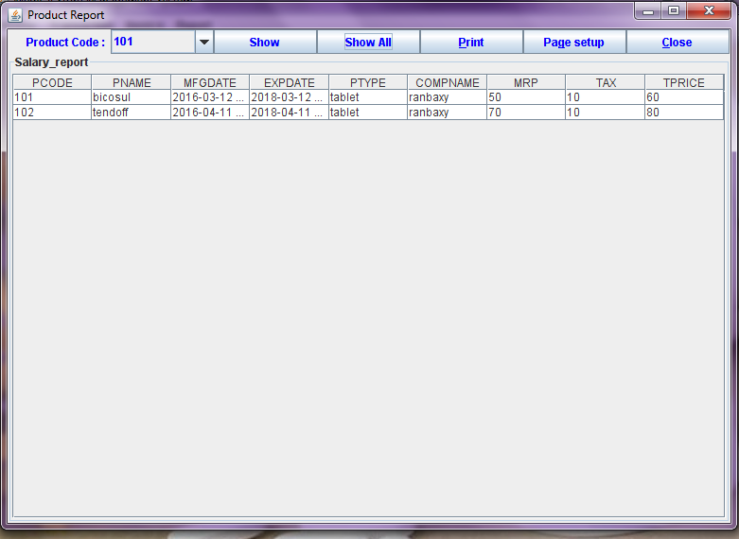

Customer Invoice

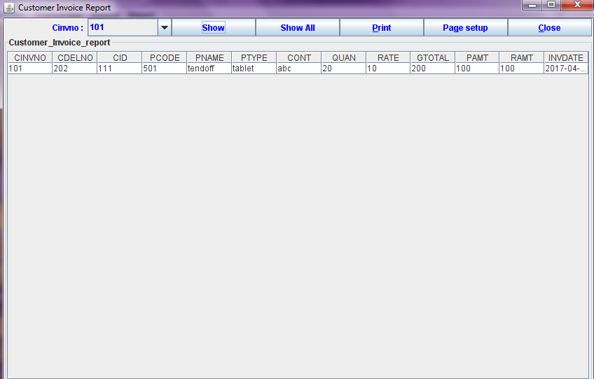

Purchase Report

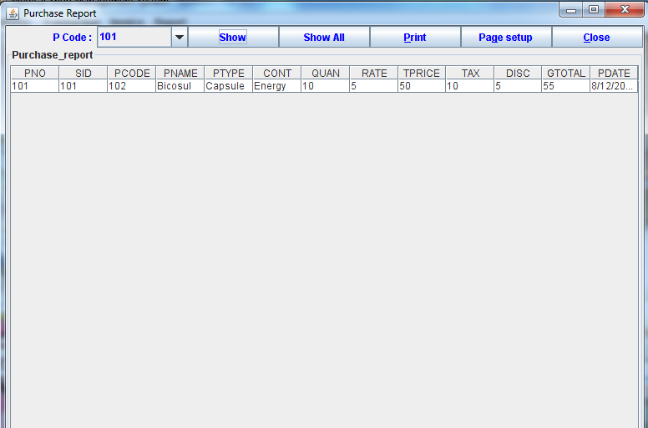

Sale Report
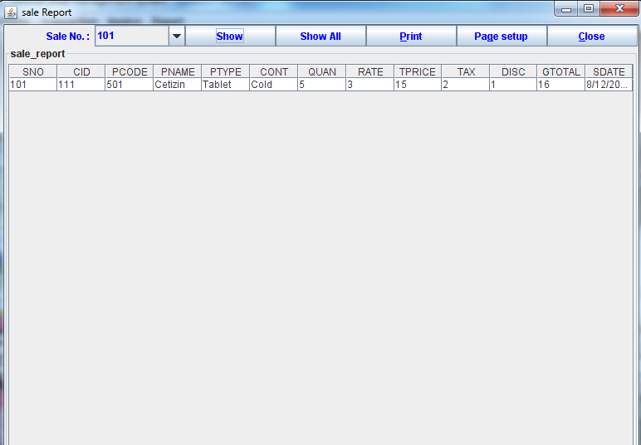

SECURITY MECHANISM
To do an adequate job on security, a system analyst must analyze the risk, exposure, and costs and specify measures such as passwords and encryption to provide protection. The backup copies of software and recovery restart procedures must be available when needed.
SECURITY AGAINST UNAUTHORIZED ACCESS:
  - Use of Administrator Passwords : The password provides security to the administrator to prevent from unauthorized access of data by the booking operator or other end users.
  - User related checks and validations: For this software, the developer uses user related checks and validations from the user.
  - User authorization keys : Passwords checking for logging of users.

IMPLEMENTATION
Implementation is the final phase of development. It consists of installing hardware, programs, collecting data and organizing people to interact with and run the system. In this project I install the proper hardware in medical shop and give the complete training to the employee about particular project.
MAINTENANCE
At the system will need maintenance. Software will definitely undergo change once it is delivered to the customer. There are many reasons for the change. Change could happen because of some unexpected input values into the system. In addition, the changes in the system could directly affect the software operations. The software should be developed to accommodate changes that could happen during the post implementation period.
If any problem occurs in the software then I resolve the particular problem.
LIMITATION OF THE PROJECT
- Limited time period
- Project currently run only windows Platform.

FUTURE SCOPE OF THE PROJECT
This project has been prepared to fulfill the requirement of MEDICAL SHOP in the standard rules and regulations. As far as project covers all important details of information.
The proposed system which is going to be developed will keep all information related this medical shop agency in easy way.
For the better management and creation of new customer, sales, purchase master etc. the data base of the application is updated on the occurrence of any concerned event therefore one can get feedback of database on single click of the mouse.
    - This system also provides facility like online query, online booking order, etc.
    - Reducing manual efforts for maintaining the record.
    - Reducing the lead time.

BIBLIOGRAPHY
1. PL/SQL PROGRAMMING BY IVAN BAYROSE

2. COMPLETE REFERENCEOF
ORACLE 10g BY ORACLE PRESS
3. CORE-JAVA PROGRAMMING By BALAGURUSWAMI

4. JAVA HOW TO PROGRAM By DEITEL & DEITEL

5. OFFICE 2007 BY NELSON

6. SYSTEM ANALYSIS
AND DESIGN BY AWARD

7. SOFTWARE ENGINEERING BY PRESSMANN
Website:
www.google.co.in

