**LAB0 REPORT**

**Shreya Chakraborty**

**PROGRAM DESCRIPTION:**

The program implements mergesort algorithm. It tries to emulate 'sort -n' linux command.

It takes command line arguments of 3 types

a. --name -> it's a flag. Causes the program to return my name regardless of any other argument after it.

b. sourcefile.txt -> non option ARG element. This is the file to sort. If it’s not followed by anything else then the program outputs the sorted numbers one per line on the stdout.

c. outputfile.txt -> optional argument. If present, the program writes the sorted integers into the output file.

./mysort --name [sourcefile.txt] -o [outputfile.txt]

The program parses the command line arguments using the wrapper function ParseCommandline(...) which internally uses getopt_long() in parse.c. It checks for the name flag, if found, the function prints my name and returns 1. The main then checks if the return value is 1, then returns 0. The parse function also stores the names of the input and output files from the command line by virtue of double pointer source and output file names in its parameter. The program then checks if the input file exists, if it does, then it opens it and reads it's content line by line using the API getline() until end of file, it converts the string in each line into integer and adds it to the end of the linked list. The linked list functions are given in linklist.c which includes functions to add, display and split list into 2.

After the list is ready it is displayed. At this point we finally start with out mergesort algorithm. After the list is sorted by the algorithm, depending on the '-o' option we either print the sorted list to the console or to output file. All the input and output files are available in the folder called 'files'

Lastly we compare our the output of our mergesort algorithm with the output of 'sort -n'. They should be same.

**MERGESORT ALGORITHM:**

Mergesort is a divide and conquer algorithm. It is implemented in 2 parts. One merges the 2 sorted array/list , function merge(...) in mergesort.c takes 2 sorted sub arrays or lists as parameter. The other is the recursive function Mergesort() which splits the list into halves and then recursively calls itself on the first half, which again splits into 2 and then on the 1st half of the split list again and again, until it has only 1 element. At this point it starts merging again. Next the function mergesort(..) is called on the 2nd half and the process repeats itself. Finally followed by the merge() function, where they compare each corresponding node/index of the sub lists, find the smaller integer and insert it into the final list until we get a sorted list.

**WHY MERGESORT?**

Quicksort has advantages like locality of reference and in place sorting. Due to these 2 reasons, the memory access is faster since the memory locations are near one another and there is no need for any addition auxiliary array. But since I am working with linked list, none of the above advantages apply since the nodes may not be in the adjacent memory locations and linked list insertion in between takes constant time. Quicksort would have been an ideal choice if I were dealing with arrays here. Mergesort on the other hand is a stable algorithm, able to efficiently handle larger data structures and still gives us a worst case time complexity of O(nlogn). Quicksort would have taken O(n^2) time. Hence Mergesort is the preferred algorithm to sort linked list and Quicksort is preferred for arrays.

**CODE ORGANISATION:**

1. bin : contains the executable of the program "mysort"

2. doc : contains "output.txt" which has the entire standard output of the bashcript.

It also contains image of the corresponding input called bash_input along with the Lab report.

3. files : contains all the testfiles, sorted testfiles by both mergesort as well as sort -n

4. includes : contains the header files (.h) of the Lab0

5. obj : contains the object files (.o) generated during make

6. script : contains the bashcript to test the entire program framework.

7. src : contains all the source files (.c) of Lab0

8. Makefile : supports make and make clean only

9. Readme : lab details

**BASH SCRIPT:**

The bashscript.sh in folder 'script' was my testing framework. It has an interactive and easy to use ui with 7 options. It can be used to generate random files for sorting. It uses the linux command 'shuf.' Based on the user input of range size and seed, the user can generate the required TestFile/TestFiles. All the TestFiles are stored in 'files'. Next it can also be used to sort the TestFile by both my sorting method and 'sort -n'. In my sorting method, it gives further options to choose algorithm (only mergesort has been attempted)and 'makes' it. It provides sub option like

sort for a single file or sort for all the 14 random generated TestFiles. The random generated testfiles and sorted and saved as 'mySortedTestFile'. The sorted files from sort -n option are saved as 'SortedTestFile'

We then compare the sorted files from both the options to see if the results match. For this we use the 'cmp' command line function. Finally we also have an option to delete all the text files in folder 'file' and make clean the code.

Folder 'doc' contains output.txt which is output of the bashcript and the image conatins the user input.

**COMPILATION INSTRUCTIONS:**

Makefile is in Lab0 folder. To compile just do $ make

and to clean just $ make clean

**EXECUTION INSTRUCTIONS:**

To execute normally go to the folder bin in Lab0. Thats where the executable mysort gets stored after make.

Then you can enter any of the configurations

$ ./mysort --name

My name is Shreya

$ ./mysort --name input.txt (name flag immediately returns)

My name is shreya

$ ./mysort input.txt

$ ./mysort input.txt -o output.txt

Alternatively you can use bashscript to automate everything. Go to in the folder 'script'.

set permission and make it executable -> $ chmod +x bashcript.sh

then -> $ ./bashcript.sh

APPENDIX:

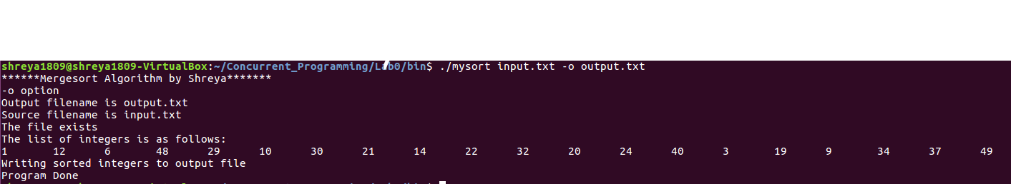

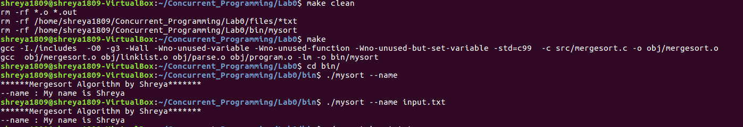

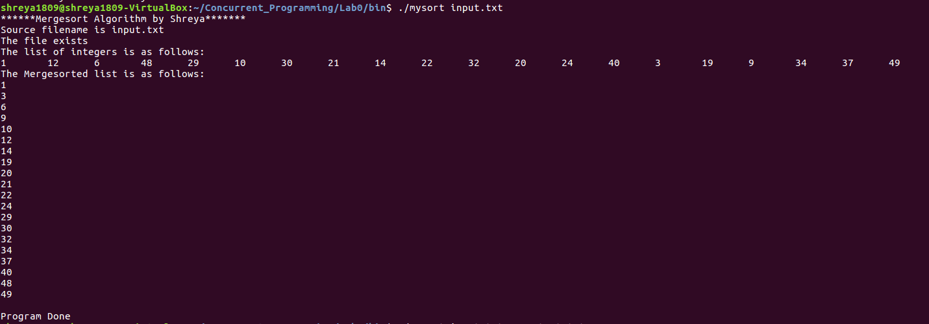

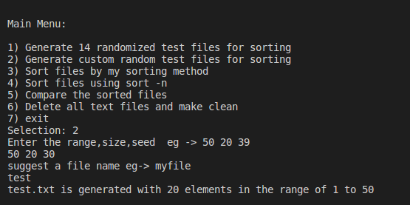

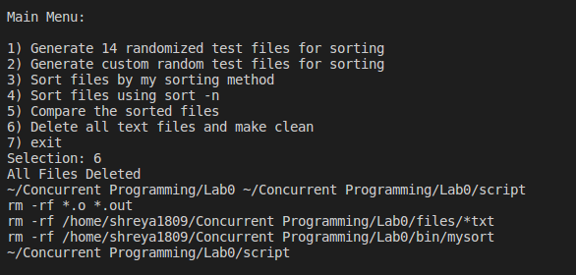

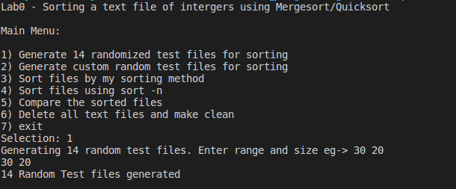

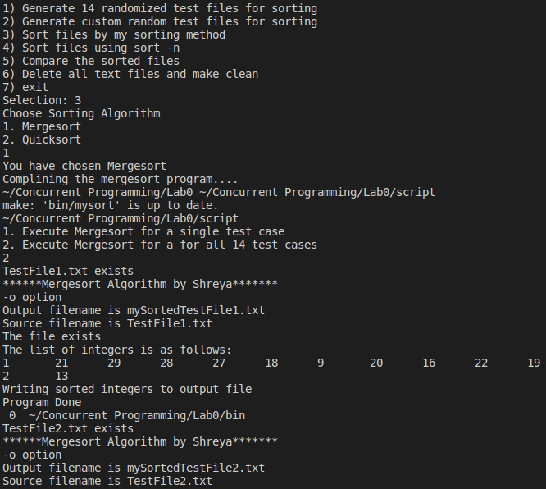

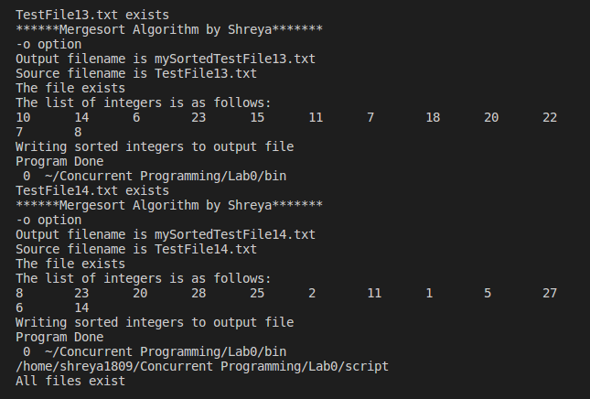

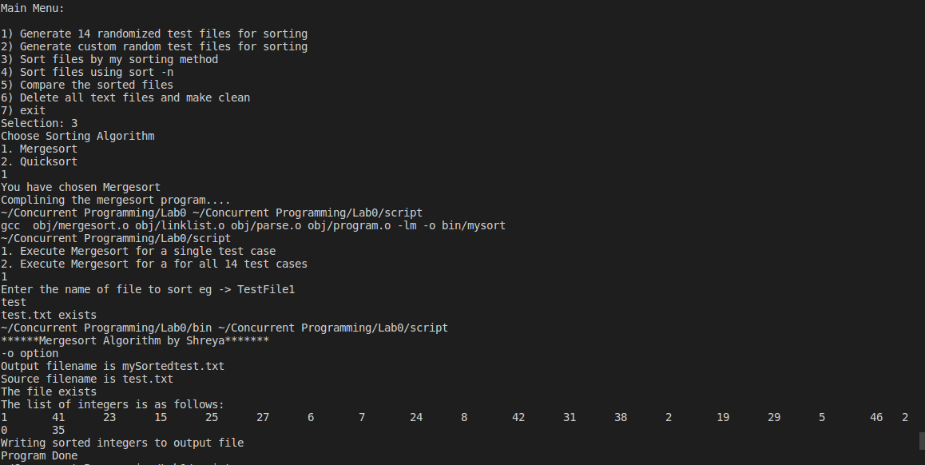

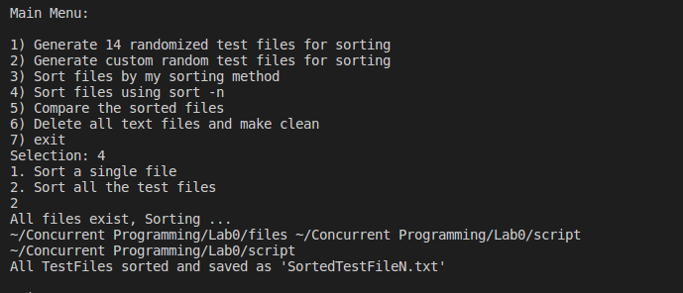

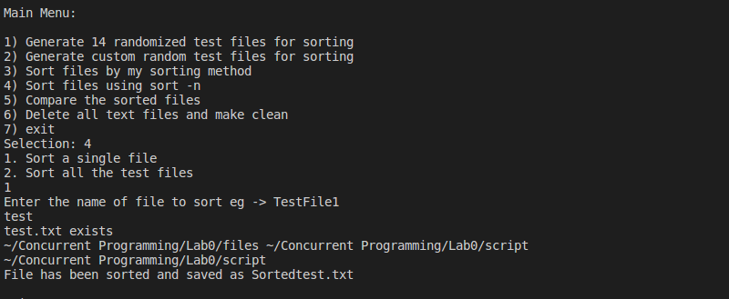

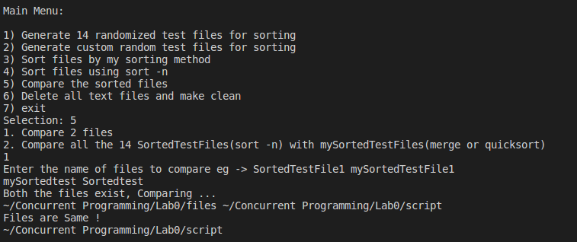

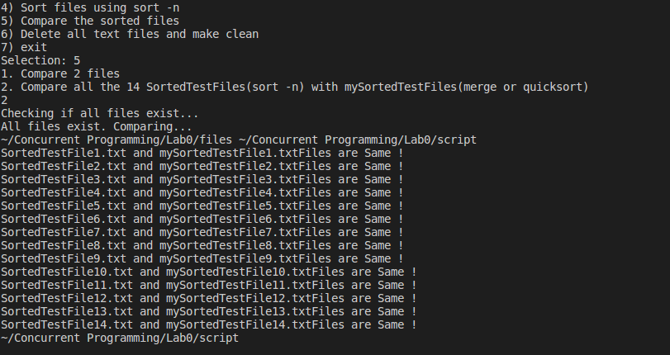

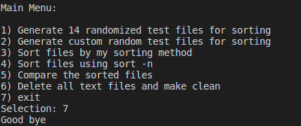

References:

1. <https://linuxconfig.org/bash-scripting-tutorial>
2. <https://stackoverflow.com/questions/30182086/how-to-use-goto-statement-in-shell-script?lq=1>
3. <https://www.gnu.org/software/libc/manual/html_node/Getopt-Long-Option-Example.html>
4. <https://stackoverflow.com/questions/30573481/path-include-and-src-directory-makefile/30602701>
5. <https://www.geeksforgeeks.org/merge-sort-for-linked-list/>
6. <https://hiltmon.com/blog/2013/07/03/a-simple-c-plus-plus-project-structure/>