HW1 REPORT
Q 1 Lab Policy Agreement
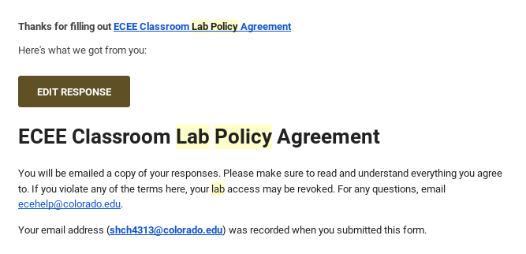
Q Problem 6

System Information Script

There are 2 script files. One prints the information on the terminal called infoscript.sh and the other file called bashscript.sh calls the infoscript.sh in it and writes the output into a file called output.txt.

bashscript.sh:
#!/bin/bash
./infoscript.sh
./infoscript.sh > output.txt

infoscript.sh:
#!/bin/bash
echo "---------System Information Script--------"
echo "--------------User Information------------"
w
echo
echo "---------Operating System Type------------"
hostnamectl
echo
echo "-------------OS Distribution--------------"
lsb_release -a
echo
echo "----------------OS Version----------------"
cat /etc/os-release
echo
echo "---------------Kernel Version-------------"
uname -r
echo
echo "---------Kernel GCC Version Build---------"
cat /proc/version
echo
echo "-------------Kernel Build Time------------"
uname -v
echo
echo "---------System Architecture Info---------"
lscpu
echo
echo "--------Info on File System Memory--------"
free
echo

output.txt contents:
---------System Information Script--------
--------------User Information------------
19:40:35 up 5:31, 1 user, load average: 0.07, 0.04, 0.01
USER TTY FROM LOGIN@ IDLE JCPU PCPU WHAT
shreya18 :0 :0 14:10 ?xdm? 2:29 0.01s /usr/lib/gdm3/gdm-x-session --run-script env GNOME_SHELL_SESSION_MODE=ubuntu gnome-session --session=ubuntu

---------Operating System Type------------
Static hostname: shreya1809
Icon name: computer-vm
Chassis: vm
Machine ID: 8b2ef35844d246afb35cbdda3e0c8080
Boot ID: 6d1d0db647c34894afb8a76338de40b1
Virtualization: oracle
Operating System: Ubuntu 18.04.1 LTS
Kernel: Linux 4.15.0-29-generic
Architecture: x86-64

-------------OS Distribution--------------
Distributor ID: Ubuntu
Description: Ubuntu 18.04.1 LTS
Release: 18.04
Codename: bionic

----------------OS Version----------------
NAME="Ubuntu"
VERSION="18.04.1 LTS (Bionic Beaver)"
ID=ubuntu
ID_LIKE=debian
PRETTY_NAME="Ubuntu 18.04.1 LTS"
VERSION_ID="18.04"
HOME_URL="https://www.ubuntu.com/"
SUPPORT_URL="https://help.ubuntu.com/"
BUG_REPORT_URL="https://bugs.launchpad.net/ubuntu/"
PRIVACY_POLICY_URL="https://www.ubuntu.com/legal/terms-and-policies/privacy-policy"
VERSION_CODENAME=bionic
UBUNTU_CODENAME=bionic

---------------Kernel Version-------------
4.15.0-29-generic

---------Kernel GCC Version Build---------
Linux version 4.15.0-29-generic (buildd@lgw01-amd64-057) (gcc version 7.3.0 (Ubuntu 7.3.0-16ubuntu3)) #31-Ubuntu SMP Tue Jul 17 15:39:52 UTC 2018

-------------Kernel Build Time------------
#31-Ubuntu SMP Tue Jul 17 15:39:52 UTC 2018

---------System Architecture Info---------
Architecture: x86_64
CPU op-mode(s): 32-bit, 64-bit
Byte Order: Little Endian
CPU(s): 1
On-line CPU(s) list: 0
Thread(s) per core: 1
Core(s) per socket: 1
Socket(s): 1
NUMA node(s): 1
Vendor ID: GenuineIntel
CPU family: 6
Model: 78
Model name: Intel(R) Core(TM) i5-6200U CPU @ 2.30GHz
Stepping: 3
CPU MHz: 2400.002
BogoMIPS: 4800.00
Hypervisor vendor: KVM
Virtualization type: full
L1d cache: 32K
L1i cache: 32K
L2 cache: 256K
L3 cache: 3072K
NUMA node0 CPU(s): 0
Flags: fpu vme de pse tsc msr pae mce cx8 apic sep mtrr pge mca cmov pat pse36 clflush mmx fxsr sse sse2 ht syscall nx rdtscp lm constant_tsc rep_good nopl xtopology nonstop_tsc cpuid pni pclmulqdq monitor ssse3 cx16 pcid sse4_1 sse4_2 x2apic movbe popcnt aes xsave avx rdrand hypervisor lahf_lm abm 3dnowprefetch invpcid_single pti fsgsbase avx2 invpcid rdseed clflushopt

--------Info on File System Memory--------
total used free shared buff/cache available
Mem: 5071924 1027824 2865232 7216 1178868 3797724
Swap: 2097148 0 2097148

Q Problem 7
Shared and Static libraries built natively
1. Proof of Execution of each application
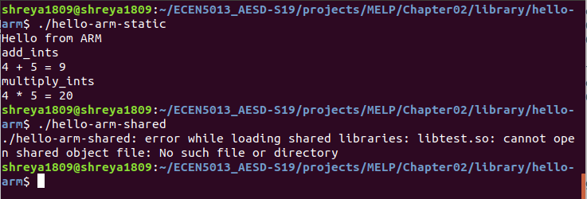
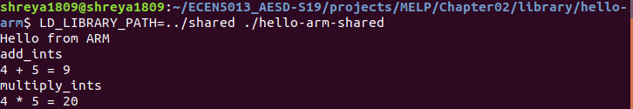

2. Difference in Size of the 2 applications
with -static argument in the makefile
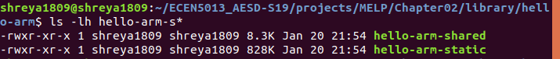
3. Shared library use of each executable using readelf as per MELP chapter 2 page 83
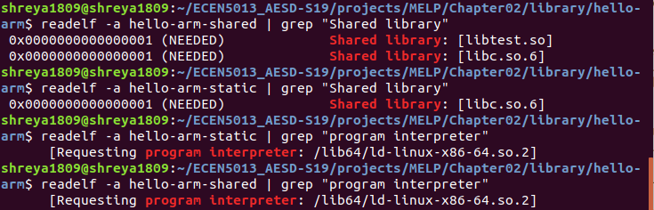
Q8 Cross Building
Crosstool-NG toolchain for the Beaglebone Black
1. The version and configuration of “arm-cortex_a8-linux-gnueabihf” gcc compiler:
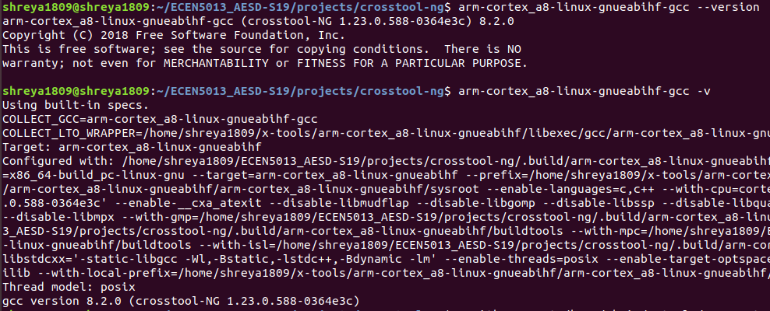
2. The sysroot directory
3. Compiling using the arm-cortex_a8-linux-gnueabihf cross-tools
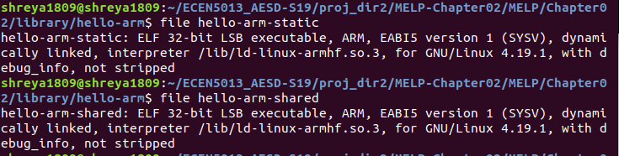
4. Size of each Executable
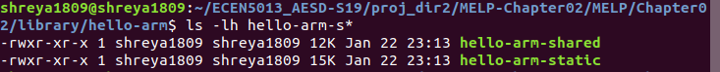

5. Shared library use of each executable
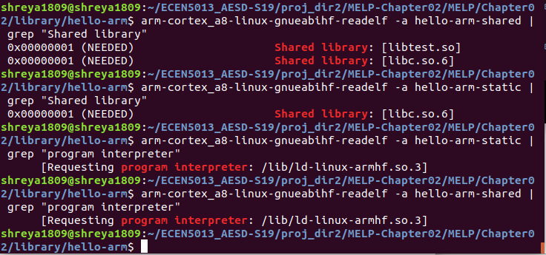

Crosstool-NG chain for the QEMU emulator
1. The version and configuration of “arm-unknown-linux-gnueabi” gcc compiler
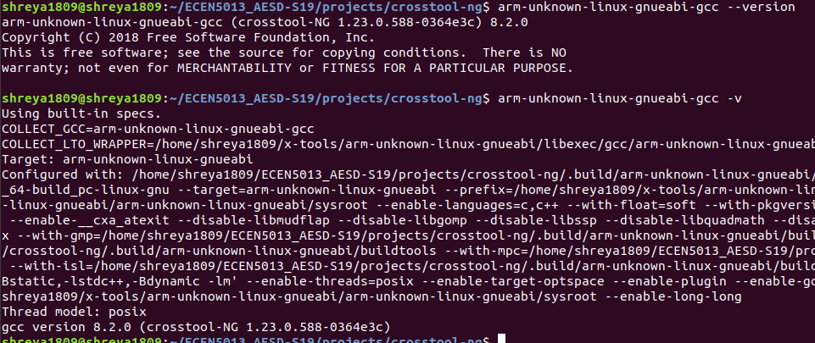
2. The sysroot directory
3. Compiling using the arm_unknown-linux_gnueabi cross-tools
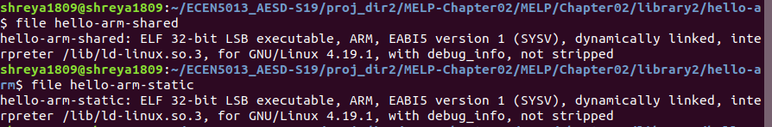
4. Size of each Executable
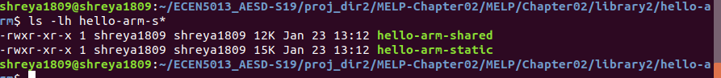
5. Shared library use of each executable
