1. How much current does a single LED draw when the output drive is set to “Strong” with the original code?

Ans: 5.27 mA -4.76 milliamps = 0.51 milliamps

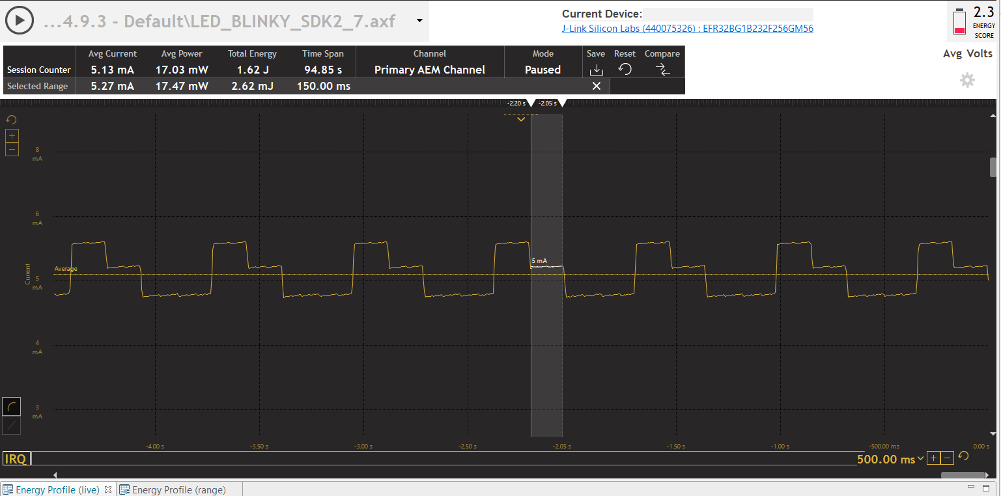

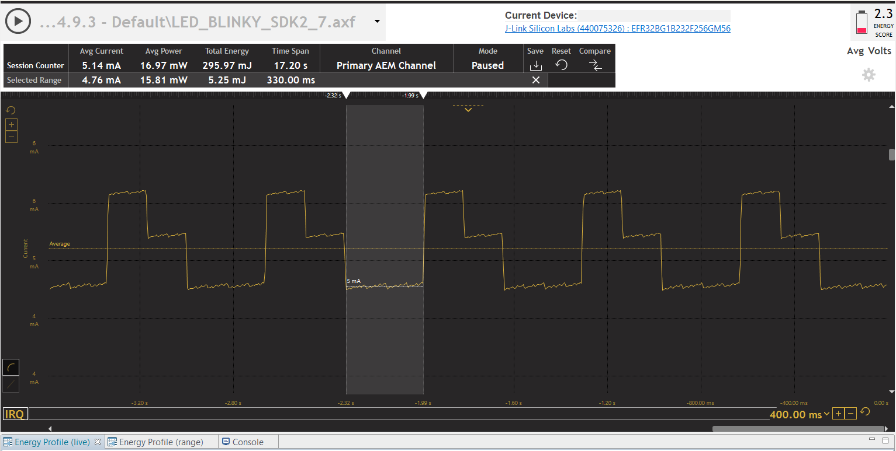

1. After commenting out the standard output drive and uncommenting “Weak” drive, how much current does a single LED draw?

Ans: 5.25 milliamps – 4.76 milliamps = 0.49 milliamps

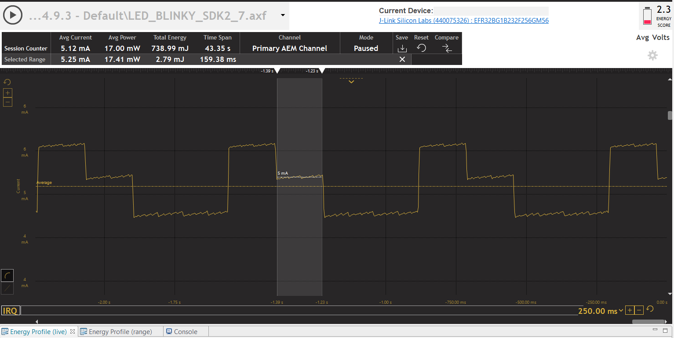

1. Is there a difference in current between the answers for question 1 and 2? And, explain your answer, why or why not?

Ans: 510 microamps – 490 microamps = 20 microamps; No significant difference. The pins of the leds are internally connected to 3k ohm resistors. According to the data sheets the weak drive strength gpio drives atleast 1 milliamps of current while the strong drives 10 milliamps. The current which follows through the pins of the led ( considering voltage drops across the resisitors) is low enough such that both strong and weak drive can provide it. The gpio works at 3.3 volts while the forward voltage is around 2 volts. So the current is less than 1milliamps which both the drives can provide.

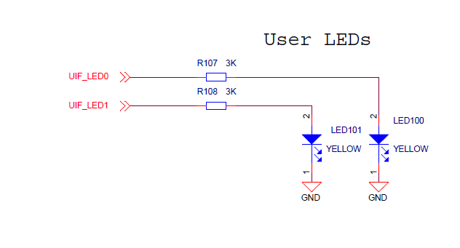

1. Using the Energy Profiler with “weak” drive LEDs, what is the Energy Score and average current measured before commenting out turning on LED1?

Ans: Energy Score: 2.3; Avg Current: 5.12mA

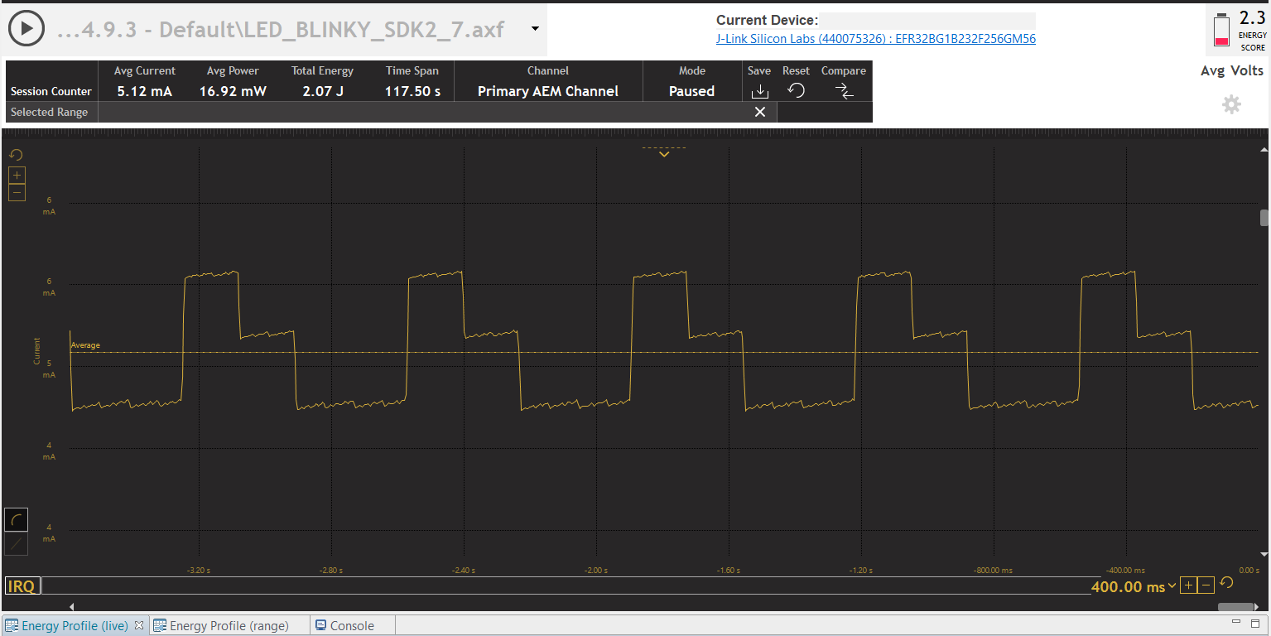

1. Using the Energy Profiler with “weak” drive LEDs, what is the Energy Score and average current measured after commenting out turning on LED1?

Ans: Energy Score: 2.3; Avg Current : 4.86 milliamps

