ECEN 5823

Managing Energy Mode Assignment

Spring 2018

* 1. 1. What is the Average Current when the Blue Gecko can only go down to EM0 and what is the average current when the LED is off? What is the average current when the LED is on? a. Wait 60 seconds after the Average Current is RESET to read the Average Current

ANS:

Avg Current : 2.47 milli amps

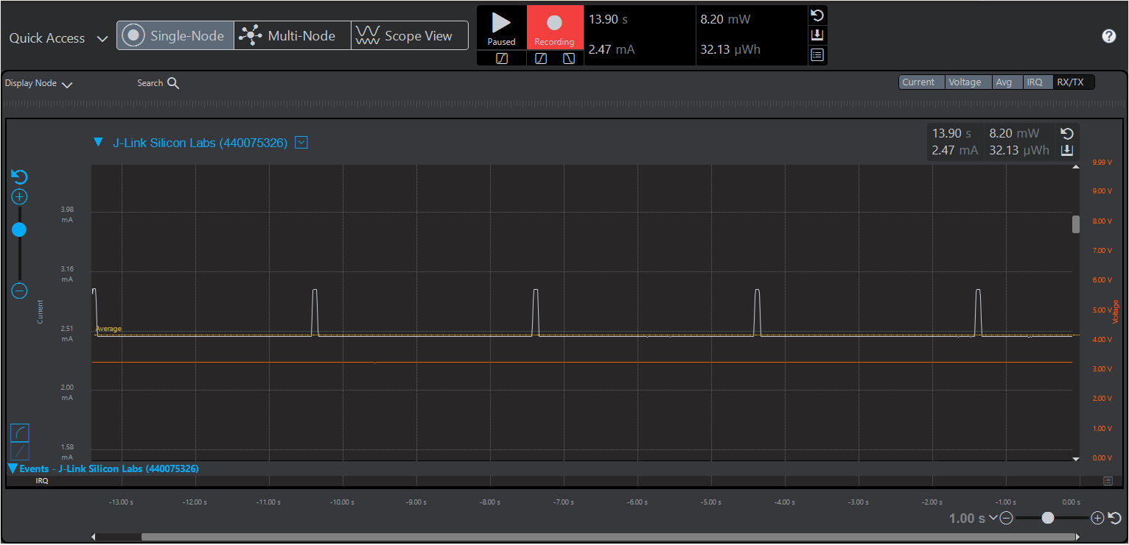

Avg Current with LED on: 3.04 milli amps

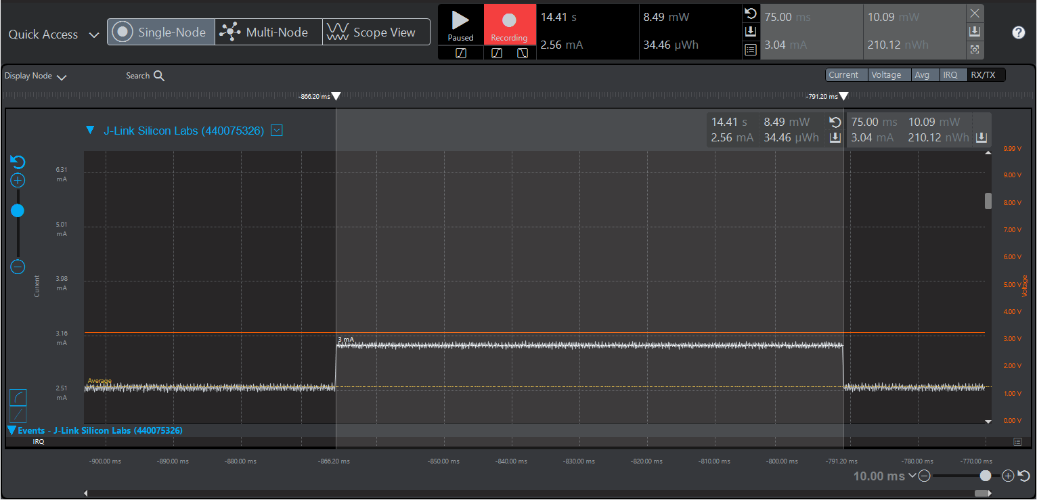

Avg Current with LED off: 2.54 milli amps

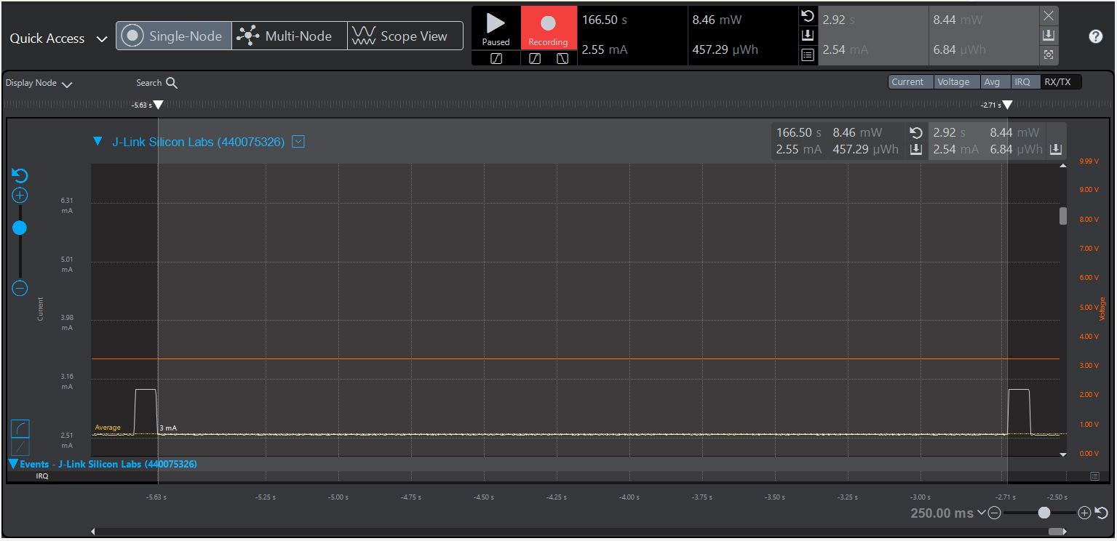

2. What is the Average Current when the Blue Gecko can only go down to EM1 and what is the average current when the LED is off? What is the average current when the LED is on?

ANS:

Avg Current: 1.79 milli amps

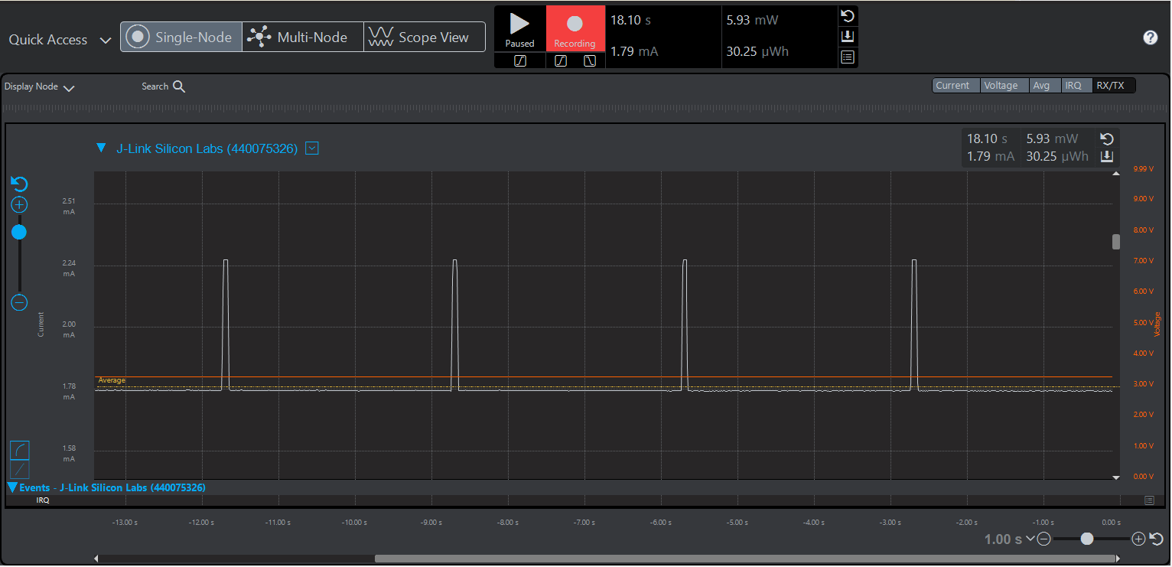

Avg Current with LED on: 2.24 milli amps

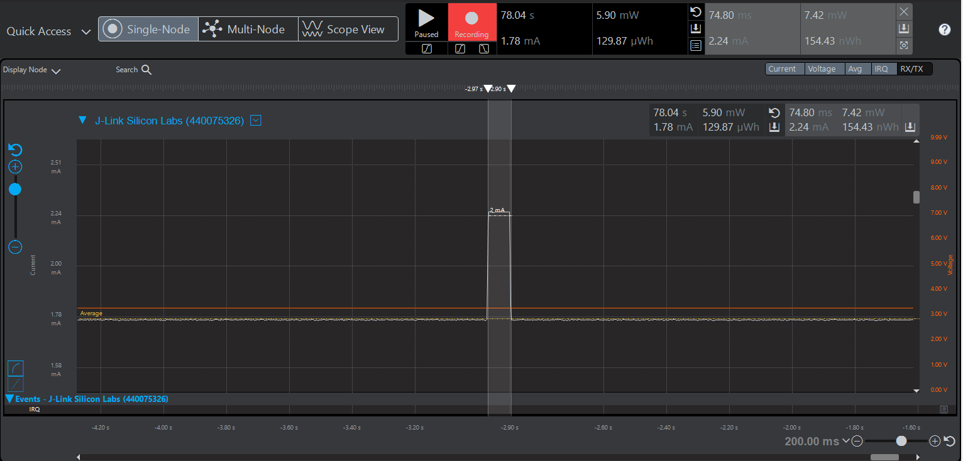

Avg Current with LED off: 1.77 milli amps

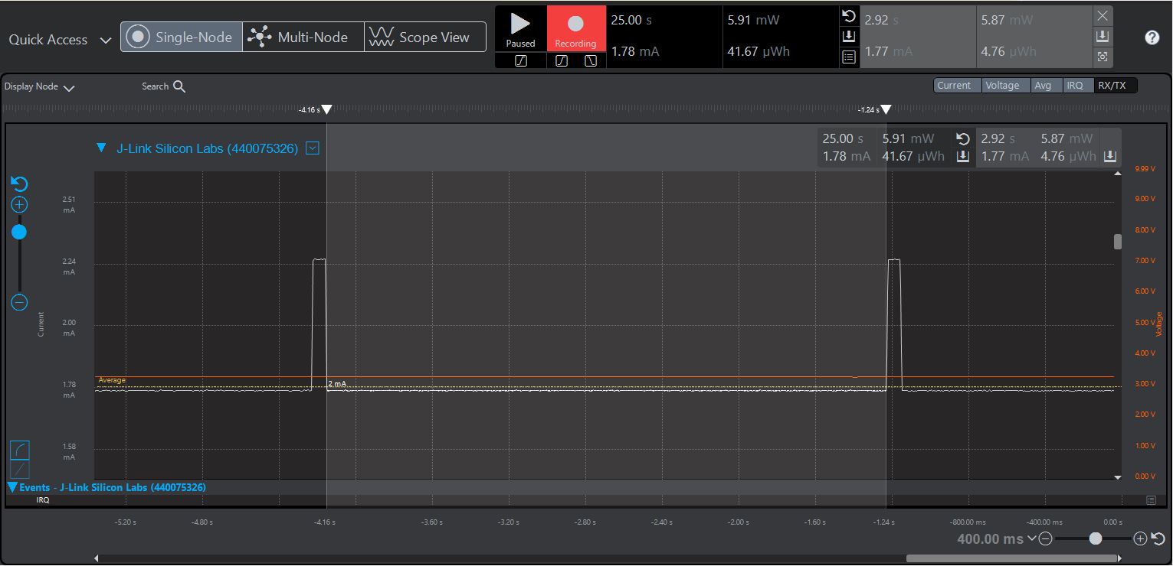

3. What is the Average Current when the Blue Gecko can only go down to EM2 and what is the average current when the LED is off? What is the average current when the LED is on?

ANS:

Avg Current: 15.99 micro amps

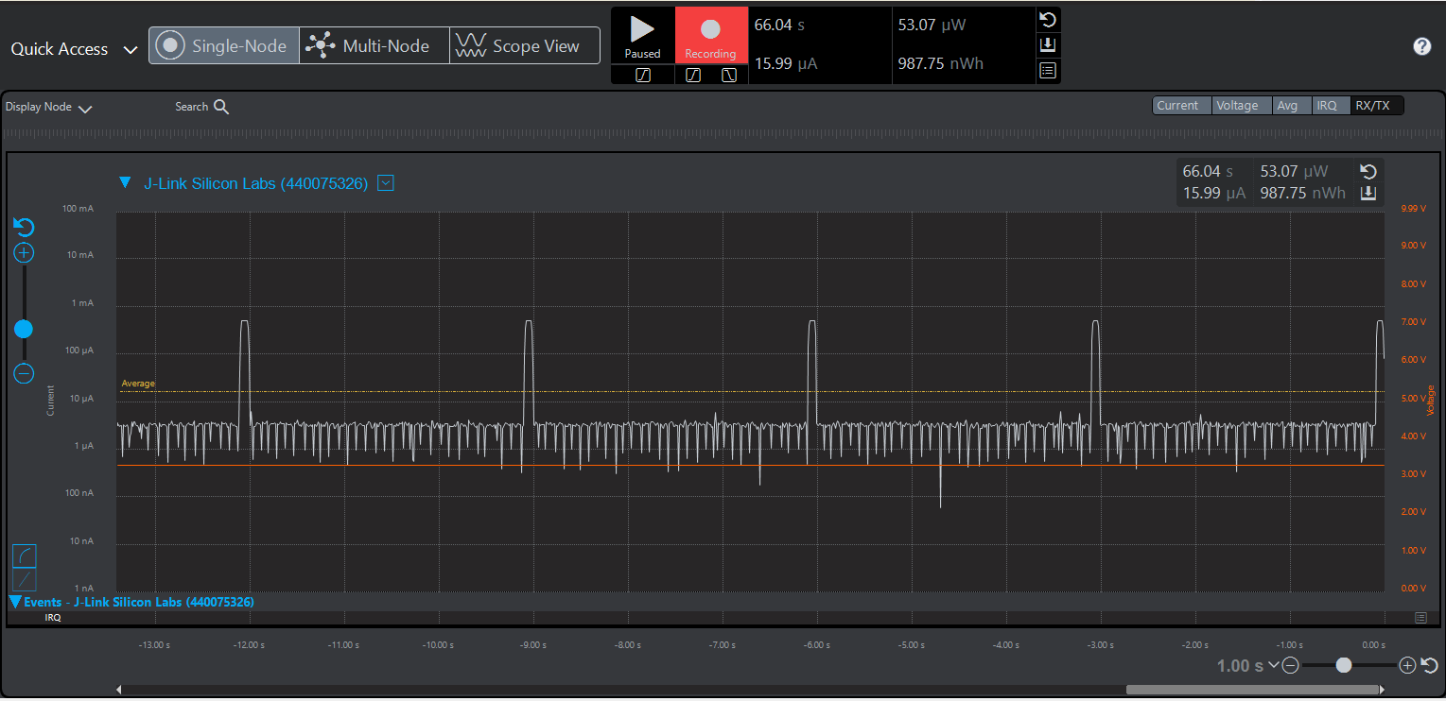

Avg Current with LED on: 494.71 micro amps

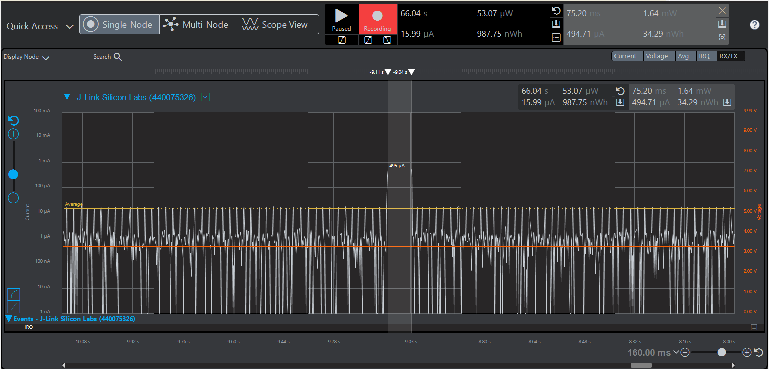

Avg Current with LED off: 4.72 micro amps

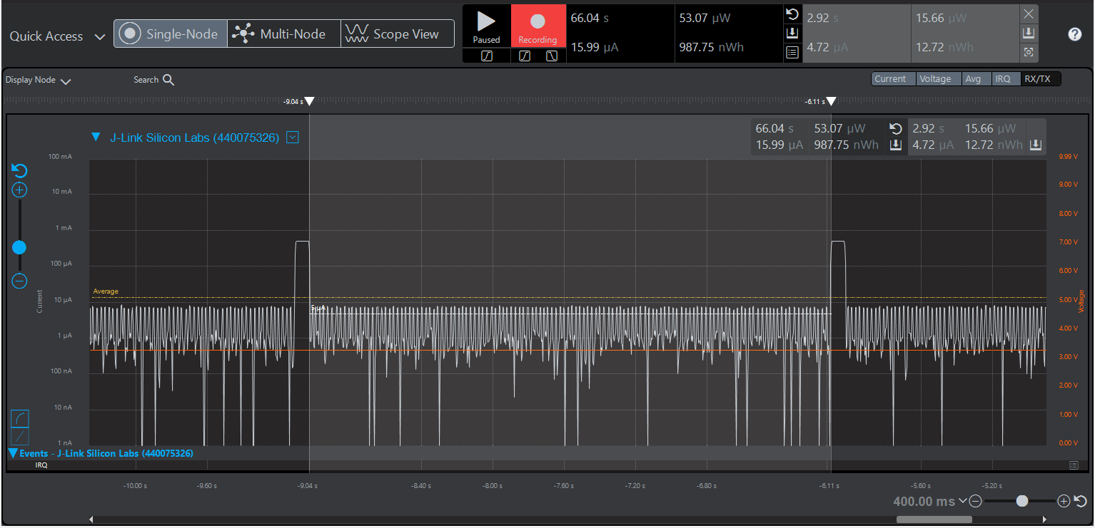

4. What is the period in milliseconds of the LED blinking using EM2 using the Average Current “selected range” markers? What is the On-Duty Cycle in milliseconds of the LED using the Average Current while limited to EM2?

ANS:

On duty Cycle in milliseconds: 75ms

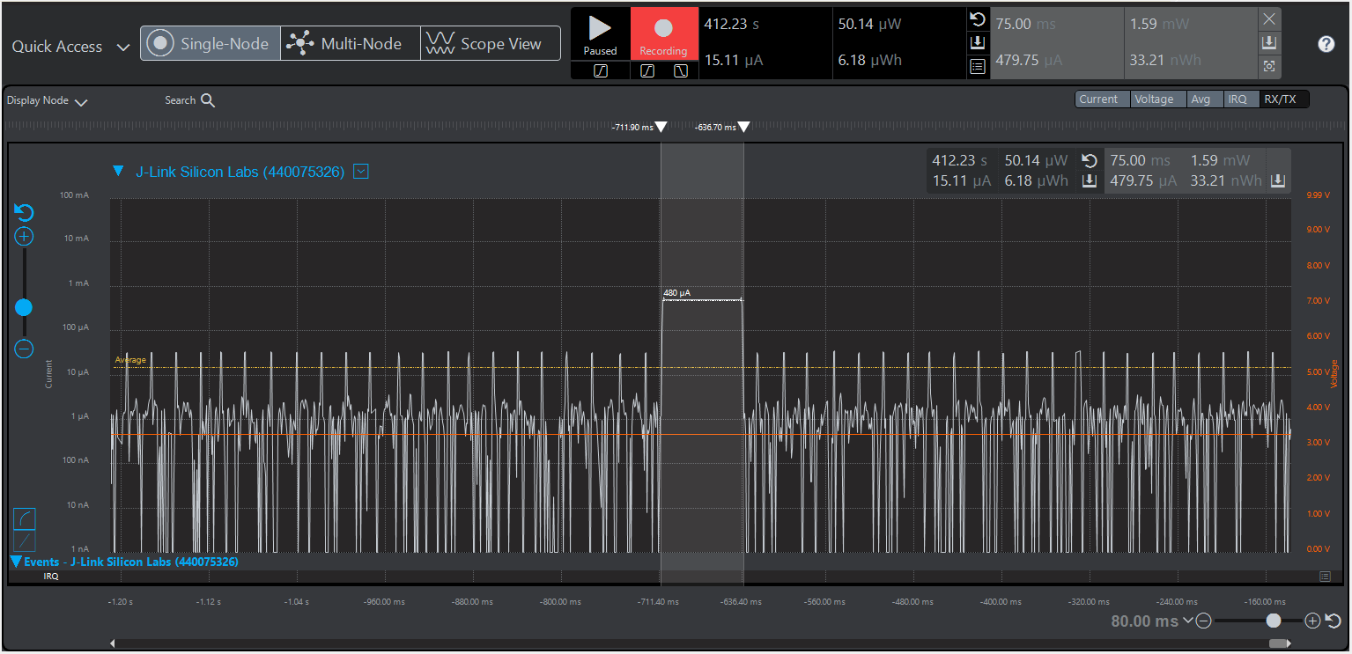

Period of LED : 3 secs

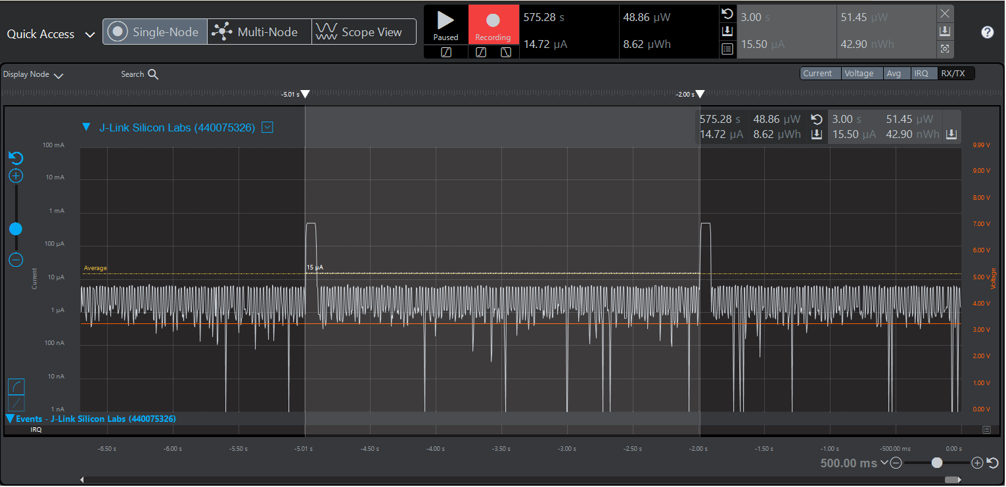

5. What is the Average Current when the Blue Gecko can go down to EM3 and what is the average current when the LED is off? What is the average current when the LED is on?

ANS:

Avg Current:14.93 micro amps

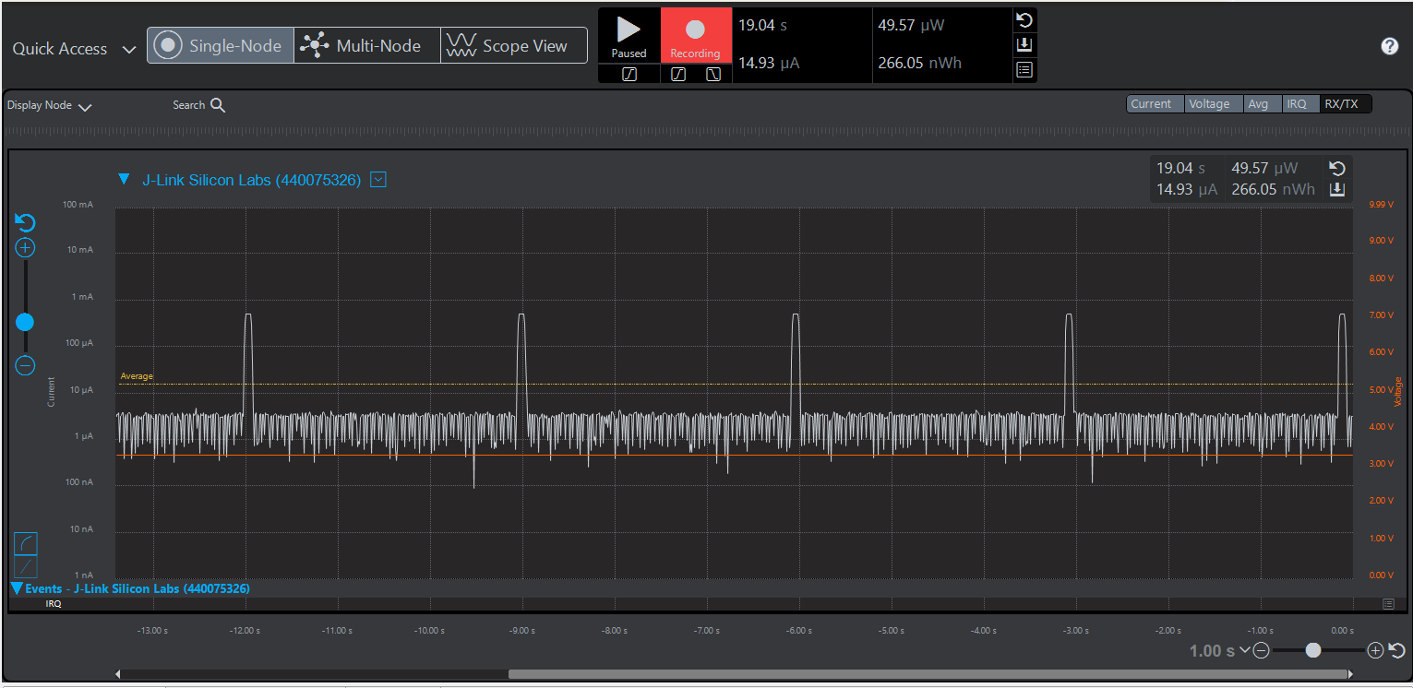

Avg Current with LED on: 490.53micro amps

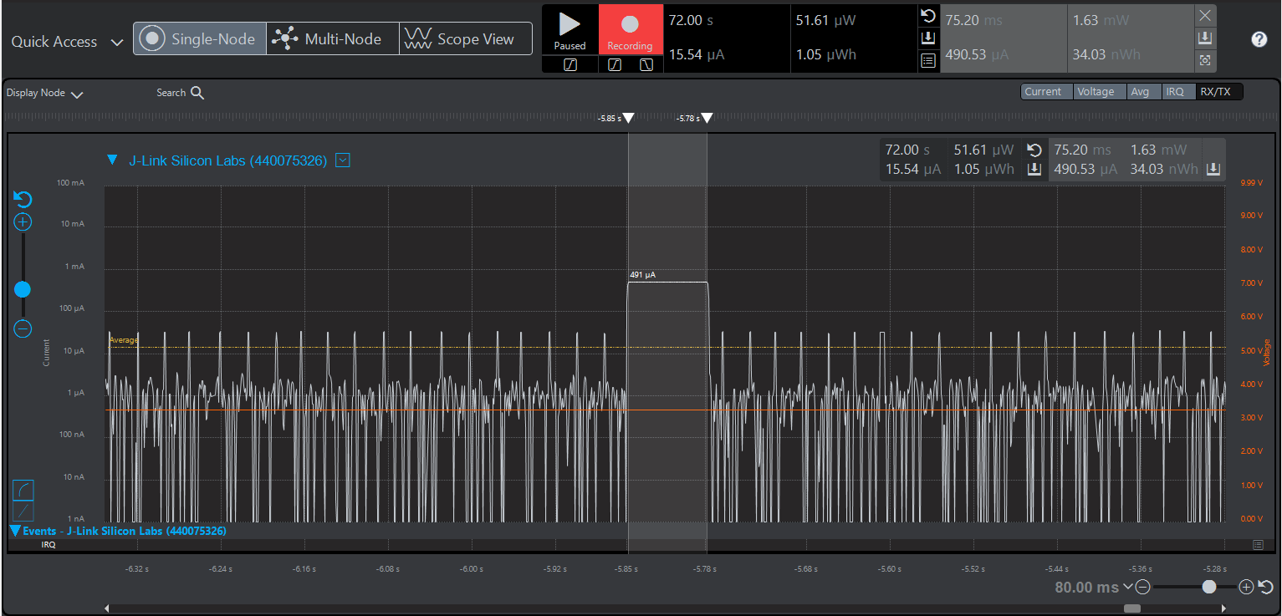

Avg Current with LED off: 2.67 micro amps

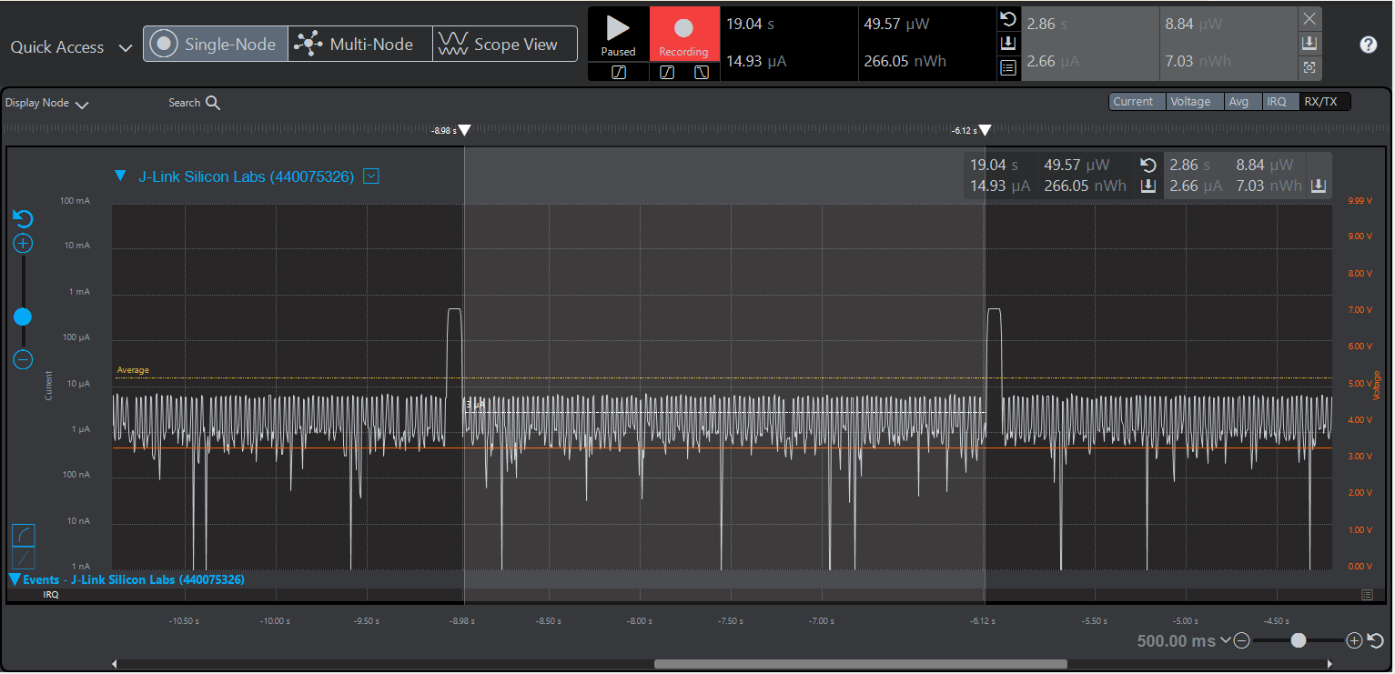

6. What is the period in milliseconds of the LED blinking using EM3 using the Average Current “selected range” markers? What is the On-Duty Cycle in milliseconds of the LED using the Average Current while limited to EM3?

Ans:

Period in Milliseconds: 2.98 ms

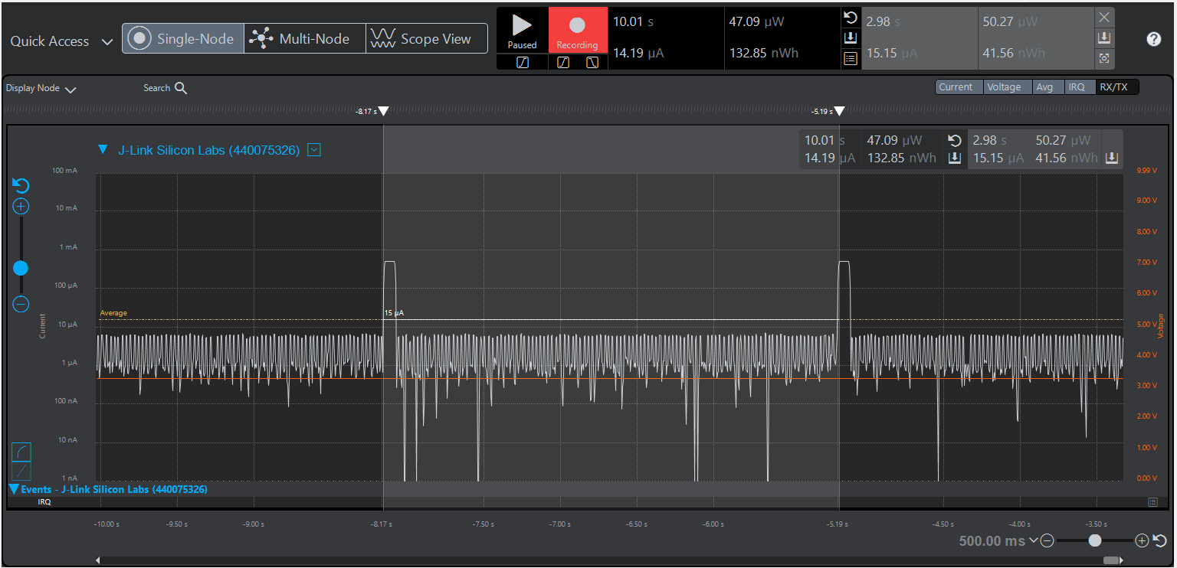

Duty Cycle of LED on: 75.20ms

